Unit II (9 Hours)
Introduction to software Engineering: Basic concepts about software and program and Evolution of Software Engineering, Basic concepts on process and life cycle models, Models: Waterfall, Prototype, Evolutionary, Incremental, spiral, V, RADM etc. Requirement Analysis: Introduction to software specification, its needs and importance, formal specification methods, SRS attributes of good SRS and organization of SRS document.

INTRODUCTION TO SOFTWARE ENGINEERING
The term software engineering is composed of two words, software and engineering.
Software is more than just a program code. A program is an executable code, which serves
some computational purpose. Software is considered to be a collection of executable
programming code, associated libraries and documentations. Software, when made for a
specific requirement is called software product.

Engineering on the other hand, is all about developing products, using well-defined, scientific principles and methods.
So, we can define software engineering as an engineering branch associated with the
development of software product using well-defined scientific principles, methods and
procedures. The outcome of software engineering is an efficient and reliable software product.
We can alternatively view it as a systematic collection of past experience. The experience is
arranged in the form of methodologies and guidelines. A small program can be written without using software engineering principles. But if one wants to develop a large software product, then software engineering principles are absolutely necessary to achieve a good quality software cost effectively.
Without using software engineering principles, it would be difficult to develop large programs. In industry it is usually needed to develop large programs to accommodate multiple functions. A problem with developing such large commercial programs is that the complexity and difficulty levels of the programs increase exponentially with their sizes. Software engineering helps to reduce this programming complexity. Software engineering principles use two important techniques to reduce problem complexity: abstraction and decomposition. The principle of abstraction implies that a problem can be simplified by omitting irrelevant details. In other words, the main purpose of abstraction is to consider only those aspects of the problem that are relevant for certain purpose and suppress other aspects that are not relevant for the given purpose. Once the simpler problem is solved, then the omitted details can be taken into consideration to solve the next lower level abstraction, and so on. Abstraction is a powerful way of reducing the complexity of the problem. The other approach to tackle problem complexity is decomposition. In this technique, a complex problem is divided into several smaller problems and then the smaller problems are solved one by one. However, in this technique any random decomposition of a problem into smaller parts will not help. The problem has to be decomposed such that each component of the decomposed problem can be solved independently and then the solution of the different components can be combined to get the full solution. A good decomposition of a problem should minimize interactions among various components. If the different subcomponents are interrelated, then the different components cannot be solved separately and the desired reduction in complexity will not be realized.
NEED OF SOFTWARE ENGINEERING
The need of software engineering arises because of higher rate of change in user requirements and environment on which the software is working.
Large software - It is easier to build a wall than to a house or building, likewise, as the size of software become large engineering has to step to give it a scientific process.
Scalability- If the software process were not based on scientific and engineering concepts, it would be easier to re-create new software than to scale an existing one.
Cost- As hardware industry has shown its skills and huge manufacturing has lower down the price of computer and electronic hardware. But the cost of software remains high if proper process is not adapted.
Dynamic Nature- The always growing and adapting nature of software hugely depends upon the environment in which the user works. If the nature of software is always changing, new enhancements need to be done in the existing one. This is where software engineering plays a good role.
Quality Management- Better process of software development provides better and
quality software product.
CHARACTERESTICS OF GOOD SOFTWARE
A software product can be judged by what it offers and how well it can be used. This software must satisfy on the following grounds:
• Operational
• Transitional
• Maintenance
Operational
This tells us how well software works in operations. It can be measured on:
• Budget
• Usability
• Efficiency
• Correctness
• Functionality
• Dependability
• Security
• Safety
Transitional
This aspect is important when the software is moved from one platform to another:
• Portability
• Interoperability
• Reusability
• Adaptability
Maintenance
This aspect briefs about how well a software has the capabilities to maintain itself in the ever changing environment:
• Modularity
• Maintainability
• Flexibility
• Scalability
SOFTWARE DEVELOPMENT LIFE CYCLE
LIFE CYCLE MODEL
A software life cycle model (also called process model) is a descriptive and diagrammatic representation of the software life cycle. A life cycle model represents all the activities required to make a software product transit through its life cycle phases. It also captures the order in which these activities are to be undertaken. In other words, a life cycle model maps the different activities performed on a software product from its inception to retirement. Different life cycle models may map the basic development activities to phases in different ways. Thus, no matter which life cycle model is followed, the basic activities are included in all life cycle models though the activities may be carried out in different orders in different life cycle models. During any life cycle phase, more than one activity may also be carried out.
THE NEED FOR A SOFTWARE LIFE CYCLE MODEL
The development team must identify a suitable life cycle model for the particular project and then adhere to it. Without using of a particular life cycle model the development of a software product would not be in a systematic and disciplined manner. When a software product is being developed by a team there must be a clear understanding among team members about when and what to do. Otherwise it would lead to chaos and project failure. This problem can be illustrated by using an example.
Different software life cycle models
• Classical Waterfall Model
• Iterative Waterfall Model
• Prototyping Model
• Evolutionary Model
• Spiral Model

1. CLASSICAL WATERFALL MODEL

The classical waterfall model is intuitively the most obvious way to develop software. Though the classical waterfall model is elegant and intuitively obvious, it is not a practical model in the sense that it cannot be used in actual software development projects. Thus, this model can be considered to be a theoretical way of developing software. But all other life cycle models are essentially derived from the classical waterfall model. So, in order to be able to appreciate other life cycle models it is necessary to learn the classical waterfall model. Classical waterfall model divides the life cycle into the following phases as shown in fig.

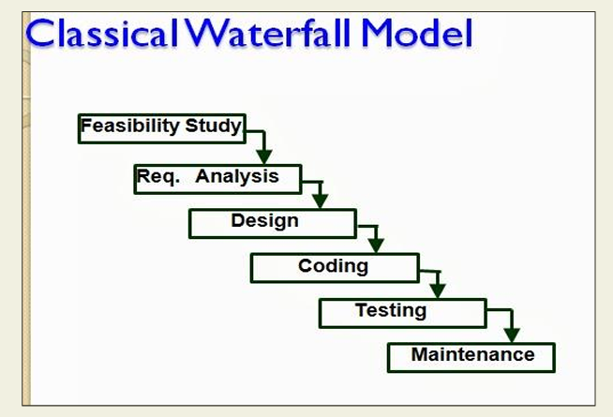

Feasibility study - The main aim of feasibility study is to determine whether it would be financially and technically feasible to develop the product.
• At first project managers or team leaders try to have a rough understanding of what is required to be done by visiting the client side. They study different input data to the system and output data to be produced by the system. They study what kind of processing is needed to be done on these data and they look at the various constraints on the behavior of the system.
• After they have an overall understanding of the problem they investigate the different solutions that are possible. Then they examine each of the solutions in terms of what kind of resources required, what would be the cost of development and what would be the development time for each solution.
Requirements analysis and specification: - The aim of the requirements analysis and specification phase is to understand the exact requirements of the customer and to document them properly. This phase consists of two distinct activities, namely

Requirements analysis and specification: - The aim of the requirements analysis and specification phase is to understand the exact requirements of the customer and to document them properly. This phase consists of two distinct activities, namely
• Requirements gathering and analysis
• Requirements specification
The goal of the requirements gathering activity is to collect all relevant information from the customer regarding the product to be developed. This is done to clearly understand the customer requirements so that incompleteness and inconsistencies are removed.
The requirements analysis activity is begun by collecting all relevant data regarding the product to be developed from the users of the product and from the customer through interviews and discussions. For example, to perform the requirements analysis of a business accounting software required by an organization, the analyst might interview all the accountants of the organization to ascertain their requirements. The data collected from such a group of users usually contain several contradictions and ambiguities, since each user typically has only a partial and incomplete view of the system.

Design: - The goal of the design phase is to transform the requirements specified in the SRS document into a structure that is suitable for implementation in some programming language. In technical terms, during the design phase the software architecture is derived from the SRS document. Two distinctly different approaches are available: the traditional design approach and the object-oriented design approach.

• Traditional design approach -Traditional design consists of two different activities; first a structured analysis of the requirements specification is carried out where the detailed structure of the problem is examined. This is followed by a structured design activity. During structured design, the results of structured analysis are transformed into the software design.
• Object-oriented design approach -In this technique, various objects that occur in the problem domain and the solution domain are first identified, and the different relationships that exist among these objects are identified. The object structure is further refined to obtain the detailed design.

Coding and unit testing:-The purpose of the coding phase (sometimes called the implementation phase) of software development is to translate the software design into source code. Each component of the design is implemented as a program module. The end-product of this phase is a set of program modules that have been individually tested. During this phase, each module is unit tested to determine the correct working of all the individual modules. It involves testing each module in isolation as this is the most efficient way to debug the errors identified at this stage.

Integration and system testing: -Integration of different modules is undertaken once they have been coded and unit tested. During the integration and system testing phase, the modules are integrated in a planned manner.
The goal of system testing is to ensure that the developed system conforms to its requirements laid out in the SRS document. System testing usually consists of three different kinds of testing activities:
• α – testing: It is the system testing performed by the development team.
• β –testing: It is the system testing performed by a friendly set of customers.
• Acceptance testing: It is the system testing performed by the customer himself after the product delivery to determine whether to accept or reject the delivered product.

Maintenance: -Maintenance of a typical software product requires much more than the effort necessary to develop the product itself. Many studies carried out in the past confirm this and indicate that the relative effort of development of a typical software product to its maintenance effort is roughly in the 40:60 ratios.

Shortcomings of the classical waterfall model
The classical waterfall model is an idealistic one since it assumes that no development error is ever committed by the engineers during any of the life cycle phases. However, in practical development environments, the engineers do commit a large number of errors in almost every phase of the life cycle. The source of the defects can be many: oversight, wrong assumptions, use of inappropriate technology, communication gap among the project engineers, etc.
Therefore, in any practical software development work, it is not possible to strictly follow the classical waterfall model.

2. ITERATIVE WATERFALL MODEL
To overcome the major shortcomings of the classical waterfall model, we come up with the iterative waterfall model.
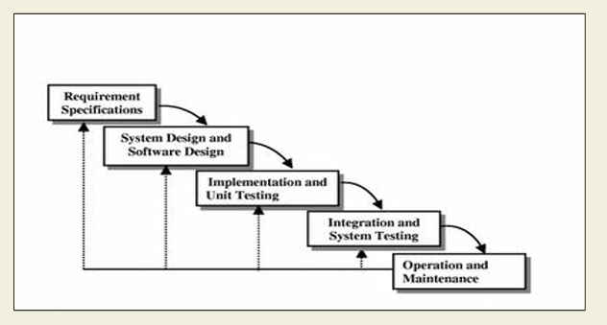

Here, we provide feedback paths for error correction as & when detected later in a phase. Though errors are inevitable, but it is desirable to detect them in the same phase in which they occur. If so, this can reduce the effort to correct the bug.
The advantage of this model is that there is a working model of the system at a very early stage of development which makes it easier to find functional or design flaws. Finding issues at an early stage of development enables to take corrective measures in a limited budget.
The disadvantage with this SDLC model is that it is applicable only to large and bulky software development projects. This is because it is hard to break a small software system into further small serviceable increments/modules.

3. PRTOTYPING MODEL

Prototype
A prototype is a toy implementation of the system. A prototype usually exhibits limited functional capabilities, low reliability, and inefficient performance compared to the actual
software. A prototype is usually built using several shortcuts. The shortcuts might involve using inefficient, inaccurate, or dummy functions. The shortcut implementation of a function, for example, may produce the desired results by using a table look-up instead of performing the actual computations. A prototype usually turns out to be a very crude version of the
actual system.
Need for a prototype in software development
There are several uses of a prototype. An important purpose is to illustrate the input data formats, messages, reports, and the interactive dialogues to the customer. This is a valuable
mechanism for gaining better understanding of the customer’s needs:
• how the screens might look like
• how the user interface would behave
• how the system would produce outputs
Another reason for developing a prototype is that it is impossible to get the perfect product in the first attempt. Many researchers and engineers advocate that if you want to develop a good product you must plan to throw away the first version.
A prototyping model can be used when technical solutions are unclear to the development team. A developed prototype can help engineers to critically examine the technical issues associated with the product development.

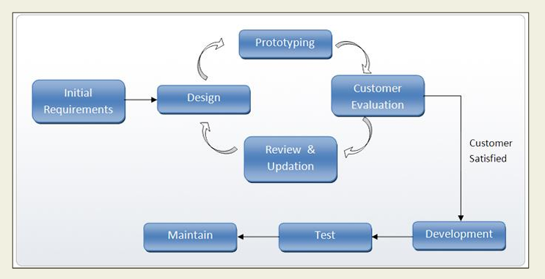

4. EVOLUTIONARY MODEL

It is also called successive versions model or incremental model. At first, a simple working model is built. Subsequently it undergoes functional improvements & we keep on adding new functions till the desired system is built.

Applications:
• Large projects where you can easily find modules for incremental implementation. Often used when the customer wants to start using the core features rather than waiting for the full software.
• Also used in object oriented software development because the system can be easily portioned into units in terms of objects.
Advantages:
• User gets a chance to experiment partially developed system
• Reduce the error because the core modules get tested thoroughly.
Disadvantages:
• It is difficult to divide the problem into several versions that would be acceptable to the customer which can be incrementally implemented & delivered.

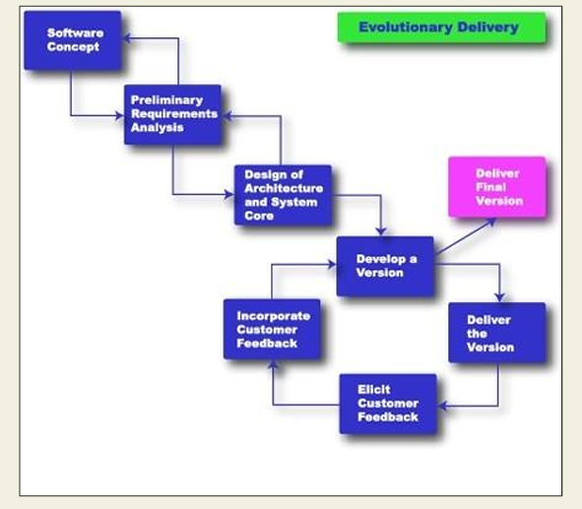

5. SPIRAL MODEL

The Spiral model of software development is shown in fig. 4.1. The diagrammatic representation of this model appears like a spiral with many loops. The exact number of loops in the spiral is not fixed. Each loop of the spiral represents a phase of the software process. For example, the innermost loop might be concerned with feasibility study, the next loop with requirements specification, the next one with design, and so on. Each phase in this model is split into four sectors (or quadrants) as shown in fig. 4.1. The following activities are carried out during each phase of a spiral model.
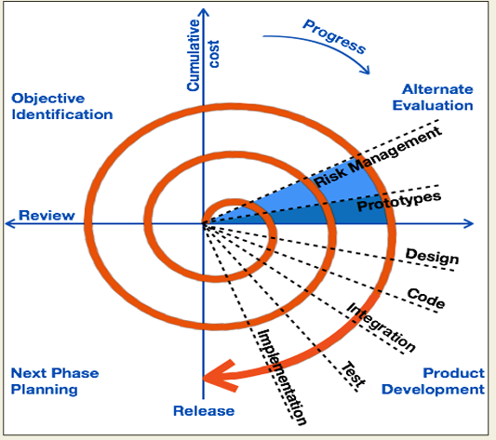
First quadrant (Objective Setting)
• During the first quadrant, it is needed to identify the objectives of the phase.
• Examine the risks associated with these objectives.
Second Quadrant (Risk Assessment and Reduction)
• A detailed analysis is carried out for each identified project risk.
• Steps are taken to reduce the risks. For example, if there is a risk that the requirements are inappropriate, a prototype system may be developed.
Third Quadrant (Development and Validation)
• Develop and validate the next level of the product after resolving the identified risks.
Fourth Quadrant (Review and Planning)
• Review the results achieved so far with the customer and plan the next iteration around the spiral.
• Progressively more complete version of the software gets built with each iteration around the spiral.
Circumstances to use spiral model
The spiral model is called a meta model since it encompasses all other life cycle models. Risk handling is inherently built into this model. The spiral model is suitable for development of technically challenging software products that are prone to several kinds of risks. However, this model is much more complex than the other models – this is probably a factor deterring its use in ordinary projects.
REQUIREMENTS ANALYSIS AND SPECIFICATION
Before we start to develop our software, it becomes quite essential for us to understand and document the exact requirement of the customer. Experienced members of the development team carry out this job. They are called as system analysts.
The analyst starts requirements gathering and analysis activity by collecting all information from the customer which could be used to develop the requirements of the system.
The following basic questions pertaining to the project should be clearly understood by the analyst in order to obtain a good grasp of the problem:
• What is the problem?
• Why is it important to solve the problem?
• What are the possible solutions to the problem?
• What exactly are the data input to the system and what exactly are the data output by the system? • What are the likely complexities that might arise while solving the problem?
• If there are external software or hardware with which the developed software has to interface, then what exactly would the data interchange formats with the external system be?
Parts of a SRS document
• The important parts of SRS document are:
Functional requirements of the system
Non-functional requirements of the system, and Goals of implementation

Functional requirements: - The functional requirements part discusses the functionalities required from the system. The system is considered to perform a set of high-level functions
{f }. The functional view of the system is shown in fig. 5.1. Each function f of the system can be considered as a transformation of a set of input data (ii) to the corresponding set of output data (o ). The user can get some meaningful piece of work done using a high-level function.
Nonfunctional requirements: - Nonfunctional requirements deal with the characteristics of the system which cannot be expressed as functions - such as the maintainability of the system, portability of the system, usability of the system, etc.
Goals of implementation: - The goals of implementation part documents some general suggestions regarding development. These suggestions guide trade-off among design goals. The goals of implementation section might document issues such as revisions to the system functionalities that may be required in the future, new devices to be supported in the future, reusability issues, etc. These are the items which the developers might keep in their mind during development so that the developed system may meet some aspects that are not required immediately.

Identifying functional requirements from a problem description
The high-level functional requirements often need to be identified either from an informal problem description document or from a conceptual understanding of the problem. Each high level requirement characterizes a way of system usage by some user to perform some meaningful piece of work. There can be many types of users of a system and their requirements from the system may be very different. So, it is often useful to identify the different types of users who might use the system and then try to identify the requirements from each user’s perspective.
Example: - Consider the case of the library system,
where –
F1: Search Book function
Input: an author’s name
Output: details of the author’s books and the location of these books in the library
So the function Search Book (F1) takes the author's name and transforms it into book details. Functional requirements actually describe a set of high-level requirements, where each high-level requirement takes some data from the user and provides some data to the user as an output. Also each high-level requirement might consist of several other functions.
Properties of a good SRS document The important properties of a good SRS document are the following:
• Concise. The SRS document should be concise and at the same time unambiguous, consistent, and complete. Verbose and irrelevant descriptions reduce readability and also increase error possibilities.
• Structured. It should be well-structured. A well-structured document is easy to understand and modify. In practice, the SRS document undergoes several revisions to cope up with the customer requirements. Often, the customer requirements evolve over a period of time. Therefore, in order to make the modifications to the SRS document easy, it is important to make the document well-structured.
• Black-box view. It should only specify what the system should do and refrain from stating how to do these. This means that the SRS document should specify the external behavior of the system and not discuss the implementation issues. The SRS document should view the system to be developed as black box, and should specify the externally visible behavior of the system. For this reason, the SRS document is also called the black-box specification of a system.
• Conceptual integrity. It should show conceptual integrity so that the reader can easily understand it.
• Response to undesired events. It should characterize acceptable responses to undesired events. These are called system response to exceptional conditions.
• Verifiable. All requirements of the system as documented in the SRS document should be verifiable. This means that it should be possible to determine whether or not requirements have been met in an implementation.
FORMAL SYSTEM SPECIFICATION
Formal Technique A formal technique is a mathematical method to specify a hardware and/or software system, verify whether a specification is realizable, verify that an implementation satisfies its specification, prove properties of a system without necessarily running the system, etc. The mathematical basis of a formal method is provided by the specification language. Formal Specification Language
A formal specification language consists of two sets syn and sem, and a relation sat between them. The set syn is called the syntactic domain, the set sem is called the semantic domain, and the relation sat is called the satisfaction relation. For a given specification syn, and model of the system sem, if sat (syn, sem), then syn is said to be the specification of sem, and sem is said to be the specific and of syn.
Syntactic Domains
The syntactic domain of a formal specification language consists of an alphabet of symbols and set of formation rules to construct well-formed formulas from the alphabet. The well-formed formulas are used to specify a system.
Semantic Domains
Formal techniques can have considerably different semantic domains. Abstract data type specification languages are used to specify algebras, theories, and programs. Programming languages are used to specify functions from input to output values. Concurrent and distributed system specification languages are used to specify state sequences, event sequences, state transition sequences, synchronization trees, partial orders, state machines, etc.
Satisfaction Relation
Given the model of a system, it is important to determine whether an element of the semantic domain satisfies the specifications. This satisfaction is determined by using a homomorphism known as semantic abstraction function. The semantic abstraction function maps the elements of the semantic domain into equivalent classes. There can be different specifications describing different aspects of a system model, possibly using different specification languages. Some of these specifications describe the system’s behavior and the others describe the system’s structure. Consequently, two broad classes of semantic abstraction functions are defined: those that preserve a system’s behavior and those that preserve a system’s structure.

