ASSIGNMENT #2
ADVANCED CSS (FLEXBOX & GRID)
Name: YOUR NAME
Group: YOUR GROUP
GitHub repository: https://github.com/YOUR-USERNAME/YOUR-REPOSITORY

Introduction
This assignment demonstrates CSS Grid and Flexbox through three practical tasks. The project uses external stylesheets and does not use Bootstrap, JavaScript, or media queries. The layouts rely on fluid sizing, flexible tracks, wrapping, and intrinsic content sizes.

Task 1. Geometric composition (CSS Grid)
I built the composition as one six-column by six-row CSS Grid. Each colored block is a grid item, and its position is controlled with grid-column and grid-row spans. The dark lines come from the grid gap, so the blocks themselves do not need borders or margins. The composition uses aspect-ratio: 1 so it stays square and its width is limited by viewport dimensions.
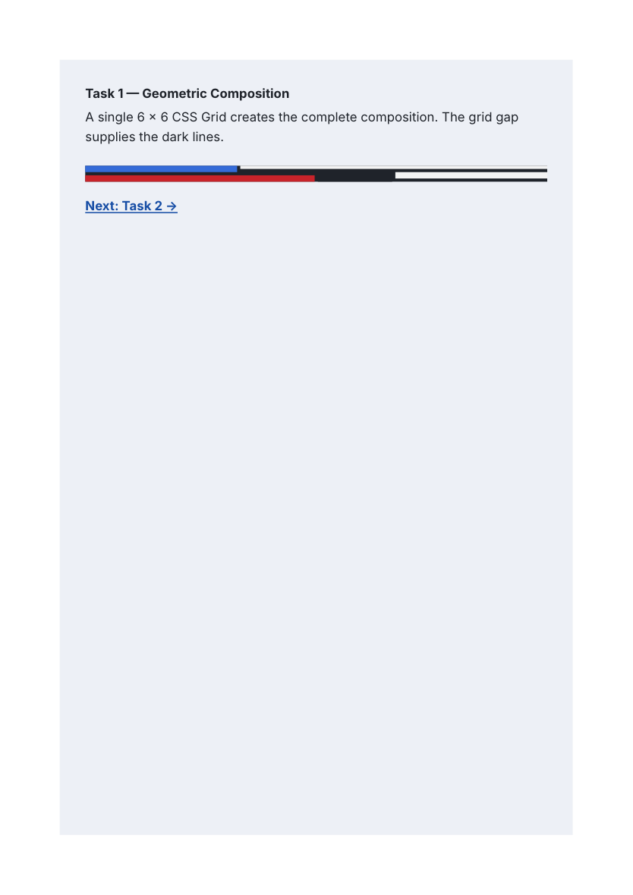
Result screenshot from the Task 1 page.

Key CSS
.composition { display: grid; grid-template-columns: repeat(6, 1fr); grid-template-rows: repeat(6, 1fr); gap: 4px; aspect-ratio: 1; }
.blue { grid-column: 1 / 3; grid-row: 1 / 4; }
.top-white { grid-column: 3 / 7; grid-row: 1 / 3; }
.red { grid-column: 1 / 4; grid-row: 4 / 7; }

Task 2. Component library (Flexbox)
I created five components with one shared stylesheet. Flexbox handles the navigation, card row, pagination, comment layout, and pricing plans. The cards use a flexible column layout so the buttons can stay at the bottom with margin-top: auto, even when descriptions have different lengths. The comment uses a non-shrinking avatar and a flexible text area. The recommended pricing plan becomes taller naturally through extra padding instead of a fixed height.
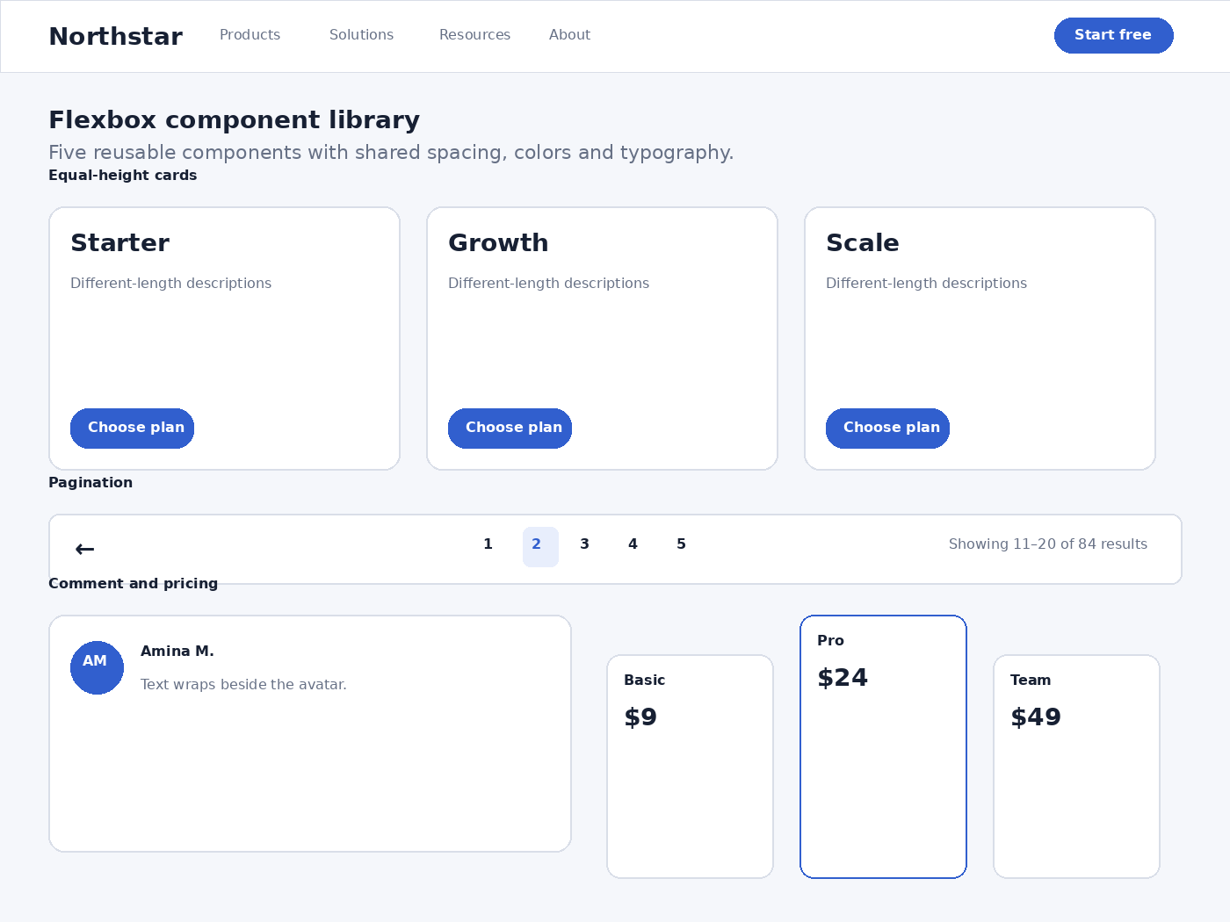
Visual result preview of the Flexbox component library.

Key CSS
.cards, .pricing { display: flex; gap: 1rem; align-items: stretch; flex-wrap: wrap; }
.card, .plan { flex: 1 1 220px; display: flex; flex-direction: column; }
.card .button, .plan .button { margin-top: auto; }
.comment { display: flex; align-items: flex-start; gap: 1rem; }
.avatar { flex: 0 0 3rem; }

Task 3. Three layouts, one markup
The same twelve article elements are used in all three modes. Only the class on the .articles container changes: grid-mode, list-mode, or magazine-mode. Grid controls the outer layout in all three modes, while Flexbox controls the internal structure of each article. No JavaScript or media queries are required.

Grid mode
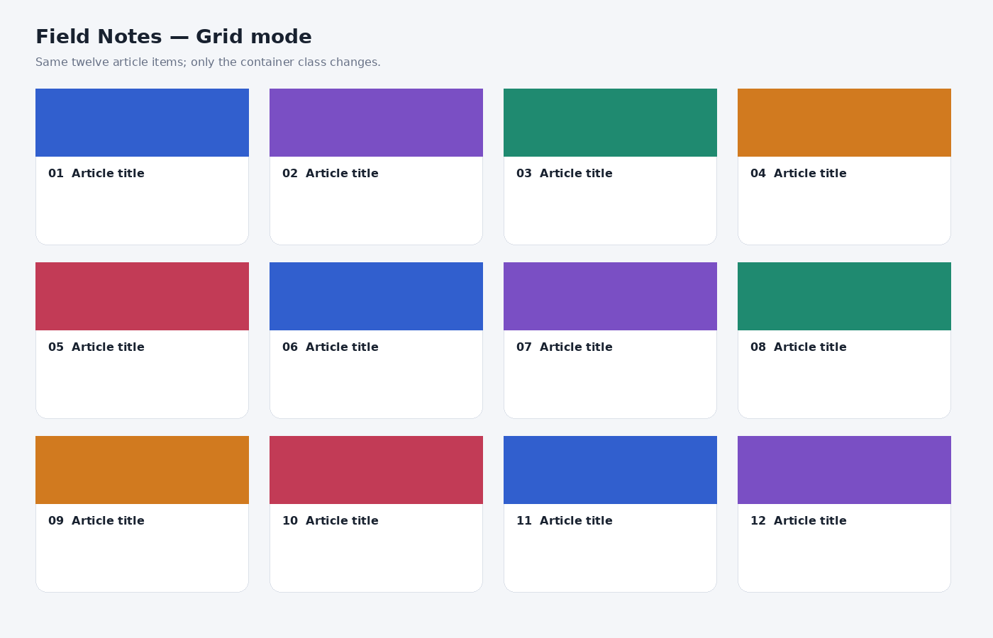
CSS tool: Grid creates fluid columns with repeat(auto-fit, minmax(...)).

List mode
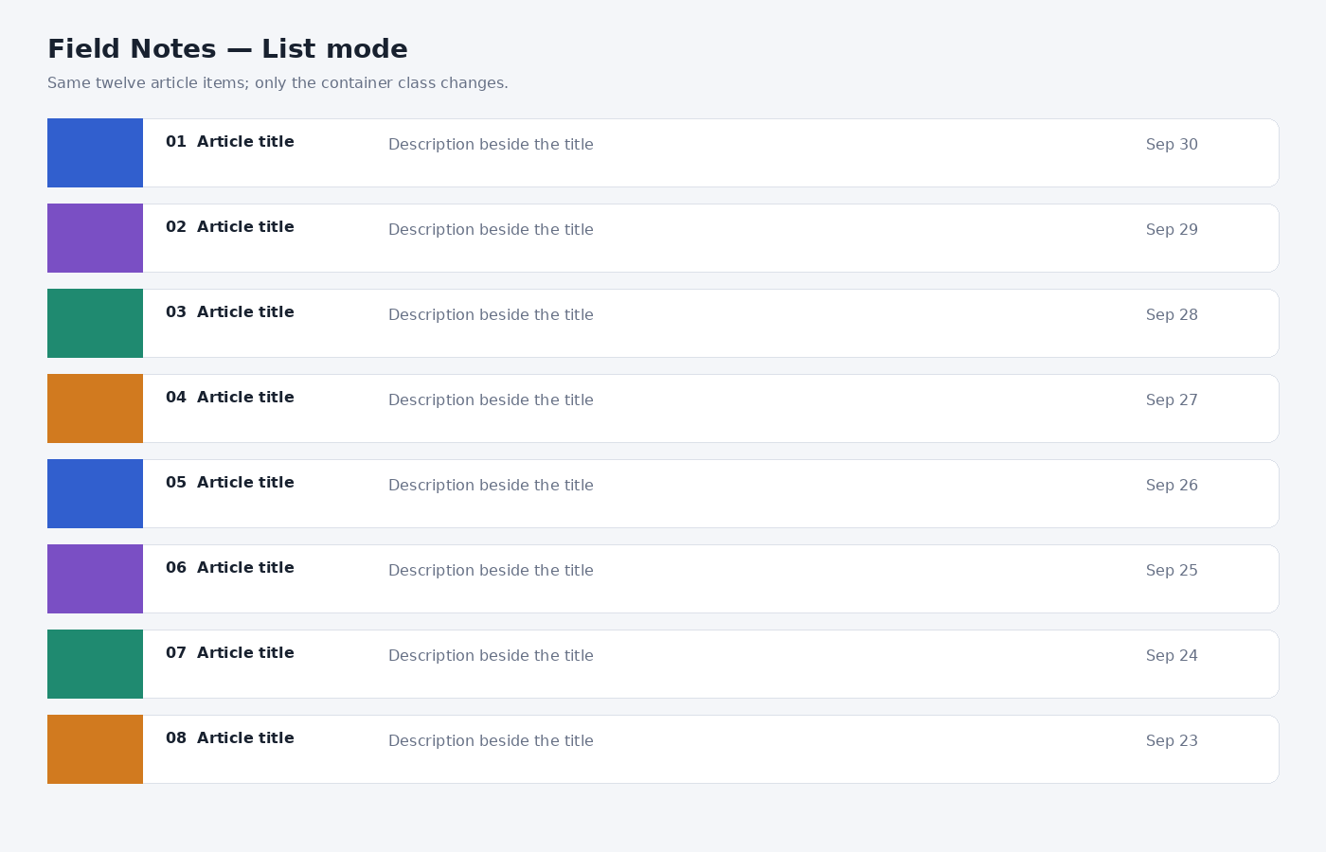
CSS tool: Grid creates the rows, while Flexbox places the thumbnail, text, and date within each row.

Magazine mode
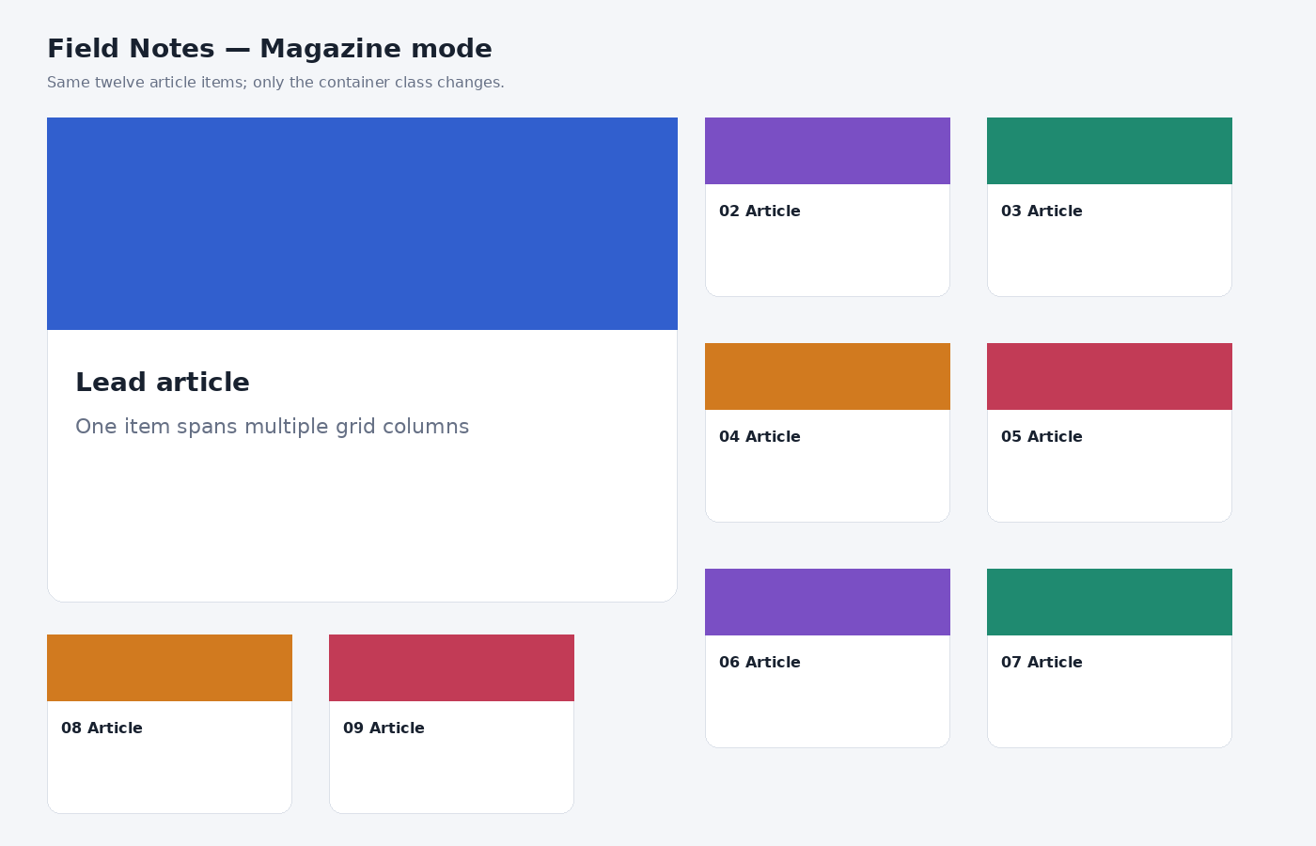
CSS tool: Grid makes the lead item span multiple columns and rows while the remaining items fill the tracks.

Key CSS for the three modes
.articles { display: grid; grid-template-columns: repeat(auto-fit, minmax(min(100%, 250px), 1fr)); gap: 1rem; }
.articles.list-mode { grid-template-columns: 1fr; }
.articles.list-mode .item { display: flex; flex-direction: row; }
.articles.magazine-mode { grid-template-columns: repeat(4, minmax(0, 1fr)); grid-auto-rows: minmax(150px, auto); }
.articles.magazine-mode .item:first-child { grid-column: span 2; grid-row: span 2; }

Conclusion
I learned how to choose between Grid and Flexbox based on the layout problem instead of using one technique everywhere. I also practiced fluid sizing, wrapping, intrinsic content behavior, grid spans, and flexible card structures without using fixed layout dimensions or media queries.

Submission checklist
- Replace YOUR NAME and YOUR GROUP in this report.
- Replace the GitHub placeholder with the real repository URL.
- Open each HTML page and verify the result in your browser.
- If required by the instructor, replace the visual previews with your own browser screenshots.
- Be ready to explain grid-column/grid-row, flex, flex-wrap, align-items, margin-top:auto, and minmax().

