HTML  
  
  
**Q1:-** Are the HTML tags and elements the same thing?  
 **Ans. :-** HTML tags and HTML elements are related concepts, but they are not the same thing.

1. HTML Tags:
   * HTML tags are the markup symbols or codes used in HTML to define the structure and elements of a web page.
   * Tags are enclosed within angle brackets, such as **<tagname>**.
   * Tags are used to specify the beginning and end of HTML elements.
2. HTML Elements:
   * HTML elements are composed of both an opening tag, a closing tag, and the content they enclose. Together, they define the structure and meaning of the content within a web page.
   * HTML elements consist of an opening tag (e.g., **<p>**) and a closing tag (e.g., **</p>**) that surround the content (e.g., text) that should be affected by that element.
   * Elements encompass the entire structure and content of a web page, such as headings, paragraphs, links, images, and more.

**Q2:-** What are tags and attributes in HTML?  
  
ANS:- In HTML, tags and attributes are fundamental components used to structure and define the content and behavior of a web page:

1. **HTML Tags:**
   * HTML tags are markup symbols enclosed within angle brackets (<>). They are used to define the structure and elements of a web page.
   * Tags are responsible for telling the browser how to display and render the content.
   * Tags come in pairs, consisting of an opening tag and a closing tag. The opening tag defines the start of an element, and the closing tag defines the end. For example:  
       
     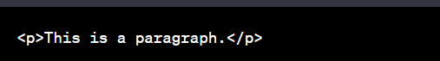
   * Some HTML tags are self-closing and don't require a separate closing tag, like the **<img>** tag:  
       
     
   * HTML tags are case-insensitive, so **<p>** and **<P>** are treated the same.
2. **HTML Attributes:**
   * HTML attributes are additional information or properties that can be added to HTML tags. Attributes provide extra details or settings for an HTML element.
   * Attributes are always specified within the opening tag and are written as name-value pairs, separated by an equal sign. For example, in the **<img>** tag:  
       
     
   * Attributes vary depending on the element and its purpose. Common attributes include **src**, **alt**, **href**, **width**, **height**, and many more.
   * Attributes provide important information or functionality. For instance, the **src** attribute in the **<img>** tag specifies the image source, and the **alt** attribute provides alternative text for the image.

**Q3:-** What are void elements in HTML? With Example  
ANS:- Void elements, also known as self-closing or empty elements, are HTML elements that don't have a closing tag because they don't contain any content. They are used to insert specific items into a web page, such as images, line breaks, or input fields. Void elements are written with a single opening tag and may include attributes, but they do not have a corresponding closing tag.

Here are some common examples of void elements in HTML:

1. **<img> Element:**
   * The **<img>** element is used to embed images in a web page.
   * It does not have a closing tag, and its content is specified through the **src** attribute.
   * Example:  
       
     
2. **<br> Element:**
   * The **<br>** element is used to create line breaks or vertical spacing within the content.
   * It also does not have a closing tag.
   * Example:  
       
     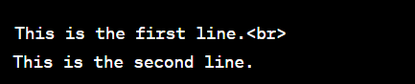
3. **<input> Element:**
   * The **<input>** element is used to create form input fields, such as text boxes, checkboxes, or radio buttons.
   * It doesn't have a closing tag, and its type and other attributes determine its behavior.
   * Example:  
       
     
4. **<meta> Element:**
   * The **<meta>** element provides metadata about the HTML document, such as character encoding and page description.
   * It is self-closing and doesn't have a closing tag.
   * Example:  
       
     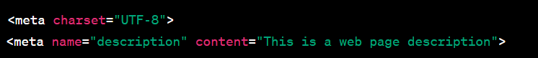
5. **<link> Element:**
   * The **<link>** element is used to link external resources like stylesheets or icons to the HTML document.
   * It's self-closing and doesn't have a closing tag.
   * Example:  
       
     

**Q4:-** What are HTML Entities? With Example  
ANS:- HTML entities are special character codes used to represent characters that have special meaning in HTML, or characters that are not easily displayed using the standard keyboard. HTML entities are often used to display characters like reserved symbols, accented letters, mathematical symbols, and other special characters in HTML documents. They are written using the **&** symbol followed by a specific code or name, and then closed with a semicolon **;**.

Here are some common examples of HTML entities:

1. **< and > Entities:**
   * These entities are used to display the less-than (<) and greater-than (>) symbols in HTML without being interpreted as HTML tags.
   * Example:  
       
     
2. **& Entity:**
   * The **&amp;** entity represents the ampersand character (&) and is used to display the ampersand symbol.
   * Example:  
       
     
3. **© Entity:**
   * The **&copy;** entity represents the copyright symbol (©).
   * Example:  
       
     
4. **€ Entity:**
   * The **&euro;** entity represents the euro currency symbol (€).
   * Example:  
       
       
     
5. **— Entity:**
   * The **&mdash;** entity represents an em dash (—) character for longer dashes.
   * Example:  
       
     
6. **“ and ” Entities:**
   * These entities represent left double quotation marks (“) and right double quotation marks (”).
   * Example:  
       
     

* **Q5:-** What are different types of lists in HTML? With Example.  
  ANS:- • **Ordered Lists (<ol>):**
* Ordered lists are used to create lists of items with a specific sequence or order, and each item is numbered by default. They are created using the **<ol>** element.
* The individual list items are defined using the **<li>** (list item) element.
* Example:  
    
  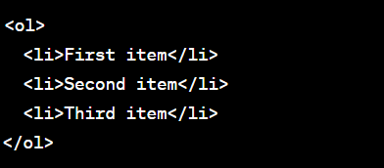

The above code will render as:

1. First item
2. Second item
3. Third item

• **Unordered Lists (<ul>):**

* Unordered lists are used to create lists of items with no inherent order. Each item is typically preceded by a bullet point. They are created using the **<ul>** element.
* The individual list items are defined using the **<li>** element.
* Example:

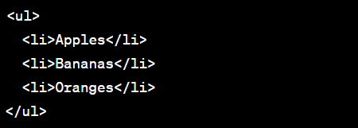  
  
The above code will render as:

* Apples
* Bananas
* Oranges

• **Description Lists (<dl>):**

* Description lists are used to create lists where each item is comprised of a term (dt - definition term) and its description (dd - definition description). They are created using the **<dl>** element.
* The term is defined using the **<dt>** element, and the description is defined using the **<dd>** element.
* Example:

**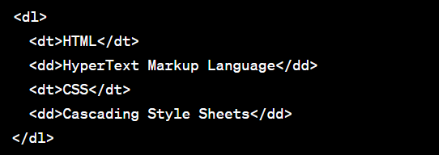  
  
Q6:-** What is the ‘class’ attribute in HTML? With Example.  
ANS:- The "class" attribute in HTML is used to assign one or more class names to an HTML element. These class names are used to associate a specific element with one or more CSS (Cascading Style Sheets) rules, allowing you to apply styling to the element. The "class" attribute is a way to target and style multiple elements with a shared class name.

Here's how the "class" attribute works with an example:

Suppose you have the following HTML code:  
  
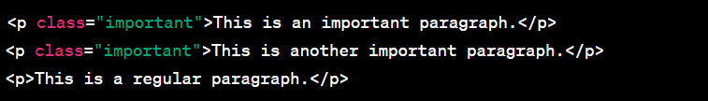

In this example, two paragraphs have been assigned the class "important" using the "class" attribute. This class name can be used to style these specific paragraphs differently from the regular paragraph without the "important" class.

You can then define CSS rules that target elements with the "important" class:  
  
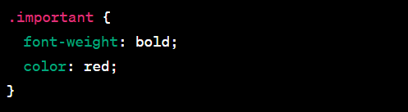

In this CSS code, we're targeting elements with the class "important" and applying specific styling to them. The paragraphs with the "important" class will be displayed in bold and red, as defined in the CSS rules.

The "class" attribute can be applied to various HTML elements, including headings, paragraphs, divs, spans, links, and more. It's a flexible way to group and style elements based on their common characteristics. You can also apply multiple class names to an element by separating them with spaces, allowing you to combine different sets of styles. For example:  
  


**Q7:-** What is the difference between the ‘id’ attribute and the ‘class’ attribute of HTML elements? With Example.  
ANS:- The "id" and "class" attributes in HTML are both used for applying styling and targeting elements with CSS, but they serve different purposes and have distinct characteristics:

1. **id Attribute:**
   * The "id" attribute is used to uniquely identify a single HTML element on a page. Each "id" should be unique within the document. You can use it to target and style a specific element or to link to it from another part of the page.
   * It is defined as follows:  
       
     
   * Example:  
       
     
2. **class Attribute:**
   * The "class" attribute is used to group multiple HTML elements together based on their shared characteristics. Multiple elements can share the same class, and you can apply the same styling to all elements with the same class.
   * It is defined as follows:  
       
     
   * Example:  
       
     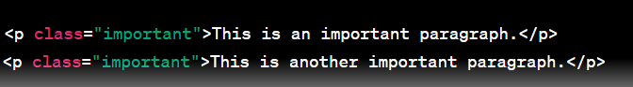

Here are the key differences between the "id" and "class" attributes:

1. **Uniqueness:**
   * "id" attributes must be unique within the HTML document. You should not have multiple elements with the same "id."
   * "class" attributes can be shared among multiple elements, allowing you to style or group them together.
2. **Targeting:**
   * The "id" attribute is primarily used to uniquely target and style a specific element with CSS or to link to that element from within the page.
   * The "class" attribute is used to apply the same styling to multiple elements with the same class or to group elements with similar characteristics.
3. **Styling:**
   * You can use both "id" and "class" attributes to apply CSS styles. However, "id" attributes are typically used for unique styling or targeting specific elements, while "class" attributes are used for shared styling among elements.

Example of CSS styling for "id" and "class" attributes:  
  
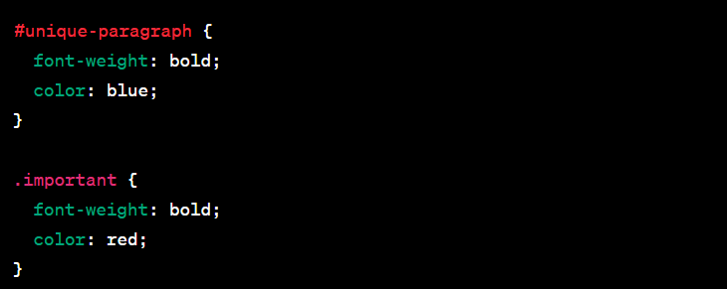

**Q8:-** What are the various formatting tags in HTML? **ANS:-** HTML provides a variety of formatting tags that allow you to control the presentation and styling of text and content on a web page. Some of the common formatting tags in HTML include:

1. **Headings (<h1>, <h2>, <h3>, <h4>, <h5>, <h6>):**
   * Headings are used to define the hierarchical structure of your content, with **<h1>** being the highest level (most important) and **<h6>** being the lowest. They are typically used for titles and subtitles.
   * Example:  
       
     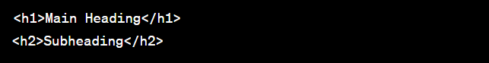
2. **Paragraphs (<p>):**
   * The **<p>** element is used to define and separate paragraphs of text.
   * Example:  
       
     
3. **Bold (<strong>) and Italics (<em>):**
   * The **<strong>** tag is used to indicate strong emphasis, typically rendering text in bold.
   * The **<em>** tag is used to indicate emphasized text, typically rendering text in italics.
   * Example:  
     
4. **Underline (<u>):**
   * The **<u>** tag is used to underline text, but it is often better to use CSS for text decoration to ensure consistent styling.
   * Example:  
       
     
5. **Strikethrough (<s>, <strike>, <del>):**
   * These tags are used to indicate text that has been struck through (line through it), typically to represent deleted or no longer relevant content.
   * Example:  
       
     
6. **Superscript (<sup>) and Subscript (<sub>):**
   * The **<sup>** tag is used to format text as superscript, appearing above the baseline.
   * The **<sub>** tag is used to format text as subscript, appearing below the baseline.
   * Example:  
       
     
7. **Blockquotes (<blockquote>):**
   * The **<blockquote>** tag is used to create a block of indented text to indicate a quotation.
   * Example:  
       
     
8. **Code (<code> and <pre>):**
   * The **<code>** tag is used to indicate inline code, while the **<pre>** tag is used for preformatted text, such as code blocks. These are often used within documents.
   * Example:  
       
     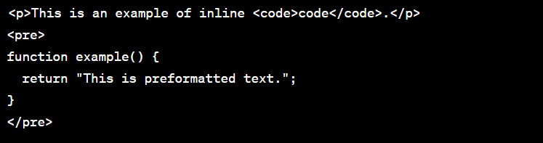

**Q9:-** How is Cell Padding different from Cell Spacing? With Example.  
ANS:- Cell padding and cell spacing are attributes in HTML tables used to control the spacing and alignment of content within table cells. They serve different purposes:

1. **Cell Padding:**
   * Cell padding controls the space between the content of a table cell and the cell's borders. It specifies the amount of space to be added between the content and the cell's edge.
   * The **cellpadding** attribute is used within the **<table>** element to set the padding for all cells in the table.
   * Example:  
       
     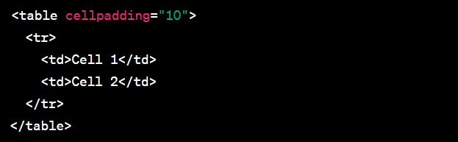
   * In the above example, the **cellpadding** attribute with a value of 10 adds 10 pixels of padding within each cell. This means there will be 10 pixels of space between the content and the cell border.
2. **Cell Spacing:**
   * Cell spacing controls the space between adjacent cells in a table. It specifies the gap between the borders of neighboring cells.
   * The **cellspacing** attribute is used within the **<table>** element to set the spacing between cells.
   * Example:  
       
     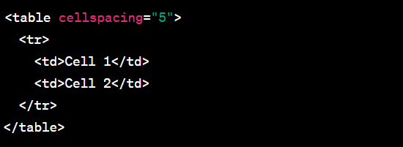

**Q10:-** How can we club two or more rows or columns into a single row or column in an HTML table? With Example.  
ANS:- In HTML tables, you can use the **rowspan** and **colspan** attributes to combine two or more rows or columns into a single row or column. These attributes alLow you to create merged cells in a table, which can be useful for creating complex table structures or spanning cells across multiple rows or columns.

Here's how to use **rowspan** and **colspan** with examples:

**Rowspan (Combine Rows):**

The **rowspan** attribute is used to merge cells vertically, i.e., to combine multiple rows into a single row. It's applied to the first cell in the merged group, and it specifies how many rows the cell should span.

Example:

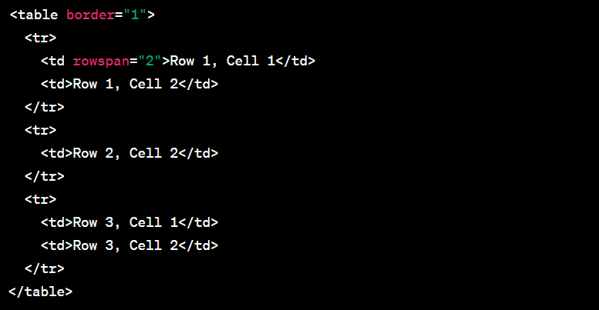In this example, the cell with "Row 1, Cell 1" has a **rowspan** of 2, so it spans two rows, effectively combining Row 1 and Row 2 into a single row.

**Colspan (Combine Columns):**

The **colspan** attribute is used to merge cells horizontally, i.e., to combine multiple columns into a single column. It's applied to the first cell in the merged group, and it specifies how many columns the cell should span.

Example:  
  
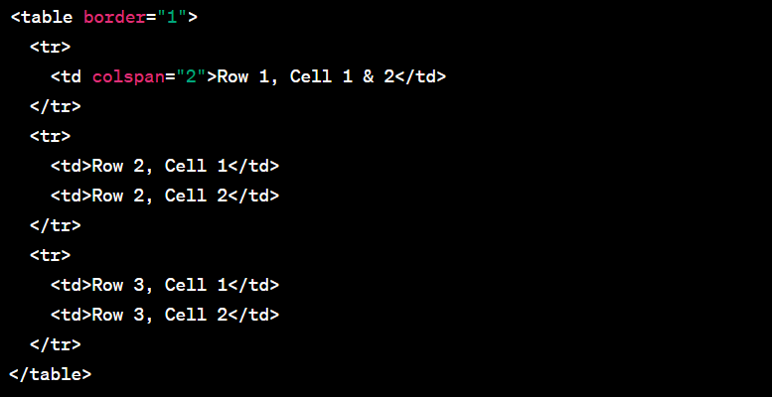  
  
  
Q11:- • What is the difference between a block-level element and an inline element?  
ANS:- Block-level elements and inline elements are two fundamental HTML elements that behave differently in terms of their display and positioning within a web page. The key differences between them are as follows:

**Block-Level Elements:**

1. **Display Behavior:**
   * Block-level elements typically create a "block" or a rectangular box in the layout, which occupies the full available width of its parent container. Each block-level element starts on a new line, pushing subsequent content down.
   * Block-level elements usually span the entire width of the parent element, creating a vertical stack of content.
2. **Examples:**
   * Common examples of block-level elements include **<div>**, **<p>**, **<h1>**, **<ul>**, **<li>**, **<table>**, and more.
3. **Usage:**
   * Block-level elements are often used to structure the layout of a web page, organize content into sections, and create structural elements like headings, paragraphs, and lists.
4. **Nesting:**
   * Block-level elements can contain other block-level elements and inline elements, but they should not be placed inside inline elements.

**Inline Elements:**

1. **Display Behavior:**
   * Inline elements do not create a new block or line. Instead, they flow within the content, wrapping around text or other inline elements without forcing a line break.
   * Inline elements take up only as much width as necessary for their content.
2. **Examples:**
   * Common examples of inline elements include **<span>**, **<a>**, **<strong>**, **<em>**, **<img>**, and **<br>**.
3. **Usage:**
   * Inline elements are used to apply formatting, emphasis, and styling to text, as well as to insert images, links, or other small content within a block-level context.
4. **Nesting:**
   * Inline elements can be nested inside other inline elements or block-level elements, allowing for more flexible formatting.

Q12:- How to create a Hyperlink in HTML? With Example.  
ANS:- To create a hyperlink (a clickable link) in HTML, you can use the **<a>** (anchor) element. The **<a>** element is used to define links to other web pages, resources, or documents. You specify the destination of the link using the **href** attribute.

Here's how to create a basic hyperlink in HTML with an example:

  
In the above example:

* **<a>** is the anchor element.
* **href** is the attribute that defines the hyperlink's destination URL. It should contain the URL you want to link to, enclosed in double or single quotes.
* The text "Visit Example.com" is the visible link text that users will see. You can replace this text with any descriptive text you want.

When a user clicks on this link, they will be taken to the "[https://www.example.com](https://www.example.com/)" website.

You can also create links to local pages or resources by specifying relative URLs within the **href** attribute. For example:

  
In this case, the link will navigate to a page named "about.html" within the same website's directory.

Additionally, you can open the link in a new browser window or tab using the **target** attribute. For example, to open the link in a new tab:  
  
  
  
  
Q13:- What is the use of an iframe tag? With Example.  
ANS:- An **<iframe>** (short for inline frame) is an HTML element that is used to embed another HTML document or web page within the current document. **<iframe>** allows you to display content from an external source within your web page, such as a different website or a subpage. It is commonly used for embedding maps, videos, forms, or other external content.

Here is an example of how to use the **<iframe>** tag:  
  
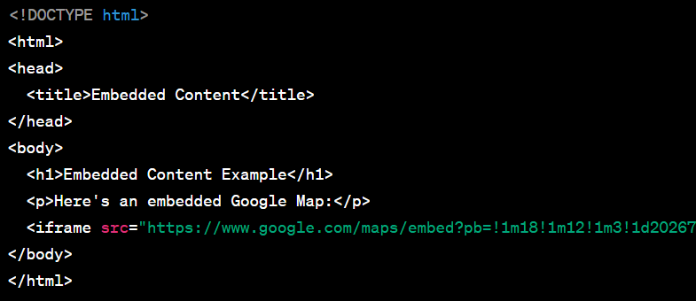

In this example:

* The **<iframe>** tag is used to embed a Google Map into the web page. The **src** attribute specifies the source URL of the content to be displayed within the frame. In this case, it's a Google Maps URL.
* The **width** and **height** attributes set the dimensions of the iframe, specifying its width and height in pixels.
* The **frameborder** attribute is set to "0" to remove the border around the iframe.
* The **allowfullscreen** attribute is added to allow the content to be displayed in fullscreen mode if the embedded content supports it.
* The content within the **<iframe>** tags is a Google Map. You can replace the source URL with the URL of any website or external content you want to embed.

Q14:- What is the use of a span tag? Explain with example?  
ANS:- The **<span>** element in HTML is a generic inline container that is often used to apply CSS styles, scripts, or other inline elements to a specific portion of text within a larger block of content. It does not add any visual formatting on its own but serves as a wrapper for applying styling or behavior to a specific portion of text or inline content.

Here's an example of how to use the **<span>** tag:  
  


In this example:

* The **<span>** tag is used to wrap the text "blue and bold" within the paragraph.
* The **style** attribute is added to the **<span>** tag to apply inline CSS styles. In this case, it changes the text color to blue and makes it bold.
* The rest of the text within the paragraph is not affected by these styles, as they are applied only to the text within the **<span>** element.

The **<span>** element is often used when you want to apply specific styles or behaviors to a portion of text within a larger block of content. It is also commonly used in conjunction with CSS classes for more controlled and reusable styling:  
  


In this case, the CSS class "highlight" would be defined in your external CSS stylesheet to specify the desired styles.  
  
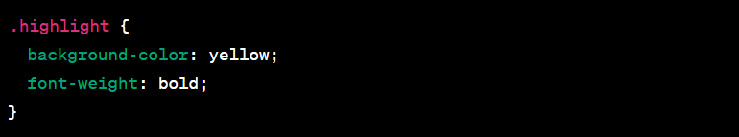

Q15:- How to insert a picture into a background image of a web page? With Example.  
ANS:- To insert a picture into the background of a web page, you can use CSS to set the background image of an HTML element, typically the **<body>** element, to display   
  
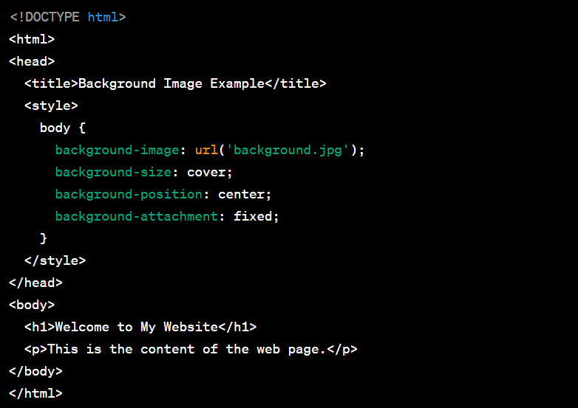

In this example:

* We first specify the background image using the **background-image** property within the CSS for the **<body>** element. You should replace **'background.jpg'** with the actual file path or URL of your image.
* The **background-size: cover;** property ensures that the background image covers the entire viewport without distortion. It may crop the image if its aspect ratio doesn't match the viewport's aspect ratio.
* The **background-position: center;** property centers the image within the viewport.
* The **background-attachment: fixed;** property makes the background image fixed, so it doesn't scroll with the page. This creates a parallax effect where the background stays in place as you scroll the content.

You can adjust these properties to achieve the desired visual effect for your background image. The **background-image** property can also be used on other elements if you want to apply a background image to a specific section or container within your webpage.

Q16:- How are active links different from normal links?  
ANS:- Active links and normal links refer to different states of hyperlinks on a web page, and they are distinguished by their behavior and appearance.

**Normal Links:**

1. **Normal links** are the default state of hyperlinks. These links appear as regular text or icons, and they are typically styled according to the CSS rules defined in the web page's stylesheet.
2. When a user hovers over or clicks on a normal link, it might change color, have an underline, or exhibit other stylistic changes defined by CSS pseudo-classes like **:hover** or **:active**.
3. Normal links take users to a new web page or resource when clicked.

**Active Links:**

1. **Active links** refer to links that are in the process of being clicked, but the user has not yet released the mouse button or activated the link.
2. The "active" state typically corresponds to the moment when a user clicks on a link, but they haven't released the mouse button yet. During this brief moment, the link may appear to be "pressed" or change its appearance according to the CSS rules defined in the **:active** pseudo-class.
3. Active links are part of the user interface feedback for indicating that the link has been successfully clicked and that the browser has recognized the user's interaction.

Here's an example of how a normal link and an active link might look with CSS styling:

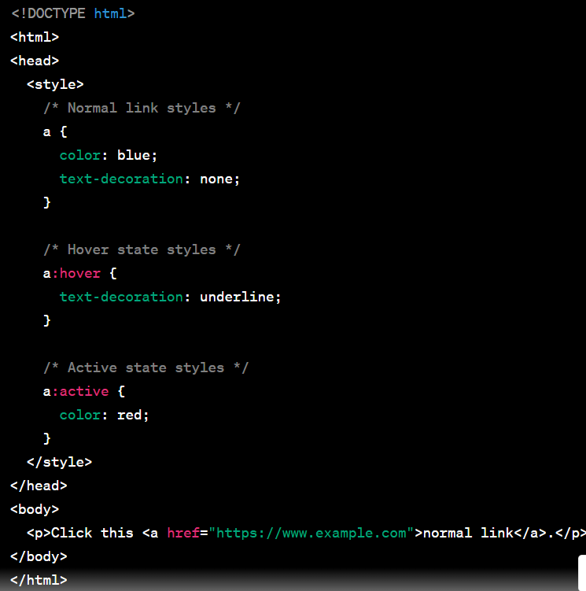  
  
In this example, the normal link appears in blue text without an underline. When you hover over it, it underlines, and when you click it, the link turns red briefly, indicating the "active" state during the click.

Q17:- What are the different tags to separate sections of text?  
ANS:- In HTML, there are several elements and tags that you can use to separate and structure different sections of text on a web page. These tags help organize and style content for improved readability and presentation. Here are some of the common tags used for this purpose:

1. **Headings (<h1> to <h6>):**
   * Headings are used to create hierarchical sections of text, with **<h1>** being the highest level (most important) and **<h6>** being the lowest.
   * Example:  
       
     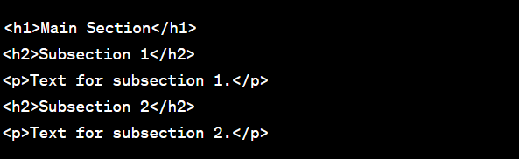
2. **Paragraphs (<p>):**
   * The **<p>** element separates text into paragraphs, providing visual and structural breaks between content.
   * Example:  
       
     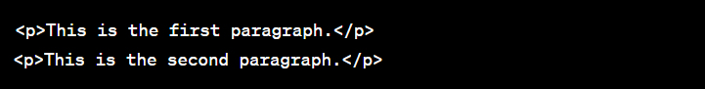
3. **Divs (<div>):**
   * The **<div>** element is a generic container that is often used to create sections or divisions within a page. It is commonly styled with CSS to structure and format content.
   * Example:  
       
     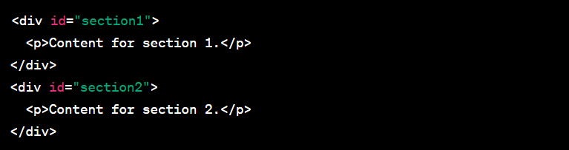
4. **Horizontal Rules (<hr>):**
   * The **<hr>** element inserts a horizontal line or rule to separate sections visually.
   * Example:  
       
     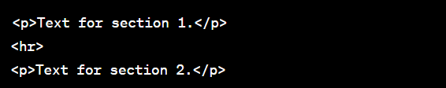
5. **Blockquotes (<blockquote>):**
   * The **<blockquote>** element is used to mark quoted text, providing a visual distinction for quoted content.
   * Example:  
       
     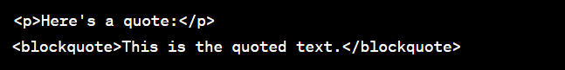
6. **Lists (<ul>, <ol>, <dl>):**
   * Lists are used to group and separate items in a structured way. They include unordered lists (**<ul>**), ordered lists (**<ol>**), and description lists (**<dl>**).
   * Example:  
       
     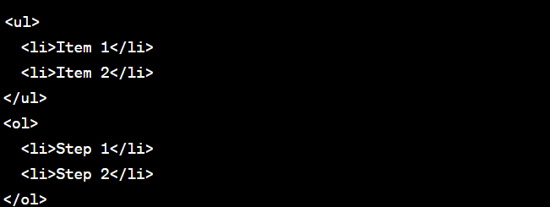

Q18:- What is SVG?  
ANS:- SVG, or Scalable Vector Graphics, is an XML-based vector image format used for creating two-dimensional, resolution-independent graphics on the web. SVG is designed to describe graphics in a format that can be scaled to different sizes without a loss of quality, making it an ideal choice for web graphics, icons, logos, charts, maps, and more.

Key features and characteristics of SVG include:

1. **Vector Graphics:** SVG graphics are made up of lines, curves, shapes, and text defined by mathematical equations. This makes them resolution-independent, meaning they can be scaled up or down without losing image quality.
2. **XML-Based:** SVG files are written in XML (eXtensible Markup Language), a standard format for describing structured data. This makes SVG files human-readable and machine-parseable.
3. **Text-Based:** SVG files can be created and edited using plain text editors or specialized SVG editing software.
4. **Support for Shapes:** SVG supports a wide range of basic shapes, including rectangles, circles, ellipses, lines, and paths, which can be used to create complex illustrations.
5. **Colors and Styling:** SVG allows you to specify colors, gradients, strokes, and fills to style elements within the graphic.
6. **Interactive Elements:** SVG can include interactive elements like links and animations, making it suitable for creating interactive web content.
7. **Accessibility:** SVG can be made accessible to users with disabilities through the use of ARIA roles and other techniques.
8. **Small File Size:** SVG files are typically smaller in size compared to bitmap images like JPEG or PNG, making them suitable for web use, especially in cases where responsive and lightweight graphics are required.
9. **Cross-Browser Support:** Most modern web browsers support SVG, and it can be embedded directly in HTML documents using the **<svg>** element.
10. **Scalability:** SVG graphics can be resized without any loss of quality, making them perfect for responsive web design.

Q19:- What is difference between HTML and XHTML?  
ANS:- HTML (Hypertext Markup Language) and XHTML (Extensible Hypertext Markup Language) are both markup languages used for structuring and presenting content on the web. While they share many similarities, there are key differences between the two:

1. **Syntax Rules:**
   * HTML: HTML has more forgiving syntax rules and allows for certain errors or inconsistencies in the code, such as unclosed tags. Browsers often attempt to render the page even if the code is not perfectly structured.
   * XHTML: XHTML has stricter syntax rules and requires well-formed documents. All elements and attributes must be properly nested and closed. Any minor syntax error can cause the entire document to fail.
2. **Document Structure:**
   * HTML: HTML documents can be more lenient in their structure, with optional elements like the **<html>**, **<head>**, and **<body>** tags. Omitting these tags can lead to successful rendering in many browsers.
   * XHTML: XHTML documents follow a stricter structure. These documents require specific elements such as **<html>**, **<head>**, and **<body>,** and these elements must be correctly nested and closed.
3. **Character Encoding:**
   * HTML: HTML documents may not strictly specify a character encoding, but they often use the **meta** tag to specify character encoding.
   * XHTML: XHTML documents should explicitly specify a character encoding, and it's typically done using a **meta** tag within the **<head>** section.
4. **Lowercase Tags and Attribute Names:**
   * HTML: HTML tags and attribute names can be in uppercase or lowercase. HTML is case-insensitive.
   * XHTML: XHTML requires all tags and attribute names to be in lowercase.
5. **Quoting Attribute Values:**
   * HTML: In HTML, attribute values can be quoted (with single or double quotes) or unquoted.
   * XHTML: In XHTML, attribute values must always be enclosed in double quotes.
6. **Self-Closing Tags:**
   * HTML: In traditional HTML, self-closing tags like **<br>** and **<img>** often omit the closing slash (e.g., **<br>** instead of **<br />**). Browsers usually handle this gracefully.
   * XHTML: In XHTML, self-closing tags must include the closing slash (e.g., **<br />**) for proper validation.
7. **Case Sensitivity in Attribute Values:**
   * HTML: Attribute values are case-insensitive in HTML.
   * XHTML: Attribute values are case-sensitive in XHTML. For example, attribute values such as "Yes" and "yes" are treated as different values in XHTML.
8. **Error Handling:**
   * HTML: Browsers often tolerate errors and try to render the page even if there are syntax issues or missing elements.
   * XHTML: XHTML documents are more intolerant of errors, and even minor issues can lead to the document not being displayed correctly.
9. **MIME Type:**
   * HTML: HTML documents are typically served with a MIME type of "text/html."
   * XHTML: XHTML documents should be served with the MIME type "application/xhtml+xml" or "application/xml."

Q20:- What are logical and physical tags in HTML?  
ANS:- In HTML, "logical" and "physical" tags refer to two different ways of thinking about the structure and presentation of a web page's content.

1. **Logical Tags:**
   * Logical tags are focused on the semantic meaning and structure of the content. They describe the purpose or meaning of an element within the document.
   * Logical tags are typically associated with the content's purpose or function, such as headings, paragraphs, lists, and links.
   * They help convey the document's meaning, making it more accessible and understandable by search engines, assistive technologies, and human readers.

Example of logical tags:  
  
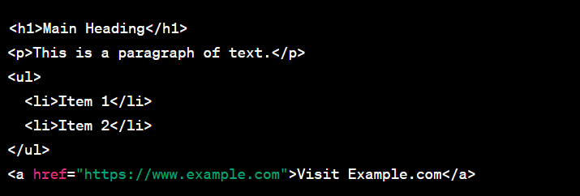

1. **Physical Tags:**
   * Physical tags are focused on the visual presentation of the content. They describe how content should appear on the screen, rather than its meaning.
   * Physical tags are associated with formatting, styling, and layout, such as fonts, colors, alignment, and spacing.
   * They are used to control the appearance of the content on the page but do not provide information about its semantic meaning.

Example of physical tags:  
  
