HTML-5  
  
  
**Q1:-**  What are the new tags added in HTML5?  
 **Ans. :-** HTML5 introduced several new elements and attributes to enhance the structure and functionality of web pages. Here are some of the key HTML5 tags with examples:  
  
**1:- <article>**: Represents an independent piece of content within a document, such as a blog post or news article.  
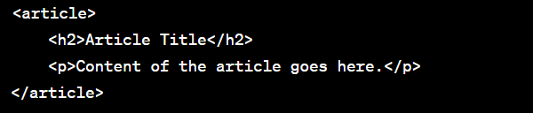  
  
  
**2:- <section>**: Defines a section in a document, often used to group related content.  
  
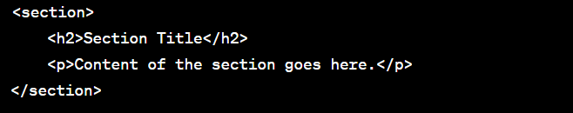  
  
**3:-<nav>**: Represents a navigation menu.  
  
  
  
**4:- <header>**: Defines a header for a document or section.  
  
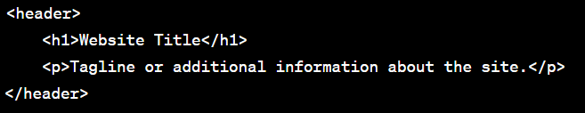  
  
**5:- <footer>**: Represents a footer for a document or section.  
  
  
  
**6:- <aside>**: Represents content that is tangentially related to the content around it.  
  
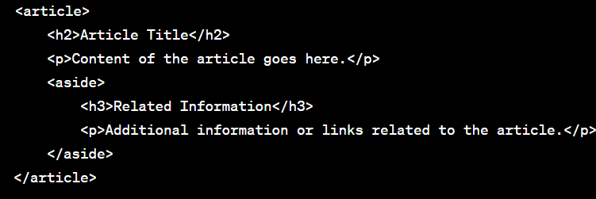  
  
**7:- <figure>** and **<figcaption>**: Used to group and caption media content, such as images or videos.  
  
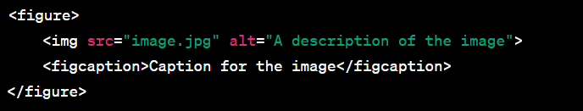  
  
**8:- <main>**: Represents the main content of the document.  
  
  
  
9:- **<mark>**: Highlights text within the context of the surrounding content.  
  
  
  
10:- **<progress>**: Represents the progress of a task.  
  


* **Q2:-** How to embed audio and video in a webpage?  
    
  ANS:- The **<audio>** element is used to embed audio content.
* The **controls** attribute adds audio controls such as play, pause, and volume.
* The **<source>** element is used to specify multiple sources for the audio file in different formats. This is helpful for cross-browser compatibility.  
    
    
  The **<video>** element is used to embed video content.
* The **controls** attribute adds video controls like play, pause, and volume.
* The **<source>** element is used to specify multiple sources for the video file in different formats.

  
  
  


### Q3:- Semantic element in HTML5? ANS:- Semantic elements in HTML5 are tags that carry meaning about the structure and content of a web page. These tags provide a more meaningful and descriptive structure to the document, making it easier for both developers and browsers to understand the purpose of different parts of the content

**Q4:-** Canvas and SVG tags  
ANS:- The **<canvas>** element is a bitmap-based drawing surface that allows you to draw graphics, shapes, and images using JavaScript. It provides a pixel-based rendering context where you can manipulate pixels directly. Here's a simple example:  
  
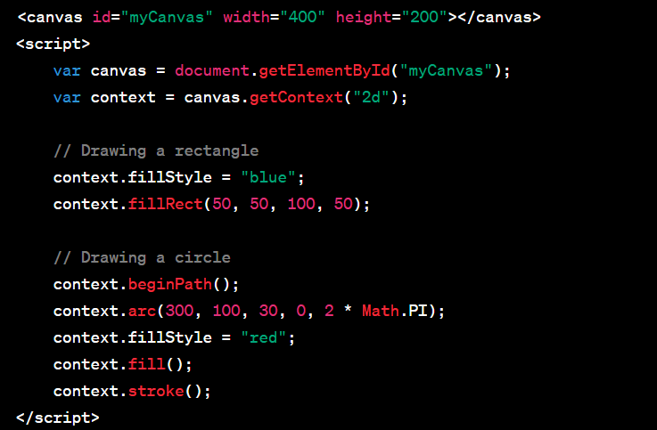  
  
  
The **<svg>** element is a scalable vector graphics format that allows you to create vector graphics, which means the graphics are defined as shapes and paths rather than pixels. SVG graphics can be scaled without loss of quality. Here's a simple example:  
  
