Database: To store and manage data at a place

-(rdms: in tables).

-Hierarchical data model: tree based(single root node multiple child node)

-Network: Graph based(multiple root & child)

-Dbms: To manage data in database. It acts as s/w to perform operation on data.

-Database is backend Dbms is used to store data on database . dbms also provide backup & security.

-Rdbms: data stored in tabled structure puls in relational manner.

It also has primary key, foreign key.

Normalization: Helps to decompose larger complex table into simpler & smaller forms.

Need is:reduce space time effort query. 1Nf 2Nf 3Nf

Functional Dependency: If in a given relation R,P & Q are attributes. Attribute Q is functionally dependent on attribute P if each value of P determines exactly one value of Q.

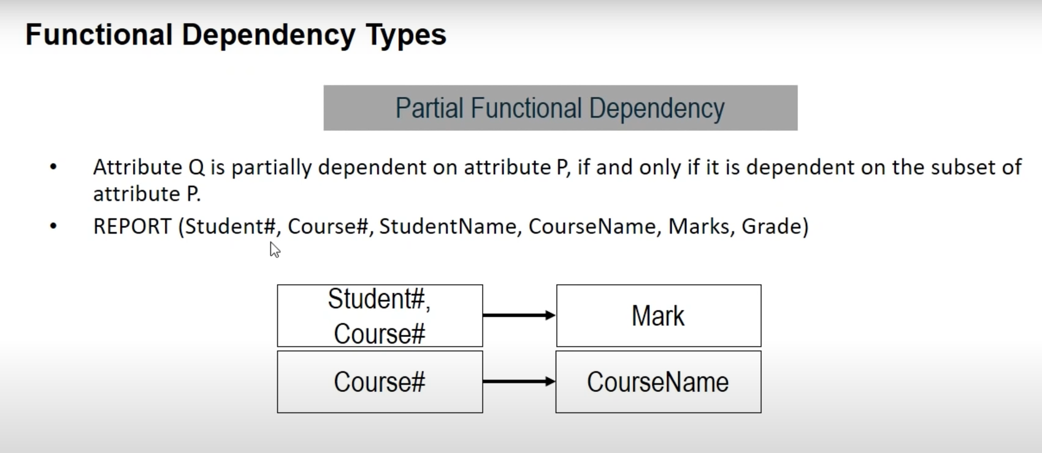

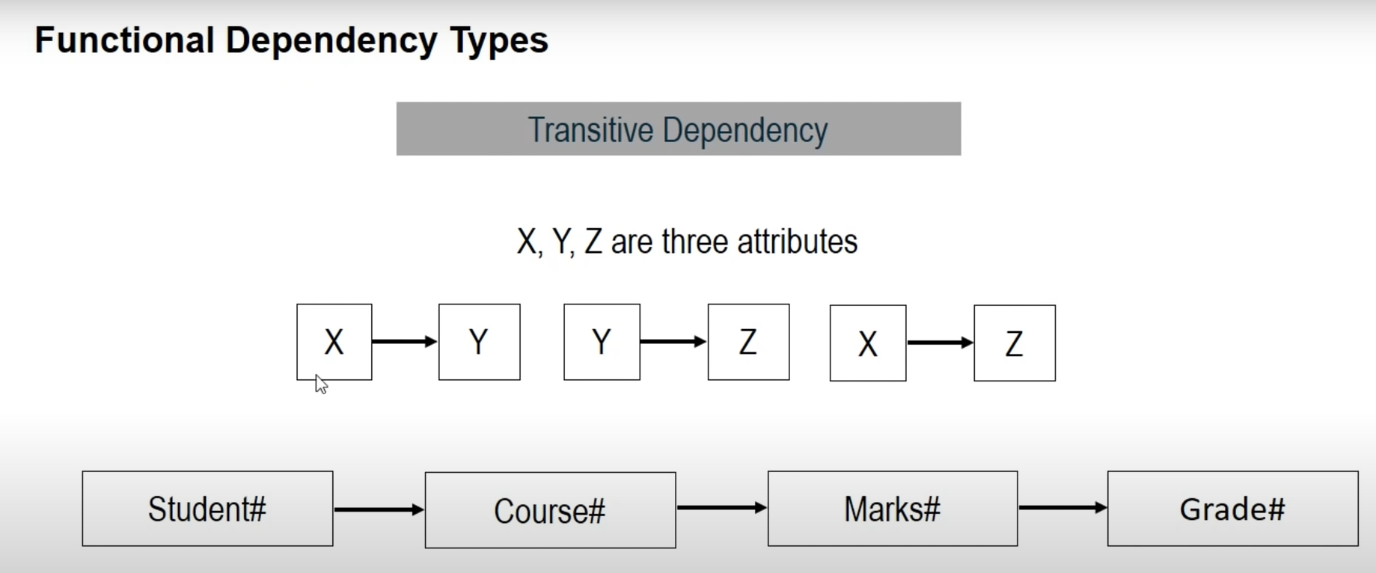

SQL

Data Type: Numeric, Character/String , Date/Time , Miscellaneous(json, xml)

Constraints: Not null, Default, Unique, Primary, Check, Index.

SQL Command Groups:

DDL

DML

DCL

TCL

DDL - Data Definition Language

|  |  |
| --- | --- |
| **Sr.No.** | **Command & Description** |
| 1 | **CREATE**  Creates a new table, a view of a table, or other object in the database. |
| 2 | **ALTER**  Modifies an existing database object, such as a table. |
| 3 | **DROP**  Deletes an entire table, a view of a table or other objects in the database. |
| 4 | **Truncate**  Remove all records from a table permanently |
| 5 | **Rename**  Renames an object |

DML - Data Manipulation Language

|  |  |
| --- | --- |
| **Sr.No.** | **Command & Description** |
| 1 | **SELECT**  Retrieves certain records from one or more tables. |
| 2 | **INSERT**  Creates a record. |
| 3 | **UPDATE**  Modifies records. |
| 4 | **DELETE**  Deletes records. |

DCL - Data Control Language

|  |  |
| --- | --- |
| **Sr.No.** | **Command & Description** |
| 1 | **GRANT**  Gives a privilege to user. |
| 2 | **REVOKE**  Takes back privileges granted from user. |

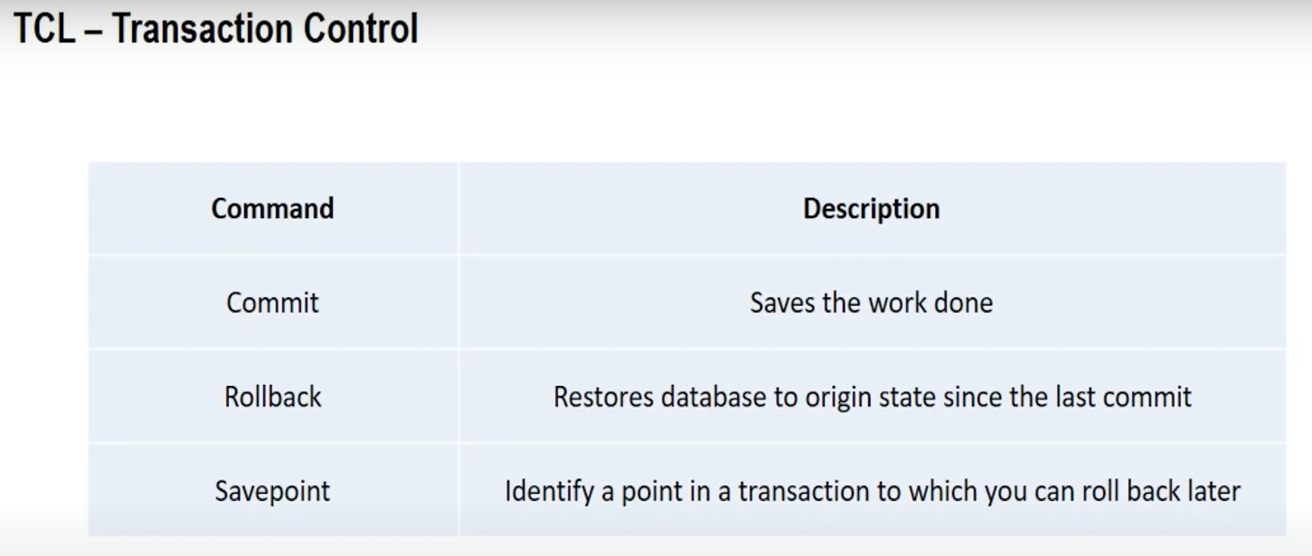

WHERE

