After you have installed terraform(in my case, I have installed v0.14.7) create the files mentioned below.

main.tf: This file is created which includes the instruction to provision the resources.

var.tf: This file is created to store the variables definitions.

terraform.tfvars: This file is created from security aspects to store the credentials.

Run the below command to initialize the Terrafrom.

terraform init

To create different environment or workspaces run the below commands which will create three separate workspaces for you i.e., Dev, Cert and Prod environment.

terraform workspace new dev

terraform workspace new cert

terraform workspace new prod

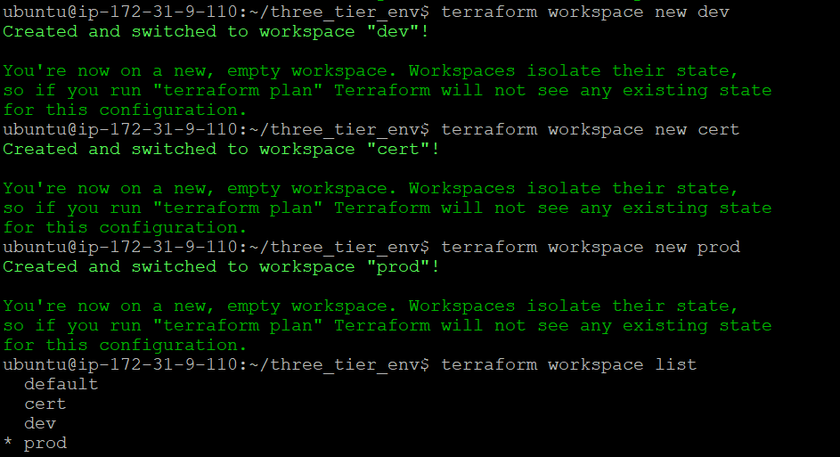

Now run the below command to create resources in different environment.

terraform workspace select dev

terraform apply --auto-approve

terraform workspace select cert

terraform apply --auto-approve

terraform workspace select prod

terraform apply --auto-approve

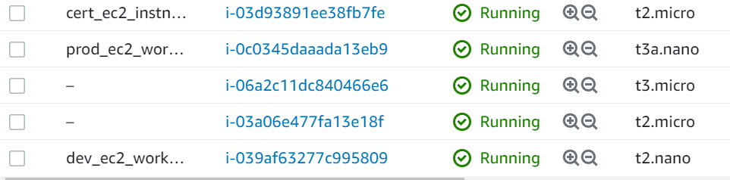

It creates a terraform.tfstate.d file for all the different environment to store the current states of resources.

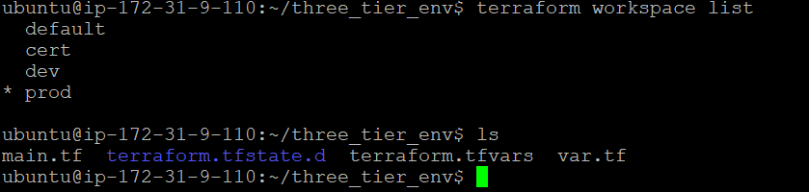

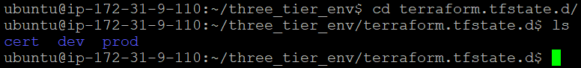

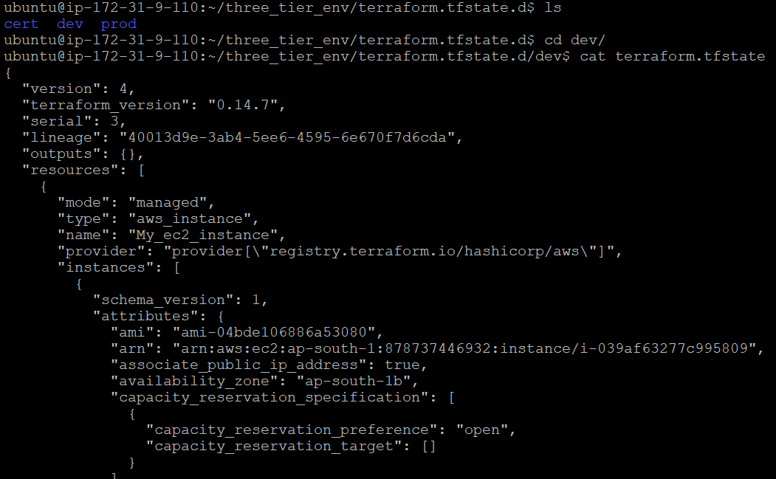

Likewise, the states can be checked for other resources running in different environment as well.