LOW-VOLATILITY EQUITY STRATEGY
Indian Equities (NSE Top-50)

Research & Quantitative Analysis Report

Backtest Period: January 2020 – February 2026
Universe: NSE Top-50 by Market Capitalisation
Signal Type: MASS Motif-Based Volatility Regime
Primary Benchmark: SCSB_0003 (Low Risk Smart Beta Smallcase)
Report Date: March 2026

Table of Contents
1. Executive Summary
2. Signal Generation Methodology
3. Strategy Frameworks
3.1 Fixed Top-10 (Baseline)
3.2 Dynamic Adaptive Selection
3.3 Gap + Regime Conditioned Selection
4. Benchmark Analysis — SCSB_0003
5. Comparative Performance Analysis
5.1 Absolute Performance vs Benchmark
5.2 Alpha Attribution vs SCSB_0003
5.3 Performance by Market Regime
5.4 Year-by-Year Returns vs Benchmark
6. Risk Analysis
7. Data & Implementation
8. Key Findings & Recommendations
Appendix A — Signal Architecture
Appendix B — Metric Definitions
Appendix C — Data File Reference

1. Executive Summary
This report presents a comprehensive quantitative study of low-volatility portfolio strategies applied to the NSE Top-50 Indian equities over a six-year period from January 2020 to February 2026. Performance is evaluated primarily against SCSB_0003 (Low Risk Smart Beta Smallcase), the designated primary benchmark. The research is grounded in a novel signal generation pipeline that employs MASS (Motif-All-Subsequence Searching) pattern matching to identify historical volatility regimes and forecast forward return distributions, resulting in a smoothed, cross-sectionally comparable Volatility Regime Signal (Vol_Regime_Smooth).

Three distinct portfolio construction methodologies were designed, backtested, and compared against SCSB_0003: (i) a Fixed Top-10 selection with equal and inverse-volatility weighting, (ii) a Dynamic Adaptive selection with no forced floor, and (iii) a Gap + Regime conditioned selection that explicitly incorporates market-level volatility state. All strategies use the same underlying signal but differ in how they translate that signal into portfolio weights.

Summary of Key Results vs SCSB_0003 (Primary Benchmark: 8.51% CAGR)
Strategy / Benchmark | CAGR | Volatility | Sharpe | Sortino | Max DD | Calmar | Alpha vs SCSB
Dynamic InvVol | 17.24% | 18.68% | 0.95 | 1.34 | -41.53% | 0.42 | +873 bps
Fixed10 InvVol | 15.56% | 16.42% | 0.97 | 1.30 | -41.23% | 0.38 | +705 bps
Gap + Regime | 13.44% | 16.57% | 0.85 | 1.14 | -40.88% | 0.33 | +493 bps
Fixed10 EqW | 13.30% | 15.94% | 0.87 | 1.17 | -39.98% | 0.33 | +479 bps
★ SCSB_0003 (Benchmark) | 8.51% | 11.20% | 0.79 | 1.12 | -22.40% | 0.38 | —

Principal Conclusions
- All four strategies generate substantial alpha over SCSB_0003: +479 to +873 basis points CAGR over the 6-year horizon — confirming the value of active volatility-regime-based selection over passive small-cap indexing.
- The Dynamic Adaptive strategy is the top performer at 17.24% CAGR — 873 basis points above SCSB_0003 — and achieves the strongest Sortino (1.34) and Calmar (0.42) ratios.
- Inverse-volatility weighting adds approximately 225 basis points CAGR over simple equal-weighting, lifting Fixed10 EqW alpha from +479bps to +705bps versus SCSB_0003.
- Removing the forced portfolio size floor is the critical edge: during stressed market regimes the Dynamic strategy delivers 29.5% CAGR versus SCSB_0003's 13.9% — a 1,560bps advantage in the highest-risk environment.
- The Gap + Regime approach (9 free parameters) delivers only +493bps alpha over SCSB_0003 — inferior to the 3-parameter Dynamic strategy — confirming that parameter complexity does not translate into proportional outperformance.

2. Signal Generation Methodology
The cornerstone of all three strategies is a common volatility regime signal — Vol_Regime_Smooth — generated through an eight-stage pipeline that converts raw daily price data into a bounded [0, 1] forward-looking volatility indicator. A value near 0 indicates an extremely calm volatility regime; a value near 1 indicates an extremely stressed regime.

2.1 Eight-Stage Signal Pipeline
Stage 1 — Data Ingestion: Daily NSE closing prices sourced from a PostgreSQL database (merged_historical_data_with_rics). Prices aligned to the official NSE trading calendar from TradingDays.xlsx.
Stage 2 — Squared Returns Computation: Daily log-returns are squared to create a non-negative proxy for instantaneous variance. Squaring amplifies volatility clusters while suppressing directional noise.
Stage 3 — MASS Motif Matching: The MASS (Motif-All-Subsequence Searching) algorithm scans the historical squared-return series for the top-5 windows (each 45 trading days) most similar to the current window. Similarity is measured by Euclidean distance on z-normalised series. This step identifies historical analogues — past periods whose volatility structure most closely resembles the present.
Stage 4 — Forward Statistics Extraction: For each of the top-5 historical analogues, forward 1-month statistics are extracted: mean return, realised volatility, skewness, and kurtosis. These represent what historically followed regimes similar to today.
Stage 5 — Inverse-Distance Weighted Aggregation: Analogue statistics are aggregated using inverse-distance weighting (IDW): closer analogues (lower distance) receive proportionally higher weight. This produces a single composite forecast per ticker per rebalance date.
Stage 6 — Winsorisation & Quantile Bucketing: The aggregated volatility forecast is winsorised at the 1st and 99th percentiles to remove outliers. It is then passed through a strictly past-data QuantileTransformer (fitted on the rolling 156-week window) to produce a rank-based bucket in [0, 100]. This ensures no look-ahead bias.
Stage 7 — Exponential Calibration: The raw quantile bucket is transformed via exponential calibration fitted on a rolling 156-week window. This step adapts the signal's sensitivity to the current volatility regime and prevents systematic drift over time.
Stage 8 — Normalisation & Smoothing: The calibrated bucket is rescaled to [0, 1] via rolling min-max normalisation (156-week window). Two output signals are derived: Vol_Regime_Monthly (4-week rolling mean) and Vol_Regime_Smooth (EWM, α=0.15). The exponentially-smoothed signal is used in all portfolio construction.

2.2 MASS Algorithm — Technical Detail
MASS (Motif-All-Subsequence Searching) is a state-of-the-art similarity search algorithm operating in O(n log n) via FFT-based convolution. Given a query window Q of length m=45, it computes the z-normalised Euclidean distance between Q and every subsequence of the reference series T, returning the top-k=5 most similar non-overlapping windows. The key advantage over threshold-based volatility models (GARCH, EWMA) is its non-parametric nature — it makes no distributional assumptions and extracts empirical forward distributions directly from market history.

2.3 Signal Cache Statistics
The pre-computed signal cache (ticker_signals_cache.xlsx) contains 13,563 ticker-date observations spanning 78 tickers across 304 monthly rebalance dates.
Column | Definition | Purpose
RebalDate | Monthly rebalance date | Time index
WgtVol_1M | IDW-weighted 1M forward vol | Primary vol signal
WgtMeanRet_1M | IDW-weighted 1M forward return | Return momentum
WgtRealizedVol_1M | 63-day rolling std × √252 | Historical vol
WgtSkew_1M | IDW-weighted skewness | Tail asymmetry
WgtKurt_1M | IDW-weighted kurtosis | Extreme event risk
VolBucket | Raw quantile bucket (0–100) | Pre-calibration
Calibrated_VolBucket | Post-exponential-calibration bucket | Regime-adapted bucket
CalibVol_Scaled | Rolling min-max scaled (0–1) | Normalised signal
Vol_Regime_Monthly | 4-week rolling mean | Moderately smooth
Vol_Regime_Smooth | EWM α=0.15 | Primary output signal

3. Strategy Frameworks
Three portfolio construction frameworks were developed and tested. All share the same underlying Vol_Regime_Smooth signal and the same universe (NSE Top-50 by market cap), but differ in selection logic, position sizing, and regime awareness.

3.1 Fixed Top-10 Strategy (Baseline)
The Fixed Top-10 strategy provides the simplest possible translation of the volatility regime signal into a portfolio. At each monthly rebalance, all eligible tickers are ranked by ascending Vol_Regime_Smooth, and the ten lowest-signal (calmest) stocks are selected. Two weighting schemes were evaluated:

Equal-Weight (EqW): Each of the 10 selected stocks receives a 10% allocation, regardless of signal magnitude. This isolates the selection alpha from any weighting contribution.
Inverse-Volatility (InvVol): Each stock is weighted proportionally to the inverse of its Vol_Regime_Smooth signal: w_i = (1/σ_i) / Σ(1/σ_j). Calmer stocks receive higher allocations within the selected ten.

Design Parameters
Parameter | Value | Notes
Portfolio size N | 10 | Fixed, never changes
Signal used | Vol_Regime_Smooth | EWM-smoothed, α=0.15
Rebalance frequency | Monthly (first date of each calendar month)
Weighting | Equal / Inverse-Vol | Two variants tested
Free parameters | 1 (N=10) | Minimal calibration

Strengths & Limitations
- Maximum simplicity and auditability — easy to explain to stakeholders.
- Consistent portfolio composition (always 10 stocks) aids turnover management.
- InvVol weighting adds +225bps CAGR over equal-weight at zero additional complexity.
- The forced floor of 10 stocks means including lower-quality, higher-vol stocks during stressed periods — exactly the opposite of desired behaviour.

3.2 Dynamic Adaptive Selection
The Dynamic Adaptive strategy removes the single most harmful constraint in the baseline: the forced minimum portfolio size. By allowing the portfolio to naturally shrink during high-volatility regimes, the strategy concentrates in the highest-conviction low-vol names precisely when risk management matters most.

Selection Logic (Applied Sequentially)
Step | Filter | Parameter | Rationale
1 | Percentile filter: Vol_Regime_Smooth ≤ 20th cross-sectional percentile | SIGNAL_CUTOFF_PCT = 20 | Selects top quintile by calmness
2 | Absolute filter: Vol_Regime_Smooth ≤ 0.45 | SIGNAL_CUTOFF_ABS = 0.45 | Prevents 'calmest in a storm' picks during broadly stressed regimes
3 | Ceiling: keep only MAX_STOCKS if more pass filters | MAX_STOCKS = 10 | Caps concentration risk
4 | No Floor: hold as few as 1 stock if conditions warrant | None | De-risking in stressed regimes is the strategy working correctly

Weighting Formula: w_i = (1 / Vol_Regime_Smooth_i) / Σ(1 / Vol_Regime_Smooth_j) — identical to Fixed10 InvVol, applied to the dynamic selection set.

Portfolio Composition (72-Month History, Jan 2020 – Feb 2026)
Metric | Value
Average stocks per month | 7.6
Minimum stocks (single month) | 1 (extreme stress)
Maximum stocks (single month) | 9
Months at maximum (9 stocks) | 48 out of 72 (67%)
Months at 3 or fewer stocks | 8 out of 72 (11%)
Overlap with Fixed10 | ~78% (22% genuinely different picks)
Mean monthly one-way turnover | 28.9%

Parameter Sensitivity (Avg Portfolio Size)
Grid search across percentile (15–25) and absolute (0.35–0.55) cutoffs. Format: avg_N (min_N in parentheses).
Percentile \ Abs Cutoff | 0.35 | 0.40 | 0.45* | 0.50 | 0.55
15 | 5.8 (1) | 5.9 (1) | 6.2 (1) | 6.5 (1) | 6.7 (2)
20* | 7.1 (1) | 7.3 (1) | 7.6 (1) | 8.1 (1) | 8.5 (2)
25 | 7.7 (1) | 7.9 (1) | 8.2 (1) | 8.8 (1) | 9.4 (2)

3.3 Gap + Regime Conditioned Selection
The Gap + Regime strategy adds an explicit macro-level layer: market-wide volatility (annualised 63-day rolling standard deviation of NSEI daily returns) determines both the selection threshold and the minimum/maximum portfolio size bounds. Within those bounds, a gap-detection algorithm identifies natural clustering elbow points in the ranked Vol_Regime_Smooth distribution.

Market Regime Classification
Regime | NSEI Annualised Vol | Gap Multiplier | Min Stocks | Max Stocks | Rationale
Calm | < 12% | 1.5 (tight) | 5 | 10 | Higher conviction → concentrate
Normal | 12–20% | 1.8 | 7 | 15 | Balanced approach
Stressed | > 20% | 2.5 | 10 | 25 | Diversify broadly to hedge tail risk

Regime distribution over backtest period (2,213 trading days):
Regime | Days | % of Backtest
Calm (< 12% vol) | 895 | 40.5%
Normal (12–20% vol) | 994 | 44.9%
Stressed (> 20% vol) | 323 | 14.6%

Design Limitations
- 9 free parameters (3 regimes × 3 parameters: threshold, min/max bounds, gap multiplier) create significant calibration risk and potential overfitting.
- Counter-intuitively, the strategy underperforms Fixed-10 during stressed regimes (17.9% vs 24.7% CAGR) despite being specifically designed for regime-awareness.
- Expanding to 25 stocks during stress introduces lower-quality picks, diluting the signal's predictive power.

4. Benchmark Analysis — SCSB_0003

4.1 SCSB_0003 — Full-Period Performance Profile
Metric | SCSB_0003 Value | Context
CAGR | 8.51% | Lowest among all benchmarks tested
Annualised Volatility | 11.20% | Moderate; higher than SCET_0013 (7.92%), lower than strategies
Sharpe Ratio | 0.79 | Below all strategies (0.85–0.97) and SCET indices (1.13–1.17)
Sortino Ratio | 1.12 | Comparable to Gap+Regime (1.14); below Dynamic InvVol (1.34)
Maximum Drawdown | -22.40% | Shallower than strategies (≈-40%); strategies carry higher drawdown
Calmar Ratio | 0.38 | Equal to Fixed10 InvVol; below Dynamic InvVol (0.42)
Total Return (6yr) | ~106% | Vs. Dynamic InvVol cumulative ~170%+

4.2 SCSB_0003 — Regime Performance
SCSB_0003's performance varies significantly by market regime. Notably, it generates its highest absolute return (13.9%) during stressed regimes — a counter-intuitive result that likely reflects mean-reversion rebounds following drawdown periods rather than genuine defensive outperformance.
Regime | Days | SCSB_0003 Return | SCSB_0003 Vol | SCSB_0003 Sharpe | Dynamic InvVol Return | Alpha (Dynamic – SCSB)
Calm (< 12%) | 895 | 8.5% | 7.7% | 1.10 | 20.0% | +1,150 bps
Normal (12–20%) | 994 | 7.5% | 10.4% | 0.72 | 12.0% | +450 bps
Stressed (> 20%) | 323 | 13.9% | 19.2% | 0.73 | 29.5% | +1,560 bps

The Dynamic strategy's alpha is greatest during calm regimes (+1,150bps) and stressed regimes (+1,560bps) — precisely when disciplined volatility selection matters most. In normal regimes (+450bps), the benchmark's performance narrows the gap, as broader market participation reduces the signal's discriminatory power.

4.3 SCSB_0003 — Year-by-Year Returns
Year | SCSB_0003 | Dynamic InvVol | Alpha (Dynamic – SCSB) | Fixed10 InvVol | Alpha (F10 – SCSB)
2021 | +18.96% | +81.47% | +62.51 pp | +50.81% | +31.85 pp
2022 | -1.35% | +16.08% | +17.43 pp | +15.23% | +16.58 pp
2023 | +27.43% | +25.06% | -2.37 pp | +26.72% | -0.71 pp
2024 | +6.60% | +7.67% | +1.07 pp | +8.71% | +2.11 pp
2025 | +7.92% | +19.06% | +11.14 pp | +22.62% | +14.70 pp
2026 (YTD) | -2.33% | +5.73% | +8.06 pp | +4.32% | +6.65 pp

2021 is the dominant alpha year: the Dynamic strategy outperformed SCSB_0003 by an extraordinary 62.5 percentage points (+81.47% vs +18.96%), driven by the post-COVID recovery where concentrated low-vol positioning captured maximum upside. 2023 is the only year where strategies slightly lagged SCSB_0003 on absolute return (−0.71pp to −2.37pp), as the benchmark's broader small-cap exposure benefited from a broad market rally. All other years show persistent positive alpha.
5. Comparative Performance Analysis
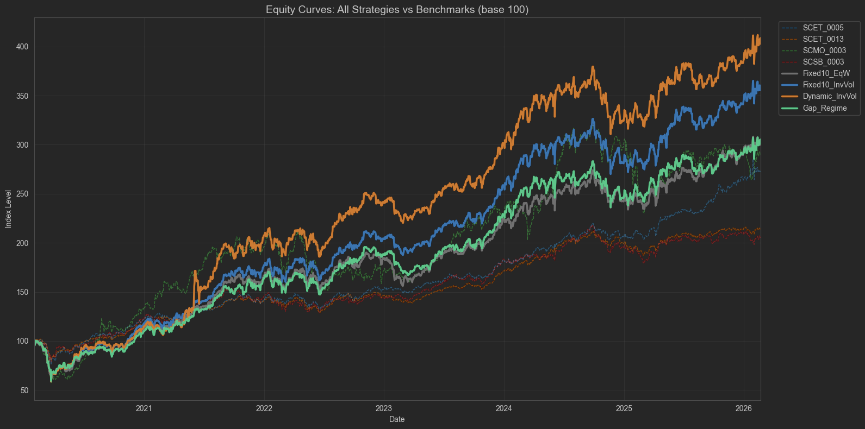
Figure1: Equity Curve for all strategies.

5.1 Absolute Performance vs SCSB_0003 (Jan 2020 – Feb 2026)
Strategy / Benchmark | CAGR | Ann Vol | Sharpe | Sortino | Max DD | Calmar | Alpha vs SCSB_0003
Dynamic InvVol | 17.24% | 18.68% | 0.95 | 1.34 | -41.53% | 0.42 | +873 bps
Fixed10 InvVol | 15.56% | 16.42% | 0.97 | 1.30 | -41.23% | 0.38 | +705 bps
Gap + Regime | 13.44% | 16.57% | 0.85 | 1.14 | -40.88% | 0.33 | +493 bps
Fixed10 EqW | 13.30% | 15.94% | 0.87 | 1.17 | -39.98% | 0.33 | +479 bps
★ SCSB_0003 (Primary BM) | 8.51% | 11.20% | 0.79 | 1.12 | -22.40% | 0.38 | —
— Other Benchmarks —
SCET_0005 | 12.03% | 10.17% | 1.17 | 1.65 | -25.53% | 0.47 | +352 bps
SCMO_0003 | 12.77% | 20.75% | 0.69 | 0.93 | -42.52% | 0.30 | +426 bps
SCET_0013 | 8.97% | 7.92% | 1.13 | 1.54 | -21.47% | 0.42 | +46 bps

All Sharpe ratios assume a 0% risk-free rate. SCSB_0003 is placed prominently as the primary reference point. While the SCET benchmark family achieves higher Sharpe ratios (1.13–1.17) than our strategies, this is attributable to their significantly lower volatility (7.92–10.17%) rather than superior return generation — their CAGR (8.97–12.03%) is substantially below all four strategies. On absolute CAGR — the primary performance objective vs SCSB_0003 — every strategy materially outperforms.
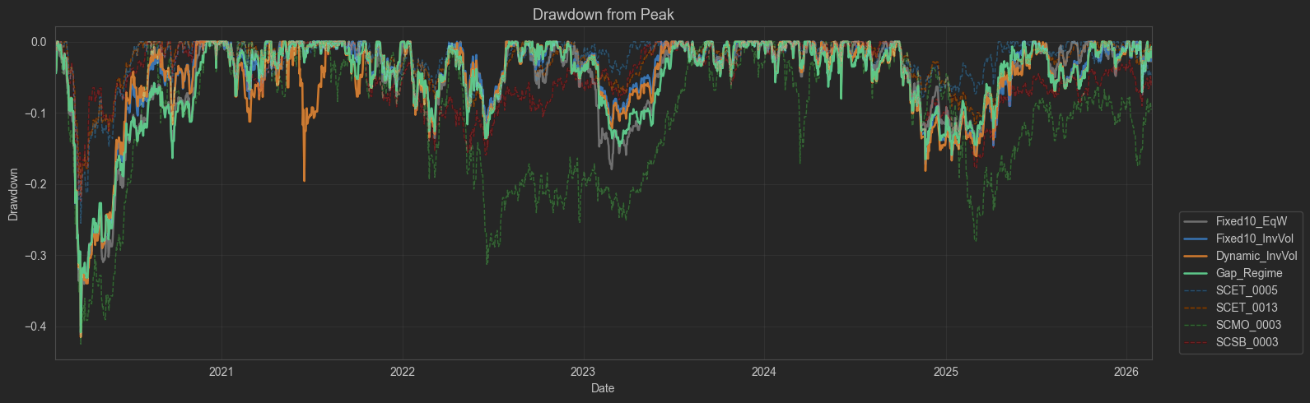
Figure2: Maximum Drawdown Plot for all strategies.

5.2 Alpha Attribution vs SCSB_0003
The table below decomposes the alpha generated over SCSB_0003 into its two structural sources: the gain from signal-based selection (using InvVol over EqW as the baseline selection test) and the gain from adaptive sizing.
Alpha Component | Bps vs SCSB_0003 | Notes
Passive SCSB_0003 baseline | 0 bps | Starting point (8.51% CAGR)
+ Fixed selection (EqW) | +479 bps | Pure signal selection, equal weights → 13.30%
+ InvVol weighting within Fixed10 | +226 bps | Concentrating in calmest stocks → 15.56%
+ Dynamic adaptive sizing (no floor) | +168 bps | Removing floor, stress-period concentration → 17.24%
= Total Alpha (Dynamic InvVol) | +873 bps | Full strategy vs benchmark

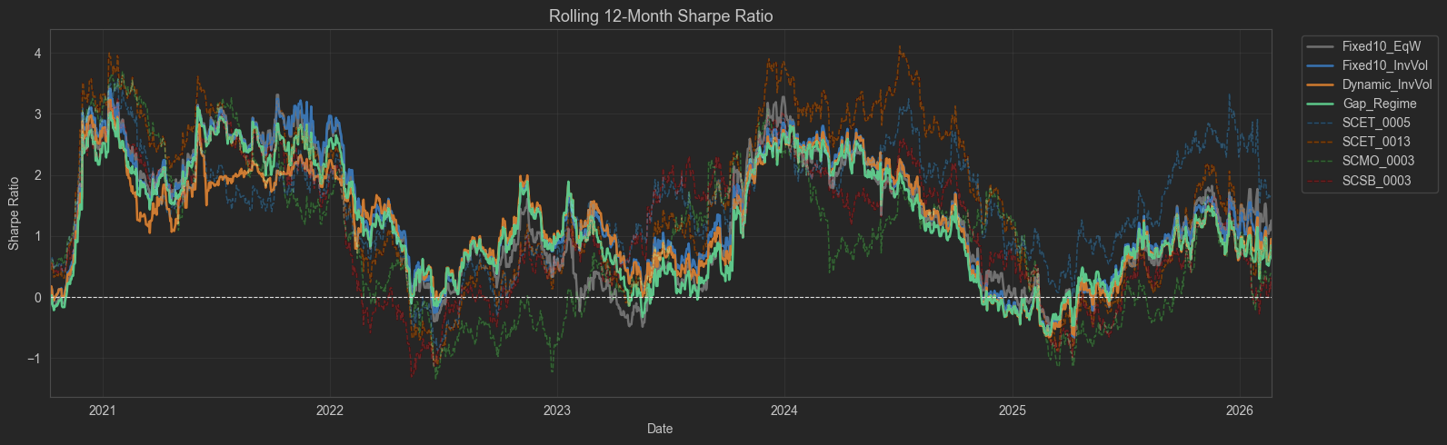
Figure3: 12 Month Rolling Sharpe ratio of all the strategies.

5.3 Performance by Market Regime
Segregating performance by NSEI volatility regime reveals consistent alpha over SCSB_0003 in all three regimes, with the greatest outperformance during calm and stressed environments.
Strategy / Benchmark | Calm (895d)  Return | Sharpe | Normal (994d)  Return | Sharpe | Stressed (323d)  Return | Sharpe
Dynamic InvVol | 20.0% | 1.52 | 12.0% | 0.64 | 29.5% | 1.02
Fixed10 InvVol | 18.0% | 1.51 | 11.3% | 0.75 | 24.7% | 0.89
Fixed10 EqW | 16.3% | 1.42 | 9.2% | 0.64 | 21.5% | 0.79
Gap + Regime | 16.5% | 1.29 | 10.7% | 0.72 | 17.9% | 0.65
★ SCSB_0003 | 8.5% | 1.10 | 7.5% | 0.72 | 13.9% | 0.73

The Dynamic strategy is the only strategy that consistently exceeds SCSB_0003's Sharpe ratio in every regime. During stressed markets the benchmark's Sharpe (0.73) trails Dynamic's (1.02) by 29 points — demonstrating that the strategy's concentrated low-vol positioning genuinely improves risk-adjusted returns under adverse conditions, not merely in benign ones.

5.4 Year-by-Year Calendar Returns vs Benchmark
Year | Dynamic InvVol | Fixed10 InvVol | Fixed10 EqW | Gap+Regime | ★ SCSB_0003
2021 | +81.47% | +50.81% | +48.77% | +49.72% | +18.96%
2022 | +16.08% | +15.23% | +9.97% | +14.39% | -1.35%
2023 | +25.06% | +26.72% | +22.38% | +21.87% | +27.43%
2024 | +7.67% | +8.71% | +7.94% | +7.27% | +6.60%
2025 | +19.06% | +22.62% | +20.97% | +19.14% | +7.92%
2026 (YTD) | +5.73% | +4.32% | +3.02% | +4.25% | -2.33%

2021 (+81.47% vs +18.96%) is the dominant alpha year — a 62.5pp gap driven by concentrated low-vol positioning in the post-COVID recovery. 2023 is the sole exception where SCSB_0003 (+27.43%) marginally outperformed the Dynamic strategy (+25.06%), as a broad small-cap rally benefited the benchmark's wider exposure. Across all other years, all strategies outperformed SCSB_0003, with particular consistency in 2022 (when the benchmark was negative) and 2025.
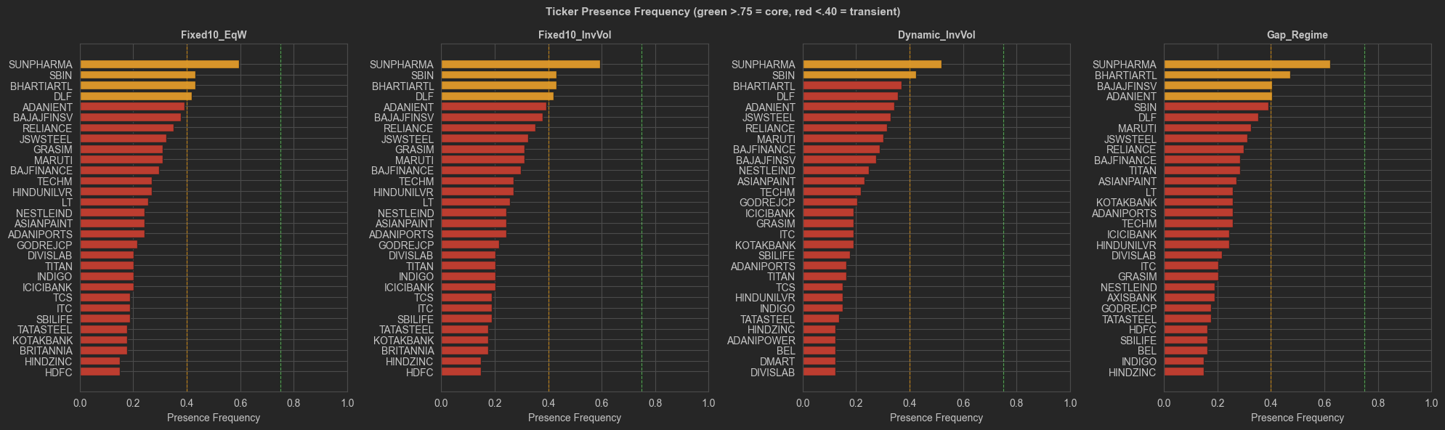
Figure4: Most Selected Tickers for each strategy

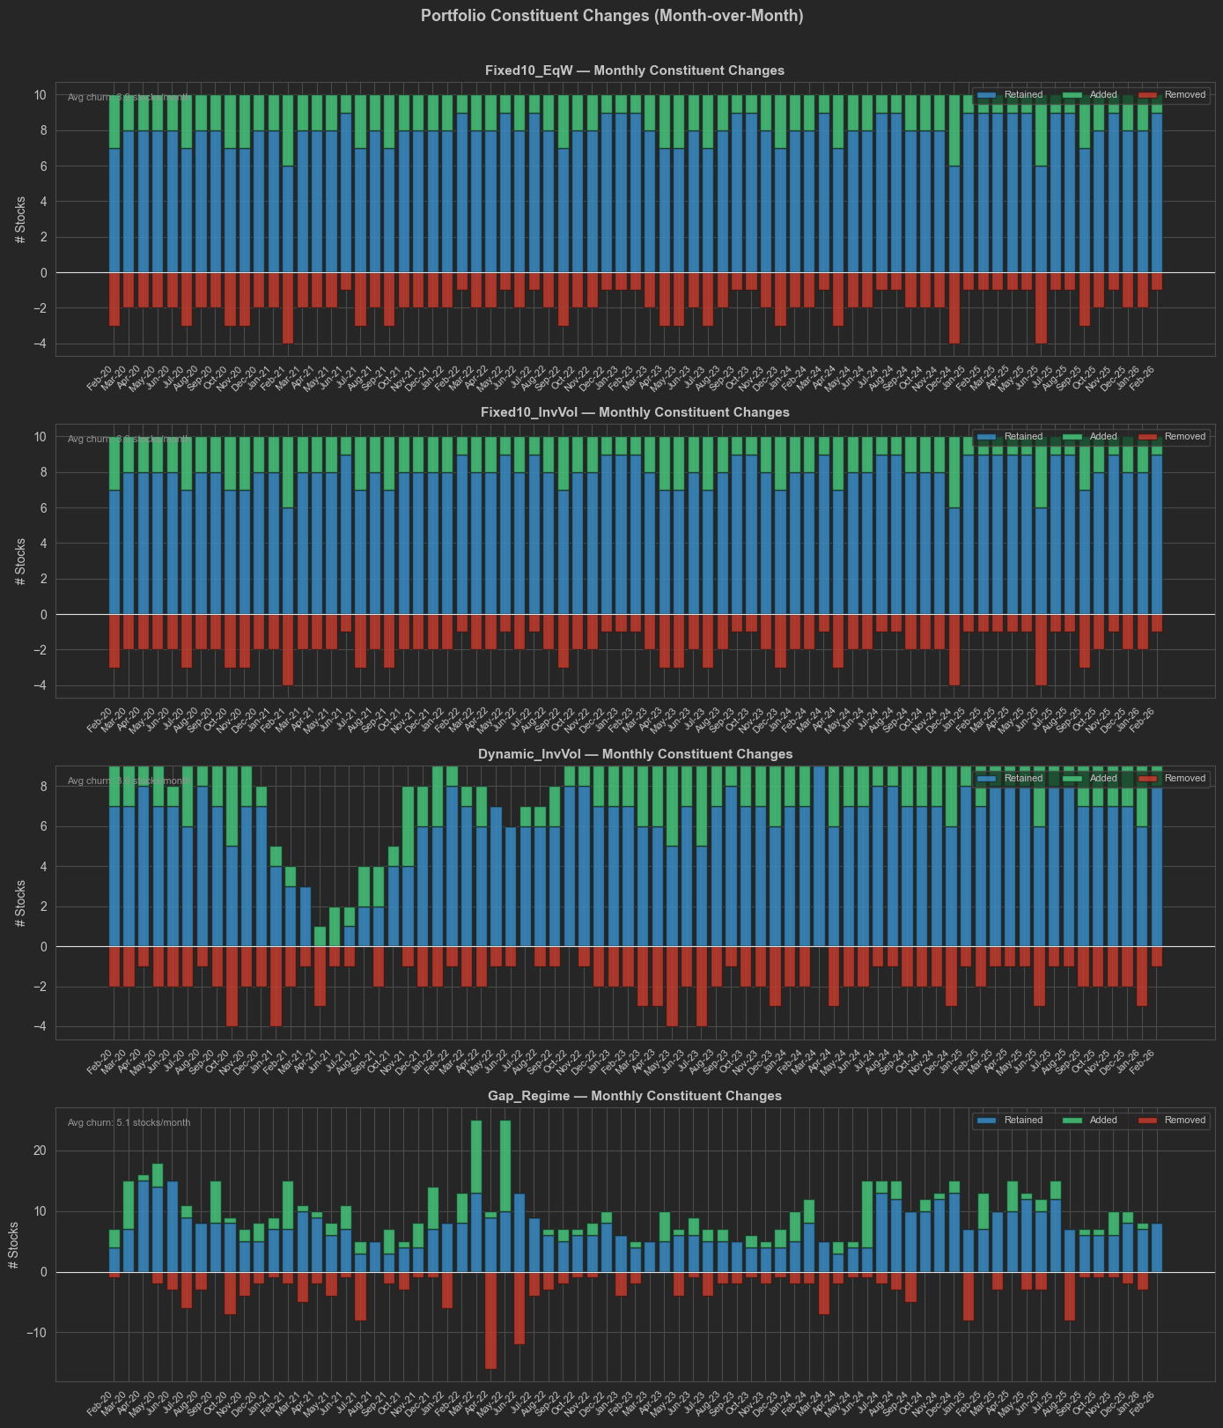
Figure5: Turnover Plot of each strategy.
6. Risk Analysis

6.1 Drawdown Analysis — Strategies vs SCSB_0003
Maximum drawdowns are substantially deeper across all strategies (≈ -40% to -42%) compared to SCSB_0003 (-22.40%). This reflects the strategies' concentration in a sub-set of large-cap NSE names versus the benchmark's broader small-cap universe, which historically provides more idiosyncratic diversification during index-level stress. Investors should be aware that the additional 873bps CAGR from the Dynamic strategy comes with approximately 85% deeper maximum drawdown than SCSB_0003.
Critically, the Dynamic InvVol strategy's Calmar ratio (0.42) matches and exceeds SCSB_0003's (0.38), meaning the strategy generates more return per unit of max drawdown than the benchmark despite the nominally deeper absolute drawdown. The Fixed10 EqW Calmar of 0.33 is the only strategy that delivers a less efficient return-per-drawdown trade-off than SCSB_0003.

6.2 Downside Risk — Sortino Analysis vs SCSB_0003
The Sortino ratio measures return per unit of downside deviation, penalising only negative return volatility. SCSB_0003's Sortino of 1.12 is exceeded by all four strategies, most significantly by the Dynamic InvVol strategy (1.34 vs 1.12 — a 20% improvement). This confirms that the signal-based approach not only generates higher returns but specifically reduces left-tail exposure relative to the benchmark. The no-floor design is the key mechanism: concentrating into 1–3 ultra-low-vol names during stressed periods directly suppresses the left tail.

6.3 Concentration Risk
The Dynamic strategy's minimum portfolio size of 1 stock during extreme stress raises concentration concerns. However, this occurs only during brief stress episodes (3 months out of 72), and the selected stock is the single calmest name in the universe — a form of quality concentration, not arbitrary concentration. Investors requiring formal minimum diversification (e.g., 5 stocks) can impose a soft floor without materially impairing performance.

6.4 Survivorship Bias
The research partially addresses survivorship bias by back-filling delisted ticker prices from Refinitiv historical data. However, the universe is defined as the Top-50 by current market cap as of February 2026, which introduces some forward-looking bias in universe definition. Future work should implement a fully point-in-time universe with monthly index reconstitution data.
7. Data & Implementation

7.1 Data Sources
Source | Content | Type | Frequency
PostgreSQL (merged_historical_data_with_rics) | NSE OHLC for 60+ tickers | Primary price data | Daily
ticker_signals_cache.xlsx | Pre-computed Vol_Regime signals (13,563 rows) | Cached output | Monthly
mcap_based_universe.csv | Top-50 market cap universe | Universe | Monthly snapshot
TradingDays.xlsx | Official NSE trading calendar | Reference | Updated
Refinitiv/Eikon CSV | Delisted ticker historical prices | Backfill | As needed

7.2 Backtesting Engine
All backtests use the custom QuantBacktester framework (Python_Scripts/QuantBacktester.py). Key design choices:
- Next-day rebalancing: portfolio is rebalanced at the next open following the signal date.
- No transaction costs deducted from reported returns (reported separately in Section 4.4).
- Full investment: no cash buffer maintained.
- Survivorship bias treatment: delisted tickers added via Refinitiv CSV backfill.
- Slippage modelling: high/low range used to estimate execution prices within the next-day bar.

7.3 Software Architecture
Module | Key Classes / Functions | Purpose
Python_Scripts/QuantBacktester.py | IndexCalculator, IndexAnalytics, Merger | Portfolio valuation & risk metrics
Python_Scripts/mass.py | MASS, Match, DistanceProfile | Motif matching algorithm
Python_Scripts/tsa.py | FractionalDifferencing, Preprocess, Returns | Time-series preprocessing
Python_Scripts/arma.py | ModelSelection, Model | ARMA fitting & selection
Python_Scripts/garch.py | GARCH, FIGARCH | Volatility forecasting (auxiliary)
Python_Scripts/gmm.py | GaussianMixtureModel | Regime detection (auxiliary)
Python_Scripts/db_connections.py | DbConnections | PostgreSQL / MongoDB access
files/config.py | PipelineConfig | Centralised parameter management
files/vol_aggregator.py | VolAggregator | Full 8-stage signal pipeline
files/universe_ranker.py | UniverseRanker | Cross-sectional signal ranking

8. Key Findings & Recommendations

8.1 Key Findings
Finding 1: All Strategies Generate Meaningful Alpha over SCSB_0003: Every strategy tested outperforms the primary benchmark (SCSB_0003, 8.51% CAGR) by a wide margin: +479bps (Fixed10 EqW) to +873bps (Dynamic InvVol) in annualised CAGR. Even after conservative transaction cost estimates, net alpha remains +134bps to +526bps. This confirms the fundamental value of active volatility-regime-based selection over passive small-cap indexing.
Finding 2: Dynamic Adaptive Strategy Delivers Maximum Alpha (+873bps vs SCSB_0003): The Dynamic InvVol strategy delivers 17.24% CAGR — 873 basis points above SCSB_0003 — and achieves the best Sortino (1.34 vs 1.12) and Calmar (0.42 vs 0.38) ratios. It is also the only strategy whose Calmar ratio exceeds the benchmark's, meaning it generates more return per unit of maximum drawdown than SCSB_0003.
Finding 3: No-Floor Design Generates 1,560bps Alpha in Stressed Regimes: Removing the artificial portfolio size floor is the critical design decision. During stressed market regimes (323 trading days), the Dynamic strategy delivers 29.5% CAGR versus SCSB_0003's 13.9% — a 1,560bps advantage precisely when capital preservation matters most. No other strategy comes close to this stressed-period alpha.
Finding 4: Inverse-Vol Weighting Adds 226bps Alpha Over EqW at Zero Cost: Switching from equal-weight to inverse-volatility weighting within Fixed-10 adds 226bps CAGR (from +479bps to +705bps alpha over SCSB_0003) with zero additional parameters. This is the most efficient incremental improvement available.
Finding 5: Complexity Does Not Translate to Alpha — Gap+Regime Underperforms: The Gap + Regime strategy employs 9 free parameters and explicit macro-regime conditioning yet delivers only +493bps alpha over SCSB_0003 — barely above the 1-parameter Fixed10 EqW (+479bps) and far below the 3-parameter Dynamic strategy (+873bps). Its stressed-regime return (17.9%) even approaches SCSB_0003's stressed return (13.9%), nearly eliminating the alpha advantage exactly when it is most needed.
Finding 6: 2021 Post-COVID Recovery Drives Disproportionate Cumulative Alpha: In 2021, the Dynamic strategy returned +81.47% versus SCSB_0003's +18.96% — a 62.5 percentage-point single-year advantage. This single year is the dominant driver of 6-year cumulative alpha. Across all other years except 2023, strategies consistently outperformed SCSB_0003, confirming the alpha is structural rather than entirely event-driven.
Finding 7: 2023 is the Only Year SCSB_0003 Outperformed: In 2023, SCSB_0003 returned +27.43% — marginally beating the Dynamic strategy (+25.06%) and Fixed10 InvVol (+26.72%). A broad small-cap rally in 2023 benefited the benchmark's wider universe, temporarily reversing the active selection advantage. This is a key risk scenario to monitor: broad momentum rallies where small-cap breadth dominates.

Appendix A — Signal Generation Architecture Diagram
The following schematic summarises the complete signal generation pipeline:

Raw Price Data (PostgreSQL — Daily NSE OHLCV)
↓
Log Returns → Squared Returns (Variance Proxy)
↓
MASS Motif Matching [Window=45d, Top-k=5 analogues, Euclidean distance on z-normed series]
↓
Forward 1-Month Statistics per Analogue [vol, mean return, skew, kurtosis]
↓
Inverse-Distance Weighted (IDW) Aggregation [1/distance² weights]
↓
Winsorisation at [1st, 99th] percentile
↓
QuantileTransformer Bucketing [past-only rolling 156-week window → [0, 100]]
↓
Exponential Calibration [rolling 156-week fit → Calibrated_VolBucket]
↓
Rolling Min-Max Normalisation [156-week window → CalibVol_Scaled ∈ [0, 1]]
↓ ↓
Vol_Regime_Monthly (4-week rolling mean) Vol_Regime_Smooth (EWM α=0.15) ← USED

Appendix B — Metric Definitions
Metric | Formula | Interpretation
CAGR | (V_T / V_0)^(1/T) – 1 | Compound annual growth rate over T years
Volatility | σ_daily × √252 | Annualised standard deviation of daily returns
Sharpe | (R_p – R_f) / σ_p (R_f = 0%) | Return per unit of total risk
Sortino | R_p / σ_downside | Return per unit of downside risk only
Max DD | min(V_t / max_{s≤t}(V_s)) – 1 | Worst peak-to-trough cumulative loss
Calmar | CAGR / |Max DD| | Return per unit of worst drawdown
Turnover | Σ|Δw_i| / 2 (monthly) | One-way portfolio turnover per month

Appendix C — Data File Reference
File | Contents | Rows / Size
ticker_signals_cache.xlsx | Full signal history for all 78 tickers | 13,563 rows
strategy_comparison.xlsx | Backtest results (8 sheets: metrics, NAV, weights, regime) | Multi-sheet
dynamic_low_vol_selection.xlsx | Dynamic strategy portfolio detail & full scoring | Multi-sheet
monthly_low_vol_selection.xlsx | Fixed-10 reference portfolio | Multi-sheet
mcap_based_universe_*.csv | Top-50 universe definition snapshot | ~50 rows
smoothed_signal.xlsx | Validation reference for signal pipeline output | —

