|  |  |
| --- | --- |
| **NAME:** | Shubham Solanki |
| **UID:** | 2022301015 |
| **BATCH:** | BE COMPS A BATCH VIII |

**1. Rail Fence Cipher**

**Plain text –** BELIEVE IN YOUR STRENGTH AND RESILIENCE. EVERY SETBACK IS A SETUP FOR A COMEBACK. EMBRACE CHALLENGES AS OPPORTUNITIES TO GROW AND LEARN. KEEP YOUR VISION CLEAR, STAY PERSISTENT, AND TRUST THE PROCESS. YOUR HARD WORK AND DEDICATION WILL LEAD YOU TO SUCCESS. KEEP MOVING FORWARD—YOU'RE CLOSER THAN YOU THINK!

**Cipher text-** BCDOE HN FRLEAAT WICL RGAEAL,UNRVRETSIDEBNNTV MGE OIEETTMN SSH Y . IEPOYKAS EUOCSRPE'UA ERKRRBOPO E EP C. SMPYESCTOOASSLRCRTSEOE TS.CSNAU CEG N,YURTRIROS HOTAU T FIEROHA EL TANPSCH NDU AU TTNROYREOODYOES I US GSWD IARIOATL OVREHISW KLIEI R NN AUALKCKNONL!ECDYDI.A W BLPD ETEEENVEAEDOESRKIIR N CTY.A

Key: 46

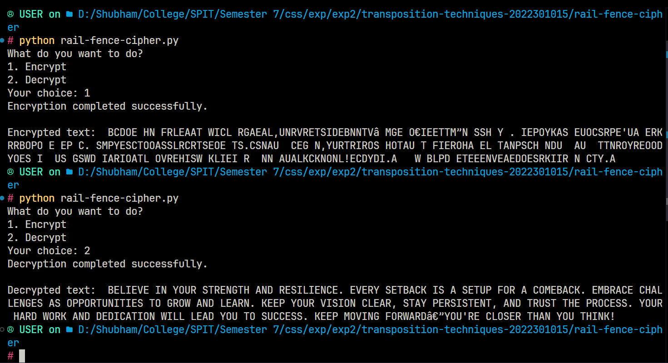

Attack:

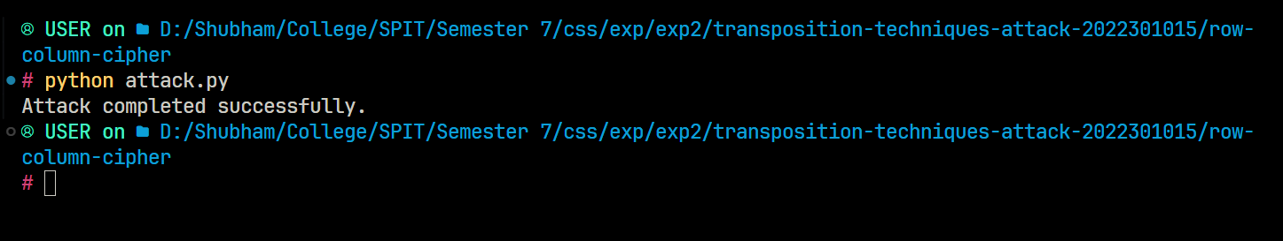

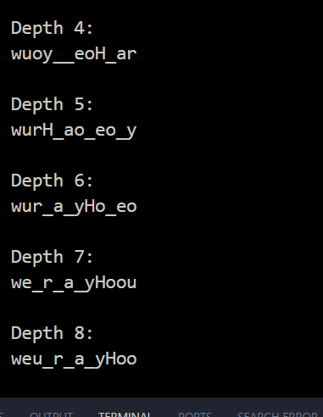

**2. Row column cipher**

**Plain text** – BELIEVE IN YOUR STRENGTH AND RESILIENCE. EVERY SETBACK IS A SETUP FOR A COMEBACK. EMBRACE CHALLENGES AS OPPORTUNITIES TO GROW AND LEARN. KEEP YOUR VISION CLEAR, STAY PERSISTENT, AND TRUST THE PROCESS. YOUR HARD WORK AND DEDICATION WILL LEAD YOU TO SUCCESS. KEEP MOVING FORWARD—YOU'RE CLOSER THAN YOU THINK!

**Cipher text -** B RG EVTSUAABHEPIOARPVCSRTTHEU NCWATEENAOLH EI TRNEB P CRASPT NN ILTS,RESRWDAIDOSPGRUOATI T SEYC FO.CLARER OIAYSASP.HRDILYS.MFâRE IEUNDIEEIT BMCGONT AE EN TCODAI E CEIWYCTU!LNSHECRAA CKAL OIGD.YSEAI U S O TL S D'SNHEYRAI. KSOM EESTSOLKUOR TNTR AKEO OU OO€ERYNVOENL S EREE N U WEERN,PED OYR DNLUCKVR

Key: 1253674

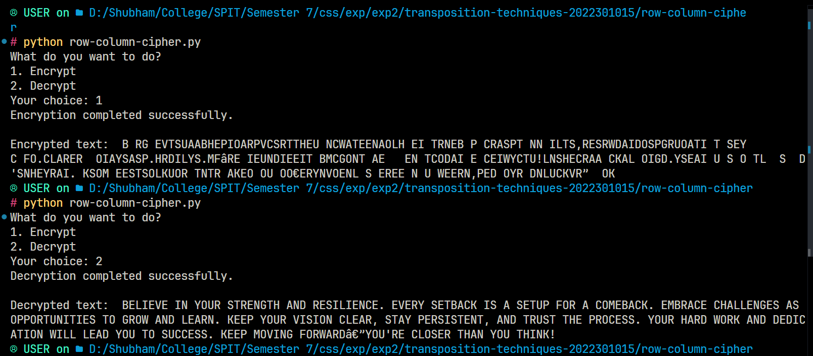

Attack:

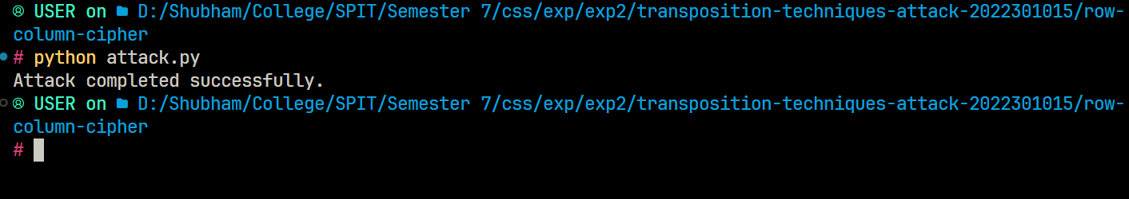

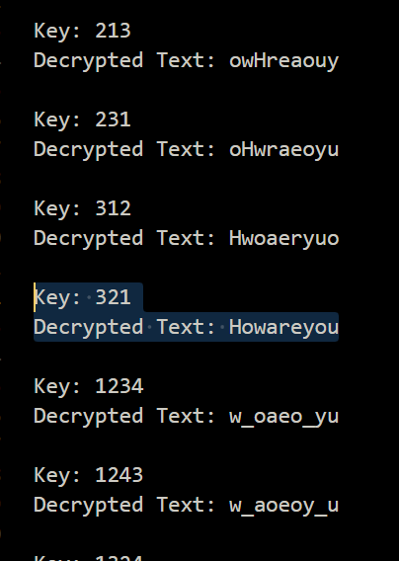

1. **Double Row Column Cipher**

**Plain text –** BELIEVE IN YOUR STRENGTH AND RESILIENCE. EVERY SETBACK IS A SETUP FOR A COMEBACK. EMBRACE CHALLENGES AS OPPORTUNITIES TO GROW AND LEARN. KEEP YOUR VISION CLEAR, STAY PERSISTENT, AND TRUST THE PROCESS. YOUR HARD WORK AND DEDICATION WILL LEAD YOU TO SUCCESS. KEEP MOVING FORWARD—YOU'RE CLOSER THAN YOU THINK!

**Cipher text –** BTEVETHNRNRIU ORSDFUTN DE!RLY SI LNO€ER P V SPCUE EA EDOS. AIâN TEAILA SS N.EKT ENEWEDRGAORNNI PLRSTYLOPYEIMA YS IAO EKSO UY E L VHPHALRCN,ARTFEYRMEIO OCUCA.UL'AMOTEOOEU,RKKRUIS EEBSISOAEC SLRDB NIWNAOE SH EURORLEEDN” AATCA PTTWPICAI.S ECETECHCGI YSTRA NSNROU EBRTWOT SDG RAH.IEG C TEKD TDROS KOV NYCO

**Key:** 1253674

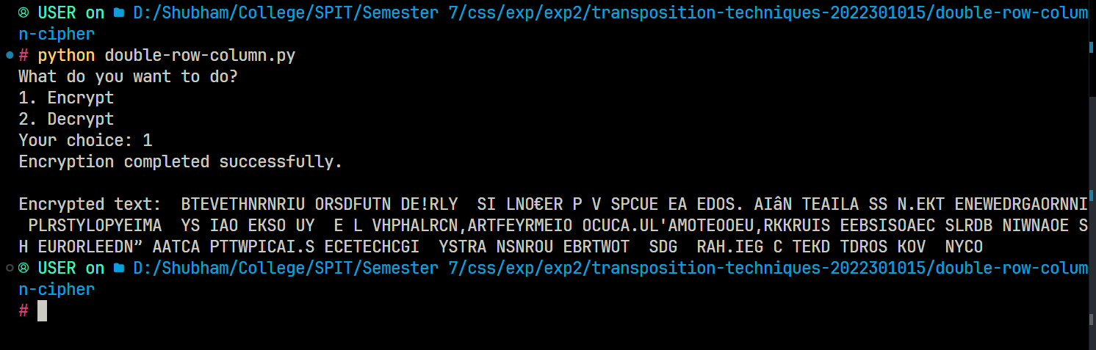

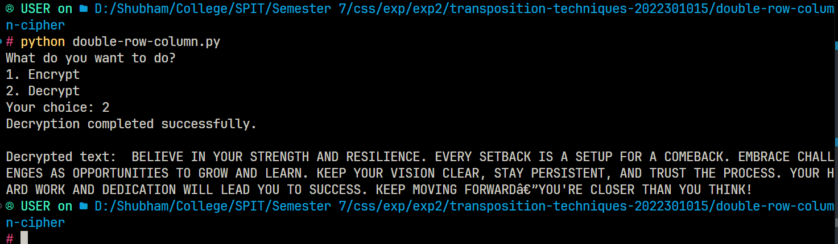

Attack:



Part 3: Plotting: Normalized Character Frequency Comparison by Frequency Rank

