**ABSTRACT**

**Gaming Website**

ABSTRACT

My project title is Hotel Management System. I have tried my best to make the complicated process of Hotel Management System as simple as possible using Structured & Modular technique & Menu oriented interface. I have tried to design the Project in such a way that user may not have any difficulty in using this package & further expansion is possible without much effort. Even though I cannot claim that this work to be entirely exhaustive, the main purpose of my exercise is perform each Employee’s activity in computerized way rather than manually which is time consuming.Just like offline Hotel Management, they can have educational benefits, and be used, for example, to develop skills and understanding. Traditionally, Hotel Management could be bought from shops, often in the form

Internet connectivity in a Hotel Management adds a new opportunity for Hotel Managementrs as it allows user to find and book room.

**ABOUT THE PROJECT**

**Hotel Management Website** Online users can see the required articles or news administrator can maintain daily updates in the hotel records. Administrator is must be an authorized user. He can further change the password. There is the facility for password recovery, logout etc.

**Introduction: -**

Even though I cannot claim that this work to be entirely exhaustive, the main purpose of my exercise is perform each Employee’s activity in computerized way rather than manually which is time consuming.

I am confident that this software package can be readily used by non-programming personal avoiding human handled chance of error. This project is used by two types of users

i. Online Users.

ii. Administrator (management of the Hotel).

Online users can see the required articles or news.

Administrator can maintain daily updates in the hotel records. Administrator is must be an authorized user. He can further change the password. There is the facility for password recovery, logout etc.

The main aim of the entire activity is to automate the process of day to day activities of Hotel like Room activities, Admission of a New Customer, Assign a room according to customer’s demand, checkout of a computer and releasing the room and finally compute the bill etc.

The limited time and resources have restricted us to incorporate, in this project, only a main activities that are performed in a HOTEL Management System, but utmost care has been taken to make the system efficient and user friendly.

“HOTEL Management System” has been designed to computerized the following functions that are performed by the system:

Room Detail Functions

Opening a New Room

Check-in and check-out Detail Functions

Admission of New customer

Check-out of customer

Room assigning related to customer’s need.

Statement of Customer Details

Check-in customer

Check-out customer

Room Details

**Purpose:-**

A computer based management system is designed to handle all the primary information required to calculate monthly statements. Separate database is maintained to handle all the details required for the correct statement calculation and generation.

This project intends to introduce more user friendliness in the various activities such as record updating, maintenance, and searching. System Description: -

The name of the project is Hotel Management site

The website provides both the user and Hotel Management the facilities to be usered.

1. User

2. Admin

This system enables the manager to login to the system and create any room and post it on the web. This system enables the user to login, to view all the room and to view the price details. He is also able to search other room which he need. The user can register any room online. He/She can search room online. He could view descriptions and details of the room.

**Project Overview:-**

**The requirementsare as follows:   
1.Generic:**  
a. Login to the system through the first page of theuser– the welcome message should display.  
b. user can chose any room.  
c. Help from the system.  
d. Room with their category.

**3. Administrator**

a. Should be able to create a new room.  
**3. User:**  
a. should be able to view all rooms and can booking.

**Room perspective:-**

This software is totally self-contained and works relatively as efficient as other packages related to the subject. It provides simple database rather than complex ones for high requirements and it provides good and easy graphical user interface to both new, naïve as well as experienced users of the computers

**Brief description of these component**

* **HTML:**
* **HTML**, which stands for **Hyper Text Markup Language**, is the predominant markup language for web pages HTML is the basic building-blocks of webpages.
* **JavaScript:**  
  **JavaScript**, also known as ECMA Script is a prototype-based object oriented scripting language that is dynamic, weakly typed and has first class functions. It is also considered a functional programming language like scheme and OCaml because it has closures and supports higher order functions.
* **CSS:-**  
  **Cascading Style Sheets** (**CSS**) is a style sheet language used to describe the presentation semantics (the look and formatting) of a document written in a markup language. This is best for styling.
* **PHP:-**  
  **PHP** is a general-purpose scripting language originally designed for web development to produce dynamicweb pages.
* **MySql**  
  MySql is a relational database management system (RDBMS) that runs as a server providing multi-user access to a number of databases.
* **Xampp server 2.0(for windows platform)  
  Xampp server** is free to use for all the developers, **Xampp server** runs on only windows based platform, if we used different OS then we have to used different version of **Xampp** i.e(lamp for linux, mamp for mac os), **Xampp** is common PHP based development tools for all perating system.
* **Filezilla**

It is a FTP(File transfer Protocol) used to upload the file/project to host site. It is ensure to upload a project to the host server through filezilla and it is very fast to upload the file.

BACK END OF THE PROJECT

Window OS:-Window Operating system used as interface

MySQL:MySQL used for database management

Server:Apache 2.0,

Software:- Xampp

**NECCESSARY TO SOFTWARE AND HARDWARE**

**Software**

Software, commonly known as programs, consists of all the electronic instructions that tell the hardware how to perform a task. These instructions come from a software developer in the form that will be accepted by the operating system that they are based on. For example, a program that is designed for the Windows operating system will only work for that operating system. Compatibility of software will vary as the design of the software and the operating system differ. Software that is designed for Windows XP may experience compatibility issue when running under Windows 7.

Software can also be described as a collection of routines, rules and symbolic languages that direct the functioning of the hardware. Software is capable of performing specific tasks, as opposed to hardware which only perform mechanical tasks that they are mechanically designed for. Practical computer systems divide software systems into three major classes:

* **System software**: Helps run computer hardware and computer system. Computer software includes operating systems, device drivers, diagnostic tools and more.
* **Programming software**: Software that assists a programmer in writing computer programs.
* **Application software**: Allows users to accomplish one or more tasks.

**Software Requirements**

**Development Platform**

Server : Apache 2.0,**Xampp**

Front End : Core PHP

Data Base : MYSQL

Operating System - : Microsoft Windows 2000 and more

Data Base : MYSQL

**Hardware**

Hardware refers to the physical elements of a computer. Also referred to as the machinery or the equipment of the computer. Examples of hardware in a computer are the keyboard, the monitor, the mouse and the processing unit However, most of a computer's hardware cannot be seen; in other words, it is not an external element of the computer, but rather an internal one, surrounded by the computer's casing. A computer's hardware is comprised of many different parts, but perhaps the most important of these is the motherboard. The motherboard is made up of even more parts that power and control the computer.

In contrast to software, hardware is a physical entity, while software is a non-physical entity. Hardware and software are interconnected, without software; the hardware of a computer would have no function. However, without the creation of hardware to perform tasks directed by software via the central processing unit (box), software would be useless. Hardware, in the computer world, refers to the physical components that make up a computer system. There are many different kinds of hardware that can be installed inside, and connected to the outside, of a computer. Some of common hardware that find inside a computer are Motherboard, Central Processing Unit (CPU), Random Access Memory (RAM), Power Supply, Video Card, Hard Drive, Optical Drive (i.e. BD/DVD/CD drive), Sound Card, Network Interface Card (NIC), Analog Modem, FireWire/USB Expansion Card, etc. Some of common hardware that might find connected to the outside of a computer is Keyboard, Mouse, Printer, Scanner, Speakers, Monitor, etc. The following hardware is referred to as network hardware and various pieces are often part of a home or business network such as Router, Network Switch, Access Point, Repeater, Bridge, Print Server, Firewall, etc.

**1. PROJECT DEFINATION, SCOPE AND OBJECTIVE**

**1.1 PROJECT PROFILE**

* **Project Title** : Hotel Management website
* **Objective :** To develop a user-friendly & efficient system
* **Operating System :** Microsoft Windows 7
* **Back End :** SQL Server, apache
* **Front End Used :** PHP

**1.2 PROJECT DEFINATION**

Now picture doing all that in front of the computer, listening to your favorite music, comparing the best deals, without anyone trying to convince you what is the perfect fit. Hotel Management online is just easier. Users choose it because it’s stress-free, it’s rational and you can get the best deal without spending a whole afternoon looking for a pair of pants. Think about Hotel Management centers. Picture the people, the crowd, the options. Hear the noise. Now think about looking for a parking space, walking to the mall.

Now picture doing all that in front of the computer, listening to your favorite music, comparing the best deals, without anyone trying to convince you what is the perfect fit. Hotel Management online is just easier. Users choose it because it’s stress-free, it’s rational and you can get the best deal without spending a whole afternoon looking for a pair of pants.

## 1.3 GOALS AND OBJECTIVES

During the past several decades’ personnel function has been transformed from a relatively obscure record keeping staff too central and top level management function. There are many factors that have influenced this transformation like technological advances, professionalism, and general recognition of human beings as most important resources.

A computer based management system is designed to handle all the primary information required to calculate monthly statements. Separate database is maintained to handle all the details required for the correct statement calculation and generation.

This project intends to introduce more user friendliness in the various activities such as record updating, maintenance, and searching.

The searching of record has been made quite simple as all the details of the customer can be obtained by simply keying in the identification of that customer.

Similarly, record maintenance and updating can also be accomplished by using the identification of the customer with all the details being automatically generated. These details are also being promptly automatically updated in the master file thus keeping the record absolutely up-to-date.

The entire information has maintained in the database or Files and whoever wants to retrieve can’t retrieve, only authorization user can retrieve the necessary information which can be easily be accessible from the file.

**1.4 ONLINE HOTEL MANAGEMENT**

The aim of the project is to build a simple, effective computerized Hotel Management Module, which complements the dealing of the room. It starts from the process of collecting room and requirements from the Users.

**Proposed Project: ONLINE HOTEL MANAGEMENT:**

Online Hotel Managementhelps both the userto play online any time anywhere.

The aim of the project is to build a simple, effective computerized Recruitment Module, which complements the dealing of the room. It starts from the process of collecting room and requirements from the Users.

**Present scenario:**

Online Hotel Management or e-Hotel Management is a form of electronic Hotel Management which allows consumers to directly buy Hotel Management over the Internet using a web browser. This research paper is based on online Hotel Management in current scenario it is a boon or curse. The research paper is based on information collected from primary and secondary sources after the detailed study. An attempt has been made to present comprehensive analysis of online Hotel Management. A good number of respondents showed their interest regarding online Hotel Management.

**Competition:**

As you are well aware, there are countless Hotel Management are available online. It should be worth to create online Hotel Management site, which would save time, reduce costs, and also assist in searching the room.

**System:**

**1. Designing and implementing user:**

In this module user can play Hotel Management online and have fun also he can enjoy his spare time on computer.

**2. Designing and implementing user Database, seller database**

The purpose of this module we are adding Hotel Management by using the form which will help to keep records of all the Hotel Management organized.

**2.1 SOFTWARE AND HARDWARE REQUIREMENT**

* **Software Environment:**

|  |  |  |  |
| --- | --- | --- | --- |
| **Tools/Technology** | **Front-end** | **-** | PHP |
| **Back-end** | **-** | MySQL |
| **Browser** | **-** | Internet Explorer 6.0, Netscape Navigator, Firefox, Google Chrome |
|  | **Editor** | **-** | BRACKET |
| **Operating System** | Windows 98 to Windows 2003 &Windows XP. | | |

* **Hardware Environment:**

|  |
| --- |
| **Client Configuration** |
| * Pentium IV, 750 MHz, 20GB HDD * Operating System : Windows XP/2000 * RAM : 512 MB minimum * 400MB Minimum Free Space on Drive * Microsoft Office |
| **Server Configuration** |
| Servers, each with following configuration   * CPU * Operating System: Windows XP * RAM : 1GB Minimum * 40GB Minimum Free Space on Drive * 750MHz |

**Advantages:**

* User friendly registration System
* Show new room.
* Easy to Hotel Management
* Time saver.
* Categories every room.

**Modules of project:**

The project can be divided in to four main modules.

**MODULE 1:**

**LOGIN PHASE:**

The registered user is allowed to login to play Hotel Management.

**MODULE 2:**

**REGISTRATION PHASE:**

A new user registers here with personal and bank account details.

**MODULE 3:**

**CATAGEORY SELECTION PHASE:**

A categ ory of the Hotel Management is chosen in order to play.

2.3CONSTRAINTS

**2.3.1 User Interface**

The user Interface is provided by the any kind of web browser like Internet Explorer, Mozilla Firefox, msn, safari etc. As the project is the extension of the live project, based on the client’s requirement, the project testing will be done for the above specified four browsers so the project would be portable and will have pluggable look and feel.

**2.3.2 Communication Interfaces**

This is website so it requires HTTP protocol and Internet connection.

**2.3.3 Software Interface**

The application mainly interacts with the SQL Server database for storing data at the back end. Other than this it does not deal with any software.

**3.SYSTEM ANALYSIS**

**3.1 STUDY OF CURRENT SYSTEM**

The internet and mobile technology have shifted the concentration of business to technology related platform where by businesses are designed and operated via these technologies. Most businesses have therefore gone electronic. However, electronic businesses on mobile forms have therefore come to be commonly referred to as mobile Hotel Management. Mobile Hotel Management according to Weinhardt, Stefan and Jochen (2008) can be considered to be “any direct or indirect transaction performed using a mobile device such as a cell phone or a personal digital assistant (PDA)” (p.52). Mobile Hotel Management have therefore emerged as a new channel of electronic Hotel Management and as such, it has received widespread attentions of both academia and business fraternity. Mobile Hotel Management is therefore viewed as a new giant wave of technology evolution. Several studies have therefore been advanced to help generate new or explore the already existing body of knowledge.

In addition, it is important to note that integration of mobile Hotel Management with electronic Hotel Management is likely to increase competitive advantage of any business including small entities like retail ventures. This is so since mobile Hotel Management provide instant response to user queries. However, it is also relevant to remember that security is a crucial issue that needs to be considered when developing any system that needs to run on mobile platform due to their extranet applications. These systems need to be robust so that they can withstand any security breaches that come with mobile Hotel Management.

In respect to these, the researcher was motivated by the development taking place in the electronic Hotel Management field and more particularly in the mobile Hotel Management. As a student majoring in mobile Hotel Management, the researcher wanted to make an online Hotel Management system for Newport Supermarket which at present time has not transformed its services to an online operation.

* 1. **ADVANTAGES AND DISADVANTAGES OF CURRENT SYSTEM:**

**Advantages**

1. **Access**- Video Hotel Management can help children's brain development. When my son was a young adolescent, I watched him play Legend of Zelda Hotel Management. He had to search, negotiate, plan, and try different approaches to advance.
2. **Online Deals and Promotions** - Many recent Hotel Management, such as Bakugan: Defenders of the Core, involve planning and problem-solving. "Modding," the process by which user customize Hotel Management characters' appearance and develop new Hotel Management levels, also allows for creative self-expression, deep understanding of Hotel Management rules and structure, and new ways of highlighting personalities and interests.

3.**3 REQUIREMENTS OF NEW SYSTEM**

The problems of the conventional recruitment process increases the need of some automated system which handles the process at some extent and can decrease the work of this process. The system can be built which is general and not specific to any company as the evaluation process contains different steps for different companies. Any company can use that system and can decrease complexity of the conventional approach. The new system may not include the phase of evaluation process but other general formalities of saving resumes and other details of the candidates, maintaining their data etc. can be included.

## 3.4 Feasibility Study

The feasibility study is the important step in any software development process. This is because it makes analysis of different aspects like cost required for developing and executing the system, the time required for each phase of the system and so on. If these important factors are not analyzed then definitely it would have impact on the organization and the development and the system would be a total failure. So for running the application and the organization successfully this step is a very important step in a software development life cycle process.

By making analysis with the requirement of the organization it would be possible to make a report of identified area of problem. By making a detailed analysis in this area a detailed document or report is prepared in this phase which has details like project plan or schedule of the project, the cost estimated for developing and executing the system, target dates for each phase of delivery of system developed and so on. This phase is the base of software development process since further steps taken in software development life cycle would be based on the analysis made on this phase and so careful analysis has to be made in this phase.

Though the feasibility study cannot be focused on a single area some of the areas or analysis made in feasibility study is given below. But all the steps given below would not be followed by all system developed. The feasibility study varies based on the system that would be developed.

* Feasibility study is made on the system being developed to analyze whether the system development process require training of personnel. This help in designing training sessions as required in later stage. So that is why this is best choice for us to make this project.
* Is the system developed has scope for expanding or scope for switching to new technology later if needed in ease. In other study is made to find the portability of the system in future.
* The above feasibilities are analysis which helps in development of the system. But the scope of feasibility study does not end with this. Analysis or feasibility study also includes the analysis of maintenance stage. In other words feasibility study is made to analyze how one would maintain the system during maintenance stage. This helps sin planning for this stage and also helps in risk analysis. Also the analysis helps in making analysis about what training must be given and how and what all documents must be prepared to help users and developers to face maintenance phase.

**3.5 FUNCTION OF SYSTEMS**

**3.5.1 USE CASE DIAGRAM**

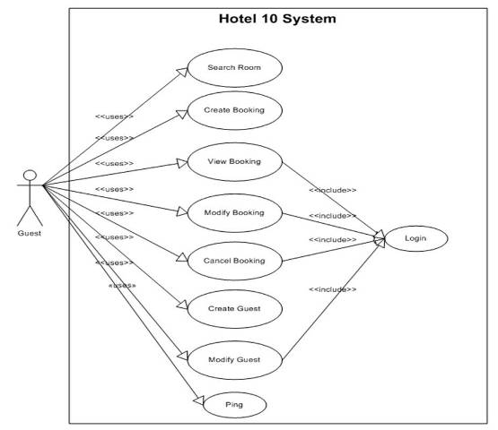

**3.6.3 SEQUENCE DIAGRAM**

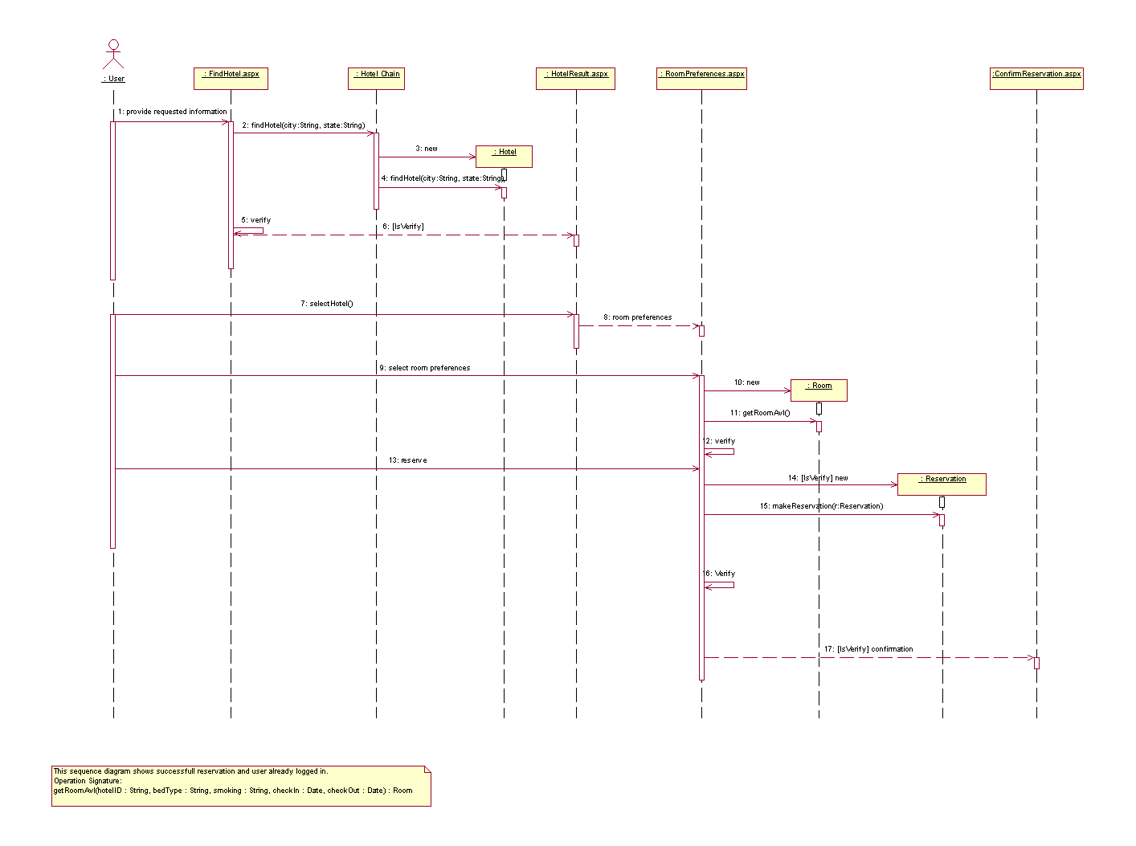

**3.6.4TABLES**

**1. ADMIN TABLE**

|  |  |  |  |  |
| --- | --- | --- | --- | --- |
| FIELD | TYPE | NULL | EXTRA | PRIMARYKEY |
| A_id | Int(100) | NO | - | YES |
| A_Name | Varchar(100) | NO | - | NO |
| A_email | Varchar(100) | NO | - | NO |
| Password | Varchar(100) | NO | - | NO |

2. BOOKING_HOTEL MANAGEMENT

|  |  |  |  |  |
| --- | --- | --- | --- | --- |
| FIELD | TYPE | NULL | EXTRA | PRIMARYKEY |
| Check-in_date | Int(100) | NO | - | YES |
| Check-out_date | int(100) | NO | - | NO |
| U_id | Varchar(100) | NO | - | NO |
| R_id | Varchar(100) | NO | - | NO |
| facilty1 | Varchar(100) | NO | **-** | NO |
| facilty2 | Varchar(100) | NO | **-** | NO |

**4. CONTECT US**

|  |  |  |  |  |
| --- | --- | --- | --- | --- |
| FIELD | TYPE | NULL | EXTRA | PRIMARYKEY |
| First_name | Varchar(100) | NO | - | NO |
| Last_Name | Varchar(100) | NO | - | NO |
| Email | Varchar(100) | NO | - | NO |
| Password | Varchar(100) | NO | - | NO |
| Phone | Varchar(100) | NO | - | NO |
| massage | Varchar(100) | NO | - | NO |

**7. Invoice billing**

|  |  |  |  |  |
| --- | --- | --- | --- | --- |
| FIELD | TYPE | NULL | EXTRA | PRIMARYKEY |
| id | int(100) | NO | - | yes |
| Status | Varchar(100) | NO | - | NO |
| Address | Varchar(100) | NO | - | NO |
| Description | int (200) | NO | - | NO |

**5. CUSTOMER_DETAIL**

|  |  |  |  |  |
| --- | --- | --- | --- | --- |
| FIELD | TYPE | NULL | EXTRA | PRIMARYKEY |
| First_name | Varchar(100) | NO | - | NO |
| Last_Name | Varchar(100) | NO | - | NO |
| Address | Varchar(100) | NO | - | NO |
| Postcode | int (200) | NO | - | NO |
| State | Varchar(100) | NO | - | NO |
| Mobile_no | Varchar(100) | NO | - | NO |
| E_mail | Varchar(100) | No | - | No |

**8.Payment**

|  |  |  |  |  |
| --- | --- | --- | --- | --- |
| FIELD | TYPE | NULL | EXTRA | PRIMARYKEY |
| Pay_type | Varchar(100) | NO | - | NO |
| customer_id | Varchar(100) | NO | - | yes |
| booking_id | Varchar(100) | NO | - | NO |
| first_name | int (200) | NO | - | NO |
| last_name | Varchar(100) | NO | - | NO |
| credit_card_no | Varchar(100) | NO | - | NO |
| Expire_date | varchar(100) | No | - | No |

**9.Room**

|  |  |  |  |  |
| --- | --- | --- | --- | --- |
| FIELD | TYPE | NULL | EXTRA | PRIMARYKEY |
| room_id | int(100) | NO | - | NO |
| room_type | Varchar(100) | NO | - | NO |
| room_name | Varchar(100) | NO | - | NO |
| room_price | varchar (100) | NO | - | NO |
| room_image | Varchar(100) | NO | - | NO |
| room_description | Varchar(100) | NO | - | NO |

**3.7 FUNCTIONAL AND BEHAVIORAL MODELLING**

**3.7. 1 CONTROL DIAGRAM**

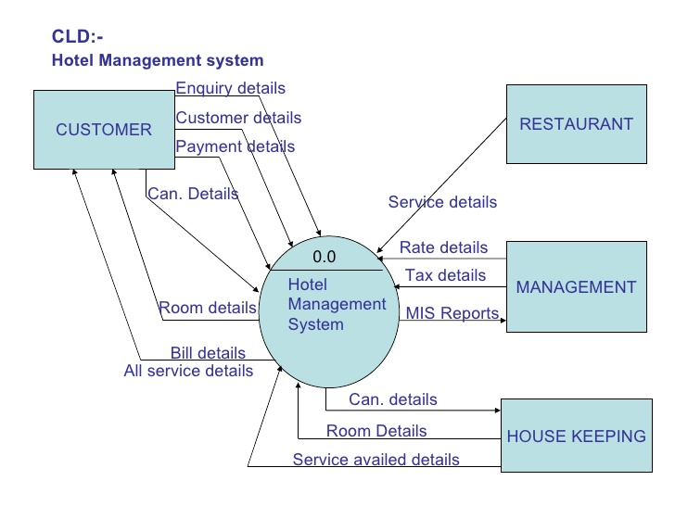

**3.7.2 DATA FLOW DIAGRAM**

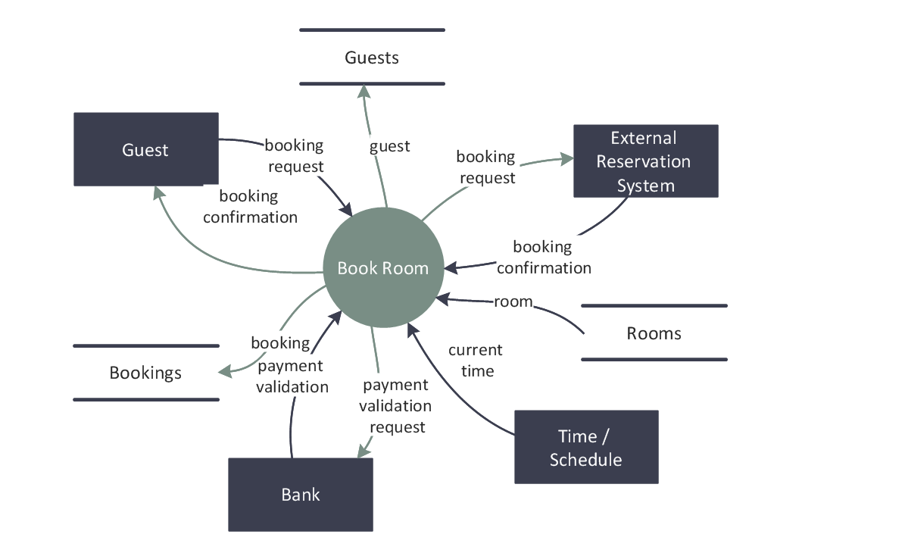

**3.7.3 ER DIAGRAM**

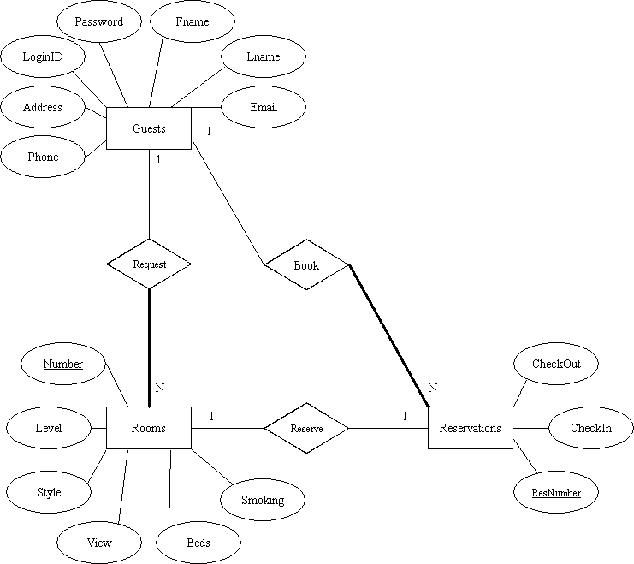

**4. SNAPSHOTS**

**4.1HOME PAGE**

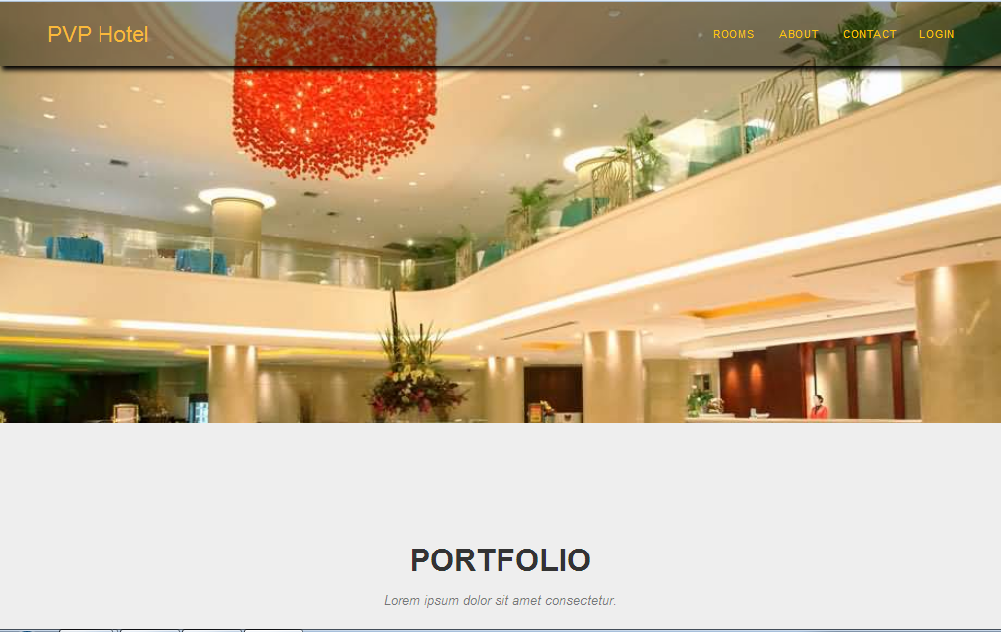

This is the home page. In this page the latest Hotel Management are shown. This page contains login form.

**4.2 Login page**

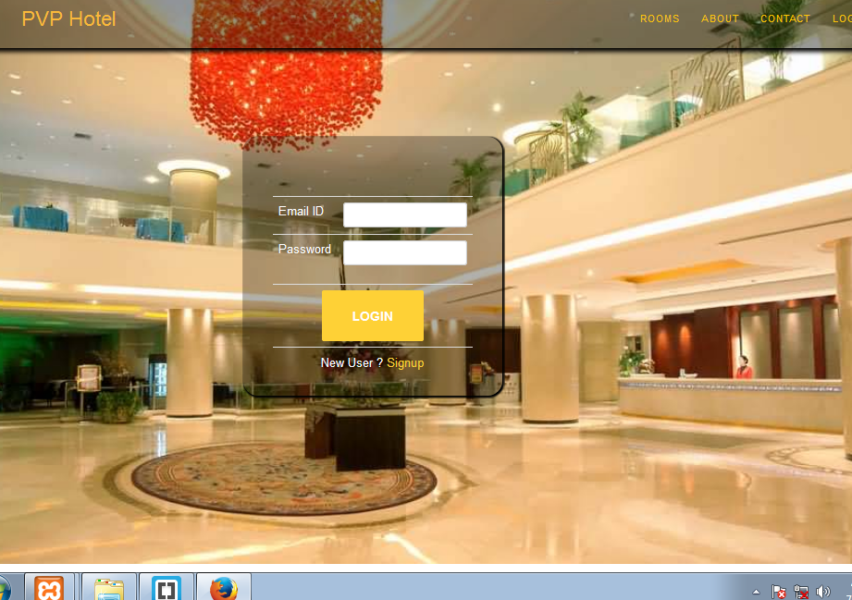

this is the login page in which to login the different Hotel Management.

**4.3 Create user**

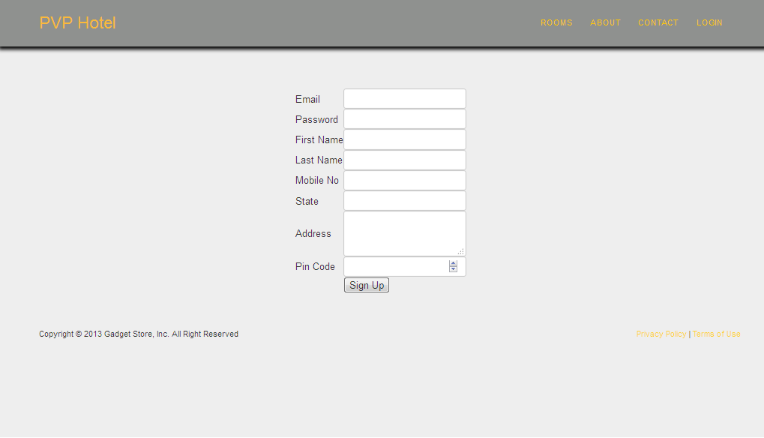

**4.3 Rooms**

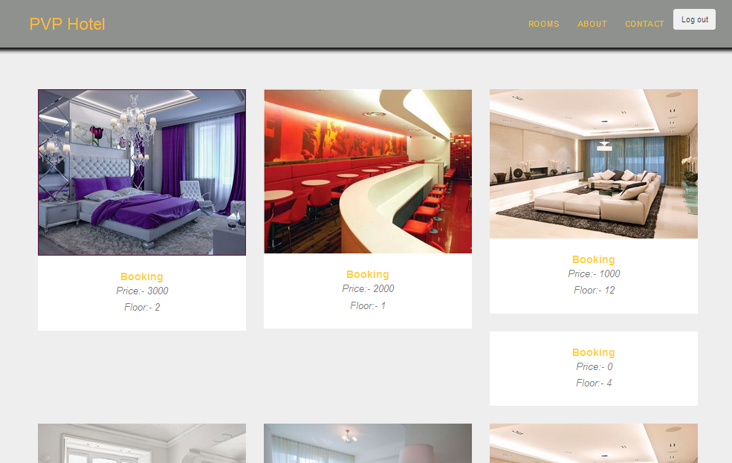

This page show to play different types of Hotel Management

**4.4 Booking**

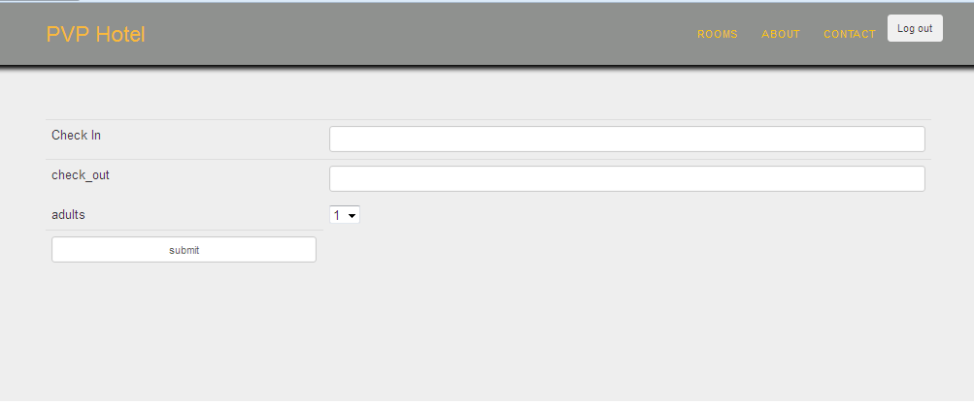

**4.5 ABOUT US PAGE**

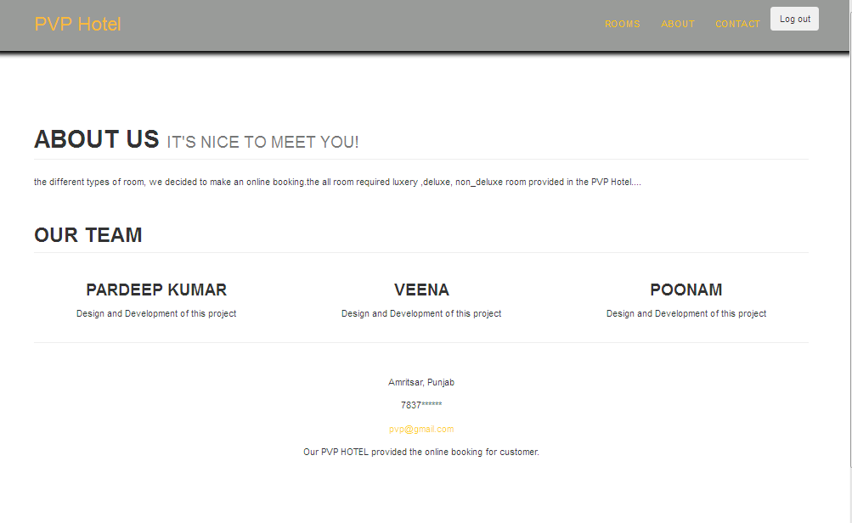

It is the the about us page.

**4.6 CONTACT US PAGE**

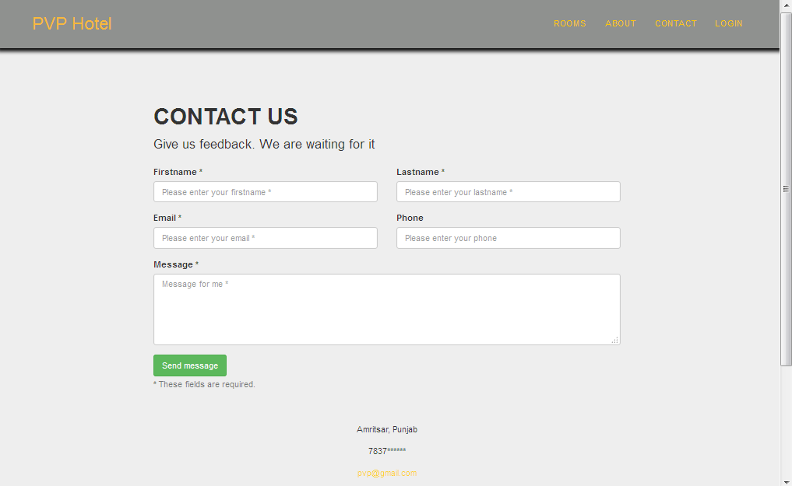

This is the contact page about site

**4.7 Add Hotel**

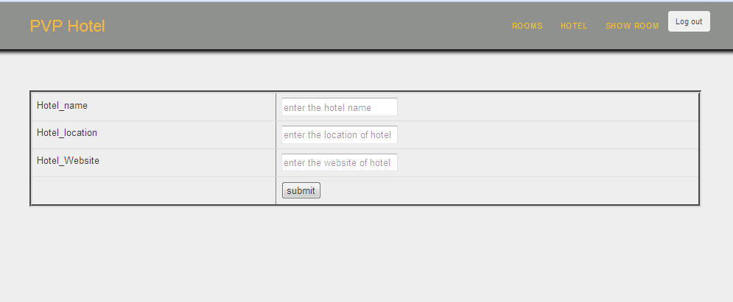**4.8 Add room**

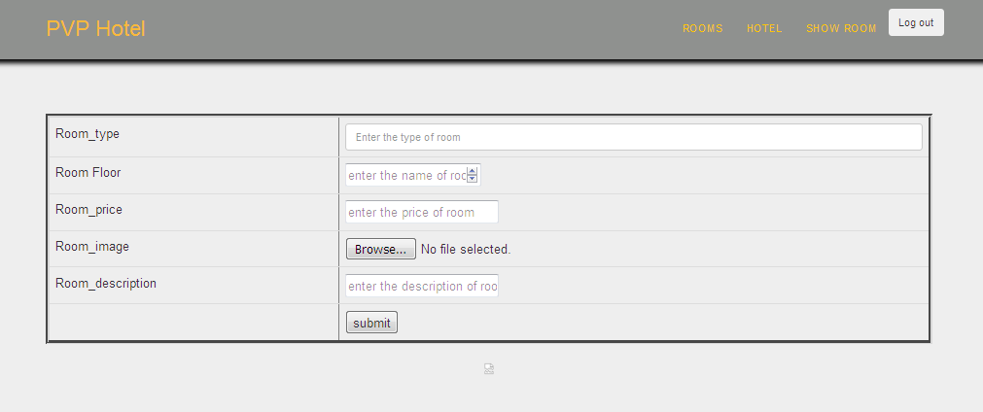

**5. ARCHITECTURE OF NEW SYSTEM**

**5.1 PACKAGE DIAGRAM**

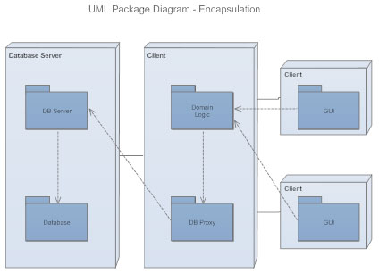

**6 .CONCLUSION**

**Online Hotel Management** is a different experience and you can make the Hotel Management creative over the internet as you get used to it. There can be lot of **apprehensions** about online Hotel Management when you get in to it for the **first time**. As you experience more and more of it those apprehensions get **disappeared** slowly. Remember that if you stick to the basics, online Hotel Management become**more enjoyable and easier**than real-world Hotel Management.

**Online Hotel Management**

PREPARED BY:

GUIDED BY:

[1]

1.