# **DIGITAL GREEN TEST APP**

## **User Interface :**

There is a single activity which contains below items :

1. Map
2. Markers for pointing out location
3. Start Button
4. Stop button

**Code :**

*<?***xml version="1.0" encoding="utf-8"***?>*<**RelativeLayout xmlns:android="http://schemas.android.com/apk/res/android"  
 xmlns:tools="http://schemas.android.com/tools"  
 android:layout_width="wrap_content"  
 android:layout_height="match_parent"  
 android:background="@color/common_google_signin_btn_text_dark_pressed"**>  
 <**fragment  
 android:id="@+id/map"  
 android:name="com.google.android.gms.maps.SupportMapFragment"  
 android:layout_width="match_parent"  
 android:layout_height="match_parent"  
 tools:context=".MapsActivity"** />  
  
 <**RelativeLayout  
 android:id="@+id/belowlayout"  
 android:layout_width="wrap_content"  
 android:layout_height="wrap_content"  
 android:layout_alignParentBottom="true"  
 android:orientation="horizontal"**>  
  
 <**Button  
 android:id="@+id/button"  
 android:layout_width="match_parent"  
 android:layout_height="wrap_content"  
 android:gravity="center|bottom"  
 android:layout_gravity="right|center_horizontal"  
 android:layout_marginRight="@dimen/margin_left"  
 android:layout_marginLeft="@dimen/margin_left"  
 android:layout_marginTop="@dimen/margin_left"  
 android:layout_marginBottom="@dimen/margin_left"  
 android:background="@color/mapbox_blue"  
 android:text="@string/start_trip"  
 android:textAllCaps="true"  
 android:textAlignment="center"  
 android:visibility="gone"  
 android:textColor="@color/common_google_signin_btn_text_dark_default"** />  
  
  
 <**Button  
 android:id="@+id/stop_trip"  
 android:layout_width="match_parent"  
 android:layout_height="wrap_content"  
 android:gravity="center|bottom"  
 android:layout_gravity="right|center_horizontal"  
 android:layout_marginRight="@dimen/margin_left"  
 android:layout_marginLeft="@dimen/margin_left"  
 android:layout_marginTop="@dimen/margin_left"  
 android:layout_marginBottom="@dimen/margin_left"  
 android:background="@color/mapbox_blue"  
 android:text="@string/stop_trip"  
 android:textAllCaps="true"  
 android:textAlignment="center"  
 android:visibility="gone"  
 android:textColor="@color/common_google_signin_btn_text_dark_default"** />  
  
  
 </**RelativeLayout**>  
</**RelativeLayout**>  
  
  
  
 **Screen Shots**

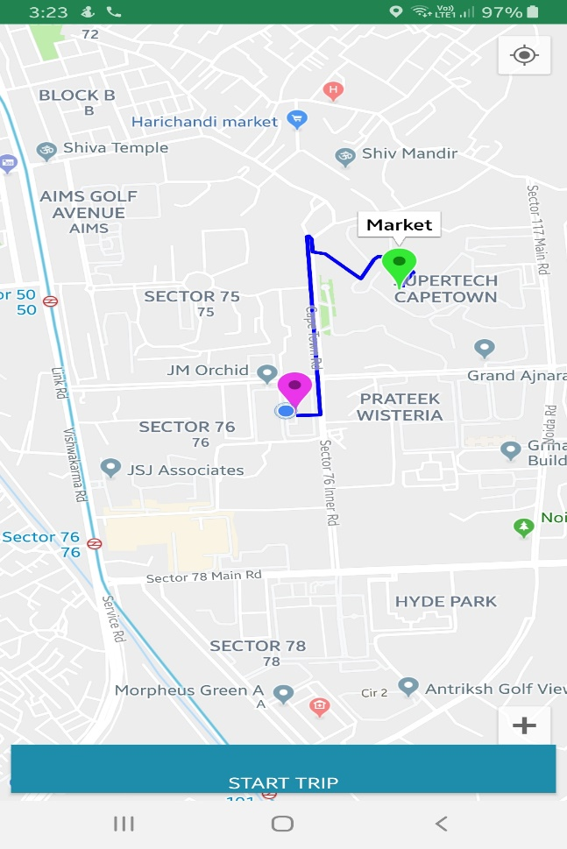 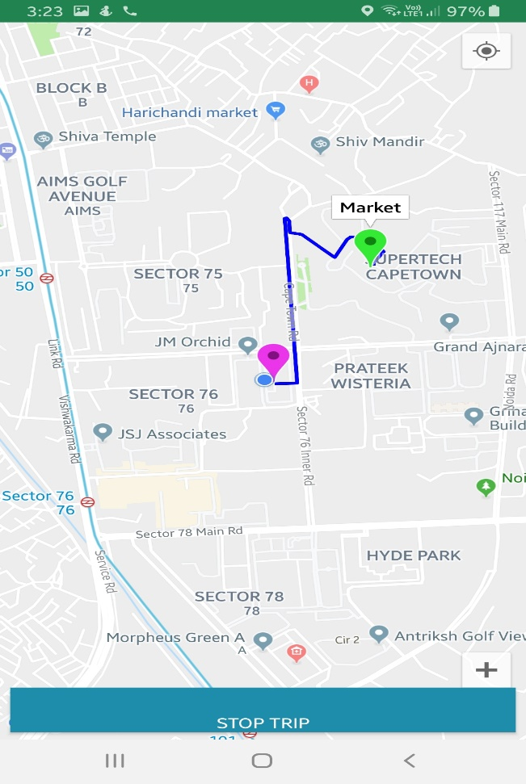

## **Things Implemented**

1. Selecting start and end location from map.
2. Drawing route for start and end point.
3. Handling ‘START’ and ‘STOP’ button functionalities depending on user movements.
4. Collecting all coordinates and timestamp of user’s movement from ‘START’ to ‘STOP’ for sending to server.
5. SDK used are MAPBOX and NAVIGATION UI (GOOGLE)

## **Things Remaining**

1. All locations need to be send to server (Tried to use Google cloud storage and integrate in the app)
2. Past history of trips. (Idea is to use same Google cloud storage data, fetch and show them in a list view. There can be menu button in side, showing the trips and on clicking fetch from server).

**Below are the details of Code Implemented**

## **CODE DESCRIPTION**

1. Granting permissions to app.

<**uses-permission android:name="android.permission.ACCESS_FINE_LOCATION"** />  
<**uses-permission android:name="android.permission.ACCESS_COARSE_LOCATION"**/>  
<**uses-permission android:name="android.permission.WRITE_EXTERNAL_STORAGE"**/>  
<**uses-permission android:name="android.permission.ACCESS_NETWORK_STATE"**/>  
<**uses-permission android:name="android.permission.INTERNET"**/>

1. Before running application, a Google Maps API key is needed.  
     
   To get one, follow this link, follow the directions and press "Create" at the end:  
     
   https://console.developers.google.com/flows/enableapi?apiid=maps_android_backend&keyType=CLIENT_SIDE_ANDROID&r=1A:CC:45:5A:8B:6F:9E:1E:F7:74:8D:DE:5F:C2:51:4E:D6:82:38:08%3Bcom.example.digitalgreen
2. **onMapReady()** Callback for showing map and marking village and market using markerOptions.

s

@Override  
**public void** onMapReady(GoogleMap googleMap) {  
 **mMap** = googleMap;  
 **mMap**.getUiSettings().setZoomControlsEnabled(**true**);  
 **if** (ActivityCompat.*checkSelfPermission*(**this**, Manifest.permission.***ACCESS_FINE_LOCATION***) != PackageManager.***PERMISSION_GRANTED***) {  
 ActivityCompat.*requestPermissions*(**this**, **new** String[]{Manifest.permission.***ACCESS_FINE_LOCATION***}, **LOCATION_REQUEST_CODE**);  
 **return**;  
 }  
 isLocationEnabled();  
 **mMap**.setMyLocationEnabled(**true**);  
 **mMap**.getUiSettings().setMyLocationButtonEnabled(**true**);  
 **mMap**.getUiSettings().setAllGesturesEnabled(**true**);  
 **mMap**.setOnMapClickListener(**new** GoogleMap.OnMapClickListener() {  
 @Override  
 **public void** onMapClick(LatLng latLng) {  
 **if** (**mMapPoins**.size() == 2) {  
 **mMapPoins**.clear();  
 **mMap**.clear();  
 }  
 **mMapPoins**.add(latLng);  
 MarkerOptions markerOpt = **new** MarkerOptions();  
 markerOpt.position(latLng);  
 **if** (**mMapPoins**.size() == 1) {  
 markerOpt.icon(BitmapDescriptorFactory.*defaultMarker*(BitmapDescriptorFactory.***HUE_MAGENTA***));  
 markerOpt.title(**"Village"**);  
 **startTripBtn**.setVisibility(View.***GONE***);  
 } **else** {  
 markerOpt.icon(BitmapDescriptorFactory.*defaultMarker*(BitmapDescriptorFactory.***HUE_GREEN***));  
 markerOpt.title(**"Market"**);  
 }  
 markerOpt.draggable(**true**);  
 Marker locationMarker = **mMap**.addMarker(markerOpt);  
 locationMarker.setDraggable(**true**);  
 locationMarker.showInfoWindow();  
 **if** (**mMapPoins**.size() == 2) {  
 *//show route and start button as enabled* showRoute();  
 }  
  
 }  
 });  
}

s

1. showRoute() for showing routes between two Points. This is downloaded from google API url.

**private void** showRoute() {  
 **startTripBtn**.setVisibility(View.***VISIBLE***);  
 String origin = **"origin="** + **mMapPoins**.get(0).**latitude** + **","** + **mMapPoins**.get(0).**longitude**;  
 String dest = **"destination="** + **mMapPoins**.get(1).**latitude** + **","** + **mMapPoins**.get(1).**longitude**;  
 String key = **"key="**+getResources().getString(R.string.***google_maps_key***);  
 String params = origin + **"&"** + dest + **"&"** +key;  
 String output = **"json"**;  
 String url = **"https://maps.googleapis.com/maps/api/directions/"**+output+**"?"**+params;  
 DownloadTask downloadTask = **new** DownloadTask();  
 downloadTask.execute(**new** String[]{url});  
  
}

1. geoCoordinates is the final variable to store all location changes . This is saved with onLocationChange callback.

**public void** notifyLocationChanged(Double lat, Double lng, **long** time) **throws** JSONException {  
 JSONObject obj = **new** JSONObject();  
 obj.put(**"latitude"**,lat);  
 obj.put(**"longitude"**,lng);  
 obj.put(**"timestamp"**,time);  
 **geoCoordinates**.put(obj);  
}

1. Location Tracker is implemented to track user’s movement .
2. DirectionsJSONParser {  
    */**  
    * Receives a JSONObject and returns a list of lists containing latitude and longitude  
    */*
3. On Stoppint trip , locationTrackr is removed by calling **locationTrack**.stopListener();
4. geoCoordinates are in below format and can be searched with log title “geoCoordinates”.

**geoCoordinates :**

**[{"latitude":28.57046234,"longitude":77.38556306,"timestamp":1566771538000}]**

## 