**Activity 1**

**Electrification / Landing Decision Simulation for Vikram Lander (C-language)**

**1)Research**

This project implements a simplified decision-logic simulator of the Vikram lunar lander’s landing sequence in C. The program evaluates a set of critical parameters (altitude, vertical velocity, tilt, fuel) and decides whether a safe landing is possible.

**Parameters** :-

**Altitude (m)** — current height above lunar surface.

**Vertical velocity (m/s)** — downward speed (positive = descending).

**Horizontal velocity (m/s)** — lateral speed across surface

**Tilt/Attitude (degrees)** — angle between lander vertical axis and surface normal.

**Fuel remaining (%) or kg** — propulsion margin to perform corrective burns.

| Parameter | Condition |
| --- | --- |
| Altitude (m) | <=5 |
| Vertical velocity (m/s) | <=2 |
| Horizontal velocity (m/s) | <=0.5 |
| Tilt/Attitude (degrees) | <12 |
| Fuel remaining (%) | >=5 |

**References** :-

1. ISRO — Chandrayaan-3 [Chandrayaan-3 Details](https://www.isro.gov.in/ISRO_EN/Chandrayaan3_Details.html)
2. Times of India <https://timesofindia.indiatimes.com/india/chandrayaan-3-pragyan-to-roll-out-soon/articleshow/102988746.cms>
3. <https://space.skyrocket.de/doc_sdat/chandrayaan-3.htm>

**2)Analyze**

Using concepts of C such as if else statements , variables and certain datatypes and taking input from the user based on above mentioned parameters. This analysis can be used for soft landing of multiple landers on any surface.The data is provided by the references used above.

**3)Ideate**

Designing the program for soft landing of Vikram-3 lander. When the program starts the user needs to provide data of certain parameters if the condition is met then only the program will respond for a soft landing or else it would abort the mission.The conditions are linked together.For a soft landing all conditions must meet. Even if a single condition does not meet, the mission will be aborted.

1. Start
2. Get data from user
3. Satisfy all conditions
4. Print result
5. Stop

**4)Build**

#include <stdio.h>

int main() {

double altitude, v_vel, h_vel, tilt, fuel;

// Thresholds

const double SAFE_ALTITUDE = 5.0; // m

const double MAX_VVEL = 2.0; // m/s

const double MAX_HVEL = 0.5; // m/s

const double MAX_TILT = 12.0; // degrees

const double MIN_FUEL = 5.0; // %

printf("=== Vikram Lander Landing Simulation ===\n");

// Step 1: Altitude

printf("Enter altitude (m): ");

scanf("%lf", &altitude);

if (altitude > SAFE_ALTITUDE) {

printf("ABORT: Altitude too high (%.2f m).\n", altitude);

return 0;

}

// Step 2: Vertical Velocity

printf("Enter vertical velocity (m/s): ");

scanf("%lf", &v_vel);

if (v_vel > MAX_VVEL) {

printf("ABORT: Vertical velocity too high (%.2f m/s).\n", v_vel);

return 0;

}

// Step 3: Horizontal Velocity

printf("Enter horizontal velocity (m/s): ");

scanf("%lf", &h_vel);

if (h_vel > MAX_HVEL) {

printf("ABORT: Horizontal velocity too high (%.2f m/s).\n", h_vel);

return 0;

}

// Step 4: Tilt

printf("Enter tilt (degrees): ");

scanf("%lf", &tilt);

if (tilt > MAX_TILT) {

printf("ABORT: Tilt angle too steep (%.2f degrees).\n", tilt);

return 0;

}

// Step 5: Fuel

printf("Enter fuel remaining (%%): ");

scanf("%lf", &fuel);

if (fuel < MIN_FUEL) {

printf("ABORT: Insufficient fuel (%.2f%%).\n", fuel);

return 0;

}

// If all safe

printf("\nSUCCESS: All parameters nominal. Safe soft landing achieved!\n");

return 0;

}

**5) Test**

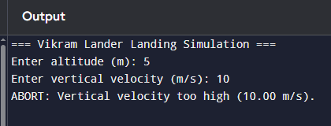

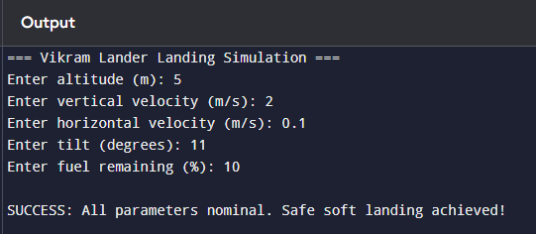

1. **Implementation**

I have upload the code and document on github page for open sourcing

<https://github.com/Citradev/Vikram_lander/tree/main>