Assignment No. 1
Name: Shubham Thongire
PRN:124B1F028
Class: TY IT A
Batch: A2
Warehouse Robot Path Planning

Results :

1. Experiment Summary
The experiment evaluates Uniform Cost Search (UCS), Greedy Best-First Search, and A* Search for navigation from the warehouse dock to ten pickup locations. Shelf cells are treated as obstacles, movement is restricted to four directions, and Manhattan distance is used as the heuristic for A*.
2. Dataset Summary

Item | Value
Grid size | 30 x 50
Total cells | 1500
Free cells | 1009
Shelf / obstacle cells | 480
Dock | 1
Pickup locations | 10 (P1-P10)

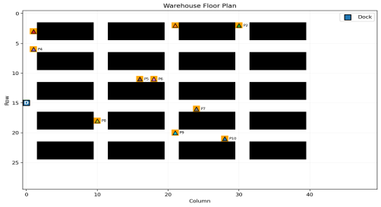Figure 1. Warehouse floor plan.

3. Detailed Results
Values below are taken from the executed search_results.csv.
Pickup | UCS path | Greedy path | A* path | UCS nodes | Greedy nodes | A* nodes
P1 | 34 | 36 | 34 | 481 | 37 | 47
P2 | 43 | 45 | 43 | 640 | 46 | 62
P3 | 13 | 13 | 13 | 103 | 14 | 14
P4 | 10 | 10 | 10 | 65 | 11 | 11
P5 | 20 | 20 | 20 | 230 | 21 | 21
P6 | 22 | 22 | 22 | 265 | 23 | 23
P7 | 25 | 25 | 25 | 325 | 26 | 50
P8 | 13 | 13 | 13 | 113 | 14 | 28
P9 | 26 | 26 | 26 | 343 | 27 | 84
P10 | 34 | 38 | 34 | 492 | 42 | 134

4. Average Performance
Algorithm | Avg Path Length | Avg Nodes Expanded | Avg Time (ms)
UCS | 24.0 | 305.7 | 0.58
Greedy | 24.8 | 26.1 | 0.05
A* | 24.0 | 47.4 | 0.10

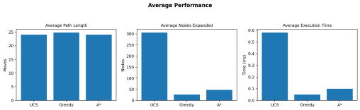Figure 2. Average performance.

5. Route Diagram - P1
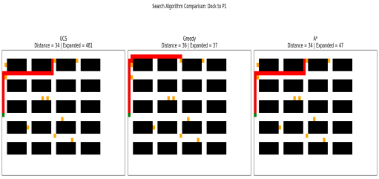Figure 3. UCS, Greedy Best-First, and A* comparison for P1.

6. A* Route - P1
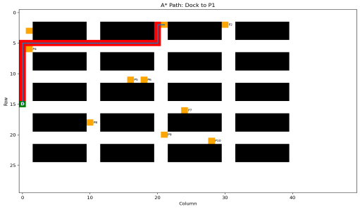Figure 4. A* route from the dock to P1.

7. Path Length Comparison
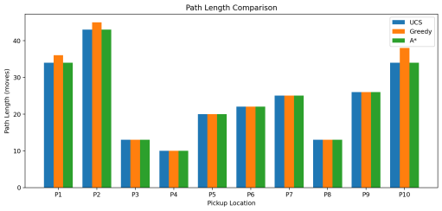Figure 5. Path length for P1-P10.

8. Nodes Expanded Comparison
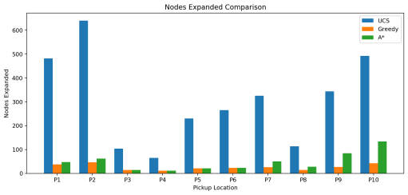Figure 6. Nodes expanded for P1-P10.
9. A* Routes for All Pickup Locations
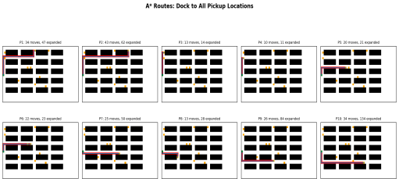Figure 7. A* route generated for each pickup location.
10. Result Analysis
UCS and A* produced the same average path length of 24.0 moves. A* matched the UCS path length on all ten pickup locations, while expanding 47.4 nodes on average compared with 305.7 for UCS. Greedy Best-First expanded 26.1 nodes on average and had an average path length of 24.8 moves.
These results show the main benefit of informed search. UCS searches without heuristic guidance and therefore expands substantially more nodes. Greedy Best-First is strongly goal-directed because it uses only h(n), but it is not guaranteed to find an optimal path. A* combines g(n) and h(n), giving both cost information and goal direction. The measured runtime is machine-dependent, so small timing differences should not be treated as universal algorithmic guarantees.

11. Conclusion
The warehouse robot path-planning problem was successfully solved using UCS, Greedy Best-First Search, and A* Search. Manhattan distance was used as the heuristic for A*. A* achieved the same path lengths as UCS for all ten pickup tasks while expanding substantially fewer nodes. This demonstrates how an admissible heuristic can make search more focused and practical for obstacle-rich robot navigation.
GitHub Link:

