Assignment No. 5
Name: Shubham Thongire
PRN: 124B1F028
Class: TY IT A Batch: A2
Course: Artificial Intelligence and Machine Learning Laboratory

Topic

Build a linear regression model for a real-life scenario such as Housing Price Prediction.

Result Screenshot

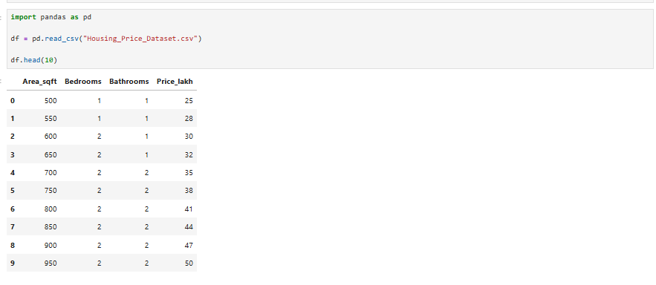
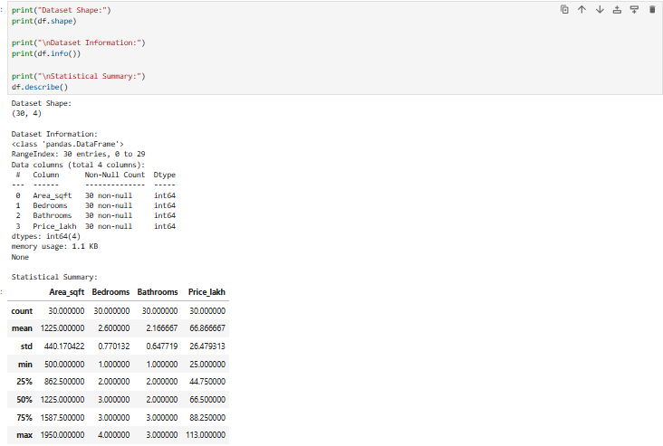
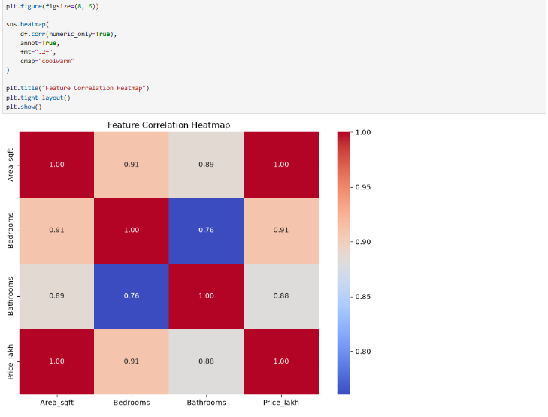

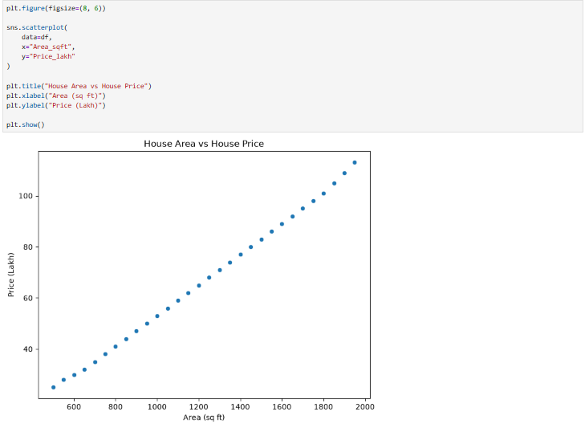

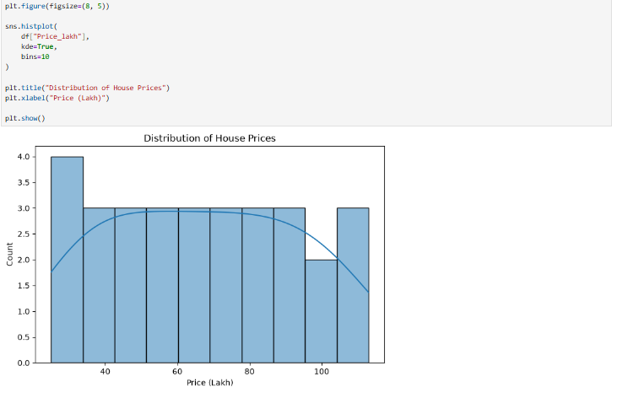
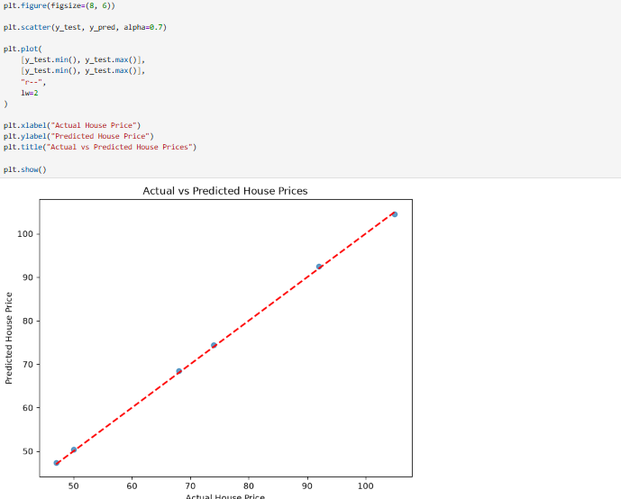

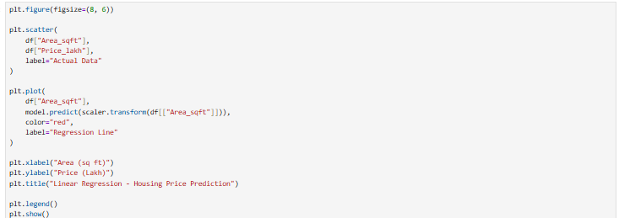

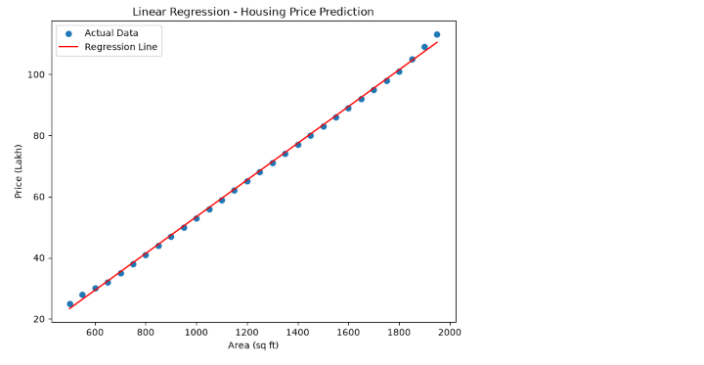

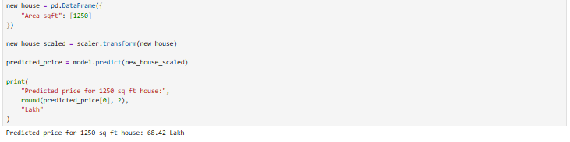

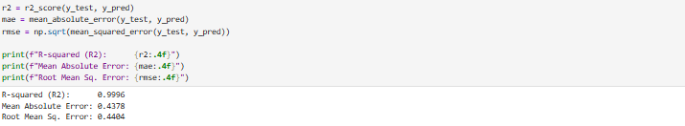

AI Usage Declaration
ChatGpt and Claude AI tools were used to help understand some of the concepts covered in this assignment, clarify a few doubts, and organize and improve the write-up. The dataset analysis, data cleaning, encoding, model training, evaluation and the results reported above were carried out as part of my own practical work in the notebook.

