DevOps Project 1

Github, Jenkins, Ansible

Developer will upload his code in Github

Github will be integrated with Jenkins-server

Jenkins will compile and build the code and give it to ansible server

Then Jenkins will trigger ansible playbook in ansible server via ssh command

Playbook will upload that code on webserver via ssh command too

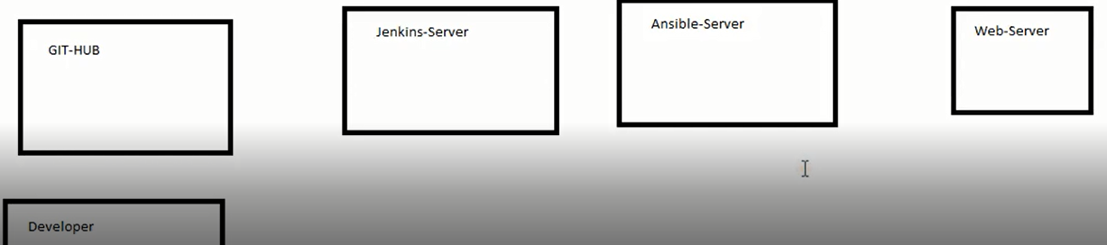

1) launch 4 ec2--> developer system, jenkins-server, ansible-server, web-server

2) connect to jenkins-server--> install java, Jenkins, git

# yum install java* -y

# wget -O /etc/yum.repos.d/jenkins.repo https://pkg.jenkins.io/redhat-stable/jenkins.repo

# rpm --import <https://pkg.jenkins.io/redhat-stable/jenkins.io.key>

# yum install Jenkins -y

# systemctl start jenkins

# systemctl enable jenkins

# yum install git -y

3) connect to ansible server--> install ansible

# amazon-linux-extras install ansible2

vim /etc/ansible/hosts

add -->

[web]

private_ip_of_webserver

4) connect to web-server -->

$ sudo -su

# cd

# yum install httpd -y

# systemctl start httpd

# systemctl enable httpd

# cd /var/www/html/

5) create pw-less authentication between ansible-server and httpd-server

Get connected with httpd-server

passwd root

vim /etc/ssh/sshd_config

PermitRootLogin yes

passwordAuthentication yes

:wq

systemctl restart sshd

Get connected with ansible-server

# ssh-keygen

# ssh-copy-id -i root@private_ip_of_httpd-server

Finally make sure whether passwordless authentication is successful or not

# ssh root@ private_ip_of_httpd-server

6) create pw-less authentication between jenkins-server and ansible-server

Get connected with ansible-server

passwd root

vim /etc/ssh/sshd_config

PermitRootLogin yes

passwordAuthentication yes

:wq

systemctl restart sshd

Get connected with jenkins-server

# ssh-keygen

# ssh-copy-id -i root@private_ip_of_ansible-server

Finally make sure whether passwordless authentication is successful or not

# ssh root@ private_ip_of_ansible-server

7) go to ansible-server to create playbook

mkdir /sourcecode

cd /sourcecode

vim playbook.yml

- hosts: all

tasks:

- copy:

src: /opt/index.html

dest: /var/www/html

7) go to github --> create one repo ‘demo-project’

create one file with following data

Welcome to India

commit

8) integrate github with jenkins

go to jenkins

copy jenkins url

go to gihub page

settings --> webhooks--> add webhook

Payload url -->http://jenkins_ip:8080/github-webhook/

content type--> application/json

go to Jenkins page

cloud--> configure --> add new token--> generate --> copy token keep it somewhere--> apply and save

go to github page

secret--> paste token

add webhook

1. install 'publish over ssh' plugin in Jenkins
2. Get connected with jenkins-server

passwd root

vim /etc/ssh/sshd_config

PermitRootLogin yes

passwordAuthentication yes

:wq

systemctl restart sshd

1. manage jenkins--> configure system --> scroll down--> SSH servers--> Add
2. fill details of jenkins server, give root id and pw,

name: Jenkins

Hostname: private-ip-of-jenkins-server

1. --> Test Configuration--> make sure whether successful or not
2. do same for Ansible server

13) create new job--> freestyle --> give name ‘demo-project’

source code management --> git

give url

change ‘master’ to ‘main’

build now

check console o/p

new folder workspace/demo-project gets created inside /var/lib/jenkins/

Build Trigger

Github hook trigger got GITScm polling

Build

Add build step

Send file or execute commands over ssh

Name: jenkins

Exec command: rsync -avh /var/lib/jenkins/workspace/demo-project/*.html root@private-ip-of-ansible-server:/opt/index.html

apply and save

build now

Check index.html file is copied from jenkins server to ansible server at /opt

configure

postbuild actions:

send build artifacts over ssh

name: Ansible

exec command: rsync /opt/index.html [root@172.31.45.39:/var/www/html](mailto:root@172.31.45.39:/var/www/html)

OR : ansible-playbook /home/ec2-user/playbook/playbook1.yml -b

apply and save

Build now

check on webserver --> /var/www/html/index.html

open its ip in browser

go to deveoper system

install git

clone repo from github

edit sourcecode i.e index.html file

commit and push

git push origin master