/*
ASSIGNMENT NO.: A(2) BATCH : T3 ROLL NO.:

TITLE: DBMS using connections(Client-application server-Data sever, three tier) Oracle/MySQL(ODBC/JDBC), SQL Joints, prompt.*/

//HTML PROGRAM

<!DOCTYPE html>
<html>
<head>
<meta charset="UTF-8">
<title>Insert title here</title>
</head>
<body>
<form action="js.jsp" method="post">
<h2 align="center"><font><strong>Mysql Database using Joins</strong></font></h2>

<p align ="center">
<input type="submit" name="button1" value="Inner join"/>
</p>

<p align ="center">
<input type="submit" name="button2" value="Left Outer join"/>
</p>

<p align ="center">
<input type="submit" name="button3" value="Right Outer join"/>
</p>

</form>
</body>
</html>

//JSP PROGRAM

<%@page import="java.sql.*"%>
<%@page import = "java.io.*" %>
<%@page import = "java.text.*" %>

<h2 align="center"><font><strong>Retrieve data from database in jsp</strong></font></h2>
<table align="center" cellpadding="5" cellspacing="5" border="1">

<tr >
<td><b>loan_no</b></td>
<td><b>branch_name</b></td>
<td><b>amount</b></td>
<td><b>loan_no</b></td>
<td><b>customer_name</b></td>

</tr>
<%
try
{
String driverName = "com.mysql.jdbc.Driver";

Class.forName(driverName);

Connection connection = null;
Statement statement = null;
ResultSet resultSet = null;

connection = DriverManager.getConnection("jdbc:mysql://localhost:3306/student", "root", "root");
statement=connection.createStatement();

if(request.getParameter("button1")!= null)
{
//String sql ="SELECT * FROM loan Left Outer JOIN borrower ON loan.loan_no=borrower.loan_no";
//String sql ="SELECT * FROM loan Inner JOIN borrower ON loan.loan_no=borrower.loan_no";
//String sql ="SELECT * FROM loan Right Outer JOIN borrower ON loan.loan_no=borrower.loan_no";
String sql ="SELECT * FROM loan Inner JOIN borrower ON loan.loan_no=borrower.loan_no";

resultSet = statement.executeQuery(sql);
while(resultSet.next())
{
%>
<tr >

<td><%=resultSet.getString("loan_no") %></td>
<td><%=resultSet.getString("branch_name") %></td>
<td><%=resultSet.getString("amount") %></td>
<td><%=resultSet.getString("loan_no") %></td>
<td><%=resultSet.getString("customer_name") %></td>

</tr>

<%
}
}
else if(request.getParameter("button2")!= null)
{
String sql ="SELECT * FROM loan Left Outer JOIN borrower ON loan.loan_no=borrower.loan_no";

resultSet = statement.executeQuery(sql);
while(resultSet.next())
{
%>
<tr >

<td><%=resultSet.getString("loan_no") %></td>
<td><%=resultSet.getString("branch_name") %></td>
<td><%=resultSet.getString("amount") %></td>
<td><%=resultSet.getString("loan_no") %></td>
<td><%=resultSet.getString("customer_name") %></td>

</tr>
<%
}
}
else if(request.getParameter("button3")!= null)
{
String sql ="SELECT * FROM loan Right Outer JOIN borrower ON loan.loan_no=borrower.loan_no";

resultSet = statement.executeQuery(sql);
while(resultSet.next())
{
%>
<tr >

<td><%=resultSet.getString("loan_no") %></td>
<td><%=resultSet.getString("branch_name") %></td>
<td><%=resultSet.getString("amount") %></td>
<td><%=resultSet.getString("loan_no") %></td>
<td><%=resultSet.getString("customer_name") %></td>

</tr>
<%
}
}
}
catch (Exception e) {
e.printStackTrace();
}
%>
</table>

//INPUT:

mysql> use student;
Reading table information for completion of table and column names
You can turn off this feature to get a quicker startup with -A

Database changed
mysql> select * from loan;
+---------+-------------+--------+
| loan_no | branch_name | amount |
+---------+-------------+--------+
| 101 | nasik | 1000 |
| 102 | pune | 2000 |
| 103 | mumbai | 1500 |
+---------+-------------+--------+
3 rows in set (0.00 sec)

mysql> select * from borrower;
+---------+---------------+
| loan_no | customer_name |
+---------+---------------+
| 101 | priya |
| 102 | priti |
| 104 | raj |
+---------+---------------+
3 rows in set (0.00 sec)

mysql>

//OUTPUT:

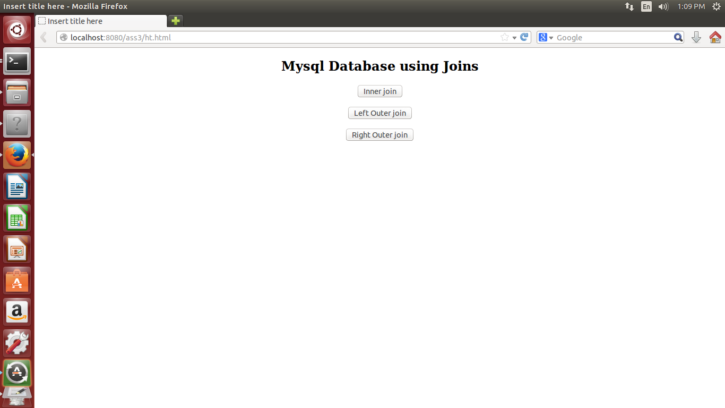

OUTPUT OF INNER JOIN:

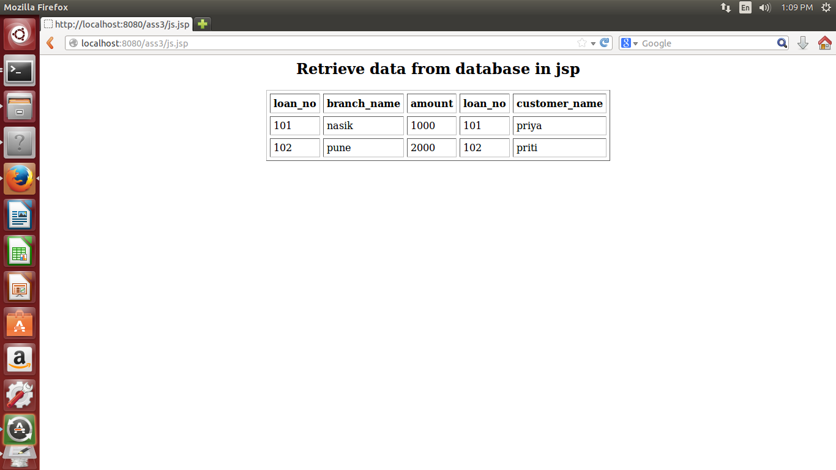

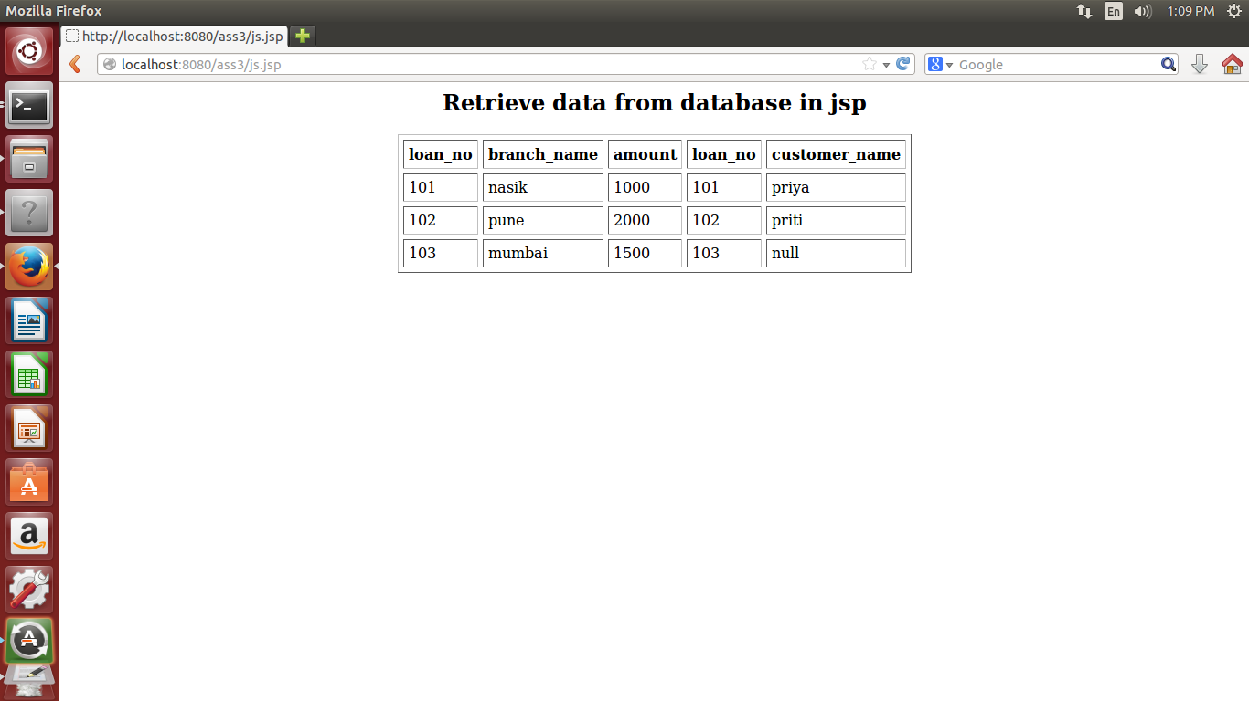
OUTPUT OF LEFT OUTER JOIN:

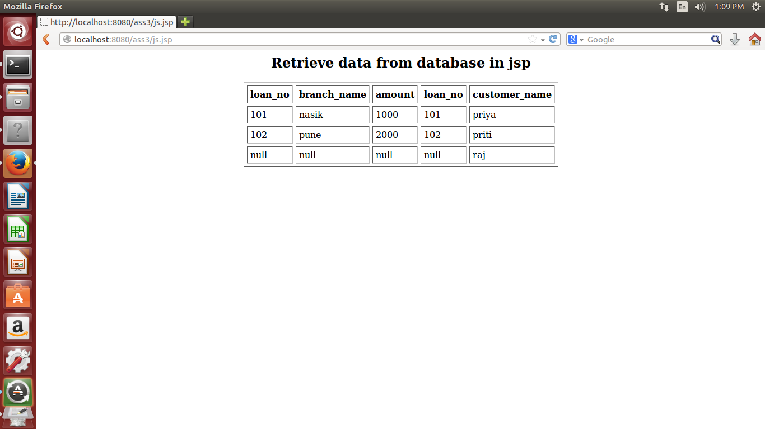
OUTPUT OF RIGHT OUTER JOIN:

