Docker –version

Docker-compose –version

Run docker service manually from service.msc

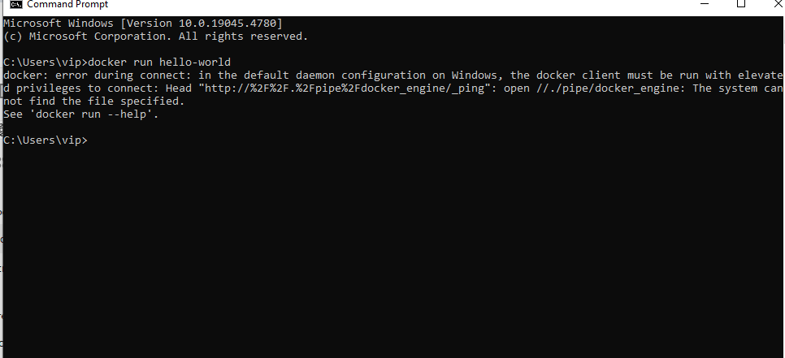

• Go to **Control Panel > Programs > Programs and Features > Turn Windows features on or off**.

• Check that **Hyper-V** and **Containers** are enabled.

