Jenkins Pipeline Assignment no. 16
In this assignment I have created a job to build LoginWebApp on JM and hosts in on other EC2 which is not a slave.
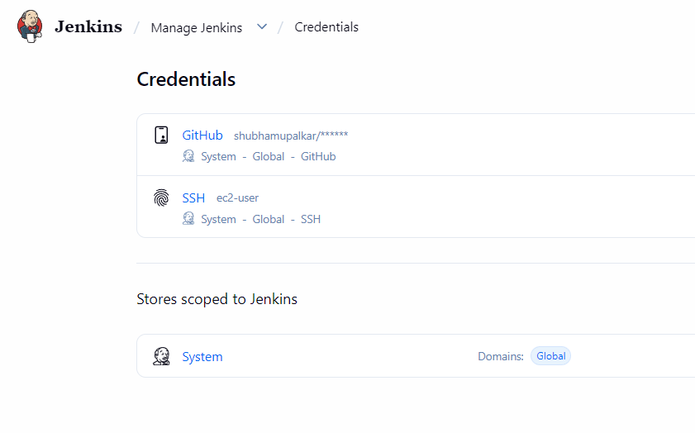

At first, I added my creds of github and ssh into the Jenkins.

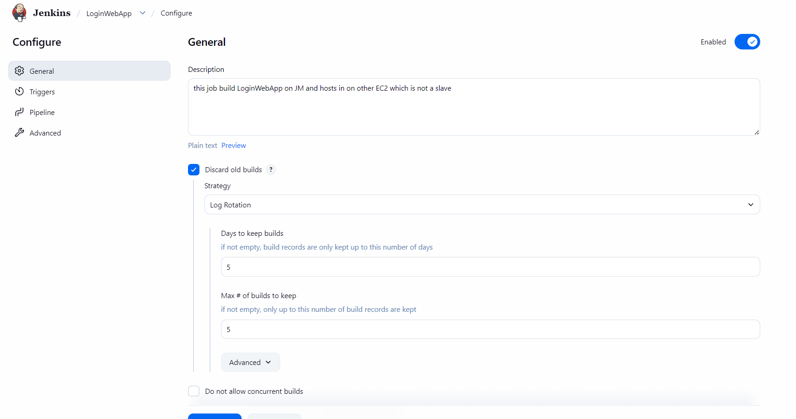
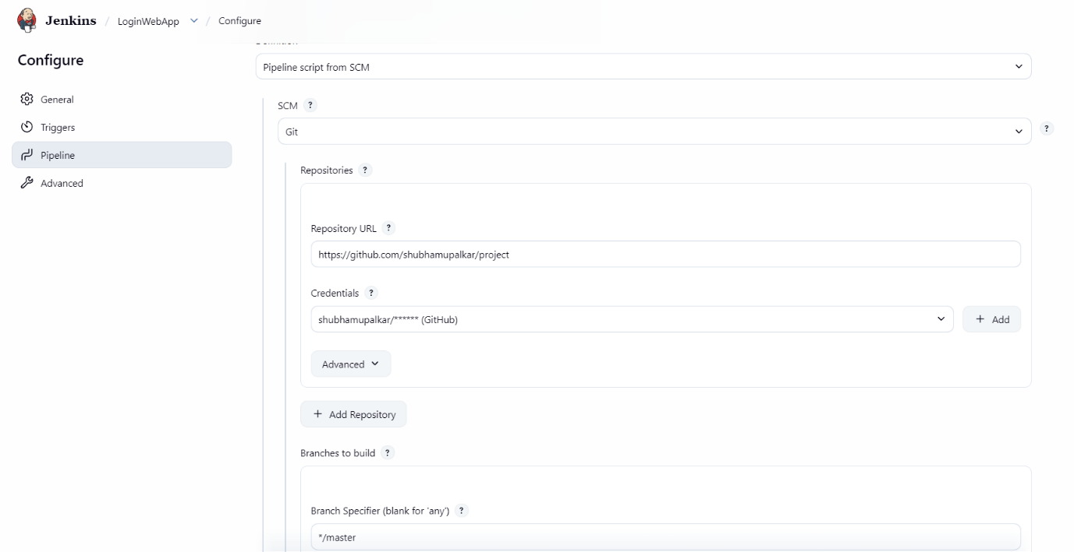

Then I configured the job as above to pull the Jenkins file from the private github repo

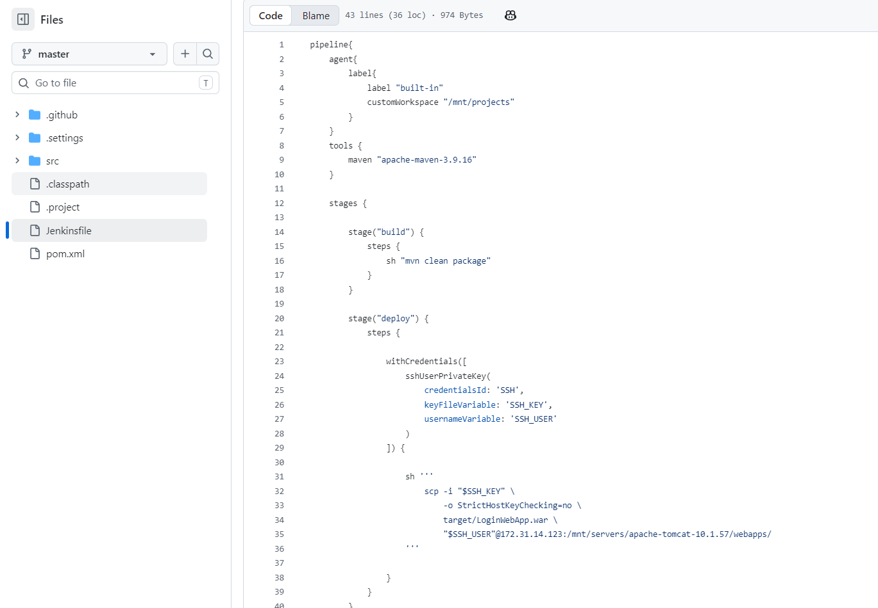
Then I wrote the above pipeline for this job
It works in two stages BUILD and DEPLOY
BUILD stage grabs the code from GitHub and builds it using maven and creates .war file in target folder.
And the DEPLOY stage copies the .war from JM to EC2 over ssh.

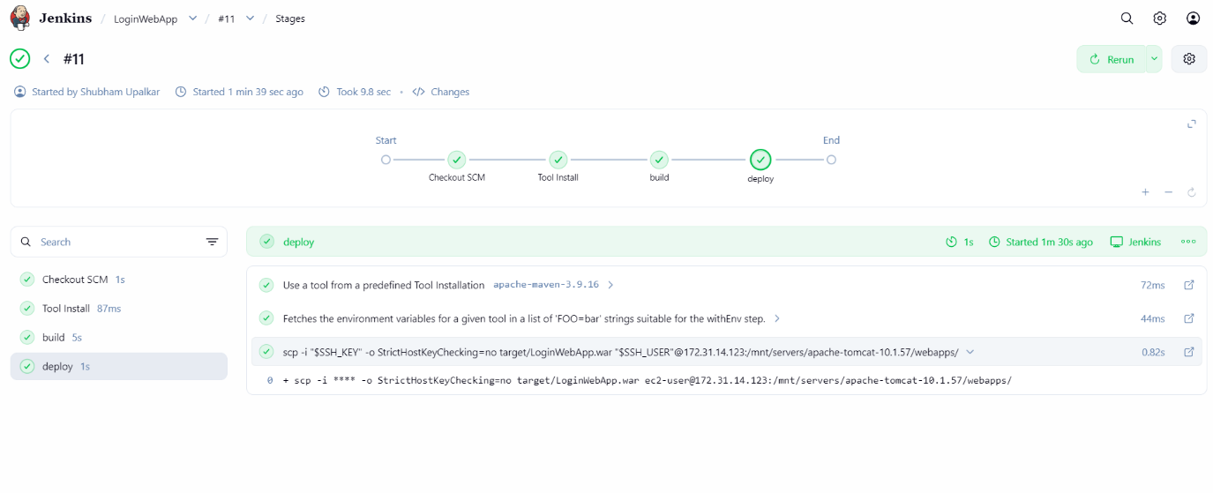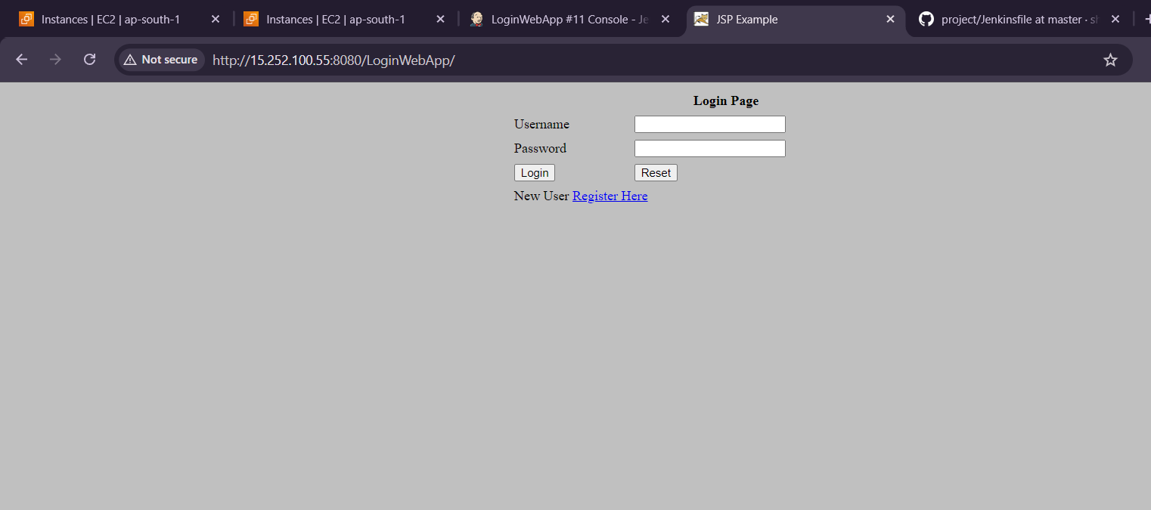

Above are the outputs of the assignment.

