Jenkins Pipeline Assignment No 15
In this assignment I have built the LoginWebApp application using maven and hosted the application on TomCat using Jenkins pipeline job.
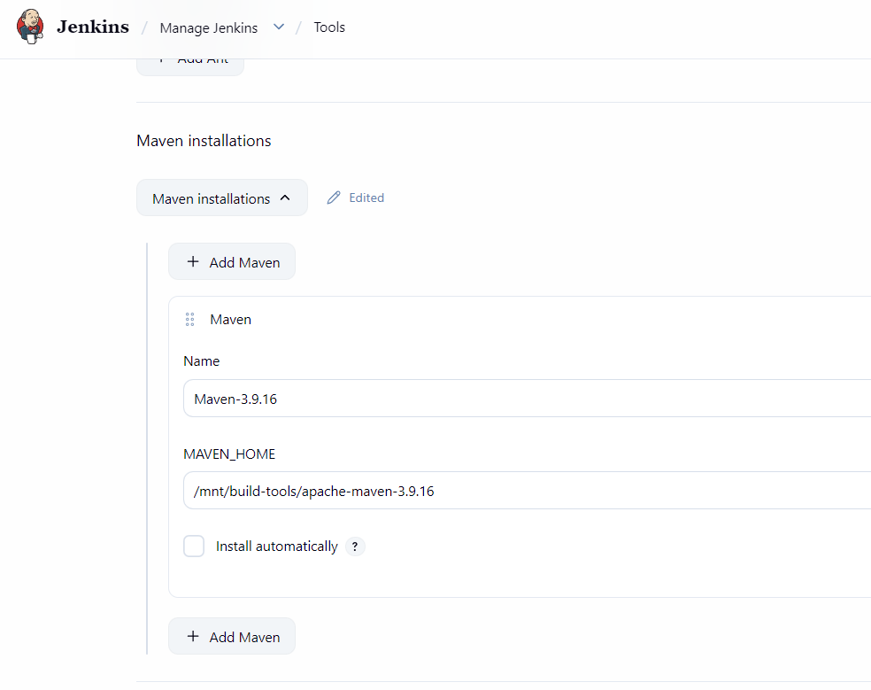
First, I have installed the maven on the JM through SSH
And then added the path of maven home into the Jenkins tools section
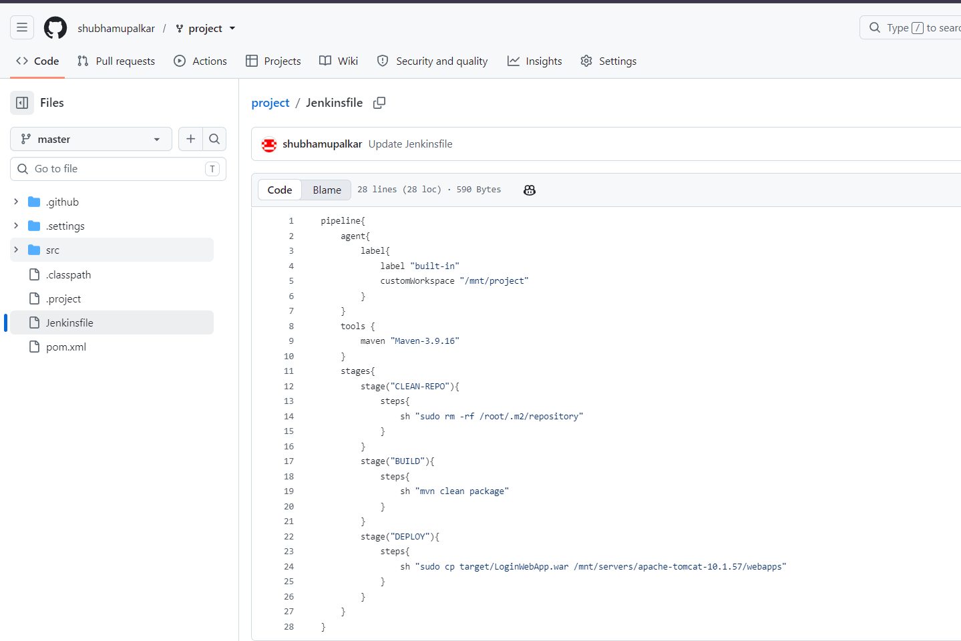
I then created this above pipeline for this assignment, it works in three stages
Stage 1 – Cleans the local maven repo
Stage 2 – Builds the application
Stage 3 – Hosts the application

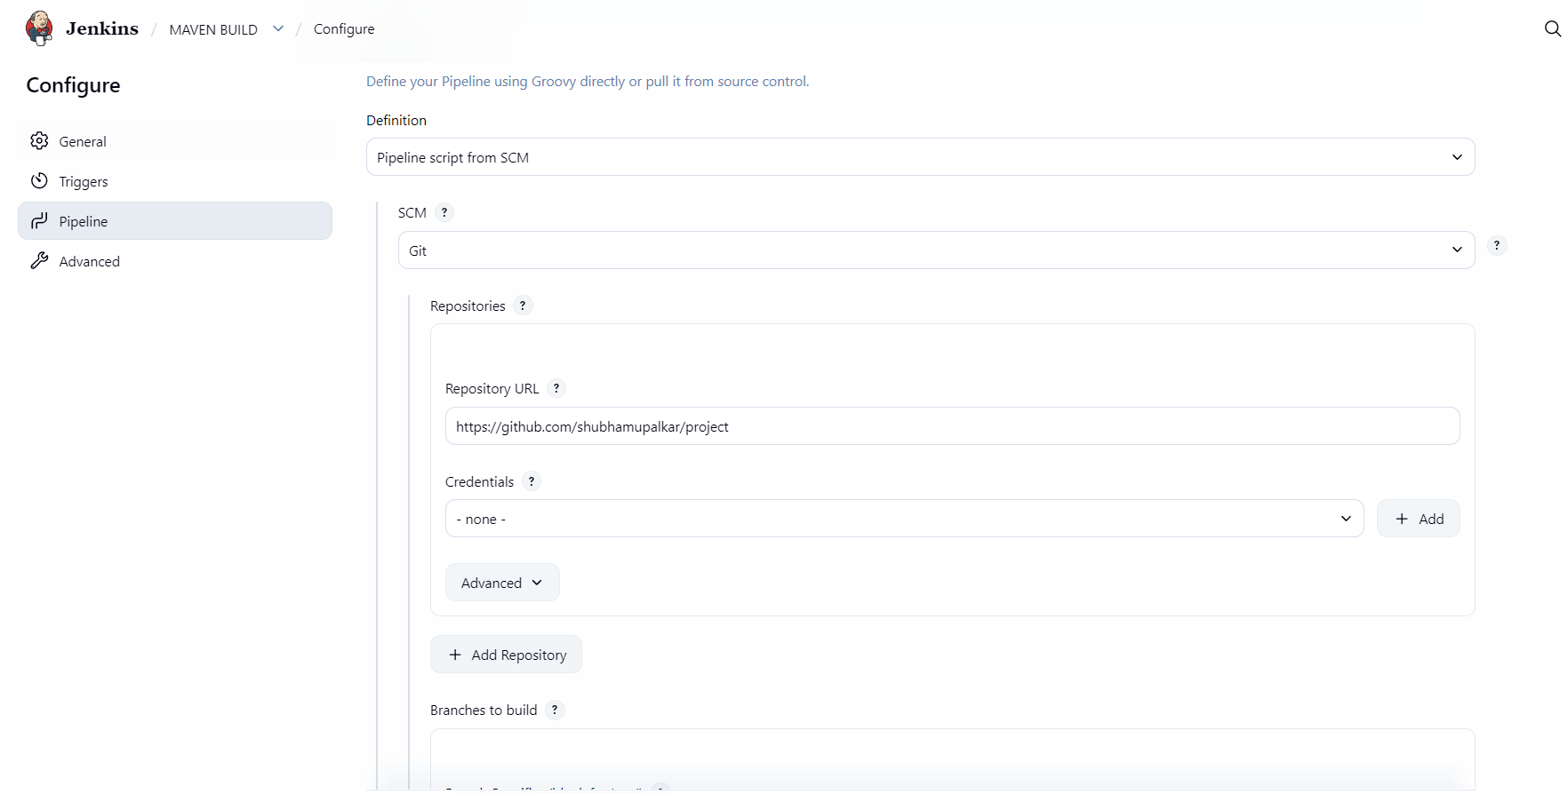
Then I used git to get my code and Jenkinsfile from the github

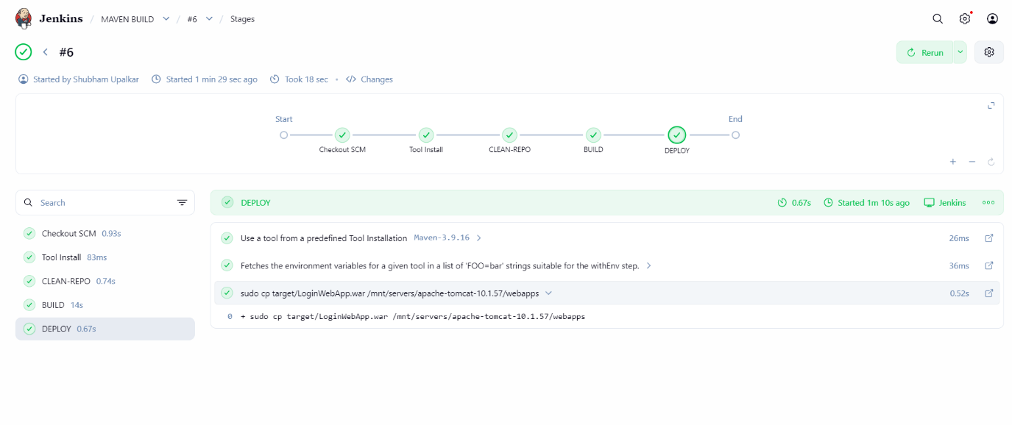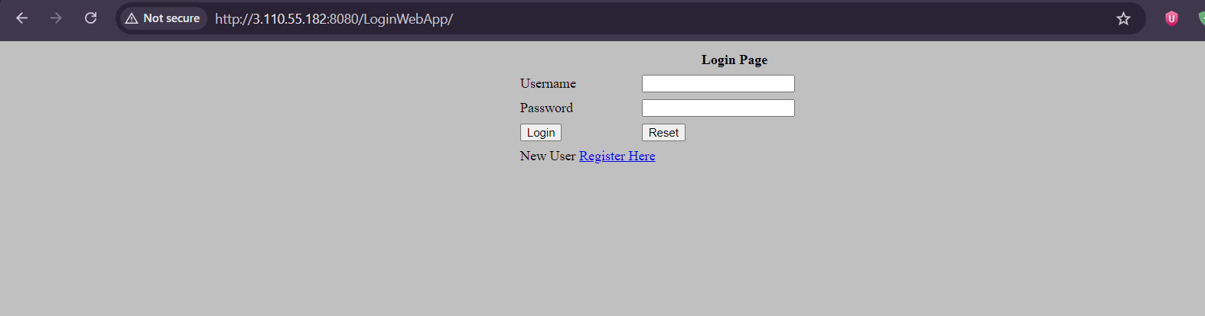

Above are the outputs of the assignments.

