Jenkins Pipeline Assignment No. 12
In this assignment we grab the index.html from the private github repo and deploys it on the httpd sever on JM
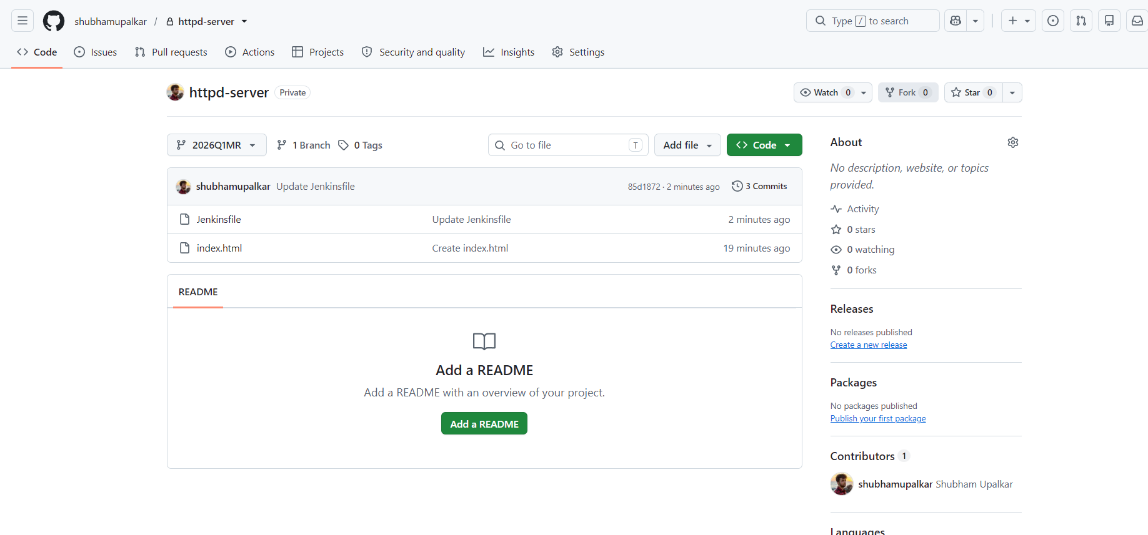
Above is the private repo that I have created for this project, with Jenkinsfile included

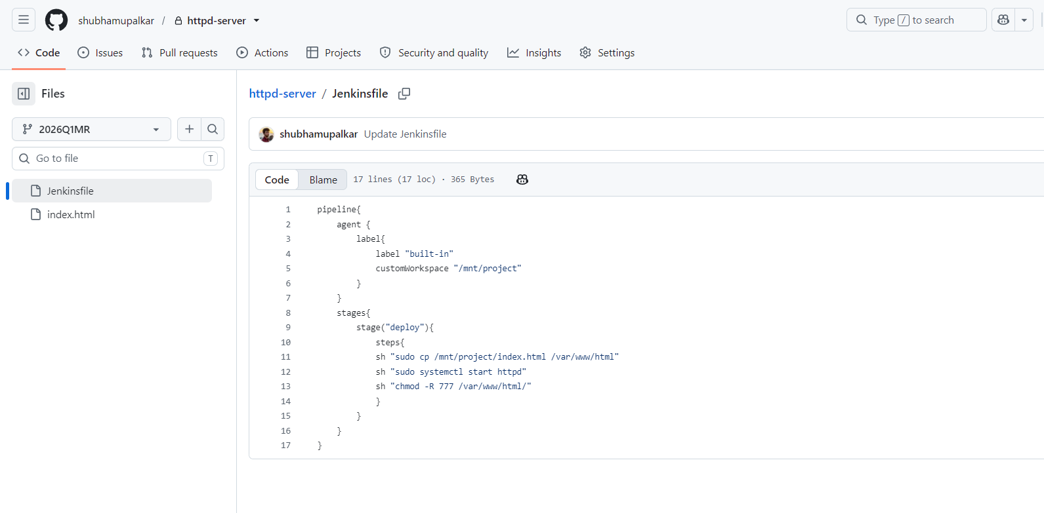

Above is the Jenkinsfile I have written for this job, it gets index.html from the 2026Q1MR branch of the private github repo and hosts in on the httpd
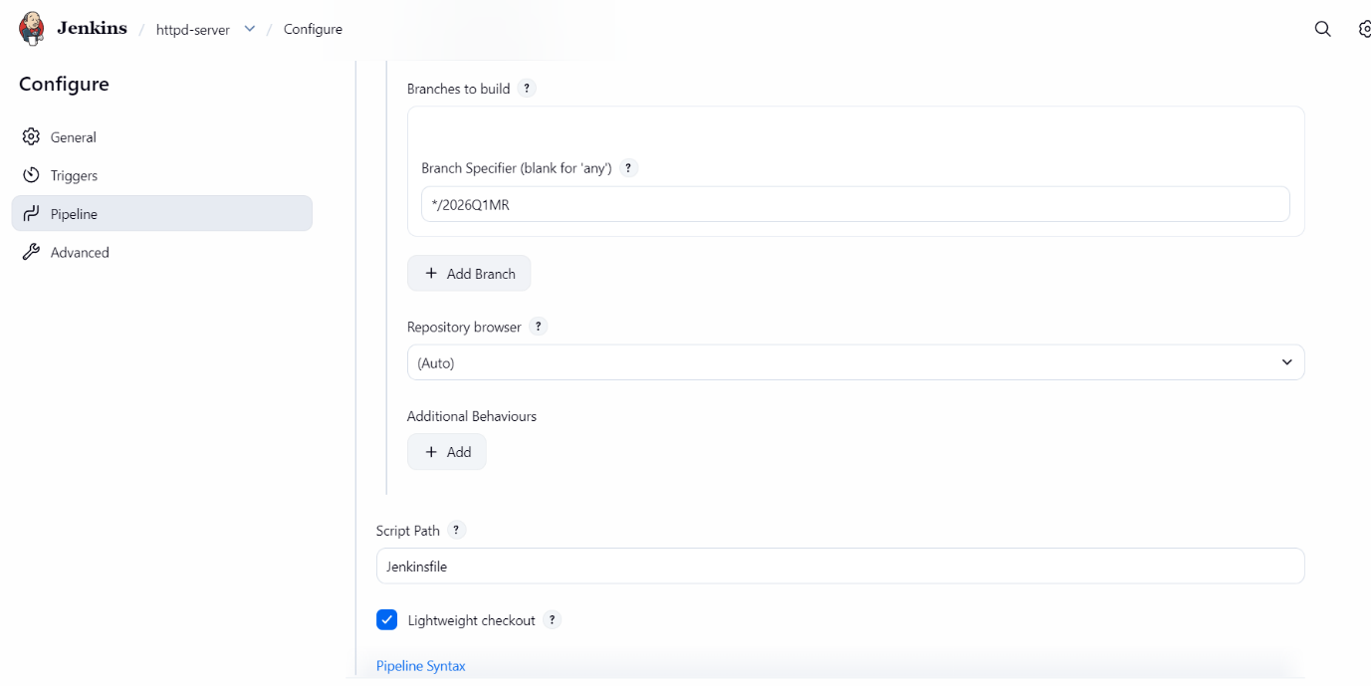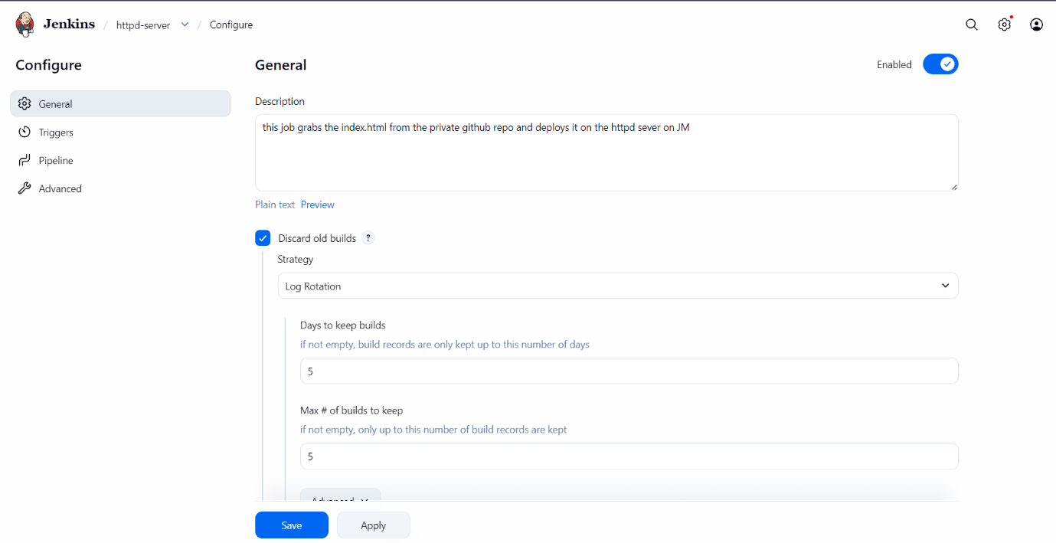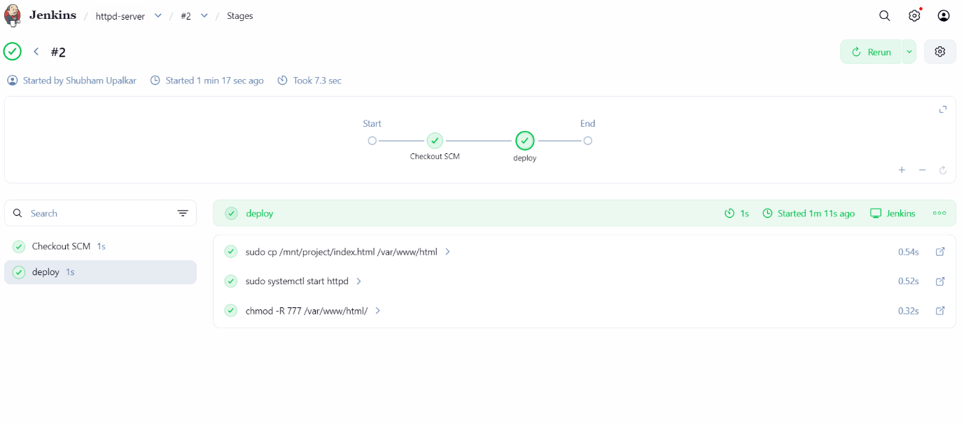

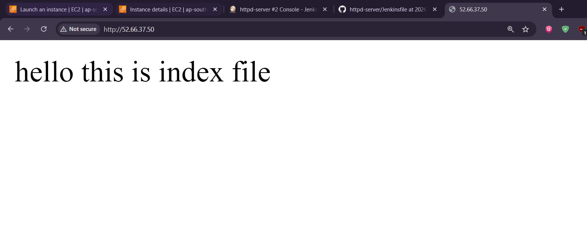
Above is the final output of the assignment

