Jenkins Assignment no. 14
In this assignment I have created a Jenkins pipeline to deploy index.html on httpd server, here we are pulling the index from different branches (Q1 Q2 Q3 Q4) of single github repo.

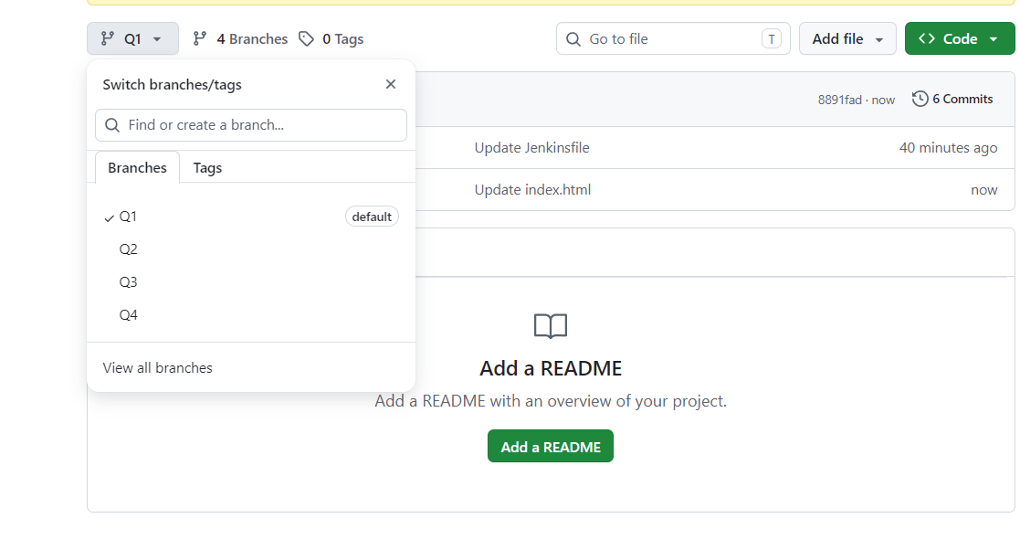

Above are the 4 branches which have index and Jenkins file in them.
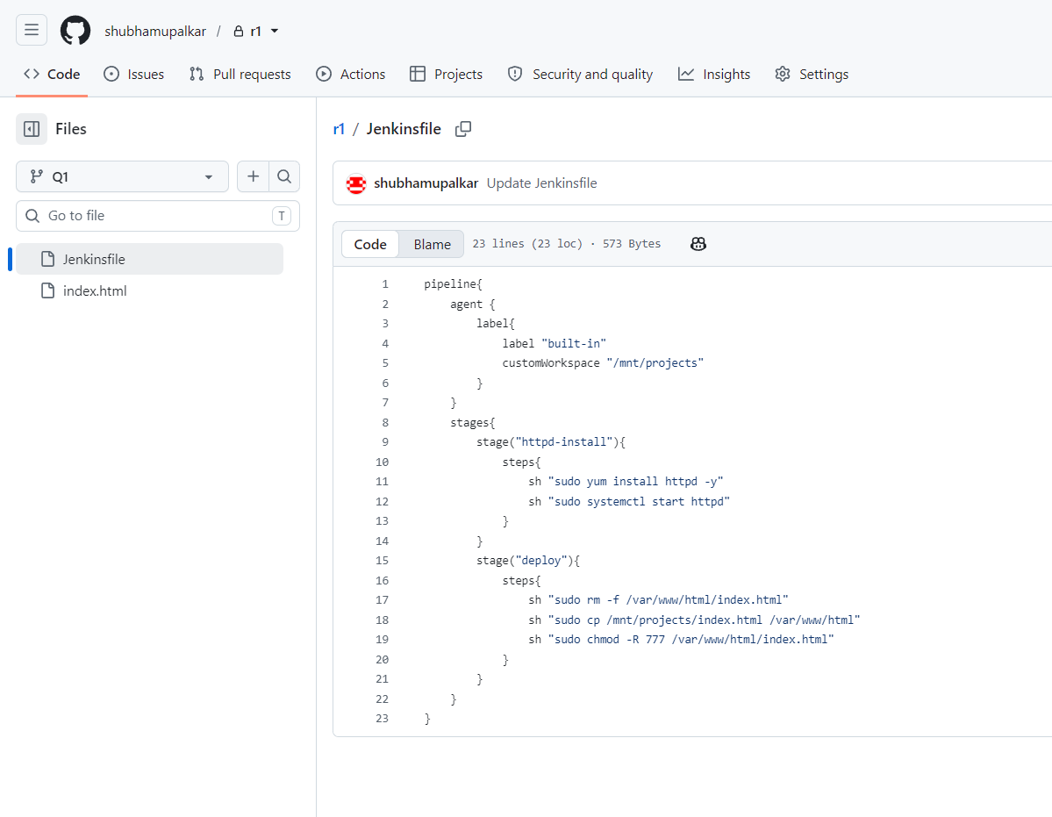

Above is the Jenkins script I have written for this job, it installs httpd and copies the index file at the deployment location.

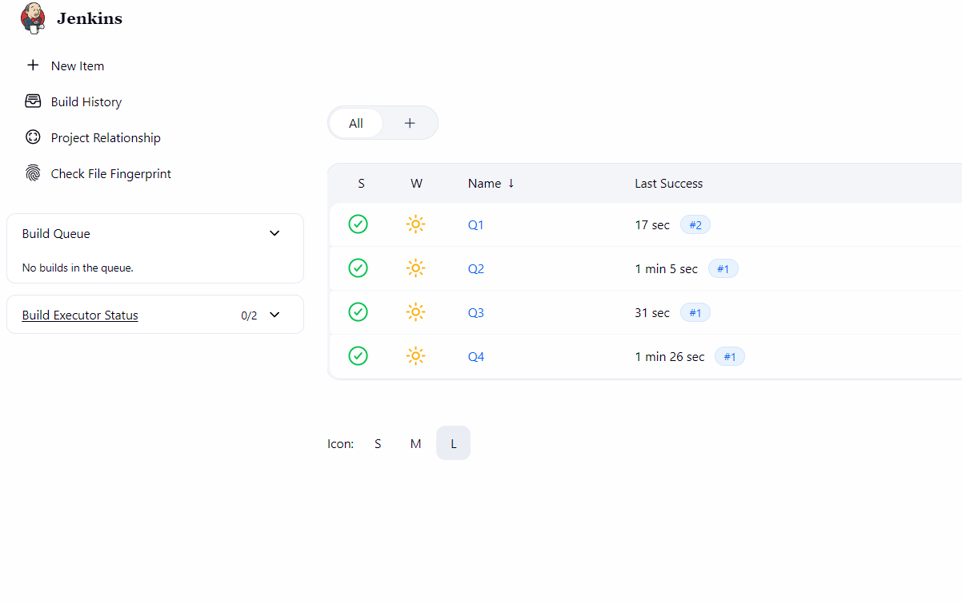
Above are the 4 jobs that I have created for each branch respectively.
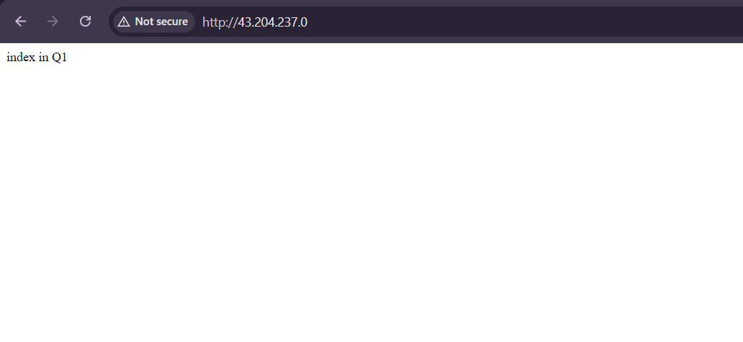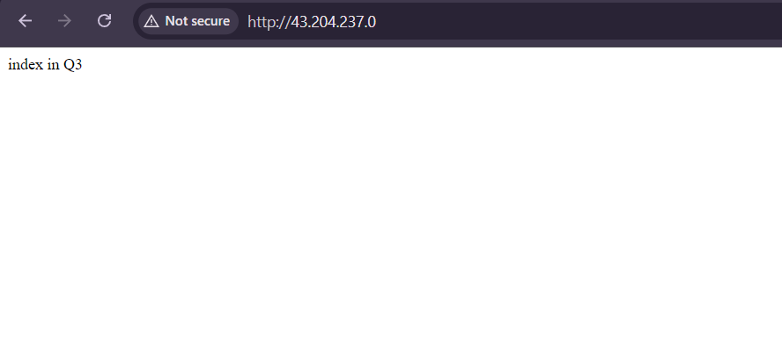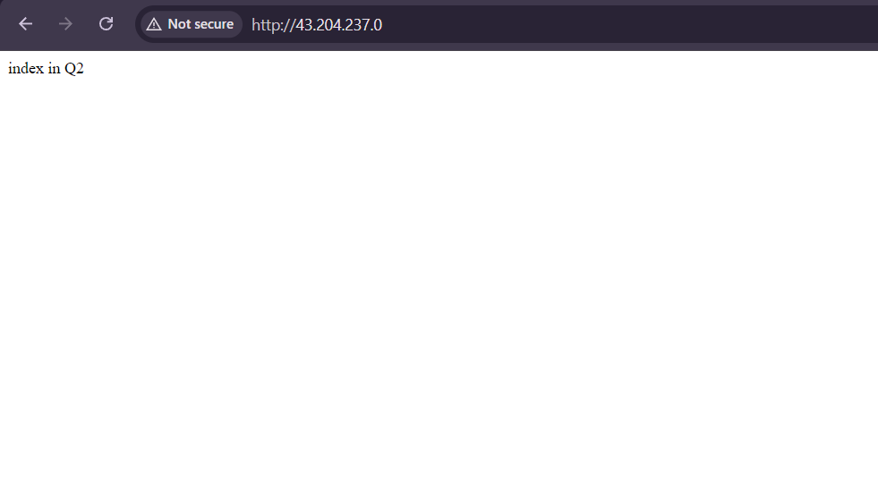
Above is the final output of the assignment

