Jenkins Pipeline Assignment 18
In this assignment I have created 3 jobs using Jenkins pipeline which grabs the index.html file from 3 different github repos and hosts them on the JM and 2 different slaves 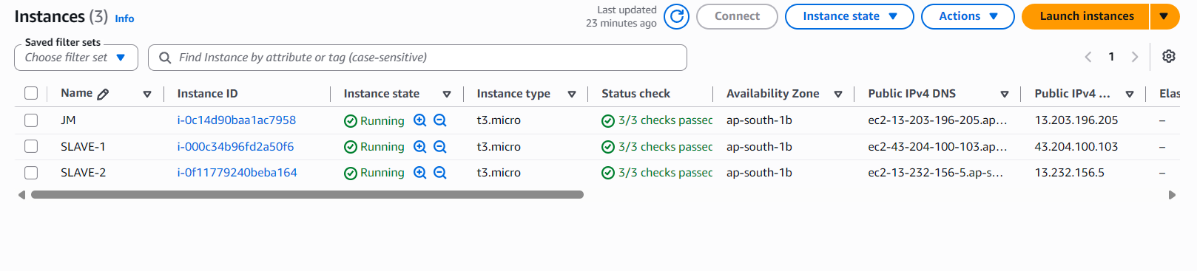

At first, I launched these instances from the AWS Console and installed Jenkins on JM and java and httpd on all of them.
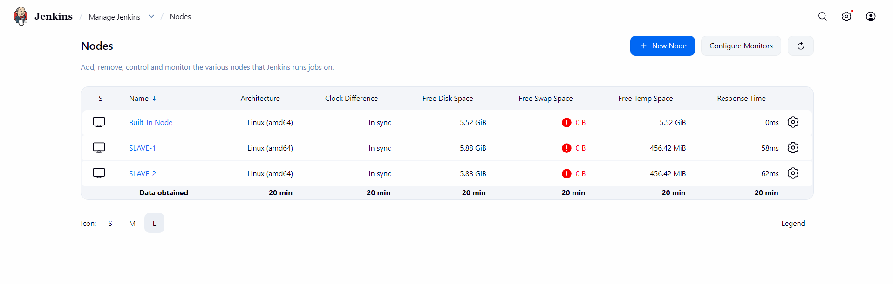

Then I configured the slaves in Jenkins dashboard
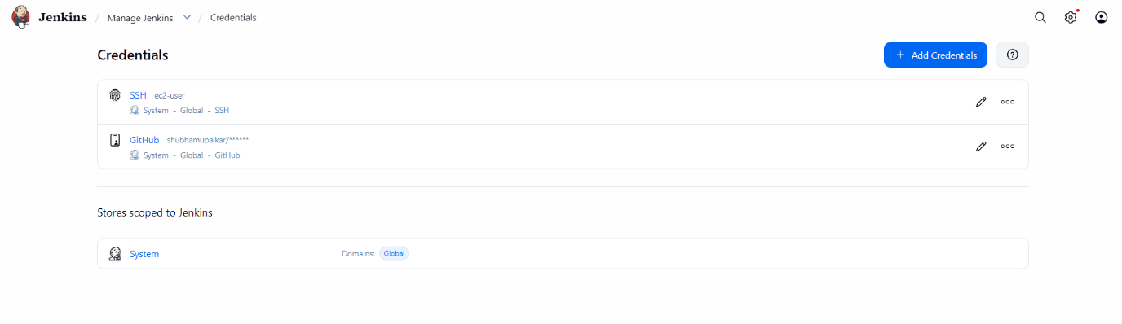
Then I added my GitHub and SSH key in the Jenkins
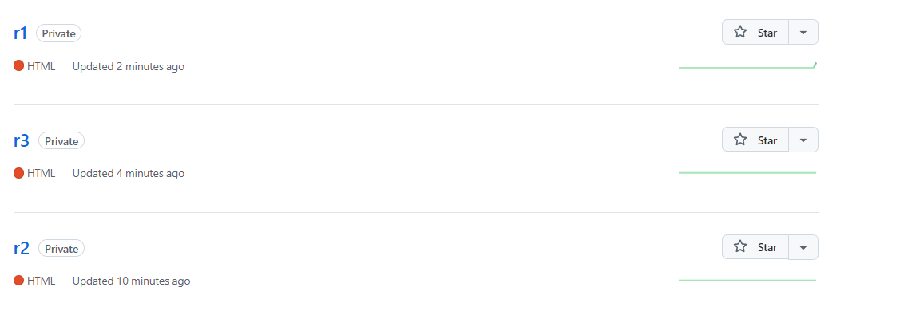
Then I created these 3 private repos where I stored the index and Jenkins file
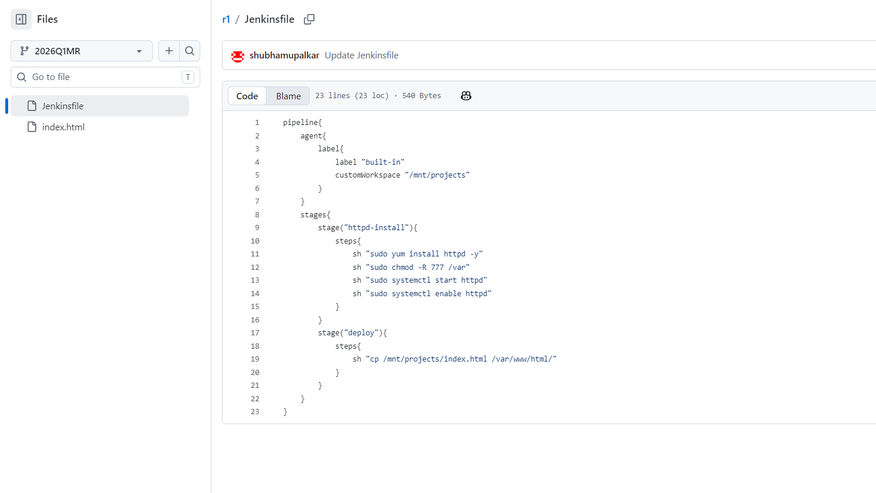
I wrote the above pipeline for each job which gets the index from the github and copies it into the deployment location, for each Jenkins file we change the “label” as per requirement.
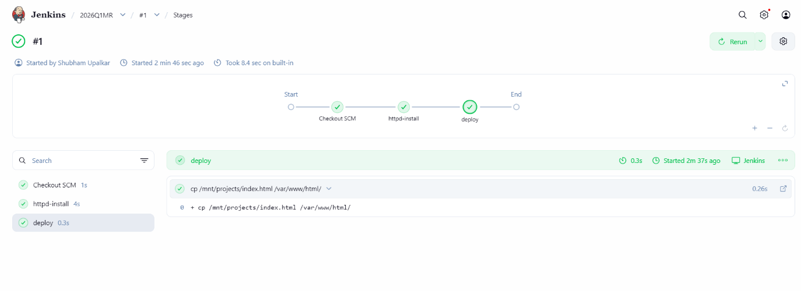
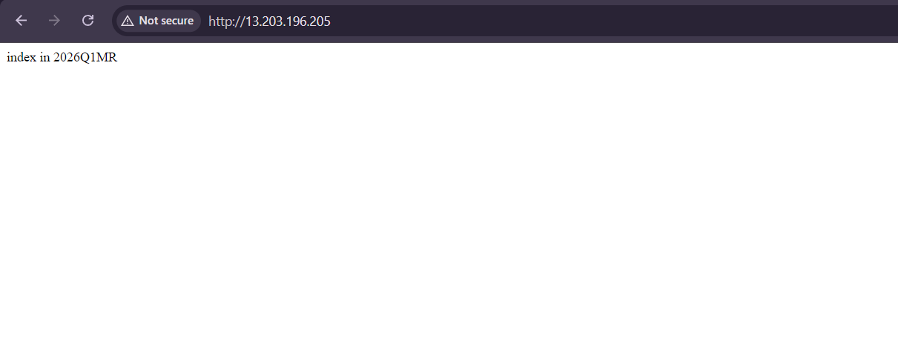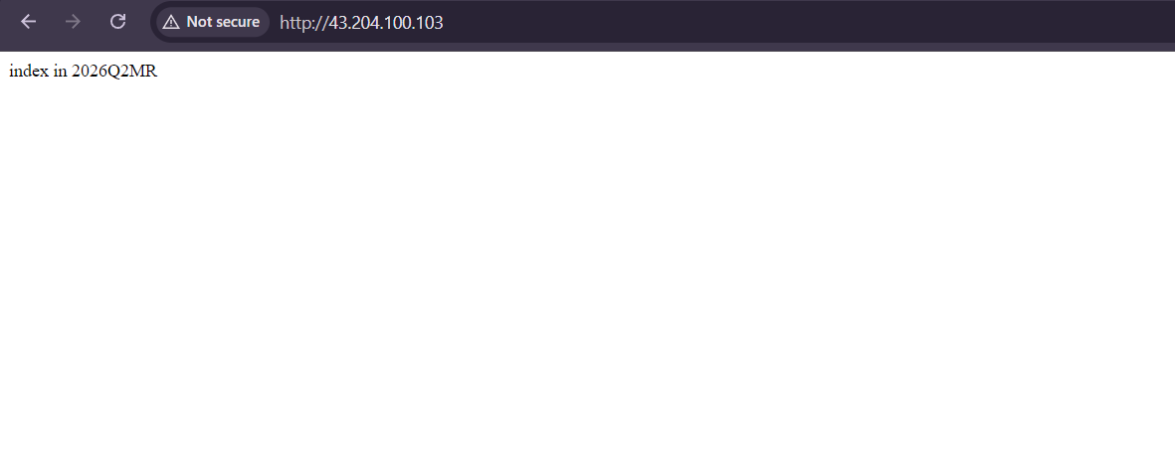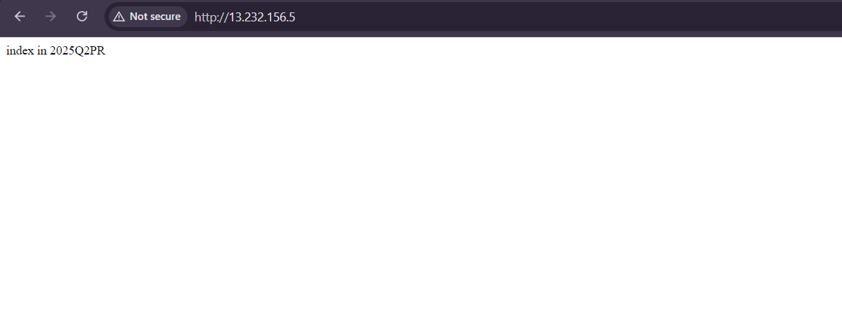
Above is the output of the assignment.

