Jenkins Assignment No. 17
In this assignment I hosted index.html on 3 different slaves by pulling the index and Jenkins file from a single github repo with multiple branches.
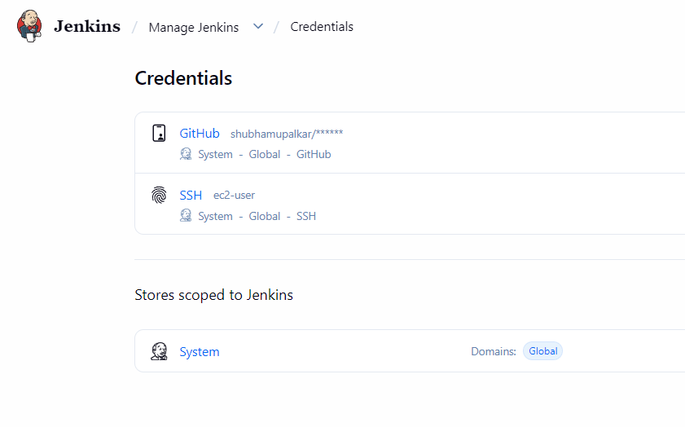

At first I added my github and ssh creds in Jenkins

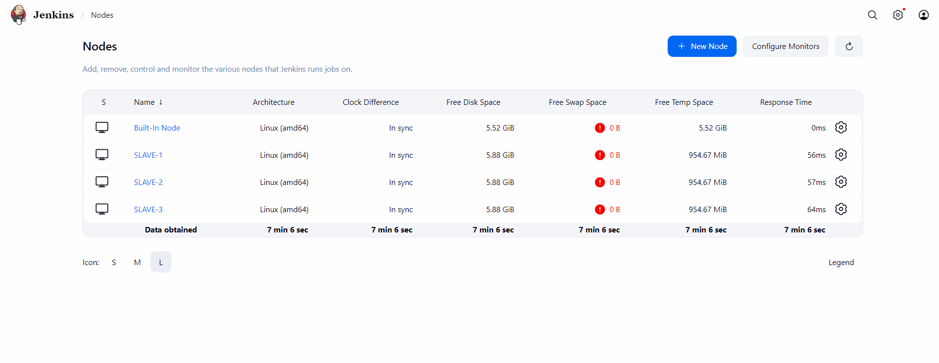
Then I configured all three slaves

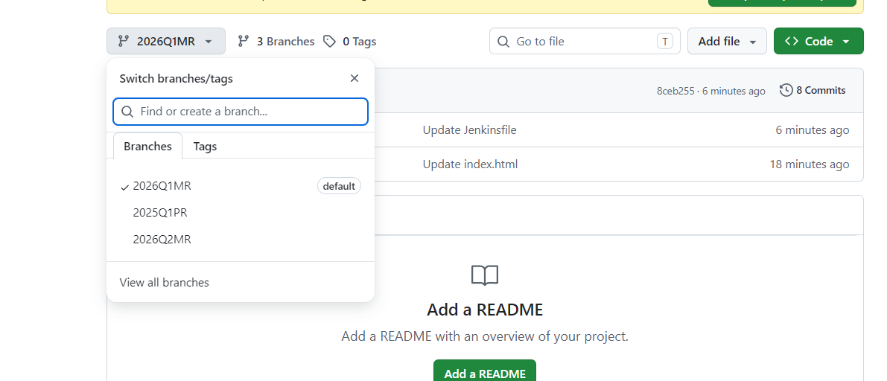

Then I created github repo with above three branches with individual index and Jenkins file.

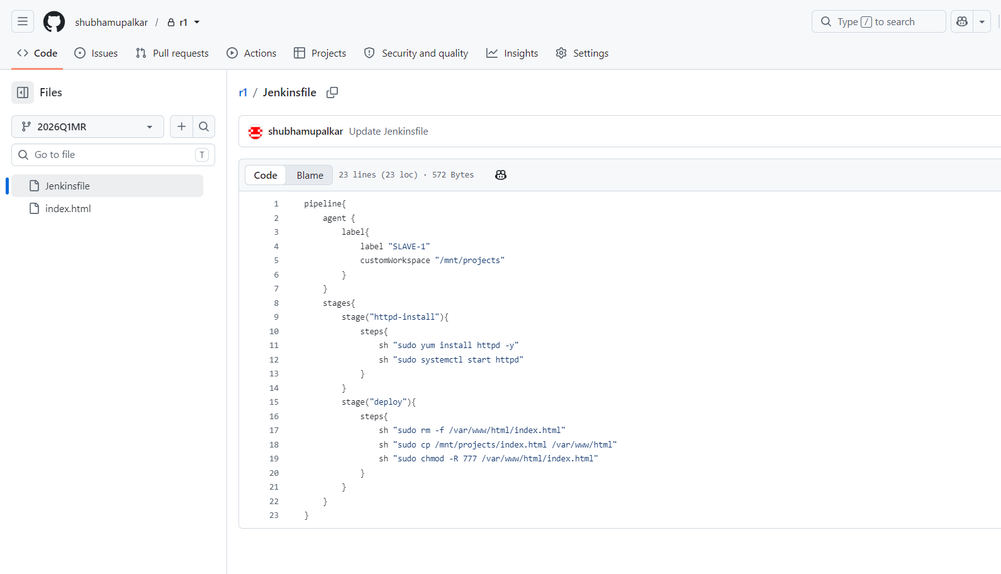
then I wrote the above pipeline for this job, it basically installs the httpd server and copies the index.html at deployment location.
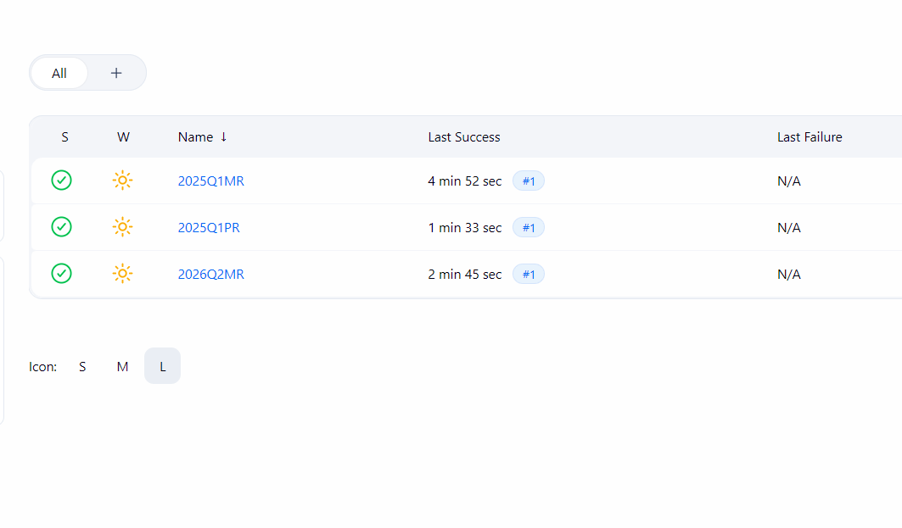

Above are the 3 jobs for all individual branches of the repo

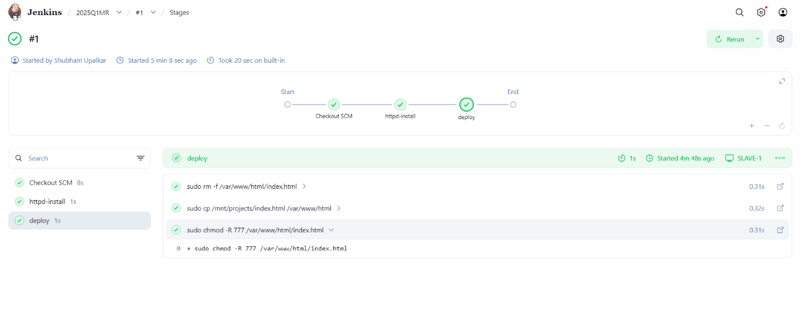

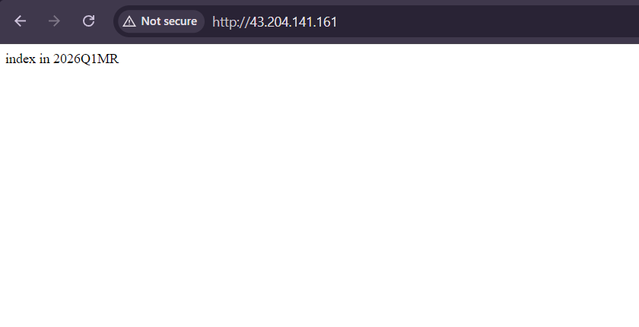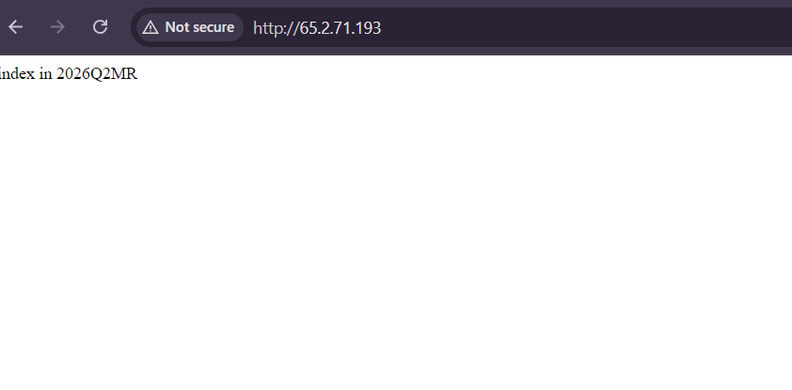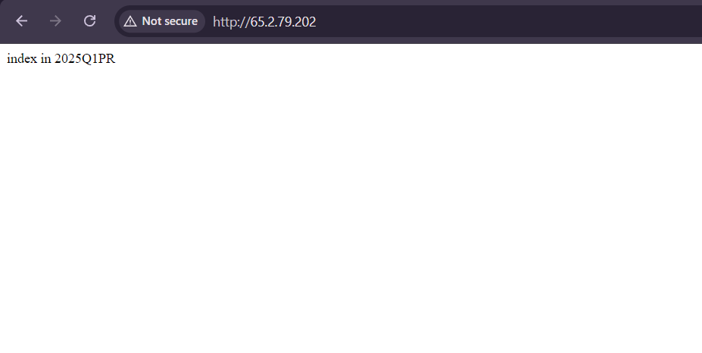
Above is the output of the assignment

