Jenkins Pipeline Assignment no. 20
In this assignment I have created Jenkins Pipeline job to host LoginWebApp on the slave. The app builds and deploys itself on the slave.

At first, I launched two EC2 instances, one for JM and one for slave
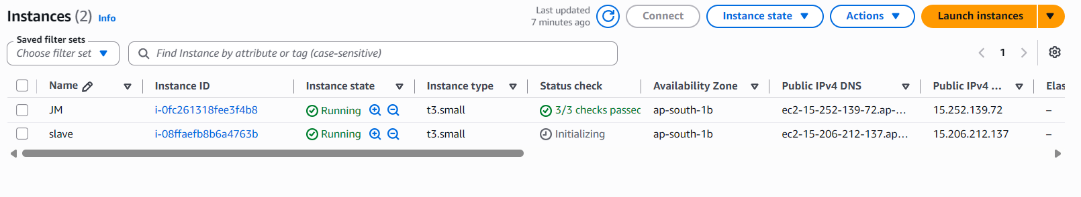
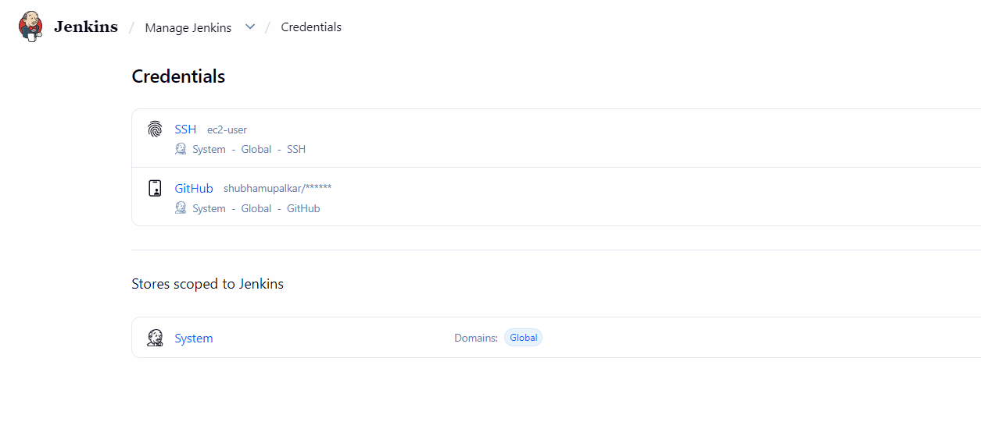
then I added my creds into Jenkins.
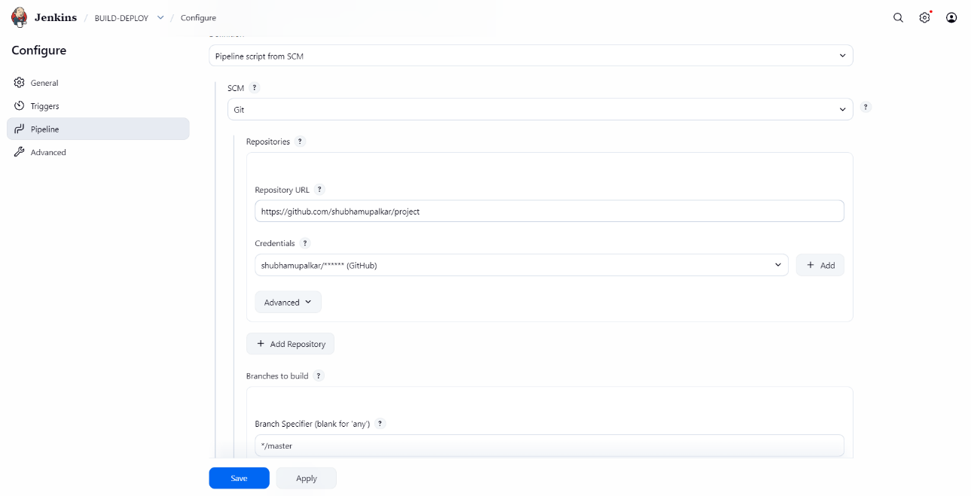
Then created job to pull code and Jenkins file from the private github repo.
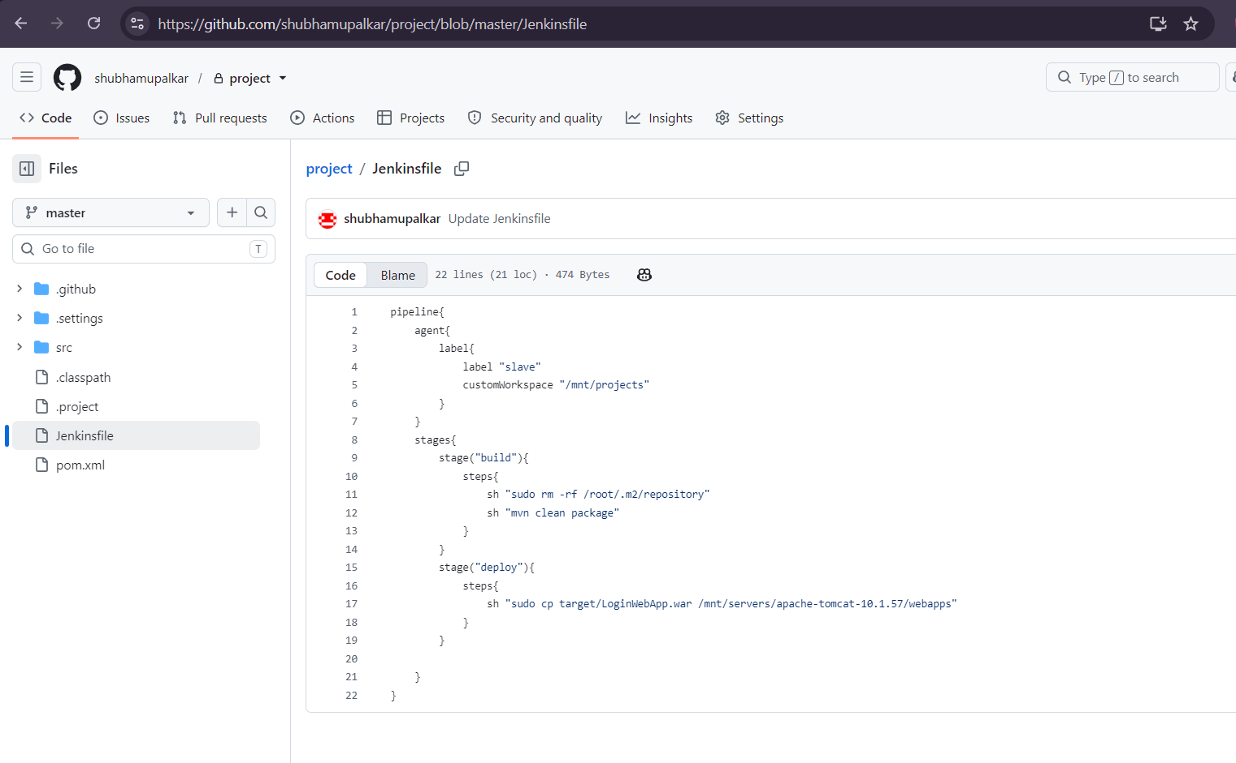

I wrote the above pipeline for this job, which basically build the application and copies it into the deployment location.
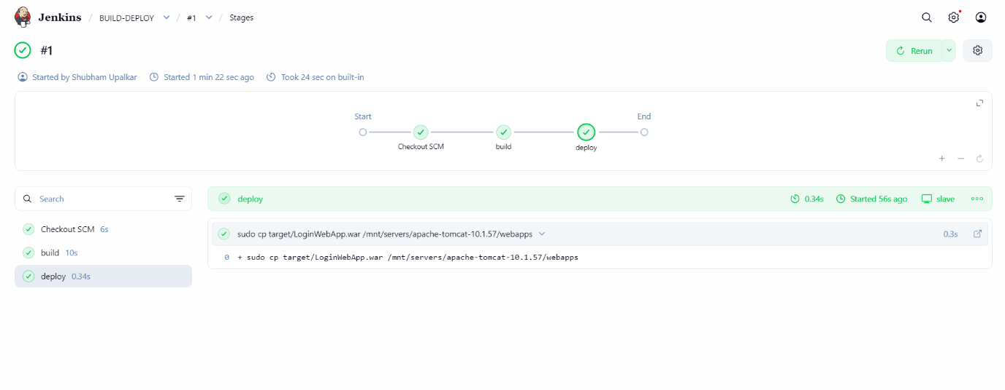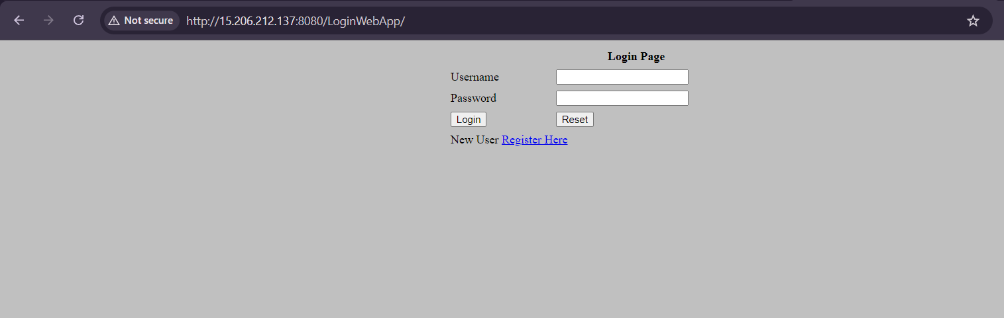

Above are the outputs of the assignment.

