Assignment No 11 :
In this assignment we are hosting index.html on httpd using Jenkins pipeline
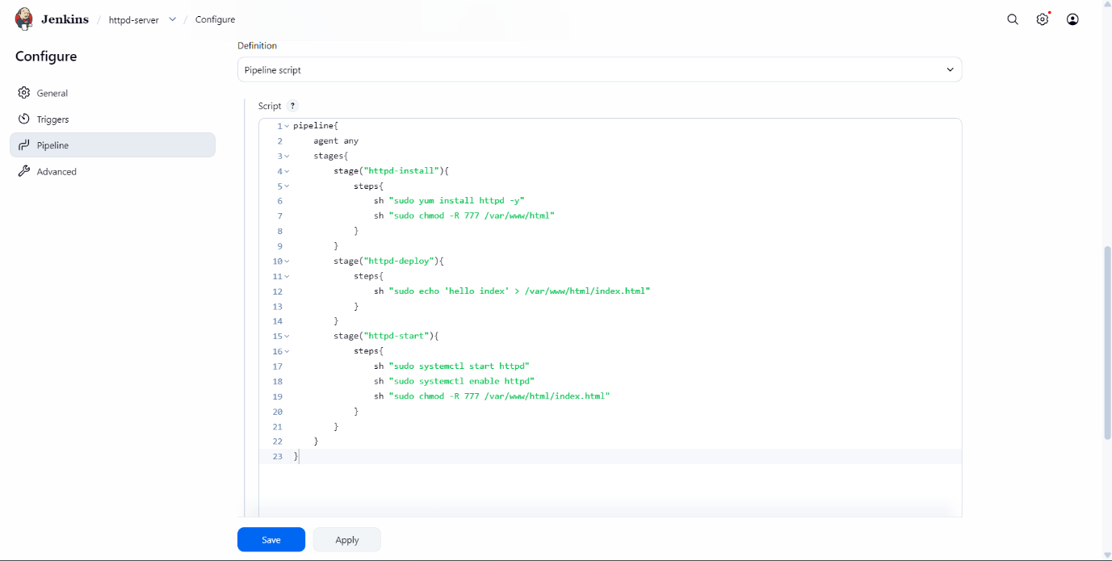

Above is the pipeline script that I have created for this job.
This script installs httpd and creates a index.html in /var/www/html and hosts that on to httpd in three stages.
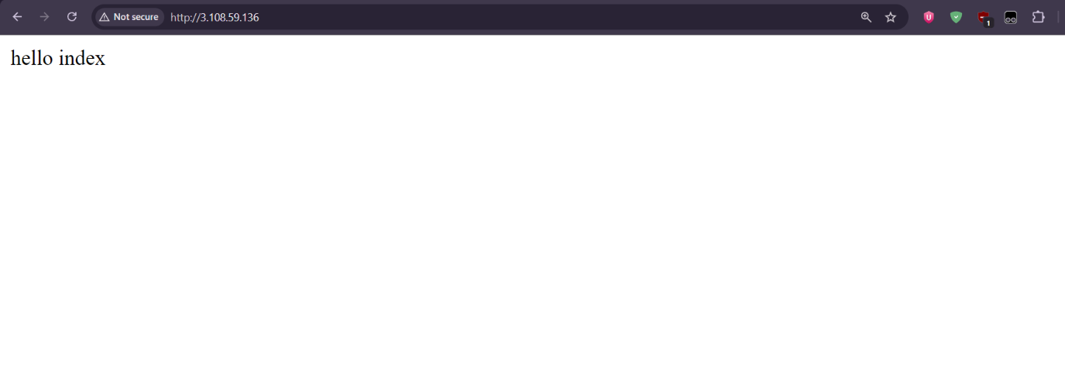
Above is the output of the assignment.

