Jenkins Pipeline Assignment No. 19
In this assignment I have created a Jenkins pipeline which build LoginWebApp on the JM and hosts in on the slave’s tomcat server.
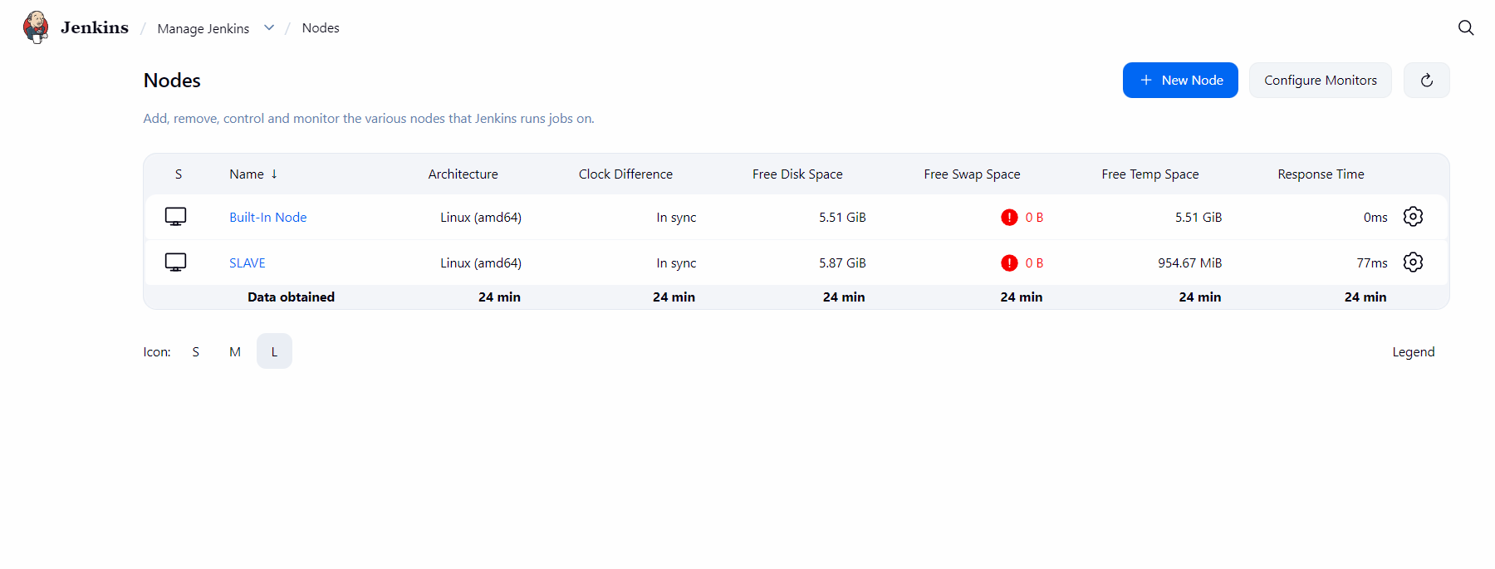
At first, I configured the slave in the Jenkins dashboard
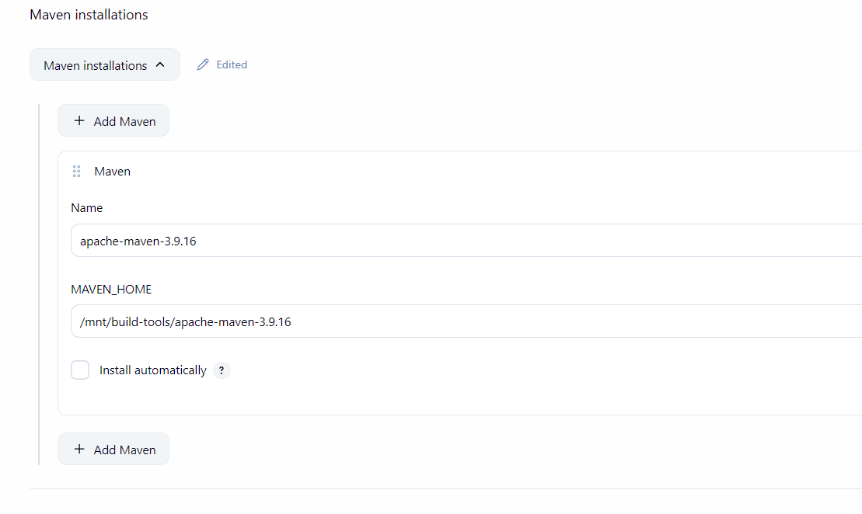
Then I added the maven home path in the Jenkins tools.
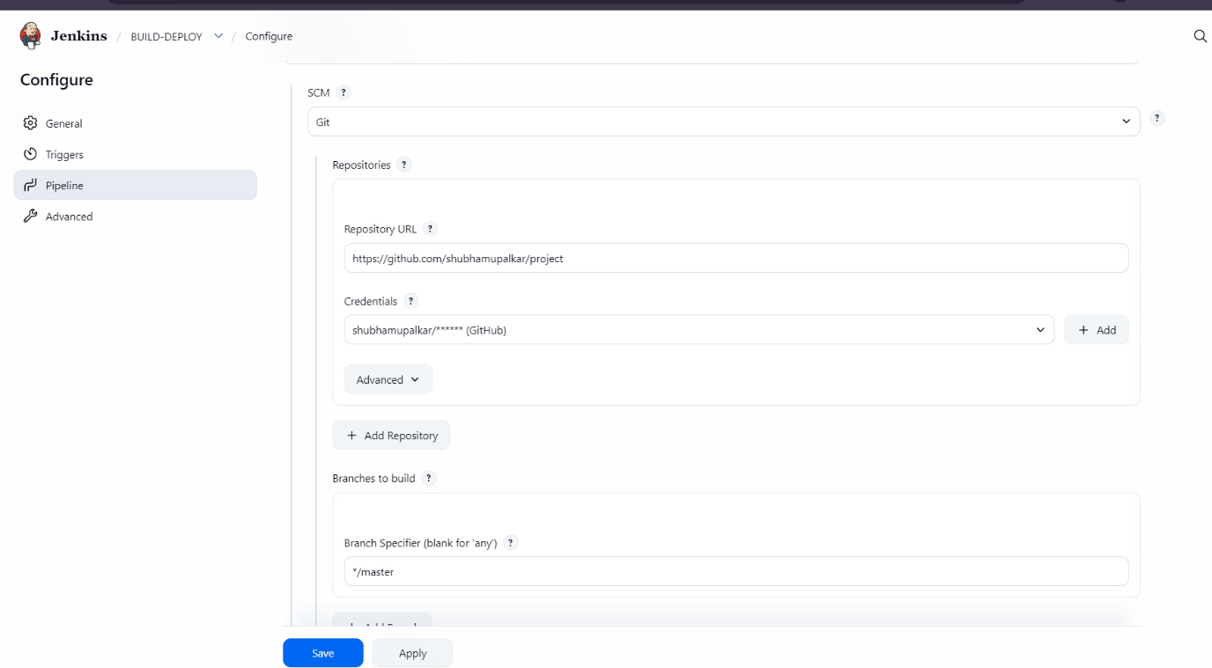
Then I created a job which grabs the LoginWebApp repo from the github along with the Jenkinsfile.

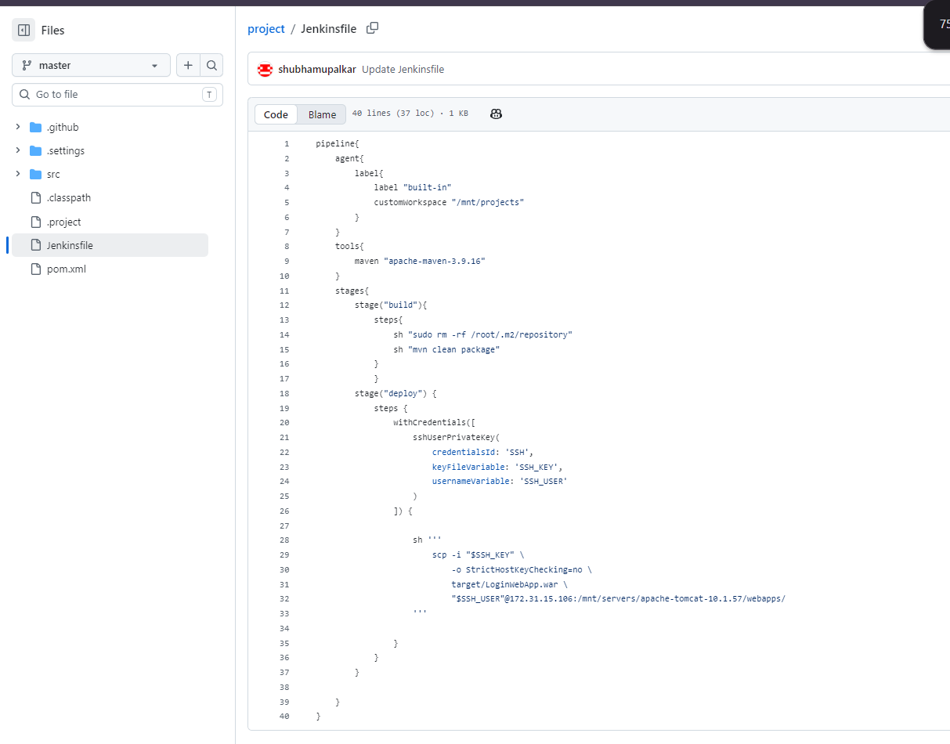
Above is the pipeline I wrote for this job, I basically builds the .war on the JM and scp it onto the slave.
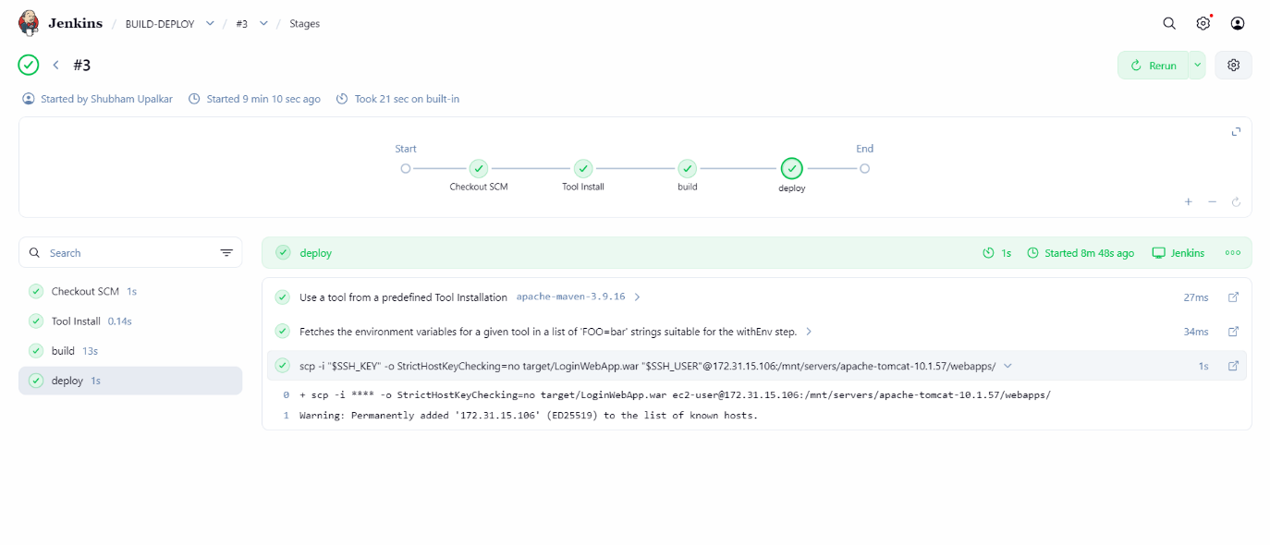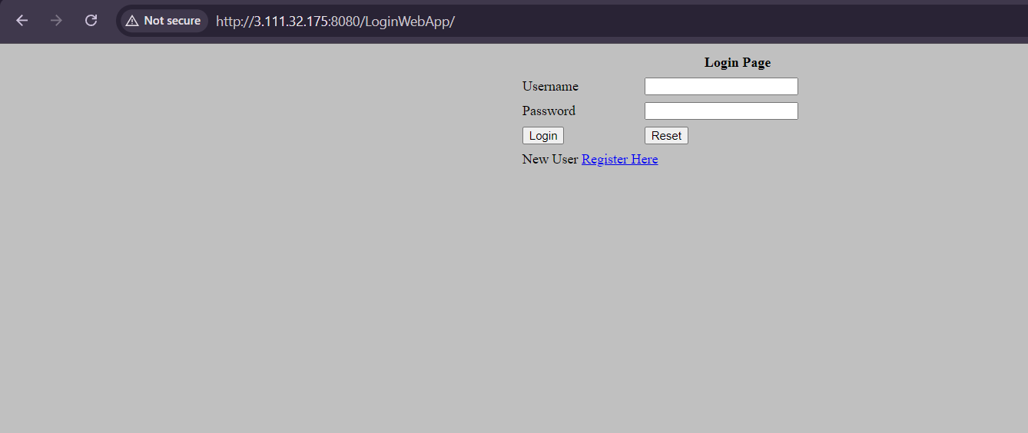
Above is the output of the assignment.

