Jenkins Pipeline Assignment No 13
In this assignment I have created a Jenkins pipeline job where we get index.html from three different github repo and host in on JM
I have pushed the Jenkinsfile for these jobs onto github

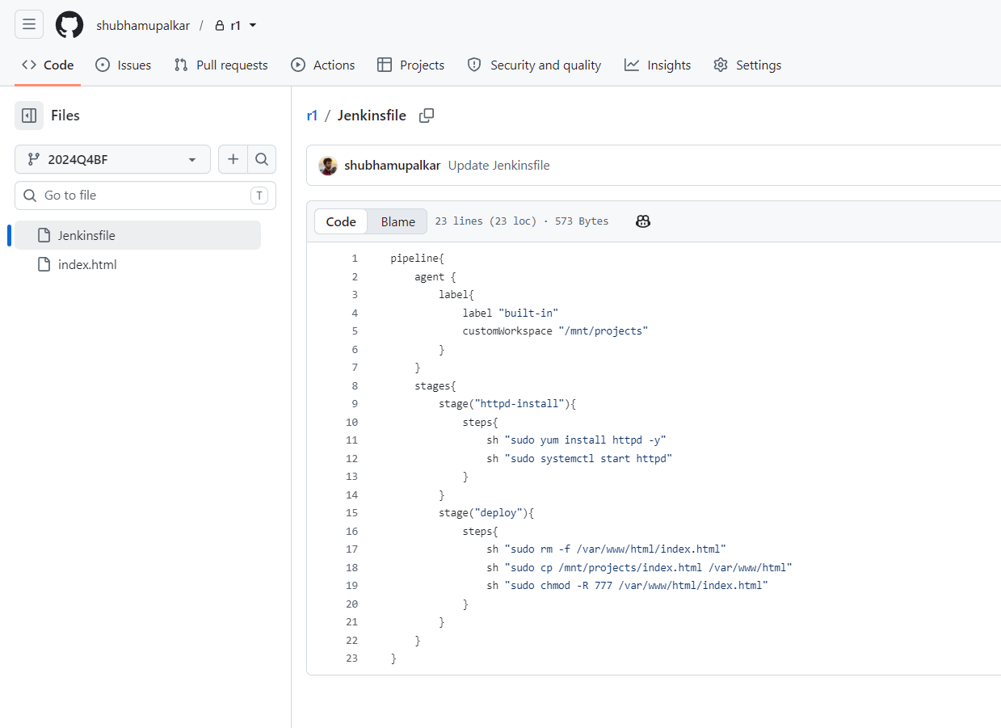

Above the pipeline that I have created for this job
It is divided into 2 stages, the stage one installs the httpd and the stage two copies the index.html at the deployment location.
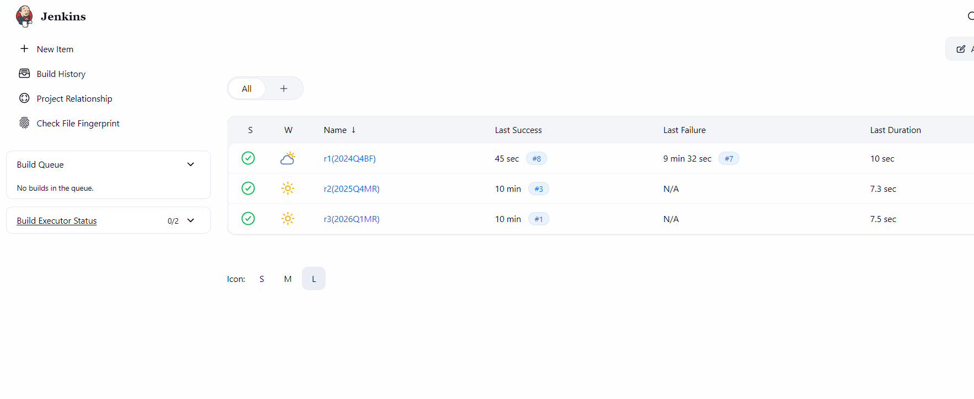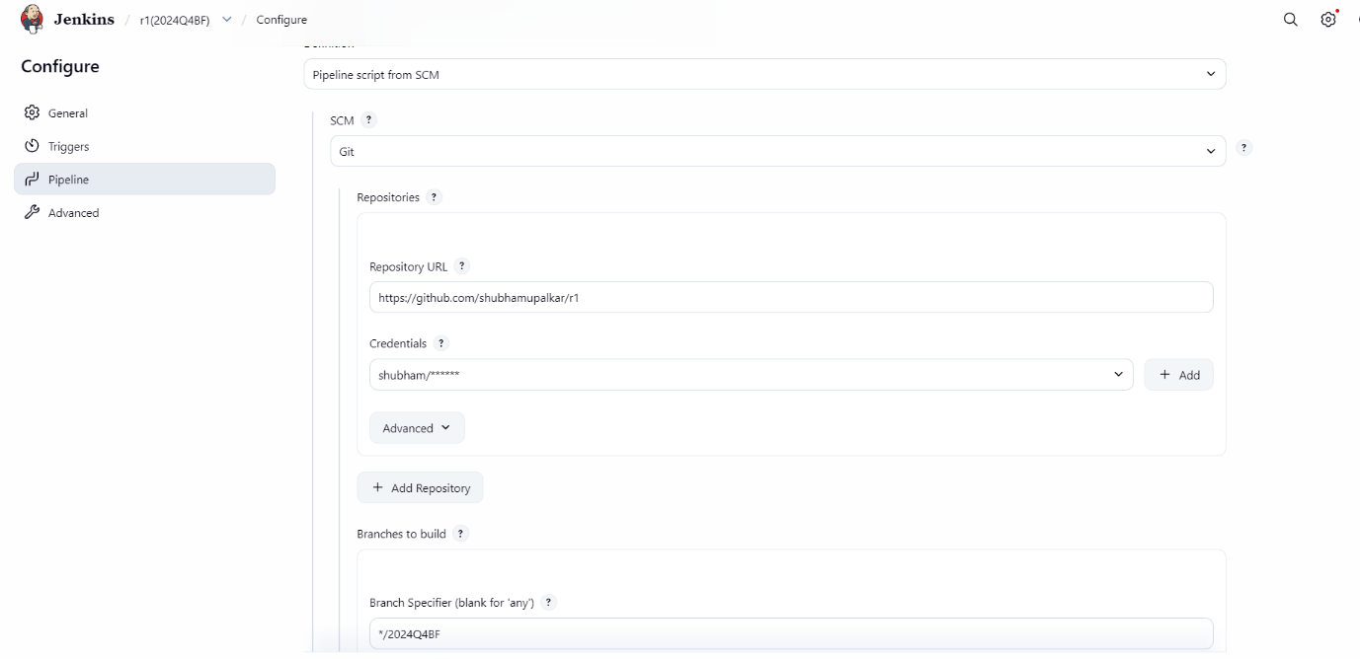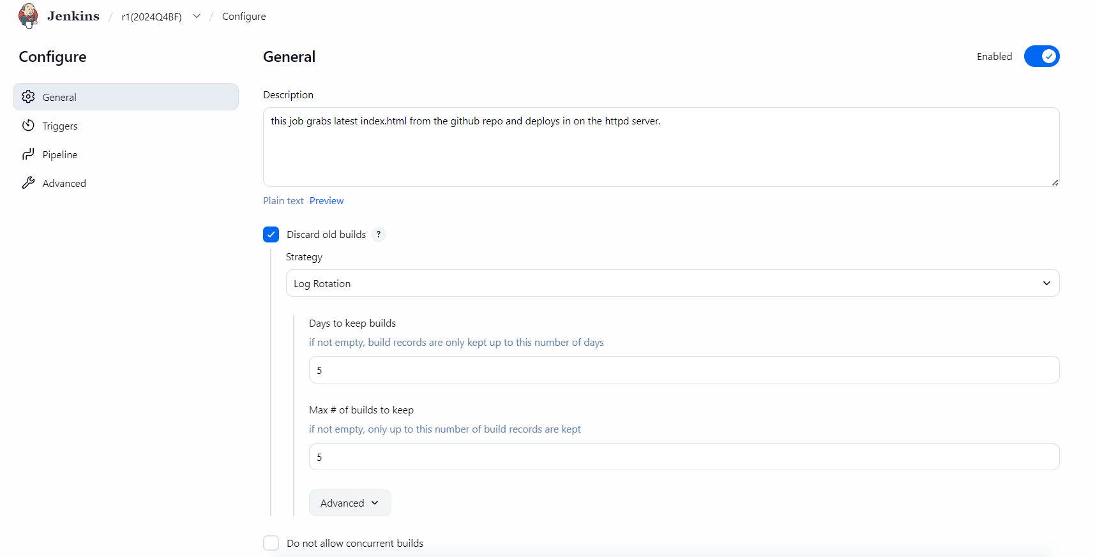

Above is the job config for all the jobs

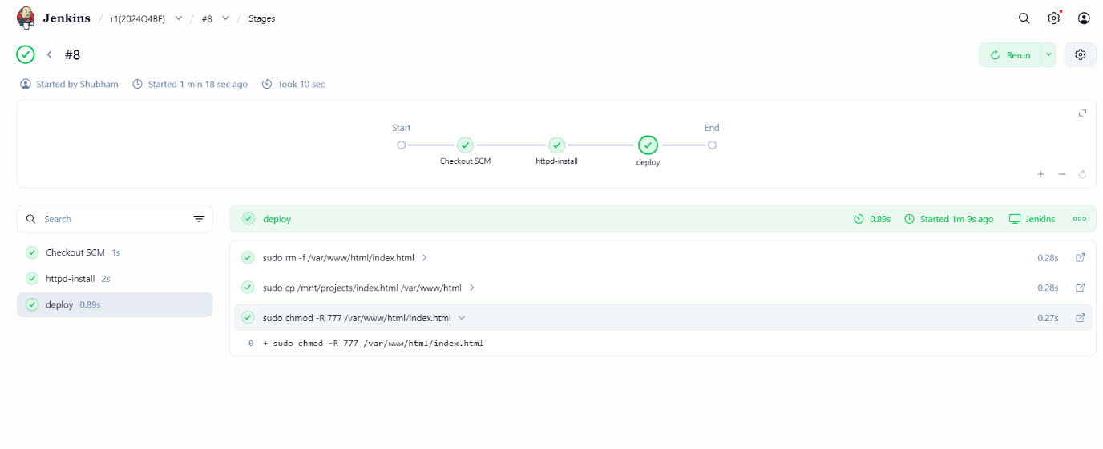
Above is the final output of the job

