RDS Assignment no. 2

Aim
To containerize and deploy a Java web application packaged as a WAR file using Apache Tomcat, while running MySQL as a separate Docker container and connecting both containers through a user-defined Docker bridge network.

Objectives
Build the Java web application using Maven and generate LoginWebApp.war.
Deploy the WAR file to Apache Tomcat 10.1 using Docker Compose.
Run MySQL 8.0 in a separate container.
Create the test database and USER table automatically using an SQL initialization script.
Connect the Tomcat application to MySQL through the Docker Compose service name db.
Persist MySQL data using a named Docker volume.
Verify user registration through the web application and verify the database structure from the MySQL container.

Docker Compose File –
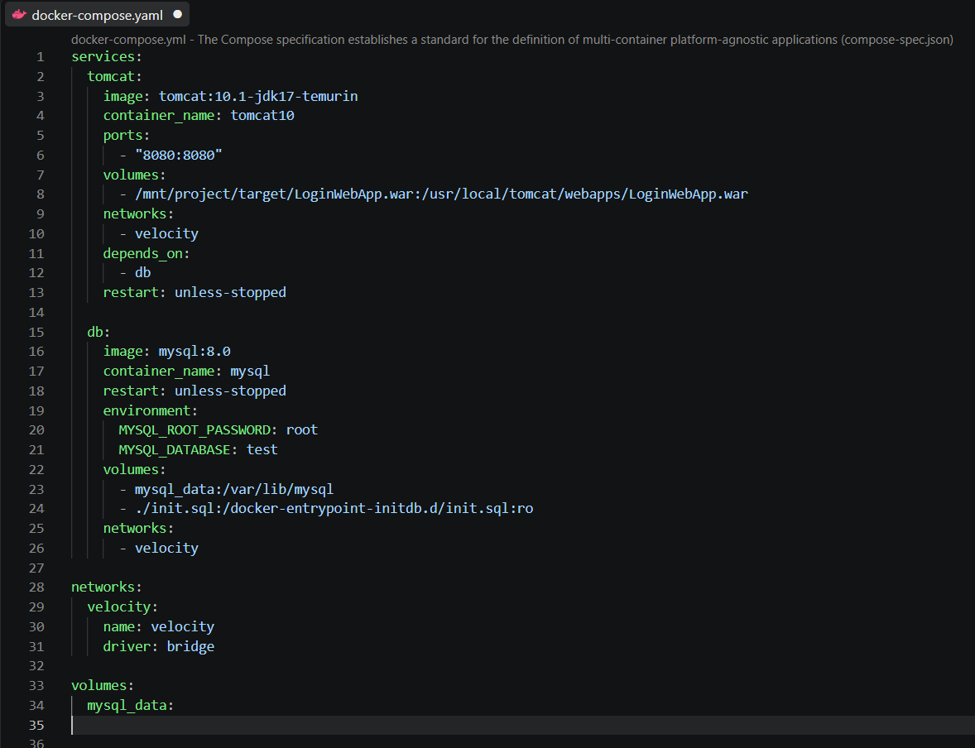

Important Compose attributes:
image: Specifies the Docker image used to create each container.
ports: Maps host port 8080 to Tomcat's container port 8080.
volumes: Mounts the WAR into Tomcat's webapps directory and mounts init.sql into MySQL's initialization directory.
environment: Supplies MySQL initialization settings, including the root password and database name.
networks: Places both services on the velocity bridge network.
depends_on: Starts the db service before Tomcat; it does not by itself guarantee that MySQL is ready to accept connections.
restart: unless-stopped: Restarts the container automatically unless it was explicitly stopped.

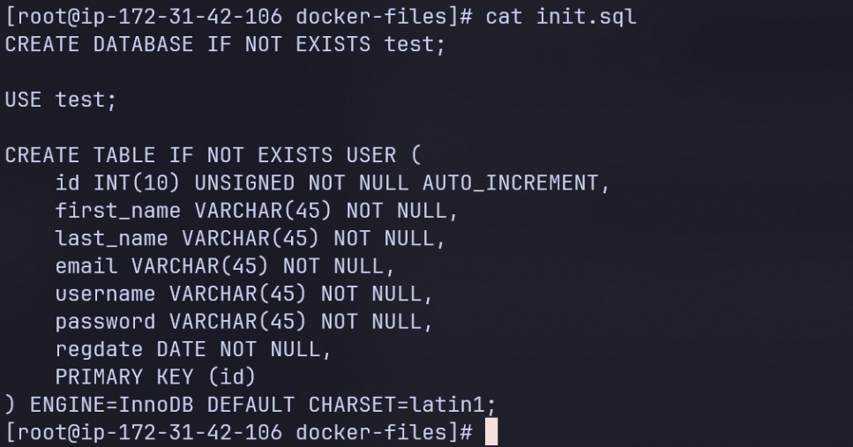

The init.sql file creates the test database and the USER table:
The official MySQL container executes SQL files mounted under /docker-entrypoint-initdb.d/ when it initializes an empty MySQL data directory. Therefore, init.sql is automatically executed when the mysql_data volume is created for a fresh database.

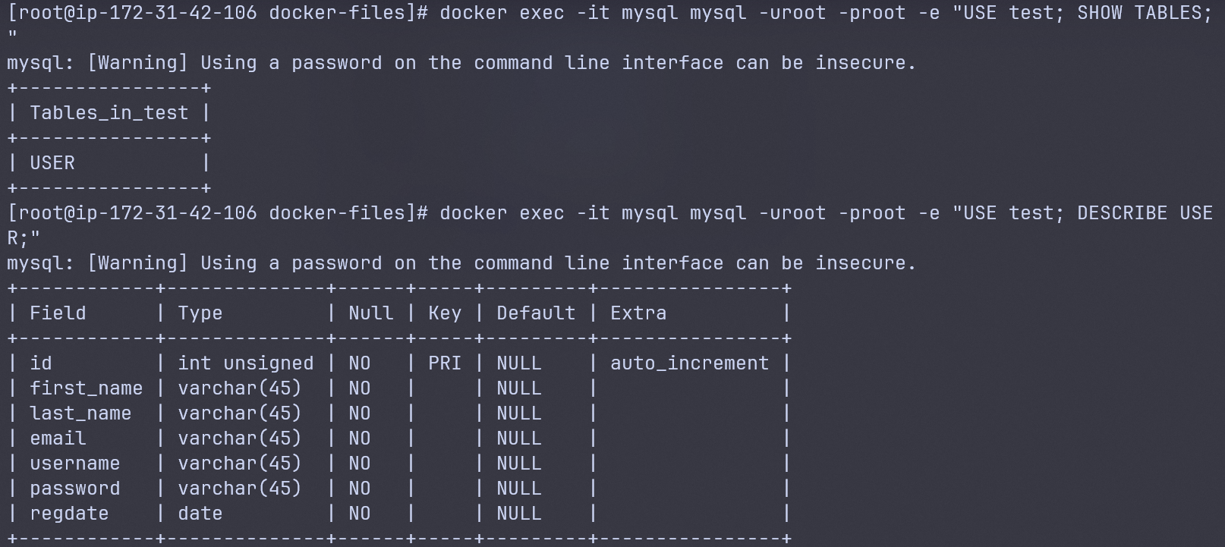
The database was verified directly from the MySQL container using:
docker exec -it mysql mysql -uroot -proot -e "USE test; SHOW TABLES;"
The result showed:
Tables_in_test
USER
The table structure was then verified using:
docker exec -it mysql mysql -uroot -proot -e "USE test; DESCRIBE USER;"
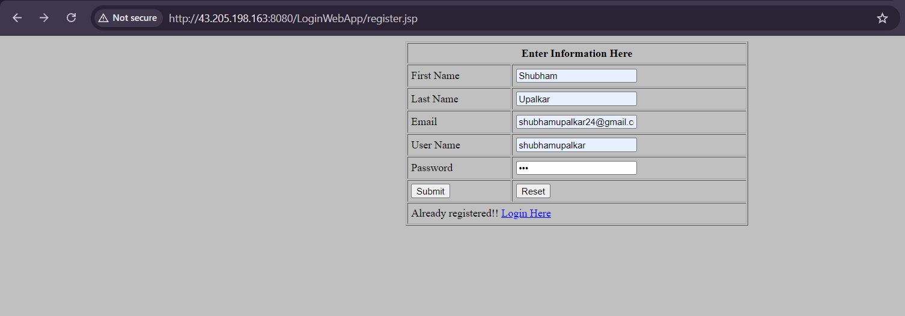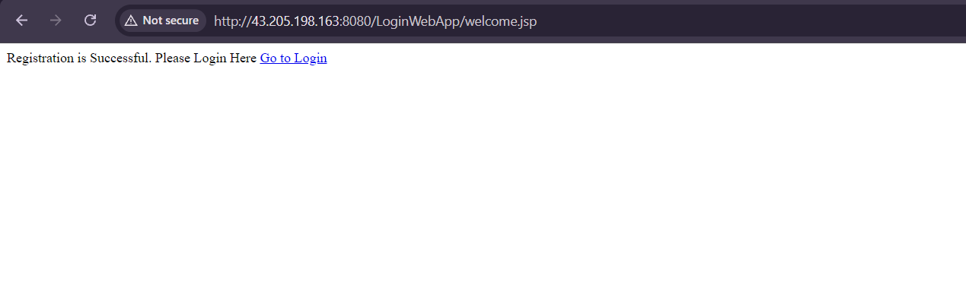
The registration page was accessed through the Tomcat application and registration data was submitted. The application redirected to the welcome page and displayed a successful registration message.

