RDS Assignment 1 –
Build the Java web application using Maven on the Jenkins master, deploy it on Apache Tomcat, configure the application to use AWS RDS MySQL, and verify user registration.
Process: GitHub → Jenkins/Maven Build → WAR Deployment → RDS Configuration → MySQL Setup → Application Test
JOB CONFIG
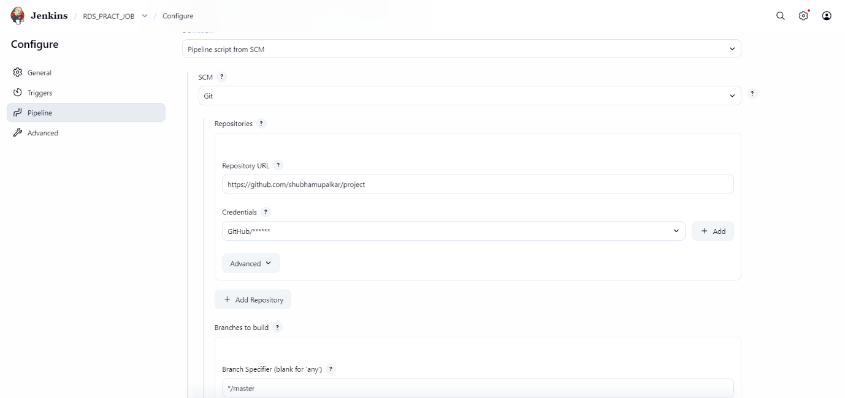

Pipeline :
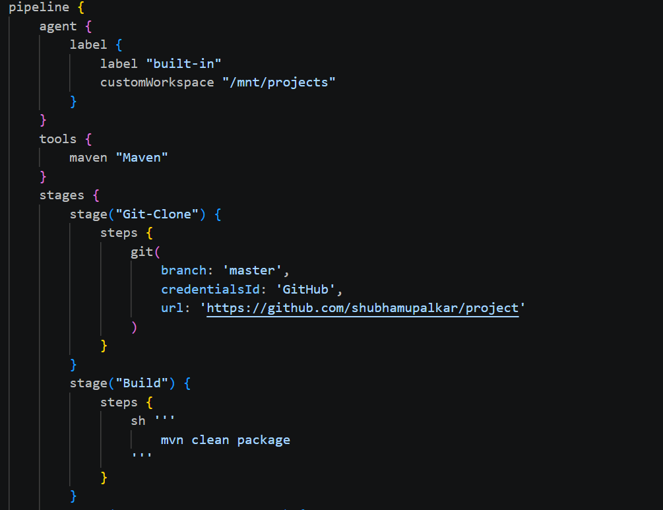
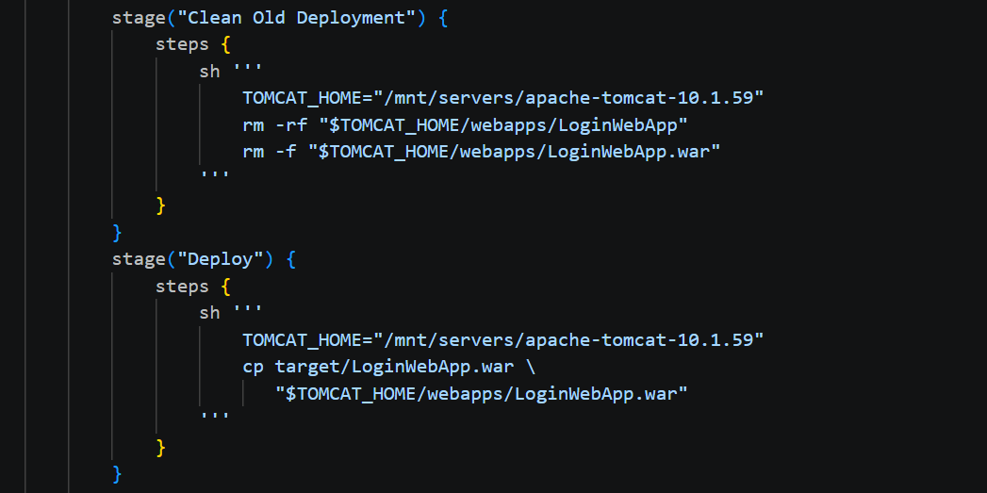
The previous application deployment is removed from the Tomcat webapps directory so that the new WAR can be deployed cleanly.
The newly generated WAR file is copied into the Tomcat webapps directory.
Tomcat then automatically extracts and deploys the application.
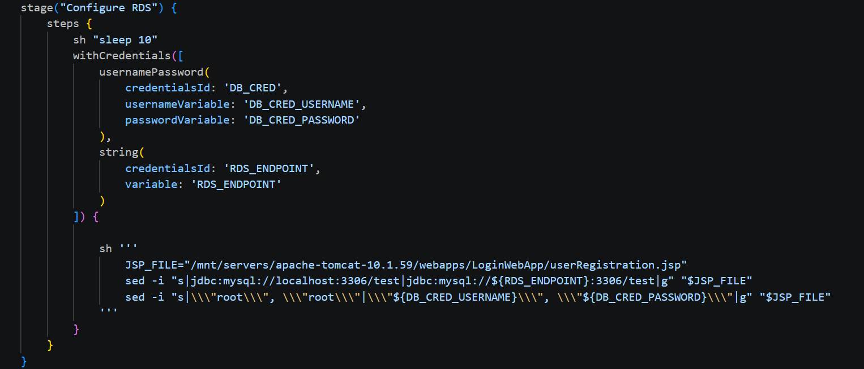
The RDS endpoint and database credentials are used to modify the application's userRegistration.jsp.
The original local MySQL connection:
jdbc:mysql://localhost:3306/test
is changed to the AWS RDS endpoint.

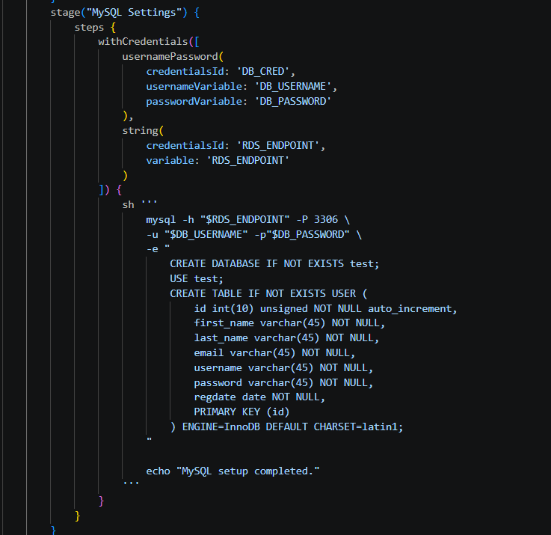
Jenkins connects directly to the AWS RDS MySQL instance using the MySQL client.
It executes:
CREATE DATABASE IF NOT EXISTS test;
Then it selects the database:
USE test;
and creates the USER table:
CREATE TABLE IF NOT EXISTS USER (...);
This automatically prepares the database required by the application.

Private GitHub Repo
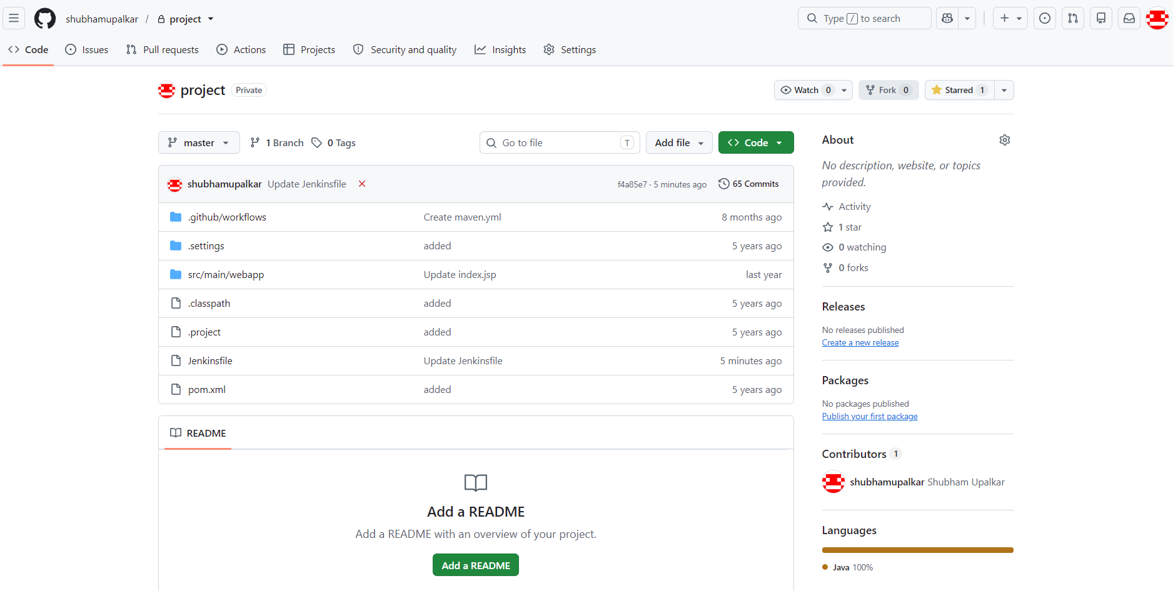

Private DB
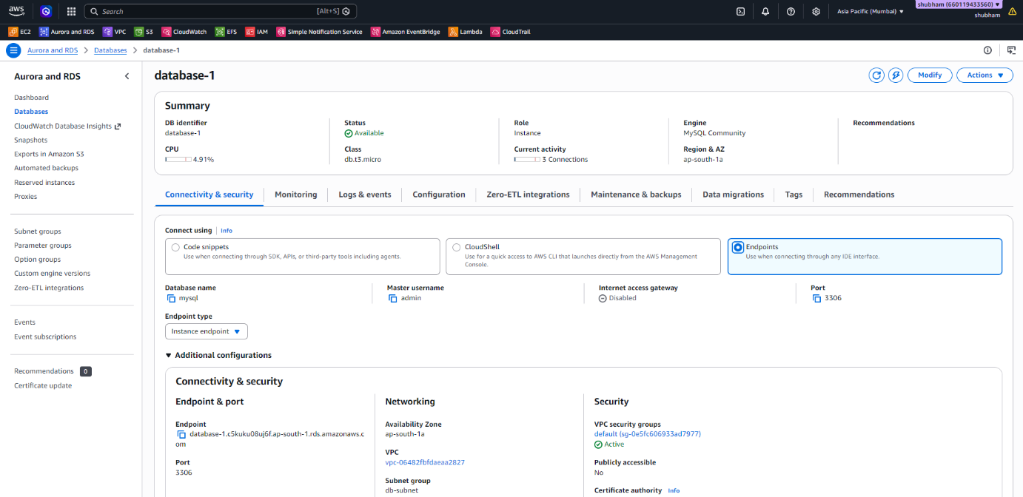

Pipeline Overview
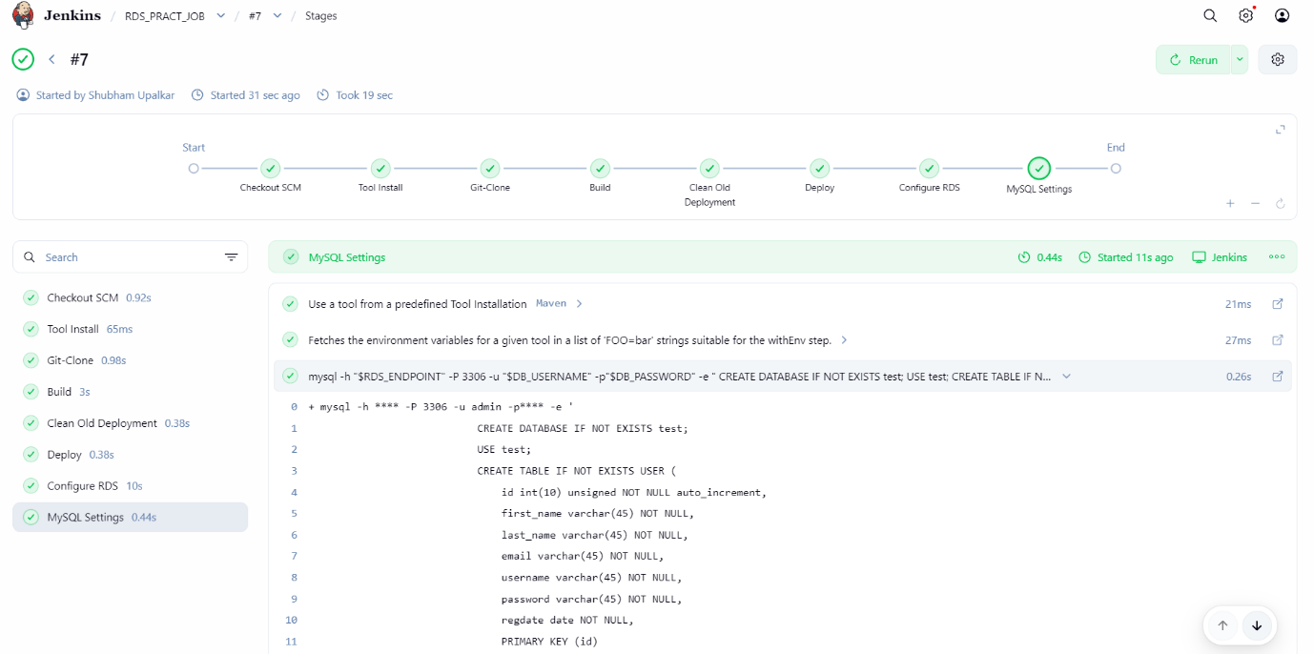

Data Entry Test
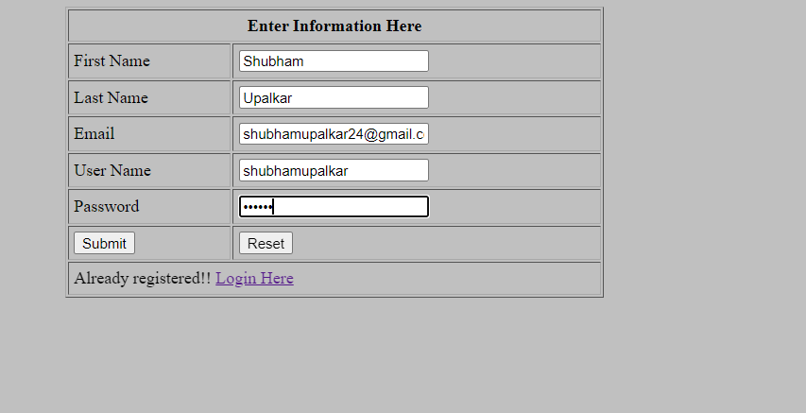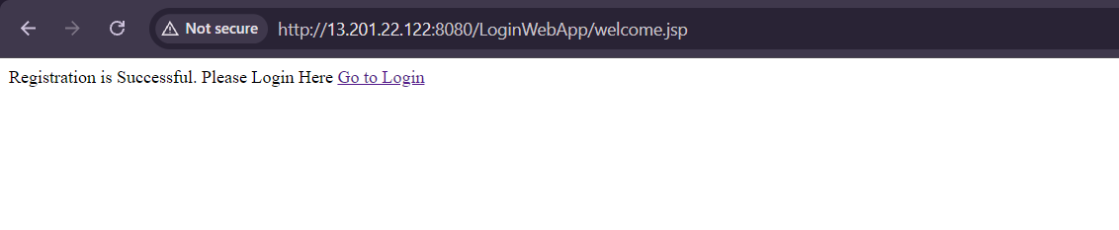

Connection Verification –
