RDS Assignment no.3
The objective of this assignment is to implement a Jenkins-based CI/CD pipeline for a Java LoginWebApp. The pipeline retrieves source code from GitHub, injects AWS RDS database configuration from Jenkins Credentials, prepares the MySQL database schema, builds the application using Maven, and deploys the generated WAR file to Apache Tomcat on the Jenkins Slave.
Credentials Configuration
The pipeline does not hard-code the RDS username, password, or endpoint. These values are stored in Jenkins Credentials and exposed to pipeline steps only through withCredentials(). The configured credentials shown in the assignment are:
GitHub — GitHub credential used to clone the project repository.
RDS_ENDPOINT — Secret text containing the AWS RDS endpoint.
RDS_LOGIN — Username/password credential containing the RDS login.
SSH — SSH credential for the EC2/Jenkins environment.
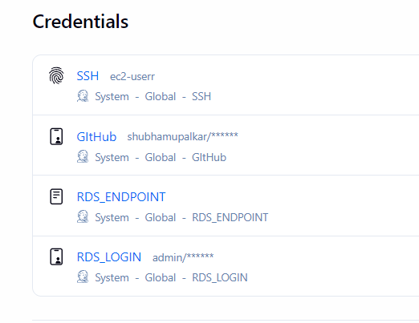

Jenkins Pipeline Configuration
The pipeline is configured to execute on the node labelled SLAVE and uses the custom workspace /mnt/projects/. This ensures that the source, build output, and deployment artifacts are created on the selected agent.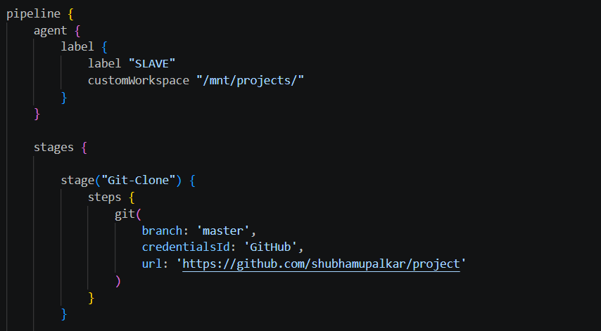
The Git-Clone stage checks out the master branch from the GitHub repository using the GitHub credential.
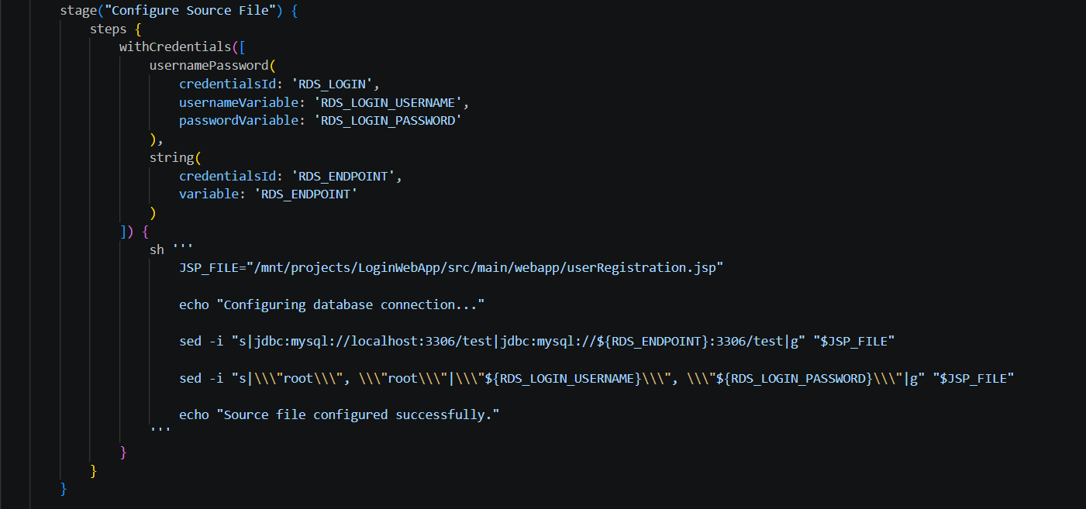
This stage modifies userRegistration.jsp before compilation. The local MySQL URL is replaced with the AWS RDS endpoint, and the database username/password are replaced using Jenkins credential variables.

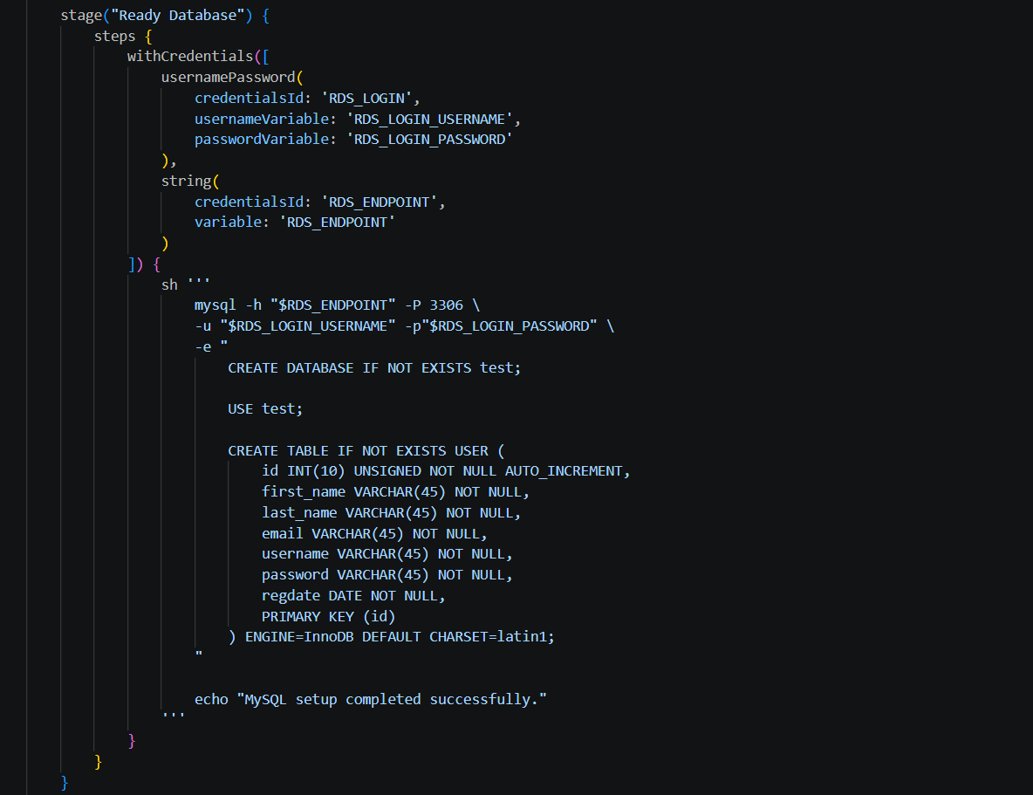
The Ready Database stage connects from the Jenkins agent to AWS RDS using the mysql command-line client. It creates the test database if required and creates the USER table if it does not already exist.
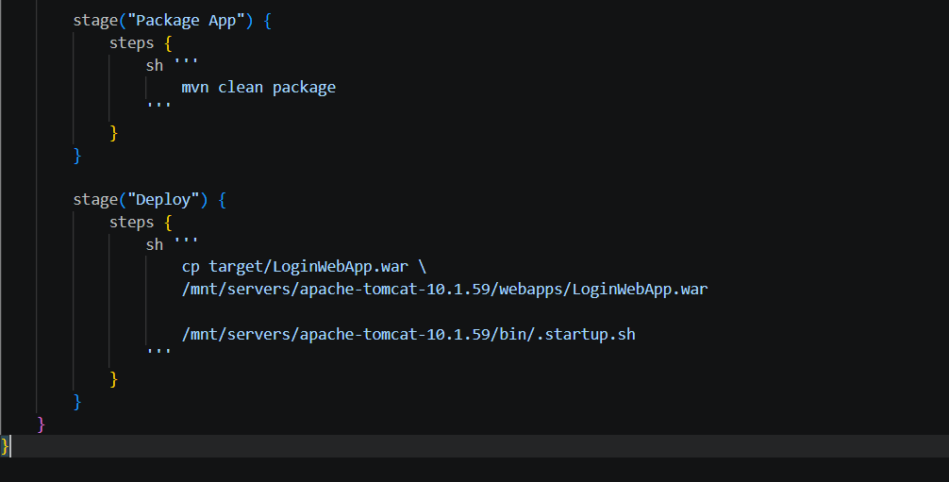
Maven cleans the previous build output and packages the application into a WAR file.
The generated LoginWebApp.war is copied into the Tomcat webapps directory and the Tomcat startup script is executed.

Added the EC2 as a slave node
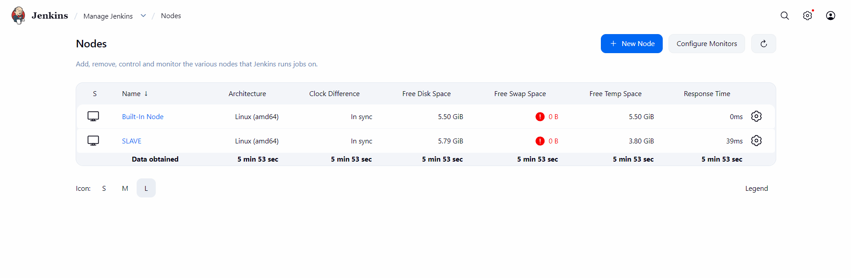

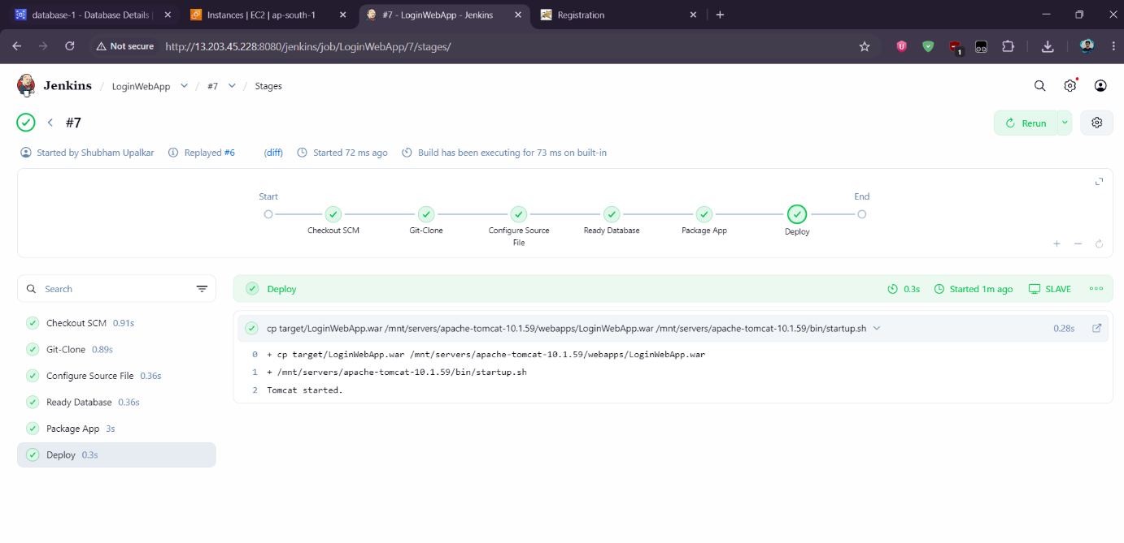The Jenkins Stage View shows successful completion of Checkout SCM, Git-Clone, Configure Source File, Ready Database, Package App, and Deploy. A successful Deploy stage confirms that the WAR artifact was copied to Tomcat and the server startup command completed.
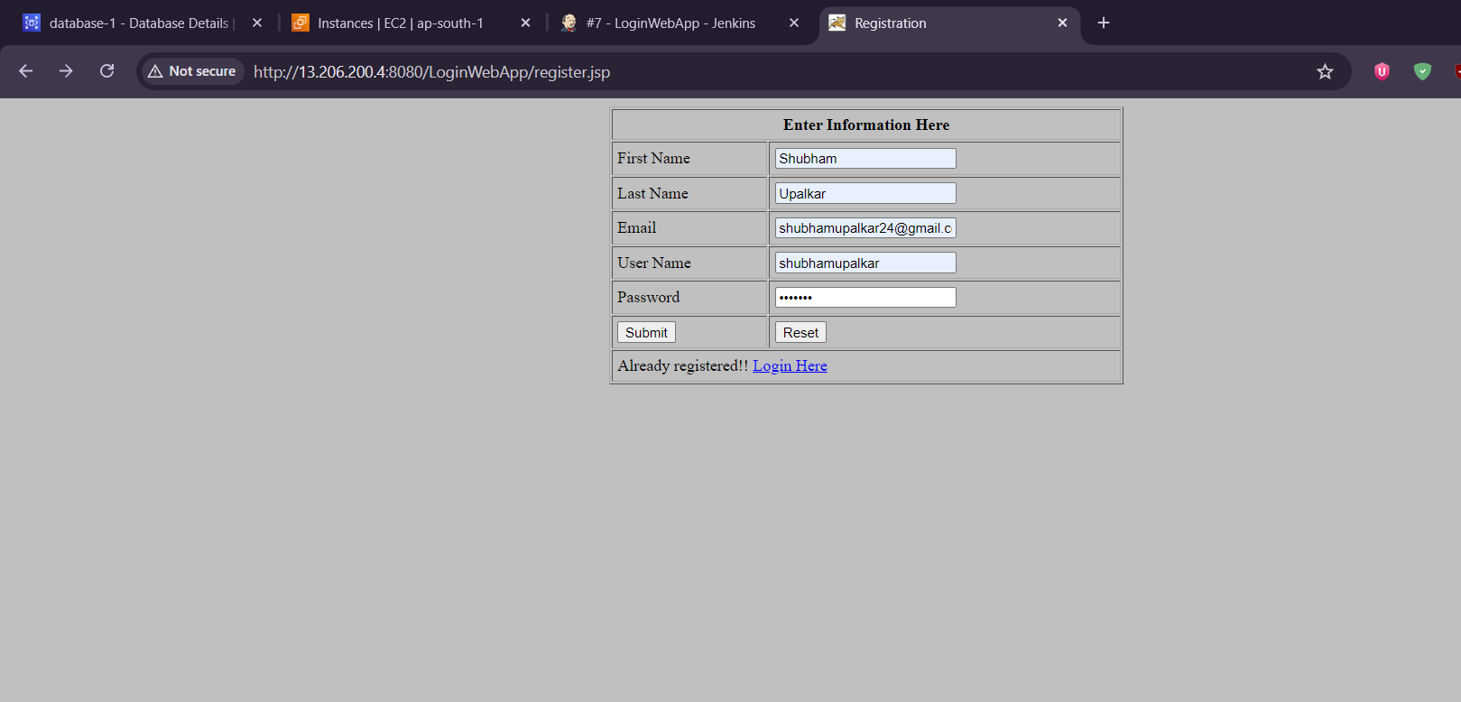
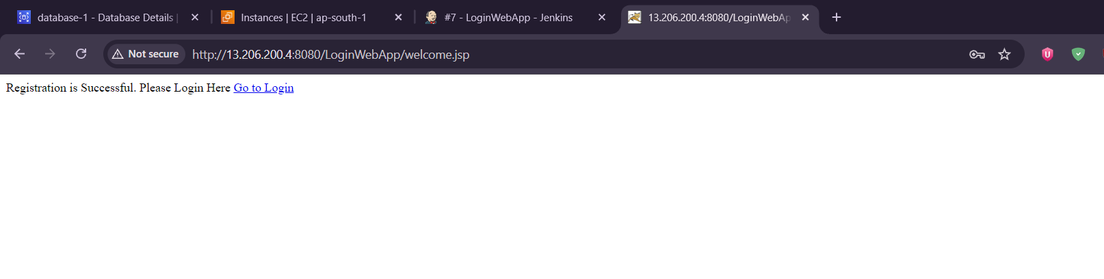
After submitting the registration form, the application displays a successful registration message. The corresponding record is then visible in the RDS USER table.
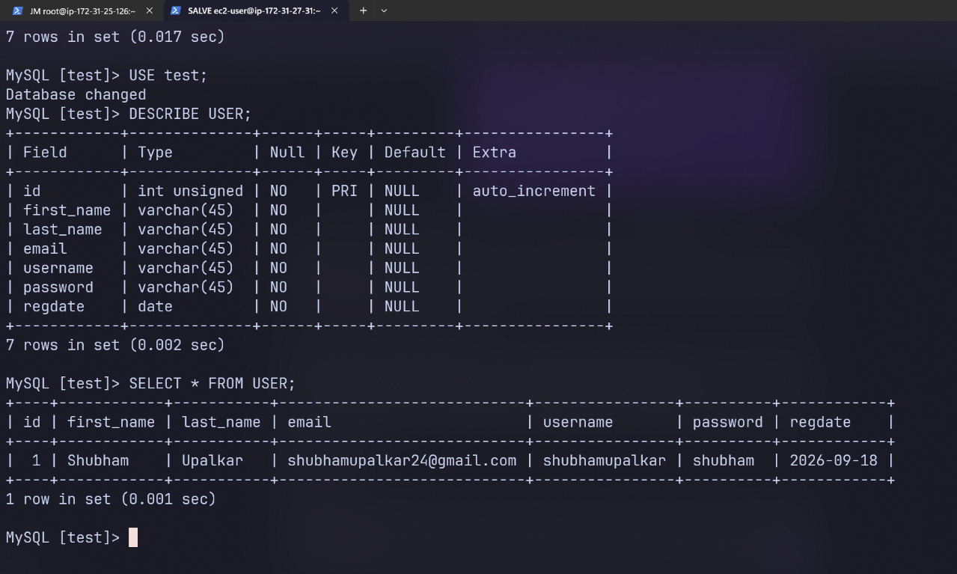
To view the stored records, the following SQL command is used:
USE test;
SELECT * FROM USER;

