RDS Assignment no 4 –
Aim
To implement a Jenkins Declarative Pipeline that checks out a Java web application from GitHub, packages it into a WAR file with Maven, starts a MySQL service through Docker Compose, initializes and verifies the application database, and deploys the WAR to Standalone Apache Tomcat.

Technology Stack
Jenkins Declarative Pipeline — CI/CD orchestration
GitHub — source-code repository (master branch)
Apache Maven — build and WAR packaging
Docker Compose — MySQL container lifecycle
MySQL 8.0 — application database
Apache Tomcat 10.1.59 — Java web application server
JSP/JDBC — registration form and database interaction

Architecture / Workflow
GitHub (master)
|
v
Jenkins Pipeline (/mnt/projects)
|
+--> Git checkout
+--> mvn clean package
+--> docker-compose up -d db
+--> Execute init.sql and verify test.USER
+--> Copy LoginWebApp.war to Tomcat
+--> Start Tomcat
|
v
Browser --> Tomcat --> JSP/JDBC --> MySQL (test database)

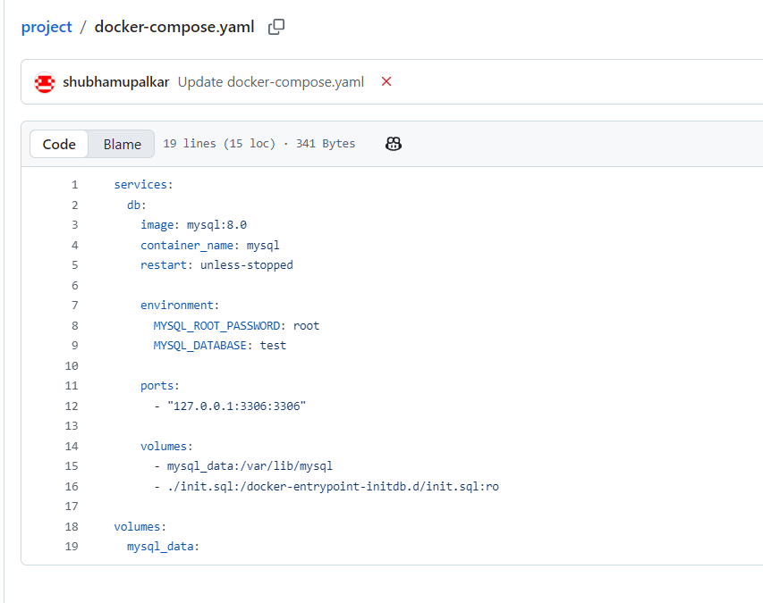
This Compose configuration starts MySQL 8.0, creates the test database on first initialization, persists database files, and mounts init.sql.

Database Schema — init.sql
The SQL script creates the test database and USER table if they do not already exist.
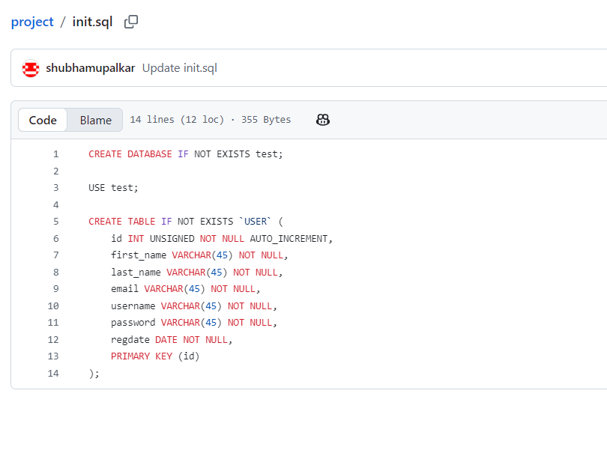
The Jenkins pipeline explicitly executes the checked-out init.sql file after MySQL is ready. This is important when mysql_data already exists: MySQL container initialization scripts are normally processed only when the data directory is initialized for the first time.

Below pipeline uses the built-in Jenkins node, the custom workspace /mnt/projects, and the Maven tool configured in Jenkins as Maven.
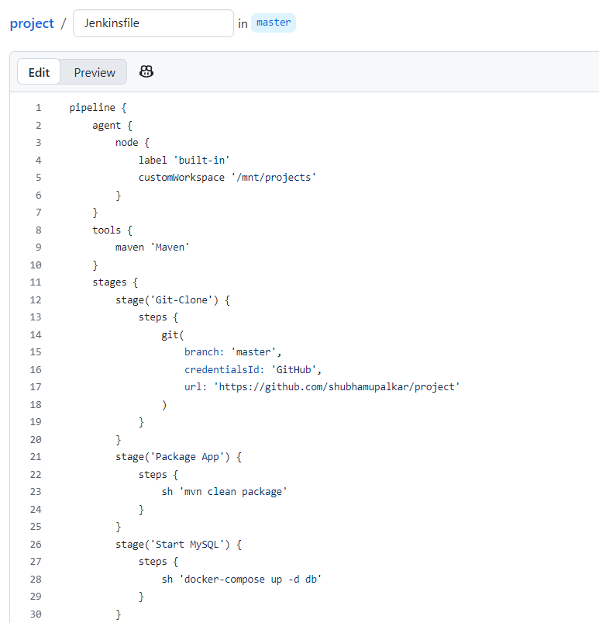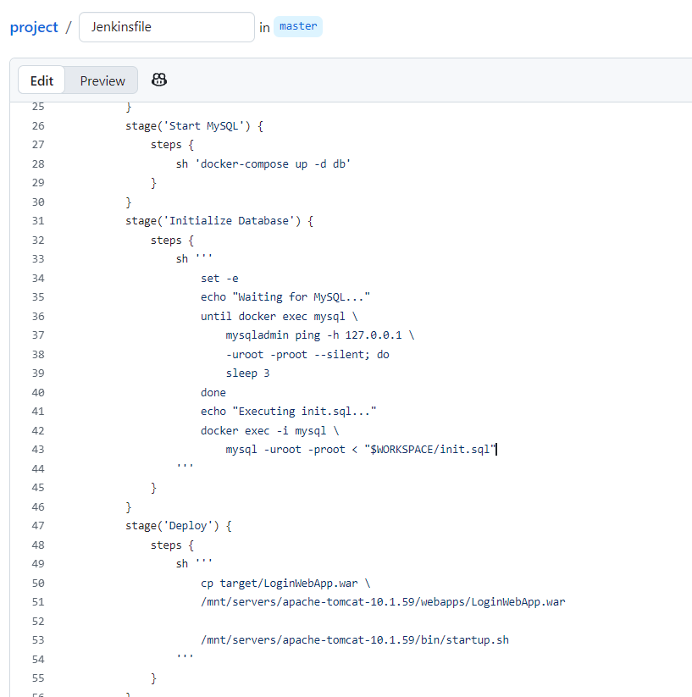

Pipeline Stage Description
Stage | Purpose
Git-Clone | Checks out the master branch from the GitHub repository using the Jenkins credential ID GitHub.
Package App | Runs mvn clean package and creates target/LoginWebApp.war.
Start MySQL | Runs docker-compose up -d db to start the MySQL service.
Initialize Database | Waits for MySQL readiness, executes $WORKSPACE/init.sql, and lists tables in the test database.
Deploy | Copies the generated WAR to Tomcat's webapps directory and invokes startup.sh.

The Jenkins pipeline successfully checked out and packaged the LoginWebApp project, started MySQL, initialized and verified the database schema, and deployed the WAR file to Tomcat. The supplied browser and MySQL screenshots show successful registration and the corresponding database record.

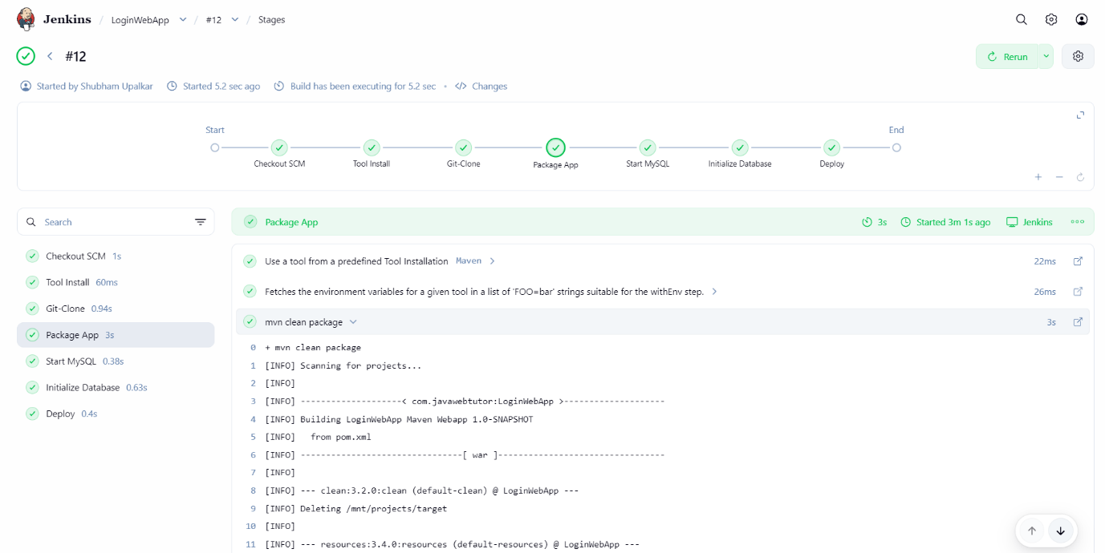

Application Testing
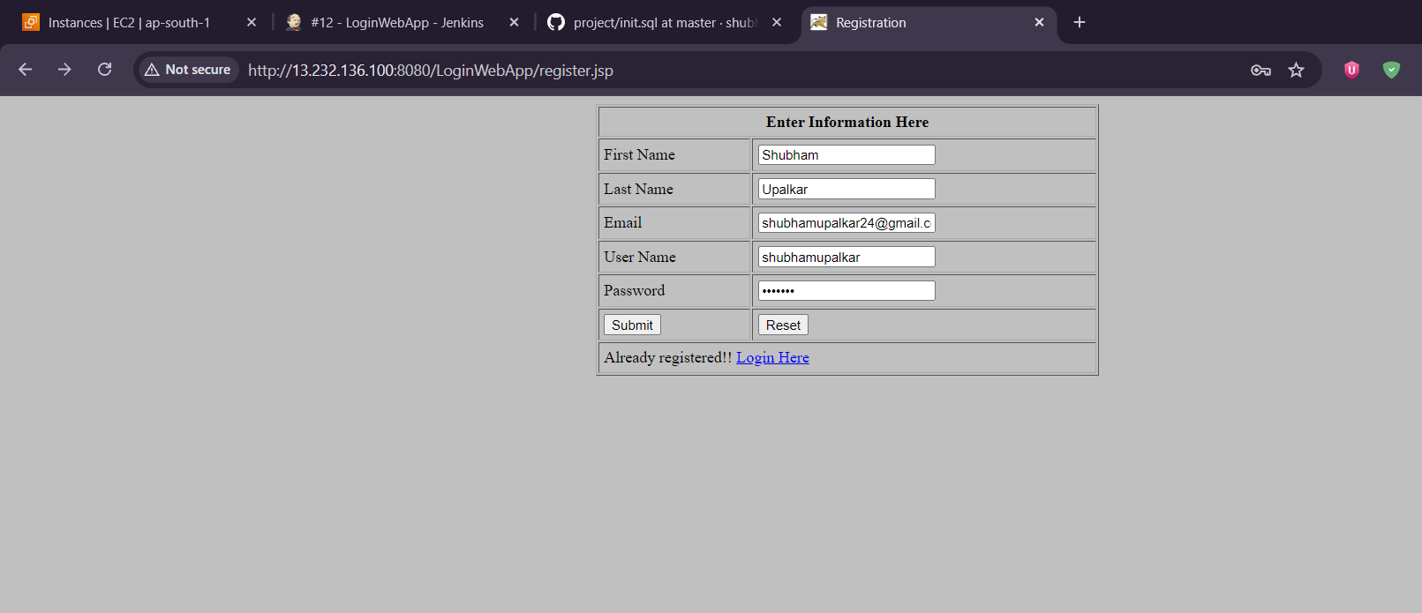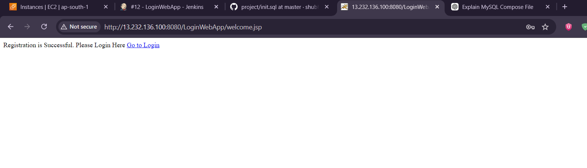
Database Verification
