**Q1.**

Query all columns for all American cities in the CITY table with populations larger than 100000. The CountryCode for America is USA.

The CITY table is described as follows:

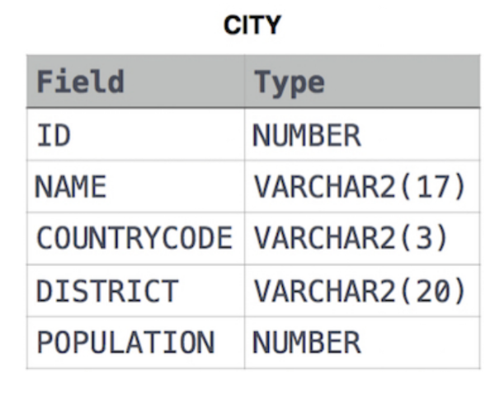

**SOLUTION :** SELECT * FROM CITY WHERE COUNTRYCODE = "USA" AND POPULATION >100000

**Q2.**

Query all columns (attributes) for every row in the CITY table.

The CITY table is described as follows:

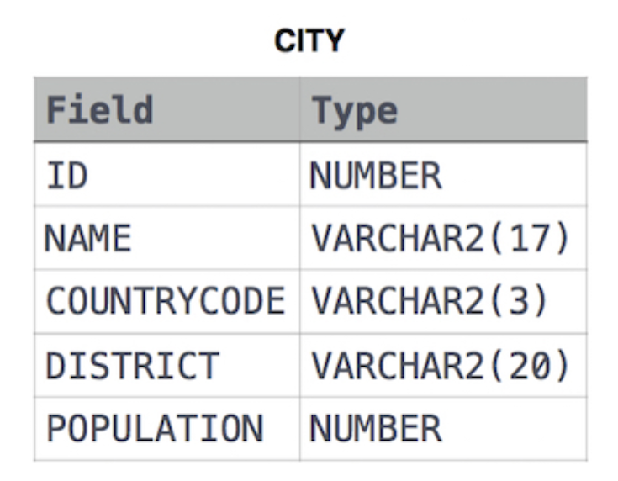

**SOLUTIONS :** SELECT * FROM CITY;

**Q3.**

Query all columns for a city in CITY with the *ID* 1661.

The CITY table is described as follows:

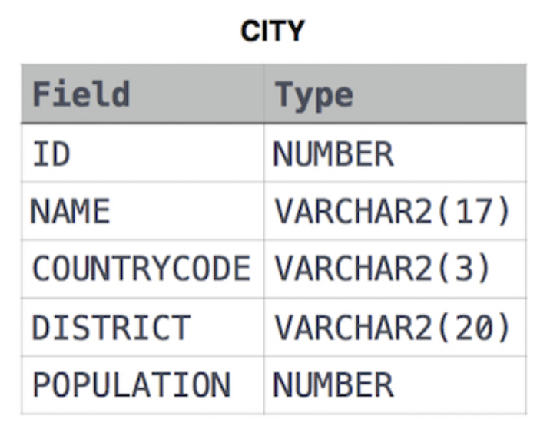

**SOLUTION:** SELECT * FROM CITY WHERE ID=1661;

**Q4.**

Query all attributes of every Japanese city in the CITY table. The COUNTRYCODE for Japan is JPN.

The CITY table is described as follows:

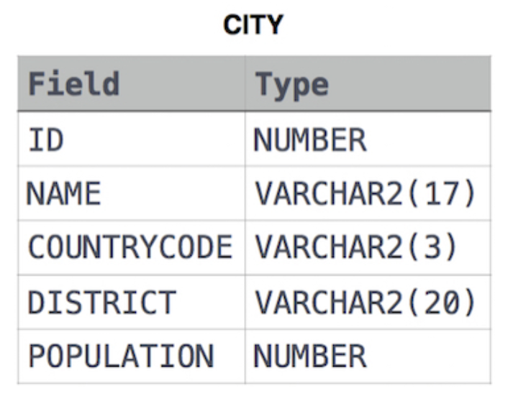

**SOLUTION :** SELECT * FROM CITY WHERE COUNTRYCODE = "JPN";