**Q1.**

Query the names of all the Japanese cities in the **CITY** table. The **COUNTRYCODE** for Japan is JPN.  
The **CITY** table is described as follows:

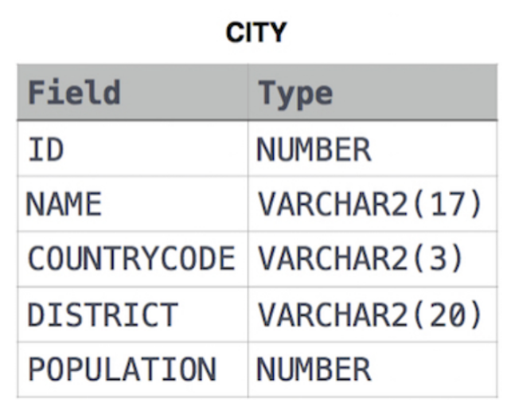

**SOLUTION**: SELECT NAME FROM CITY WHERE COUNTRYCODE = "JPN";

**Q2.**

Query a list of **CITY** and **STATE** from the **STATION** table.  
The **STATION** table is described as follows:

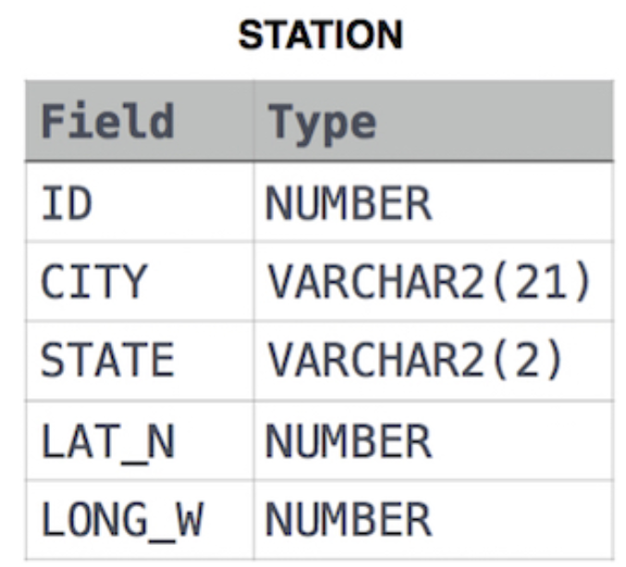

**SOLUTION** : SELECT CITY,STATE FROM STATION;

**Q3.**

Query a list of CITY names from STATION for cities that have an even ID number. Print the results in any order, but exclude duplicates from the answer.  
The STATION table is described as follows:

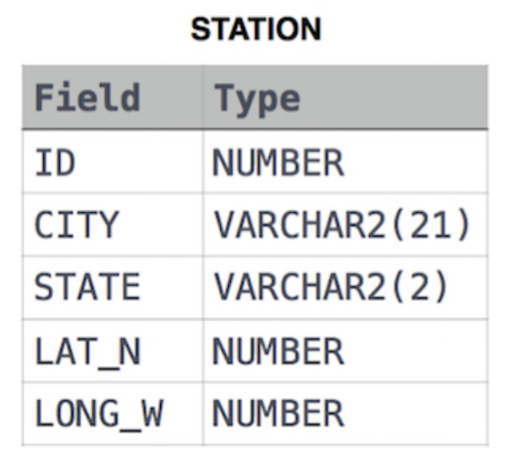

**SOLUTION :** SELECT DISTINCT CITY FROM STATION WHERE (ID%2)=0;

**Q4.**

Find the difference between the total number of CITY entries in the table and the number of distinct CITY entries in the table.  
The STATION table is described as follows:

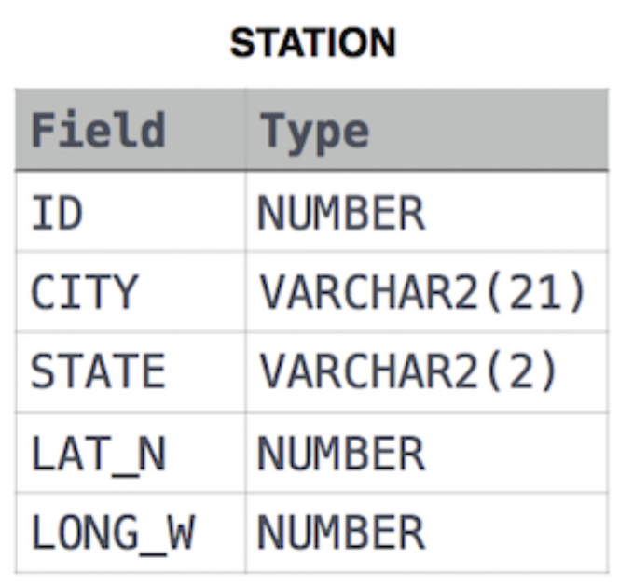

**SOLUTION :** SELECT ((SELECT COUNT(CITY) FROM STATION) - (SELECT COUNT(DISTINCT CITY) FROM STATION)) AS ANS