**Q1.**

Query the **NAME** field for all American cities in the **CITY** table with populations larger than 120000. The *CountryCode* for America is USA.

The **CITY** table is described as follows:

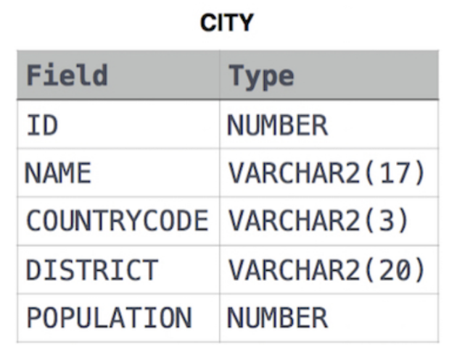

**SOLUTION** : SELECT NAME FROM CITY WHERE COUNTRYCODE = 'USA' AND POPULATION > 120000;

**Q2.**

Query the list of *CITY* names from **STATION** that *do not start* with vowels. Your result cannot contain duplicates.

**Input Format**

The **STATION** table is described as follows

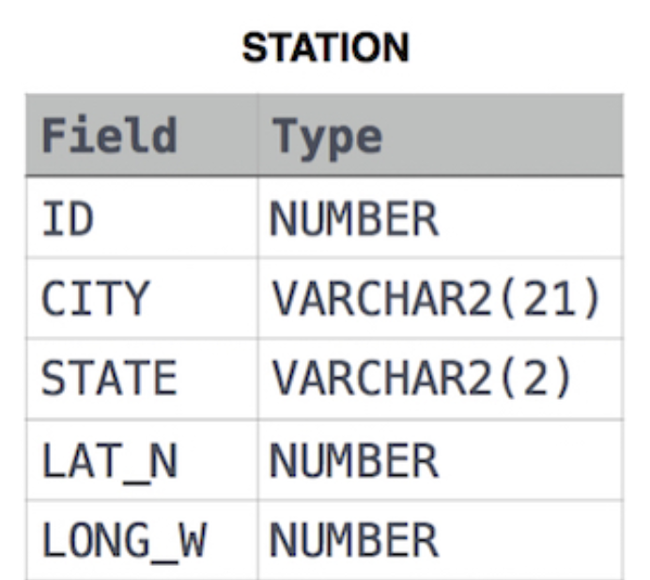

**SOLUTION** : SELECT DISTINCT CITY FROM STATION

WHERE CITY NOT LIKE 'A%'

AND CITY NOT LIKE 'E%'

AND CITY NOT LIKE 'I%'

AND CITY NOT LIKE 'O%'

AND CITY NOT LIKE 'U%';

**Q3**

Query the list of *CITY* names from **STATION** that *do not end* with vowels. Your result cannot contain duplicates.

**Input Format**

The **STATION** table is described as follows:

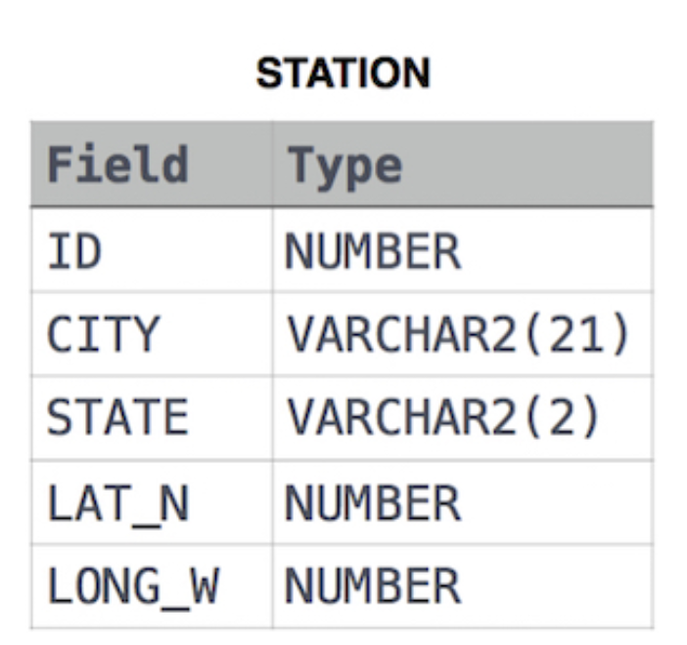

**SOLUTION** : SELECT DISTINCT CITY FROM STATION

WHERE CITY NOT LIKE '%a'

AND CITY NOT LIKE '%e'

AND CITY NOT LIKE '%i'

AND CITY NOT LIKE '%o'

AND CITY NOT LIKE '%u';

**Q3.**

Query the list of *CITY* names from **STATION** that either do not start with vowels or do not end with vowels. Your result cannot contain duplicates.

**Input Format**

The **STATION** table is described as follows:

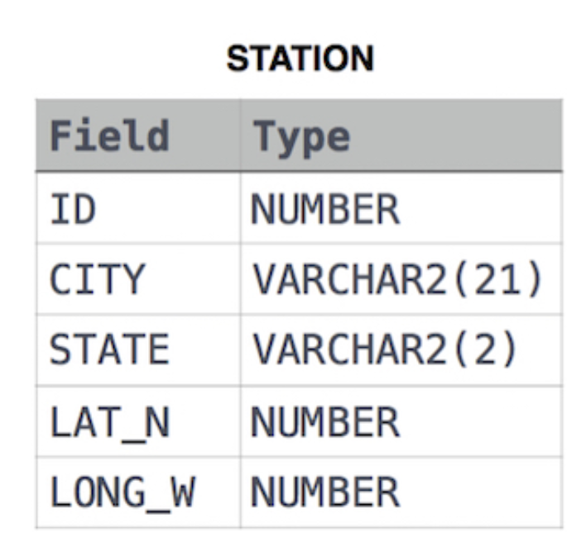

**SOLUTION** : SELECT DISTINCT CITY FROM STATION

WHERE ((CITY NOT LIKE 'A%'

AND CITY NOT LIKE 'E%'

AND CITY NOT LIKE 'I%'

AND CITY NOT LIKE 'O%'

AND CITY NOT LIKE 'U%') OR

(CITY NOT LIKE '%a'

AND CITY NOT LIKE '%e'

AND CITY NOT LIKE '%i'

AND CITY NOT LIKE '%o'

AND CITY NOT LIKE '%u'));

**Q3.**

Query the list of *CITY* names from **STATION** that *do not start* with vowels and *do not end* with vowels. Your result cannot contain duplicates.

**Input Format**

The **STATION** table is described as follows:

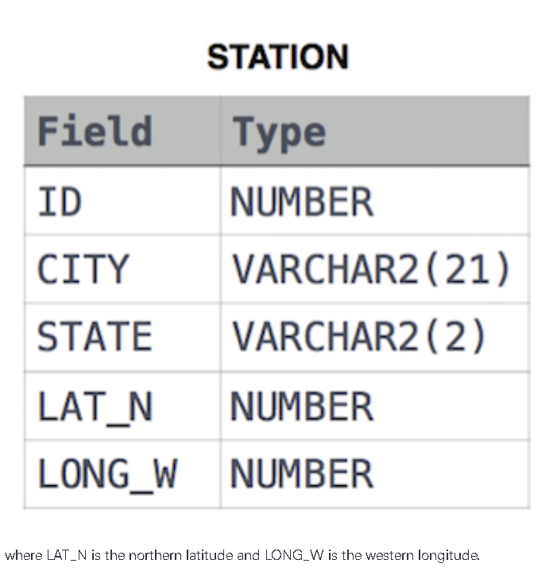

**SOLUTION:** SELECT DISTINCT CITY FROM STATION

WHERE ( CITY NOT LIKE 'A%'

AND CITY NOT LIKE 'E%'

AND CITY NOT LIKE 'I%'

AND CITY NOT LIKE 'O%'

AND CITY NOT LIKE 'U%'

AND CITY NOT LIKE '%a'

AND CITY NOT LIKE '%e'

AND CITY NOT LIKE '%i'

AND CITY NOT LIKE '%o'

AND CITY NOT LIKE '%u');