**Q1.**

Query the two cities in STATION with the shortest and longest *CITY* names, as well as their respective lengths (i.e.: number of characters in the name). If there is more than one smallest or largest city, choose the one that comes first when ordered alphabetically.  
The STATION table is described as follows:

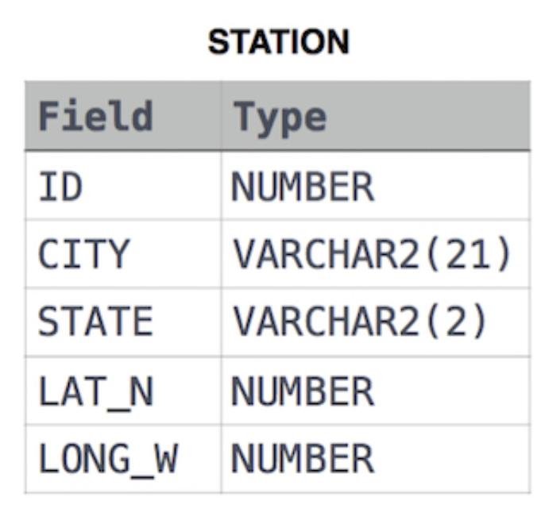

**SOLUTION :** SELECT CITY, LENGTH(CITY) FROM STATION ORDER BY LENGTH(CITY), CITY LIMIT 1;

SELECT CITY, LENGTH(CITY) FROM STATION ORDER BY LENGTH(CITY) DESC, CITY LIMIT 1;

**Q2.**

Query the list of *CITY* names starting with vowels (i.e., a, e, i, o, or u) from STATION. Your result *cannot* contain duplicates.

Input Format

The STATION table is described as follows:

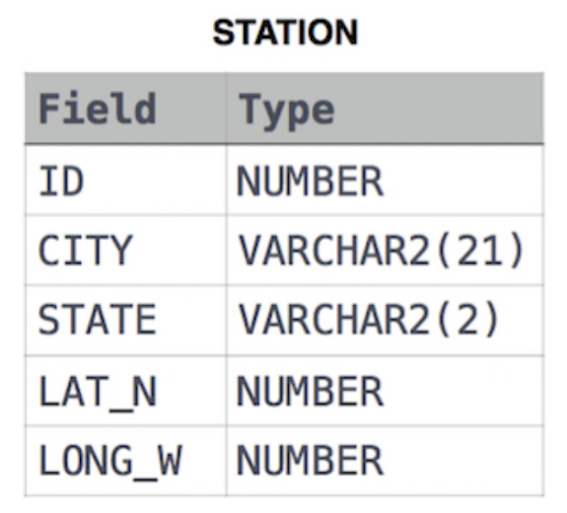

**SOLUTION :** SELECT DISTINCT CITY

FROM STATION

WHERE CITY LIKE 'A%' OR CITY LIKE 'E%' OR CITY LIKE 'I%' OR CITY LIKE 'O%' OR CITY LIKE 'U%';

**Q3.**

Query the list of *CITY* names ending with vowels (a, e, i, o, u) from STATION. Your result *cannot* contain duplicates.

Input Format

The STATION table is described as follows:

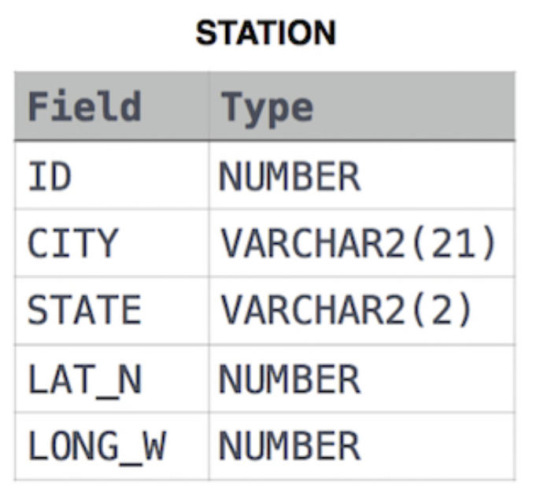

**SOLUTION:** SELECT DISTINCT CITY

FROM STATION

WHERE CITY LIKE '%a' OR CITY LIKE '%e' OR CITY LIKE '%i' OR CITY LIKE '%o' OR CITY LIKE '%u';

**Q4.**

Query the list of *CITY* names from STATION which have vowels (i.e., *a*, *e*, *i*, *o*, and *u*) as both their first *and* last characters. Your result cannot contain duplicates.

Input Format

The STATION table is described as follows:

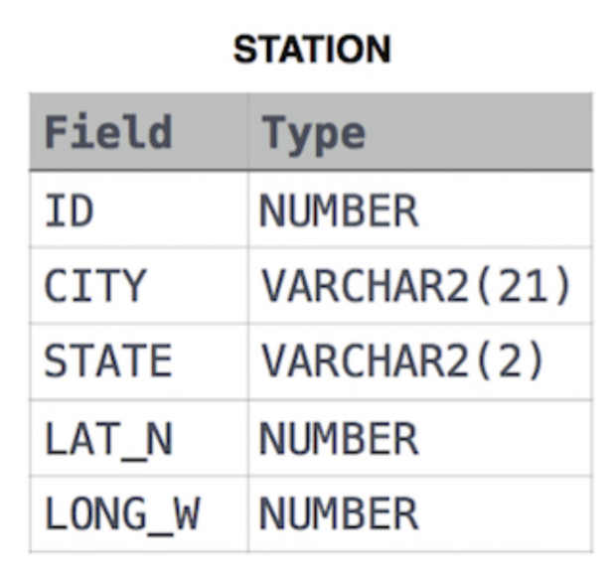

**SOLUTION :** SELECT DISTINCT CITY

FROM STATION

CITY WHERE (CITY LIKE 'A%' OR CITY LIKE 'E%' OR CITY LIKE 'I%' OR CITY LIKE 'O%' OR CITY LIKE 'U%') AND (CITY LIKE '%a' OR CITY LIKE '%e' OR CITY LIKE '%i' OR CITY LIKE '%o' OR CITY LIKE 'u%');