**Assignment-2**

--1. write a SQL query to find the salesperson and customer who reside in the same city. Return Salesman, cust_name and city

select salesman.name, customer.cust_name, customer.city from customer inner join salesman on salesman.city=customer.city;

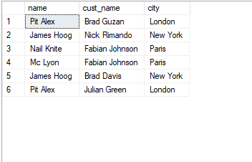

--2. write a SQL query to find those orders where the order amount exists between 500 and 2000. Return ord_no, purch_amt, cust_name, city

select ord_no, purch_amt, cust_name, city from myorders inner join customer on customer.customer_id=myorders.customer_id where purch_amt between 500 and 2000;

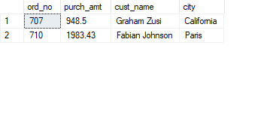

--3. write a SQL query to find the salesperson(s) and the customer(s) he represents. Return Customer Name, city, Salesman, commission

select

cust_name,c.city, name,commission

from salesman s inner join

customer c on c.salesman_id=s.salesman_id;

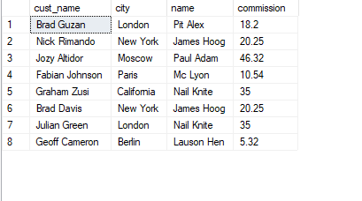

--4. write a SQL query to find salespeople who received commissions of more than 12 percent from the company. Return Customer Name, customer city, Salesman,commission.

select c.cust_name, c.city, s.name, s.commission

from customer c inner join

salesman s on c.salesman_id=s.salesman_id

where s.commission > 12;

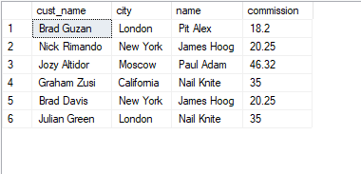

--5. write a SQL query to locate those salespeople who do not live in the same city where

--their customers live and have received a commission of more than 12% from the

--company. Return Customer Name, customer city, Salesman, salesman city, commission

select c.cust_name, c.city, s.name, s.city, s.commission

from customer c inner join salesman s

on c.salesman_id=s.salesman_id

where s.commission > 12 and c.city != s.city

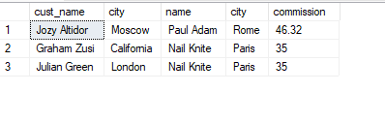

--6. write a SQL query to find the details of an order. Return ord_no, ord_date, purch_amt, Customer Name, grade, Salesman, commission

select o.ord_no, o.ord_date, o.purch_amt,c.cust_name, c.grade, s.name, s.commission

from myorders o inner join customer c

on o.customer_id = c.customer_id inner join salesman s

on o.salesman_id=s.salesman_id;

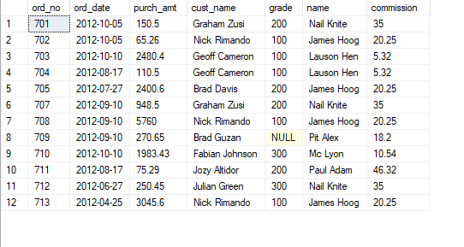

--7. Write a SQL statement to join the tables salesman, customer and orders so that the

--same column of each table appears once and only the relational rows are returned.

select *

from myorders o left join customer c

on o.customer_id = c.customer_id

left join salesman s

on o.salesman_id=s.salesman_id;

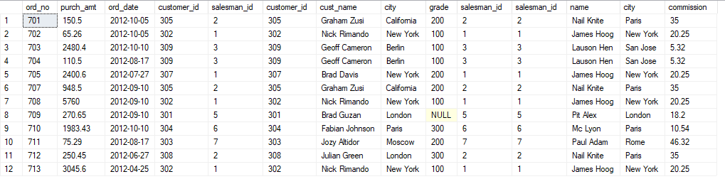

--8. write a SQL query to display the customer name, customer city, grade, salesman,

--salesman city. The results should be sorted by ascending customer_id.

select c.customer_id, c.cust_name, c.city, c.grade, s.name, s.city

from customer c inner join salesman s

on c.salesman_id=s.salesman_id

order by c.customer_id asc;

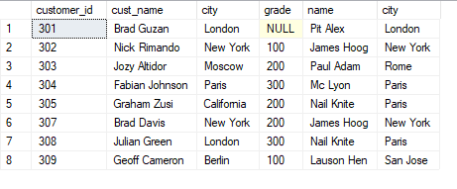

--9. write a SQL query to find those customers with a grade less than 300. Return

--cust_name, customer city, grade, Salesman, salesmancity. The result should be ordered by ascending customer_id.

select c.cust_name, c.city,c.grade, s.name, s.city

from customer c inner join salesman s

on c.salesman_id=s.salesman_id

where c.grade < 300

order by c.customer_id asc;

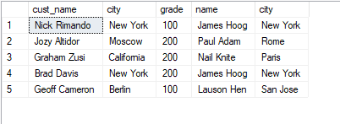

--10. Write a SQL statement to make a report with customer name, city, order number, order date, and order amount in ascending order according

--to the order date to determine whether any of the existing customers have placed an order or not

select c.cust_name, c.city,o.ord_no, o.ord_date, o.purch_amt

from customer c inner join myorders o

on c.customer_id=o.customer_id

order by o.ord_date asc;

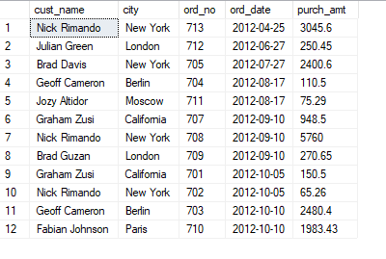

--11. Write a SQL statement to generate a report with customer name, city, order number,order date, order amount, salesperson name, and commission to

--determine if any of the existing customers have not placed orders or if they have placed orders throughtheir salesman or by themselves

select c.cust_name,c.city,o.ord_no,o.ord_date,o.purch_amt,s.name,s.commission

from customer c

left join myorders o

on c.customer_id=o.customer_id

left join salesman s

on c.salesman_id=s.salesman_id;

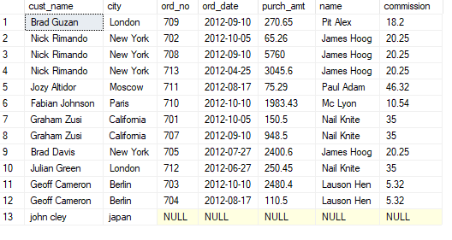

--12. Write a SQL statement to generate a list in ascending order of salespersons who

--work either for one or more customers or have not yet joined any of the customers

select s.name, c.cust_name

from salesman s left join customer c

on s.salesman_id = c.salesman_id;

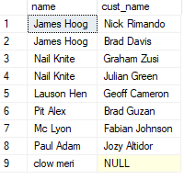

--13. write a SQL query to list all salespersons along with customer name, city, grade, order number, date, and amount.

select s.name, c.cust_name, c.city, c.grade, o.ord_no, o.ord_date, o.purch_amt

from salesman s

left join customer c

on s.salesman_id=c.salesman_id

left join myorders o

on s.salesman_id=o.salesman_id;

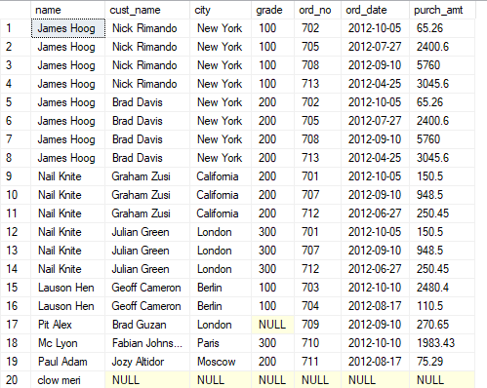

--14. Write a SQL statement to make a list for the salesmen who either work for one or

--more customers or yet to join any of the customers. The customer may have placed,

--either one or more orders on or above order amount 2000 and must have a grade, or

--he may not have placed any order to the associated supplier.

select distinct s.name

from salesman s

left join customer c

on s.salesman_id=c.salesman_id

left join myorders o

on c.customer_id=o.customer_id

where o.purch_amt > 2000 and c.grade is not null;

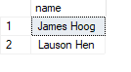

--15. Write a SQL statement to generate a list of all the salesmen who either work for one

--or more customers or have yet to join any of them. The customer may have placed

--one or more orders at or above order amount 2000, and must have a grade, or he

--may not have placed any orders to the associated supplier.

select distinct s.name

from salesman s left join customer c

on s.salesman_id=c.salesman_id

left join myorders o

on s.salesman_id=o.salesman_id

where o.purch_amt>2000 and c.grade IS NOT NULL;

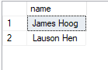

--16. Write a SQL statement to generate a report with the customer name, city, order no.

--order date, purchase amount for only those customers on the list who must have a

--grade and placed one or more orders or which order(s) have been placed by the

--customer who neither is on the list nor has a grade.

select c.cust_name, c.city, o.ord_no, o.ord_date, o.purch_amt

from myorders o left join customer c

on o.customer_id=c.customer_id

where c.grade is not null

or o.salesman_id is null;

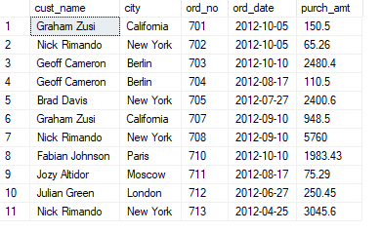

--17. Write a SQL query to combine each row of the salesman table with each row of the customer table

select *

from salesman s full join customer c

on s.salesman_id = c.salesman_id;

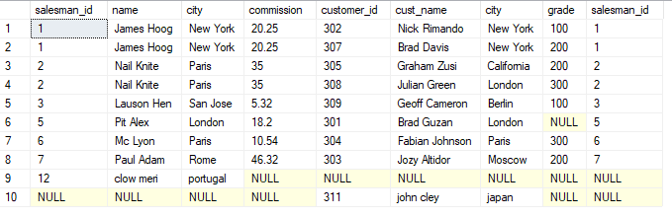

--18. Write a SQL statement to create a Cartesian product between salesperson and

--customer, i.e. each salesperson will appear for all customers and vice versa for that

--salesperson who belongs to that city

select s.name ,

c.cust_name

from salesman s

cross join customer c

where s.city is not null;

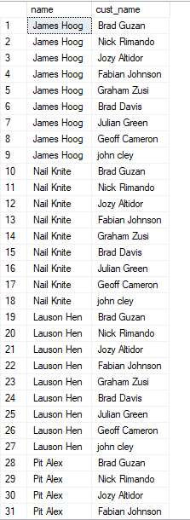

--19. Write a SQL statement to create a Cartesian product between salesperson and

--customer, i.e. each salesperson will appear for every customer and vice versa for

--those salesmen who belong to a city and customers who require a grade

select s.name, c.cust_name, c.city, c.grade

from salesman s cross join customer c

where s.city is not null

and c.grade is null;

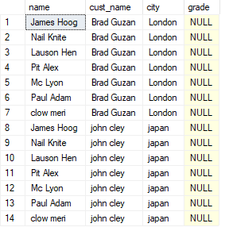

--20. Write a SQL statement to make a Cartesian product between salesman and

--customer i.e. each salesman will appear for all customers and vice versa for those

--salesmen who must belong to a city which is not the same as his customer and the

--customers should have their own grade

select s.name, c.cust_name, c.city, c.grade

from salesman s cross join customer c

where s.city != c.city

and c.grade is not null;

