1.)Bulk posting upload/Bulk schedule via csv
1.1) BulkVideoUpload
(image1)
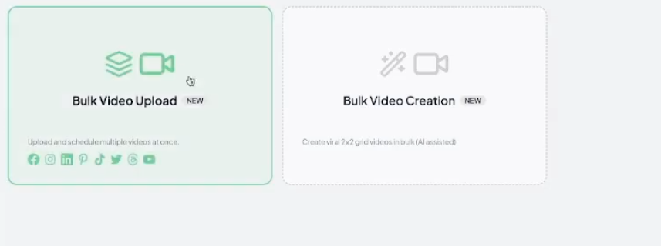

image2
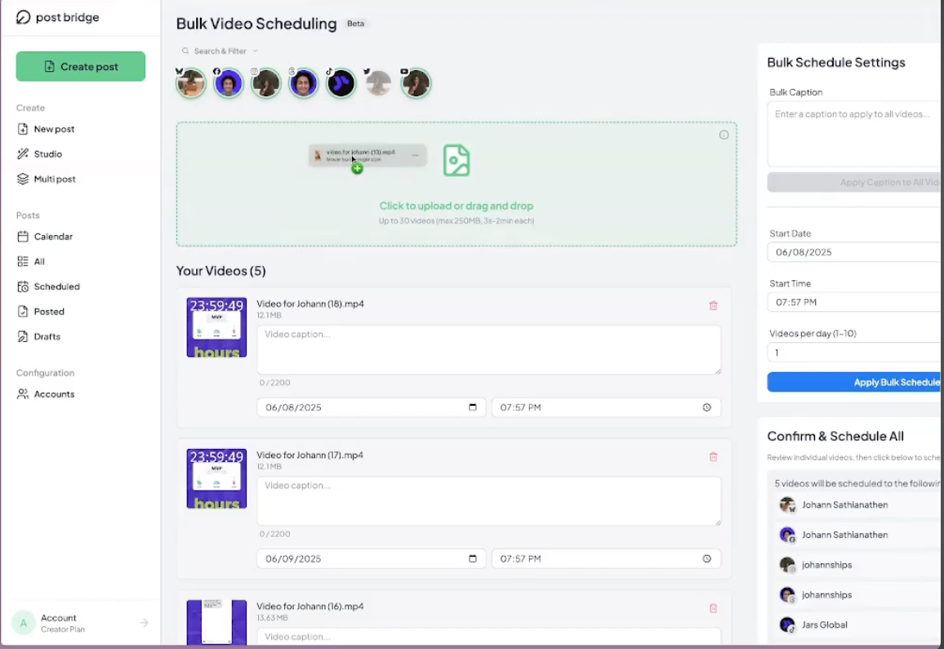
In our application inside the Bulk video tab is there in the rigth side
when we click that I want it to open like the UI in image1.
Then when we click on bulk video upload
our ui should be similar to 2nd image
it should have clik to upload or drag and drop section to upload video
once use upload a video then for each video we should see separate section to write video caption date and time and on the left side bulk schedule ssetting common for all uploaded video. at the top we should also see all the connected accounts.
design the ui similar to image
once scheduled it should be visible in calender in scheduled tab and all tabs.
1.2) For this now again in Image1 we have bulk video creation change the name to Bulk Upload via csv
when we clik that a window should popup like below image
(image3)
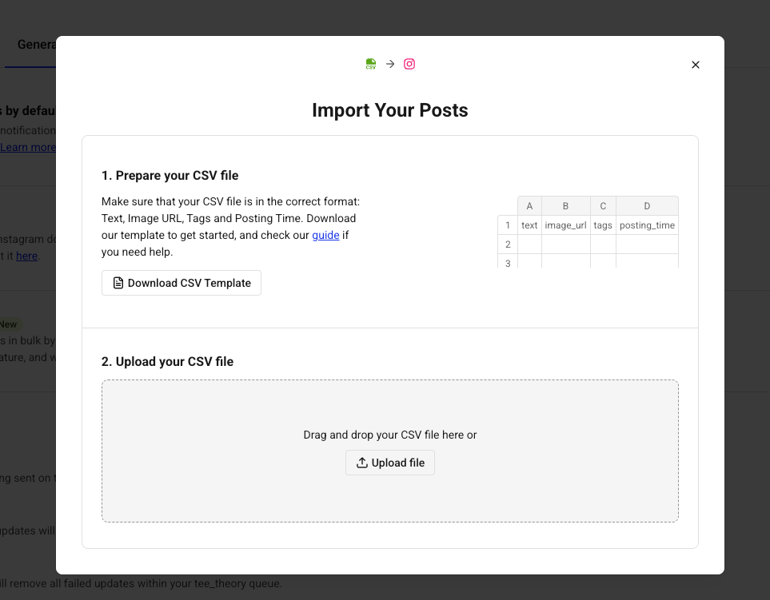
an option to upload csv and an option to download csv template which when cliked should download a csv file with a template.
after that when a user uploads a csv a below kind of window should showup
image4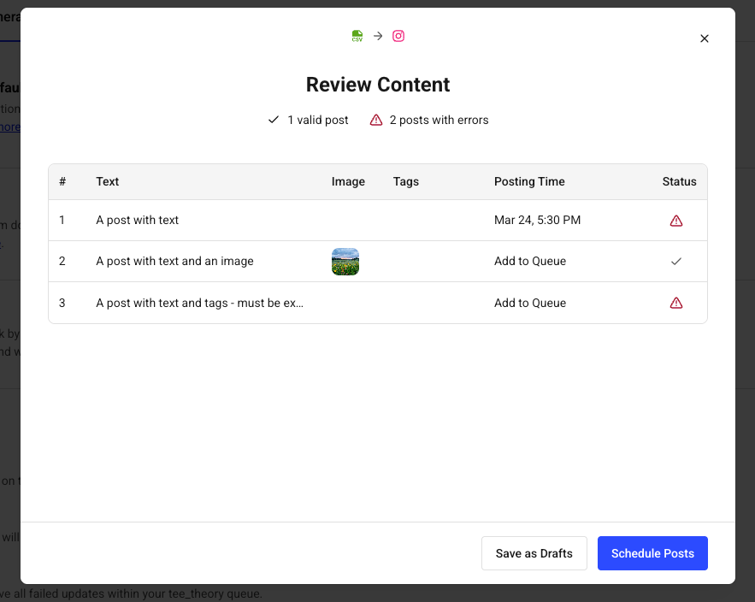
in this window we are checking the uploaded csv and showing which is correct and which is wrong and at bottom option to schedule upload(validation).
This below link is for reference and I want a silimar link to be opend for our application.
https://support.buffer.com/article/926-how-to-upload-posts-in-bulk-to-buffer
This is the link to guide to upload csv as u can see in the previous image
I want a similar page with a link as a guide just like in the previous image.
Go through the content in this link and create a similar page whit he instructions and link it to our application. .
for our application CSV format design should be like
Content, platforms, accounts, scheduled_time, timezone,
image_urls, video_url, title, tags, post_type
or validation logic will be like this below

CSV Column Validation Rules
Column | Required | Default if blank | Format & accepted values | Errors (blocks import) | Warnings (non-blocking)
content | Conditional | — | Plain text. UTF-8 or UTF-16 (required for emoji). At least one of content, image_urls, or video_url must be present. | - All three media fields empty  - Exceeds platform char limit | - Instagram: over 125 chars will be hidden behind "more"  - LinkedIn: over 140 chars collapses to "See more"
platforms | Yes | — | Comma-separated. Case-insensitive.  instagram · youtube · twitter · tiktok · linkedin · facebook · bluesky | - Missing or empty  - Unrecognised platform name | —
accounts | No | All workspace accounts | Exact display name as shown on Accounts page. Comma-separated for multiple. Use all to target every account. | - Account name not found in workspace | - More than 1 account per platform in same row
scheduled_time | No | Auto-queue to next available slot | YYYY-MM-DD HH:mm  MM/DD/YYYY HH:mm  MM/DD/YYYY HH:mmAM/PM  DD/MM/YYYY HH:mm | - Date is in the past  - Date more than 365 days ahead  - Unrecognisable format | - Within 2 min of now  - Ambiguous DST transition (EC10)
timezone | No | Workspace default | IANA string e.g. America/New_York, Asia/Kolkata | - Invalid IANA timezone string | —
image_urls | No | — | Direct URLs ending in .jpg .png .webp .gif. Separate multiple with ||. Google Drive & Dropbox direct-link formats accepted. Max 10 URLs per row. | - Invalid URL format  - Not publicly accessible (SSRF)  - image_urls + video_url both present  - More than 10 URLs | - URL doesn't end in image extension  - Image over 5 MB may fail
video_url | No | — | Single direct URL. Google Drive (<100 MB) and Dropbox direct links accepted. Cannot coexist with image_urls. | - Invalid URL format  - Not publicly accessible  - Both video_url + image_urls present | - Google Drive video over 100 MB — Google blocks fetch
title | No | — | Plain text. Applies to YouTube (100 chars) and LinkedIn articles (150 chars) only. | - YouTube title over 100 chars  - LinkedIn title over 150 chars | - YouTube: over 70 chars cut off in search results  - title provided for platform that ignores it
tags | No | — | Comma-separated. Must be existing tags in workspace. Case-sensitive. | — | - Tag not found in workspace — silently ignored
post_type | No | Auto-detected | text · image · video · carousel · reel · story | - reel without Instagram  - story without Instagram or Facebook  - video without video_url  - carousel with video_url | —
Content character limits by platform
Platform | Content hard limit | Truncated in feed at | Title hard limit | Title visible in search
Instagram | 2,200 | 125 chars → "… more" | — | —
Facebook | 63,206 | 477 chars → "See More" | — | —
X (free) | 280 | Hard cut — post fails | — | —
X (premium) | 25,000 | — | — | —
TikTok | 4,000 | 150 chars → "see more" | — | —
LinkedIn | 3,000 | 140 chars → "See more" | 150 chars | Full title shown
YouTube | 5,000 (description) | 157 chars in search | 100 chars | 70 chars visible
Validation layers — order of execution
Layer | Checks | When
1 · File | File is .csv · encoding is UTF-8 or UTF-16 · size <10 MB · row count within plan limit · required column headers present | On file upload
2 · Structure | At least one of content / image_urls / video_url present · image_urls and video_url not both present · platforms not empty · no completely empty rows | Per row, no DB
3 · Platform | Platform names valid · post_type compatible with platforms · Instagram requires image or video · content length within each platform's limit | Per row, no DB
4 · Content | Title within limit for YouTube / LinkedIn · first_comment length · tags format | Per row, no DB
5 · DateTime | Date parseable in one of 4 accepted formats · not in the past · not >365 days ahead · valid IANA timezone · not an ambiguous DST time (EC10) | Per row, no DB
6 · URLs | Valid URL format · ends in image extension (or Google Drive / Dropbox pattern) · max 10 images · no localhost / 169.254.x.x / private IP (SSRF, Rule 12) | Per row, no network
7 · Schedule | Account names exist in workspace · daily platform posting limit not exceeded for any day · scheduling conflict within 30-min window for same account | Per row, DB call

ok so when we will be applying validation and reading the csv we will show error for all the row which are not passing the validation
but we will taking the rows which is passing the validation
2. Social Tools
I want this section in header in Landing page as well as a dedicated section in right side bar when the user logs in.
Remove Insatgram grid section and place this section there “SocialTools”
now once we click that
it should open like below make the uis similar to below image.
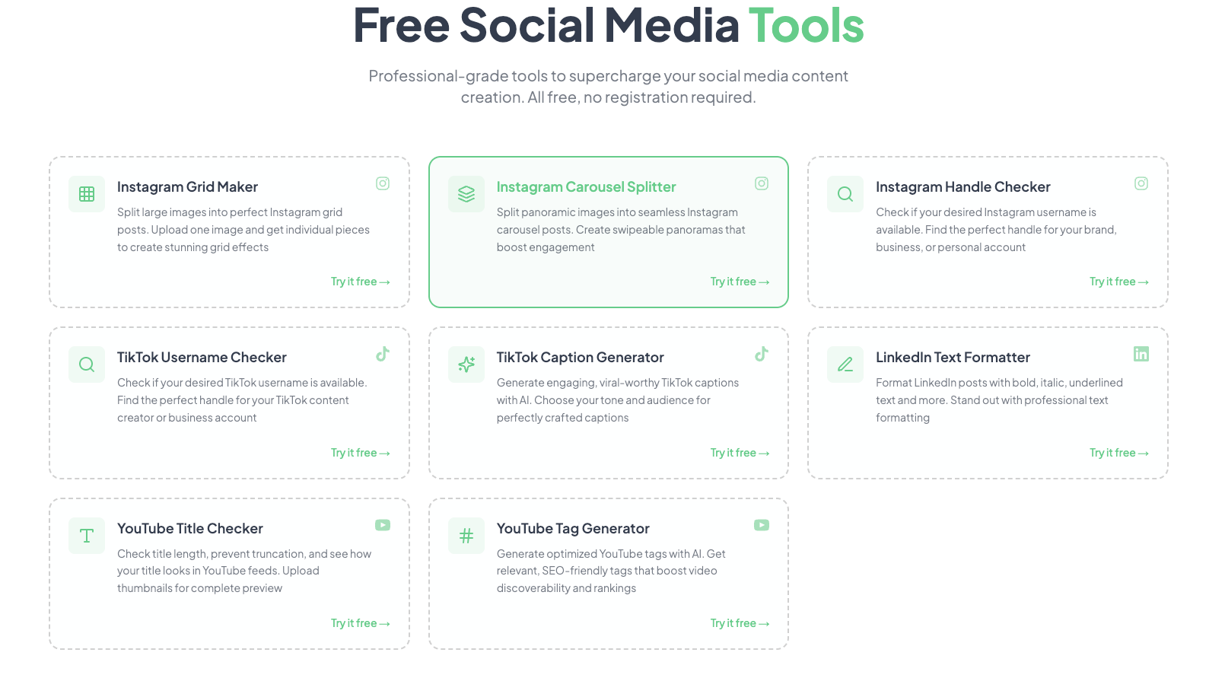
2.1 )Instagaram Grid maker
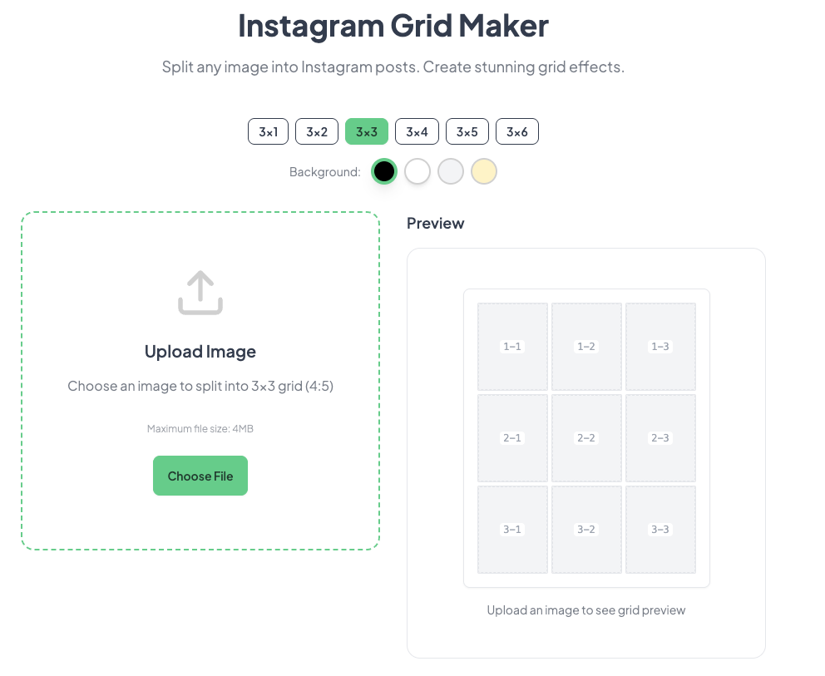
after uploading image
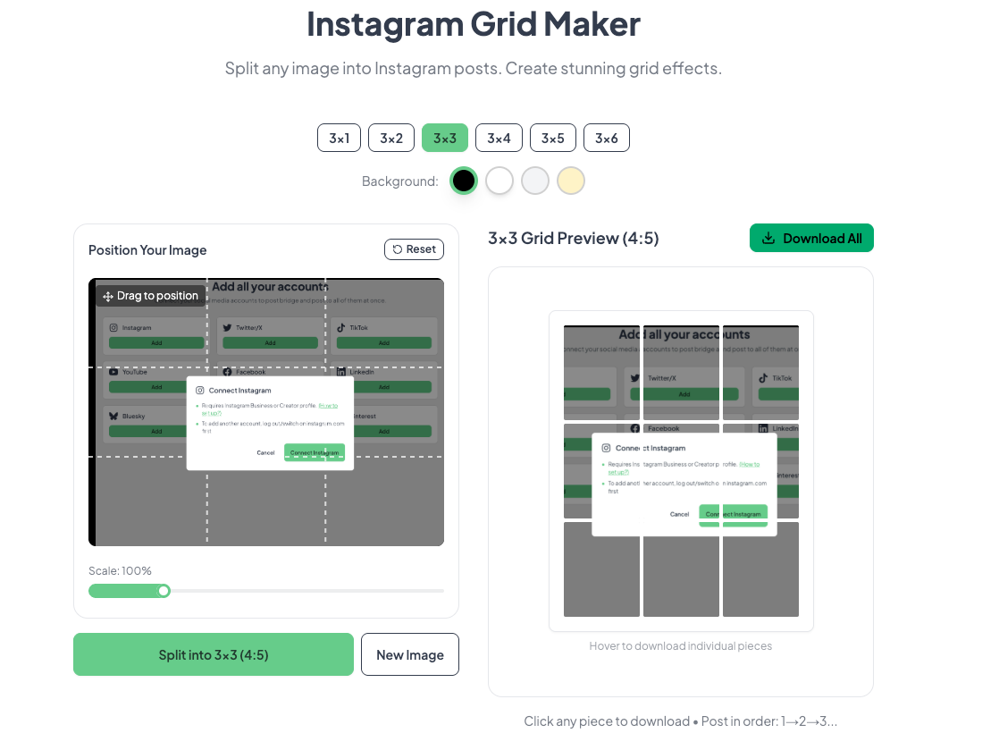
add below at the botoom in the same page.
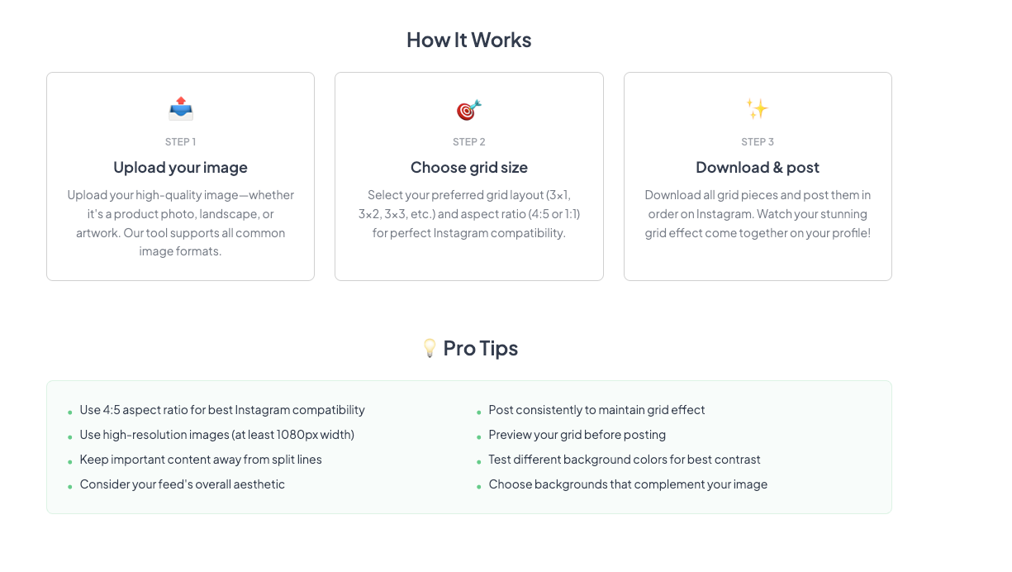
our aplication should also look similar and work properly
when we click download all it should give us a zip file will all the grid images with proper marking as image 1,2,….etc.
2.2 Instagaram Carousel spiltter
Ui should look like below image
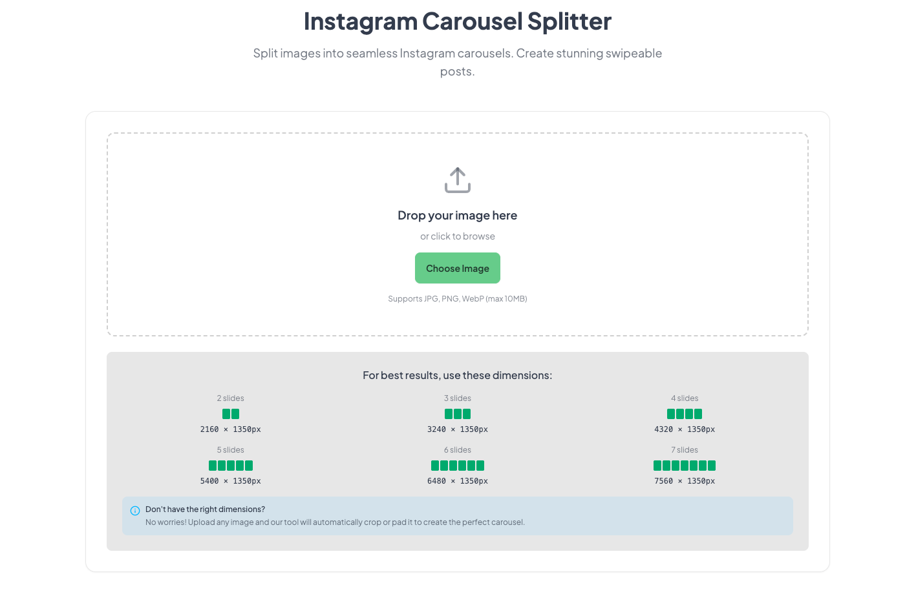
after uploading image
3.) TimeSlots
Creating a timeslot allows you to set predetermined timeslots for your posts, such as every weekday at 12:30 PM. When you choose "Add to Timeslot", that post will be added to the next unfilled timeslot under that category and account.

below is the image for ur UI reference
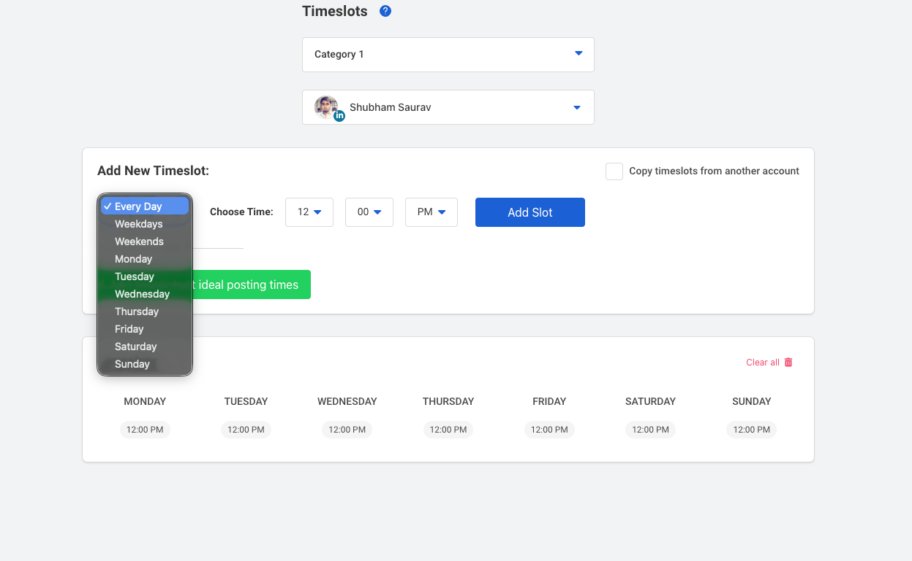
so I want to add one section called as Timeslots in side bar menu
which when clicked then the ui should look something like the above image
where we have one category drop down another dropdown to select connected account
and then time slot with a option in dropdowen as shown in the image
once selected it show show bellow week with the selected timeslot with a save button.
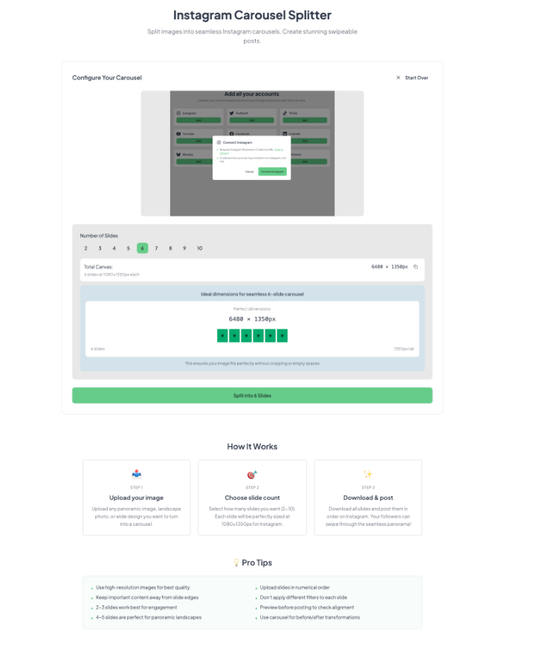
this feature should cut the image into carousel based on the values selected in the ui and download all image in a zip with proper marking.

