**Billing Trends Across Genders**

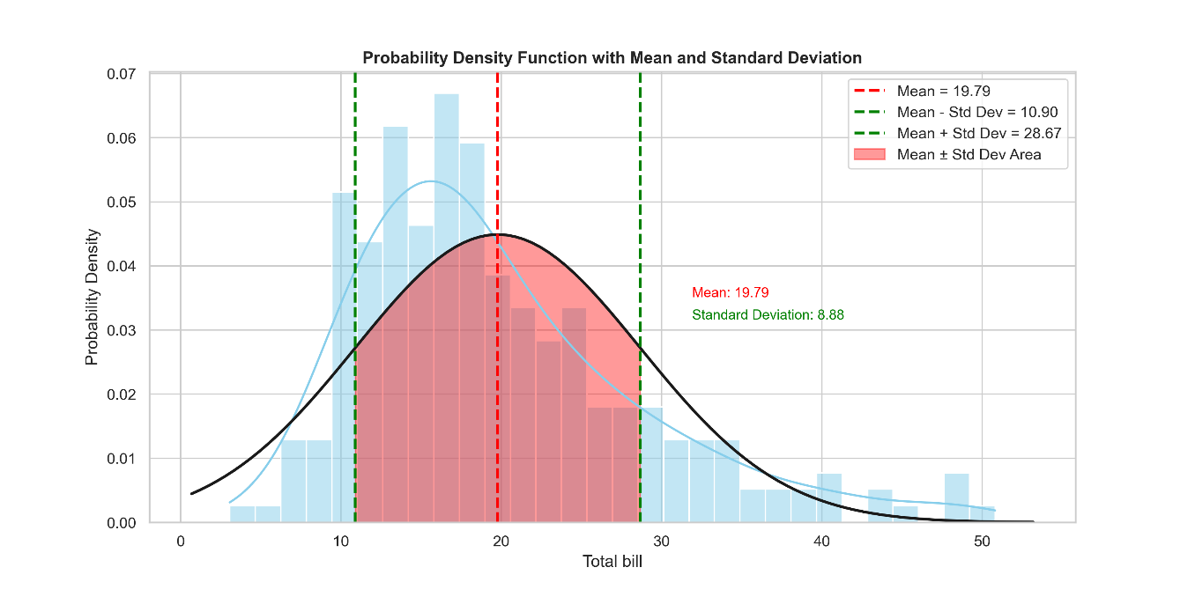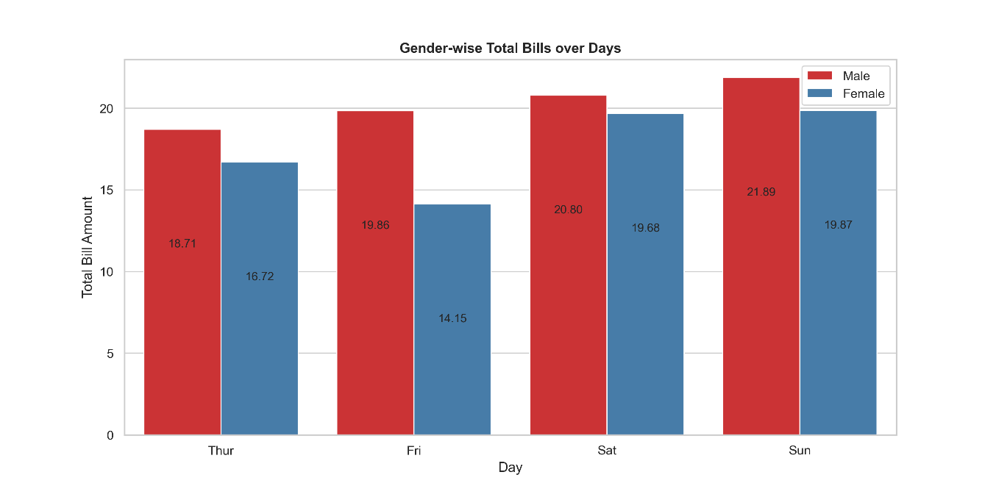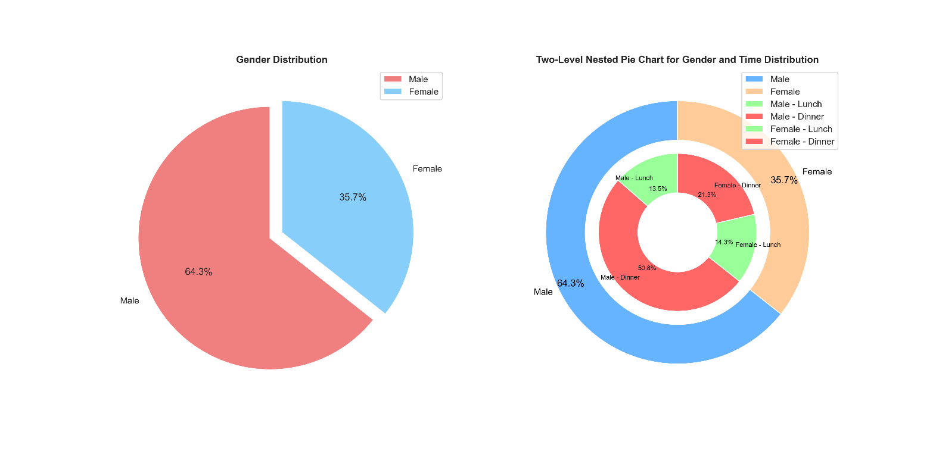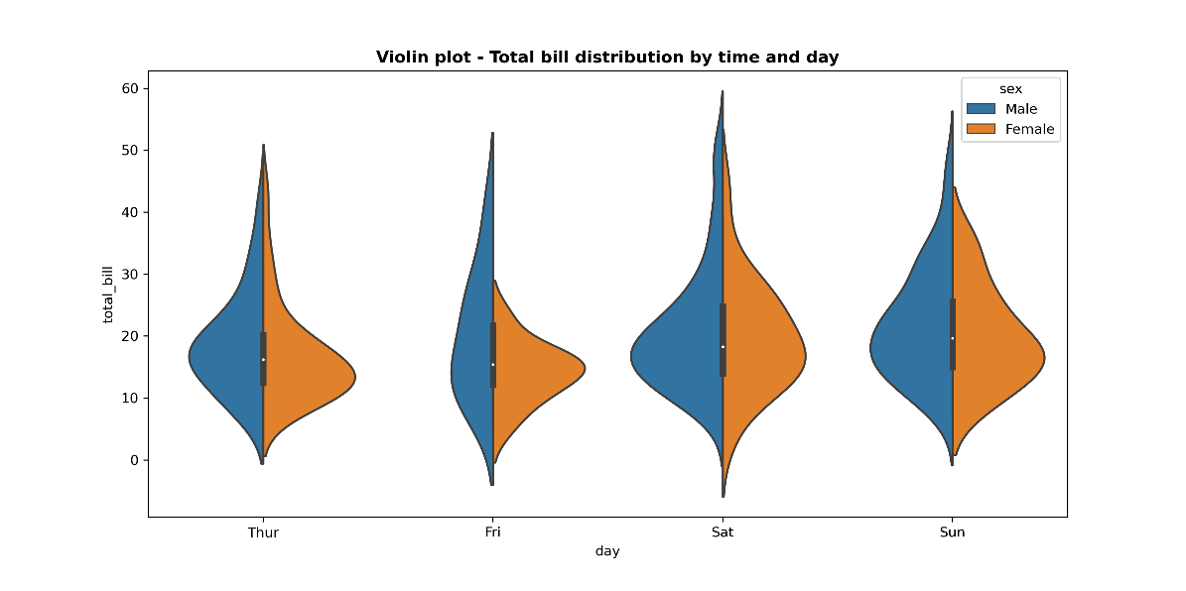

The information provided shows the probability density function (PDF) for total invoices, showing a mean of $19.79 and a standard deviation of $8.88. This means that 68% of bills are likely to be between $10.90 and $28.67. The data also shows that men generally spend more on their bills than women on different days, with total bill amounts by gender appearing from Thursday to Sunday. The two-level pie chart shows the distribution by gender: 64.3% women, 35.7% men, with differences in preferred time; More women visit for lunch and more men for dinner. On Saturday, males tend to have higher total bills compared to females. On Sunday, the distribution of total bills is more spread out for females compared to males, with a few very high outliers. This suggests that there are distinct habits when it comes to weekend spending. Males tend to lean towards higher expenditures on Saturdays, while females show a wider range of total bills on Sundays, which could possibly be influenced by these outliers.