Note:- In the code separate function is created for every question and called it just below where it created. To test function, tester can also call function one by one, by commenting other function calls.

Q1. Read CSV

Q2. Print CSV

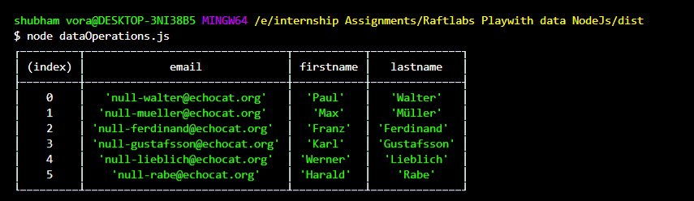

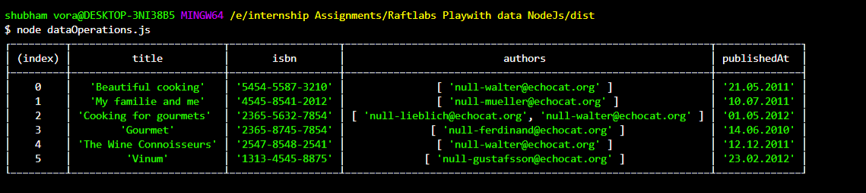

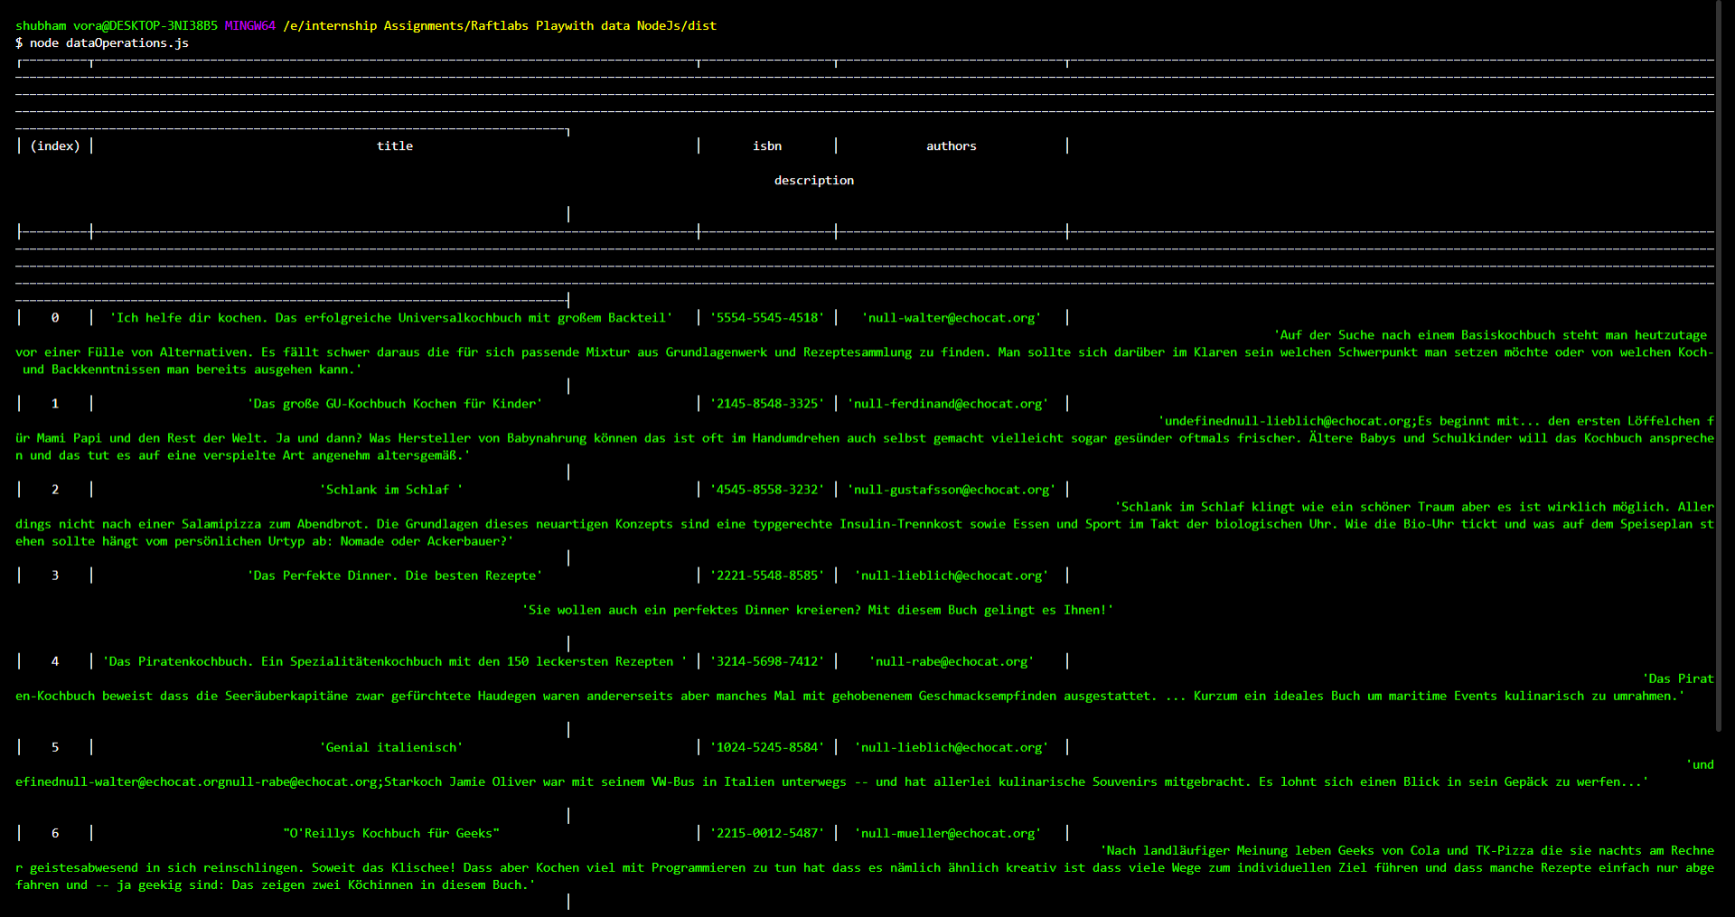

Q3. Find book or magazine which has isbn “5454-5587-3210”

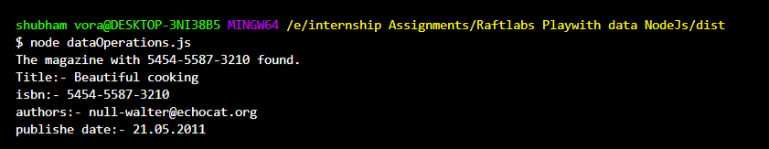

Q4. Find book or magazine which has author ’null-walter@echocat.org’

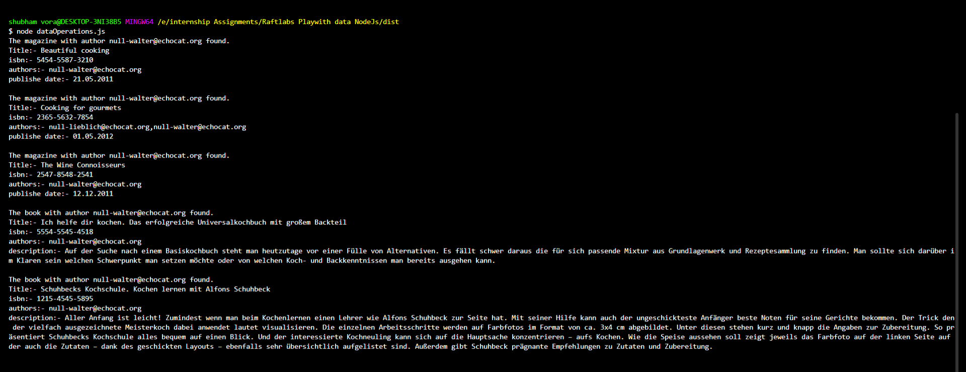

Q5. Print book and magazine details in sorted order.

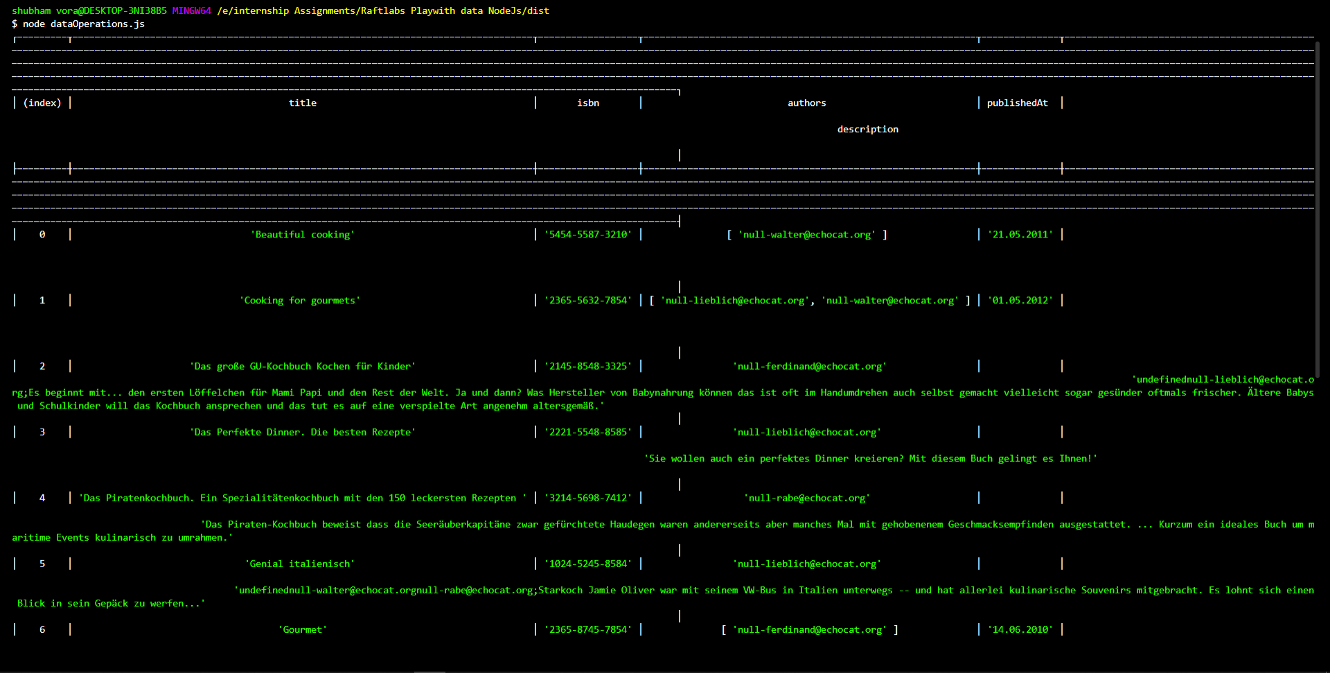

Q6. Export to CSV

Initially

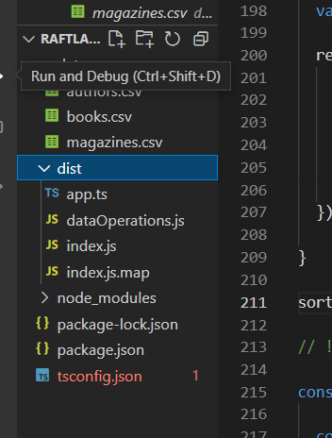

After generating CSV

