The Logistic Function, often called the Sigmoid function, is the core component of Logistic Regression. It transforms any real number into a value between 0 and 1, making it ideal for modeling probabilities in classification problems.
Concept of the Logistic Function (Sigmoid)
The Logistic Function, denoted as σ(z), is defined by the formula:
σ(z)=$\frac{1}{1+ⅇ^{-z}}$ ​
Where:
- z is the input (the result of the linear combination of features and weights: z=β0​+β1​x1​+⋯+βn​xn​).
- e is the base of the natural logarithm (approximately 2.718).
Key Properties:
- S-Shape: The function produces a characteristic S-shaped curve.
- Output Range: The output σ(z) always falls strictly between 0 and 1.
- Interpretation: This output is interpreted as the probability P(Y=1∣X), i.e., the probability that a given observation X belongs to the positive class (class 1).
- Threshold: At z=0, the sigmoid output is 0.5. This is typically the decision boundary:
  - If σ(z)≥0.5, the observation is classified as Class 1 (Positive).
  - If σ(z)<0.5, the observation is classified as Class 0 (Negative).

🔄 Difference between Logistic and Linear Regression
While both algorithms use a linear equation (z=β0​+β1​x1​+…), they differ fundamentally in their purpose and output function.
Feature | Linear Regression | Logistic Regression
Problem Type | Regression (Predicting continuous values) | Classification (Predicting categories or probabilities)
Output Range | −∞ to +∞ | 0 to 1 (A probability)
Core Equation | y=z | P(y)=σ(z)
Activation | None (Output is the linear combination itself) | Uses the Sigmoid (Logistic) Function to squash the output to [0,1].
Cost Function | Mean Squared Error (MSE) | Log Loss (Cross-Entropy)
Export to Sheets
Crucial Point: Logistic Regression is essentially Linear Regression passed through a Sigmoid activation function. The sigmoid function allows the output to be interpreted as a probability.

Logistic Regression is a statistical model used for binary classification, meaning it predicts the probability that an instance belongs to one of two classes (e.g., Yes/No, 0/1, True/False). Despite the name, it's a classification algorithm, not a regression one.
Here is a detailed breakdown of how Logistic Regression works, covering the three main stages: the Linear Model, the Logistic Function, and the Cost Function.

1. The Linear Model (The Input)
Like Linear Regression, the process starts by calculating a linear combination of the input features and their corresponding weights (coefficients). This intermediate result, often called z, can range from −∞ to +∞.
The equation is:
z=β0​+β1​x1​+β2​x2​+⋯+βn​xn​
Where:
- z is the linear predictor.
- β0​ is the bias (or intercept).
- βi​ are the weights (coefficients) the model learns.
- xi​ are the input features.

2. The Logistic Function (The Transformation)
The core difference from Linear Regression is that z is passed through the Sigmoid (Logistic) Function (σ) to transform the output into a probability.
The Sigmoid Function
The Sigmoid function, σ(z), squashes any real-valued input z into an output between 0 and 1.
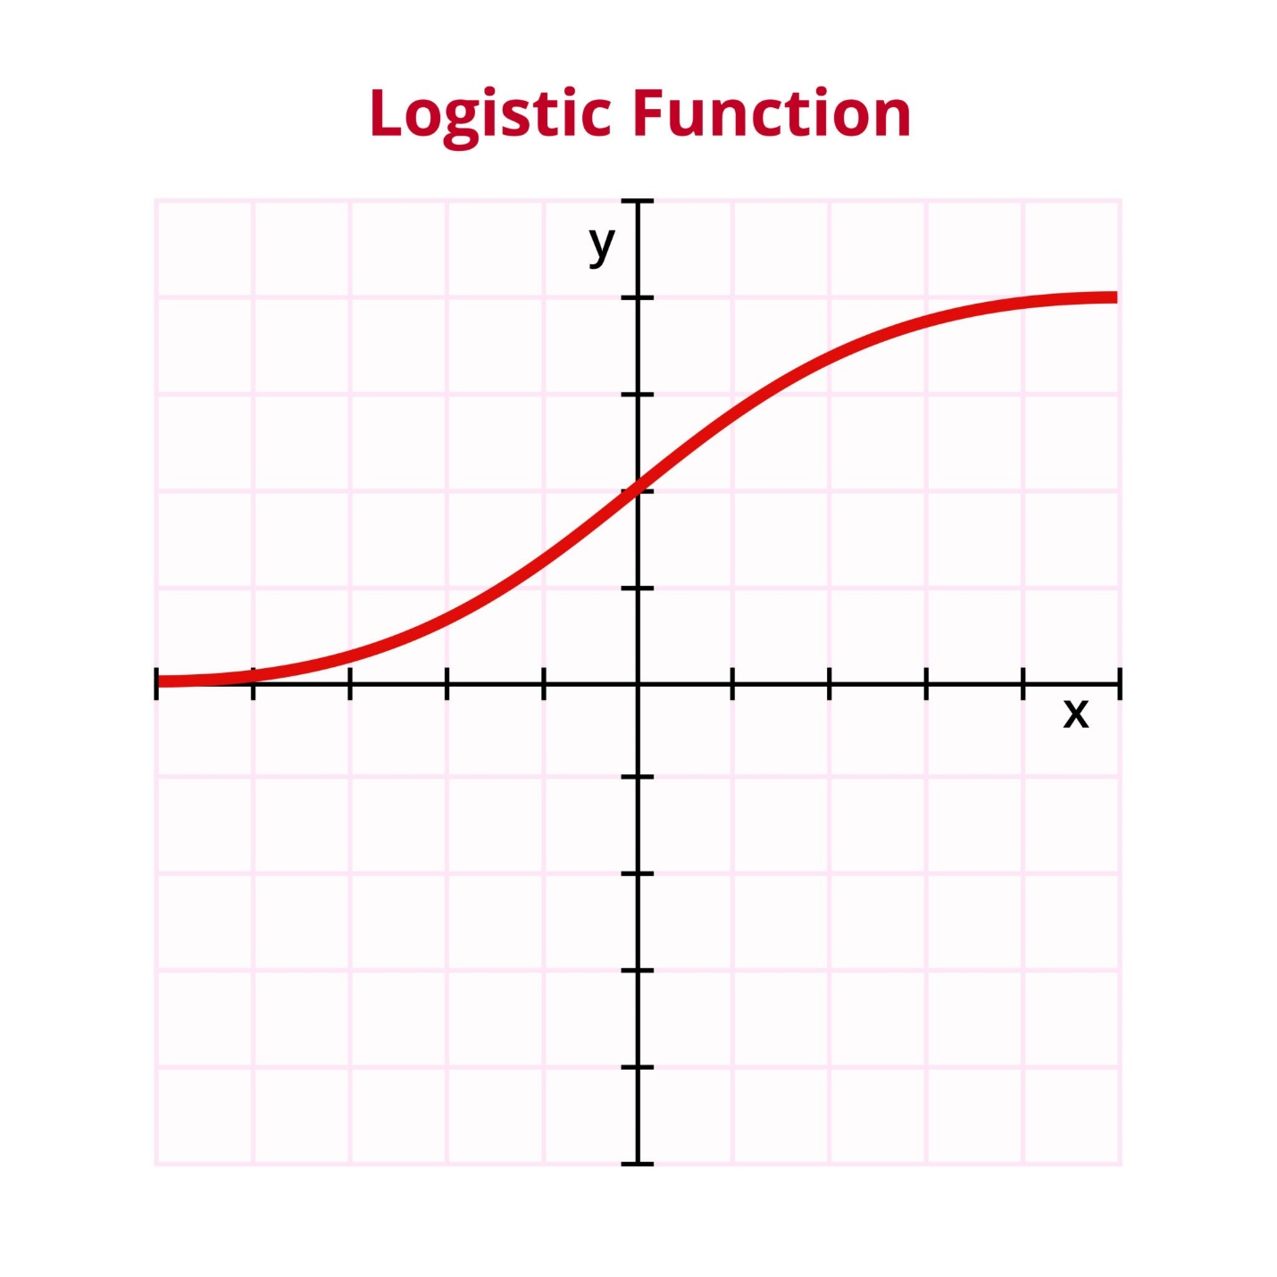
σ(z)=$\frac{1}{1+ⅇ^{-z}}$
Interpretation as Probability
The output σ(z) is interpreted as the estimated probability p^​ that the input instance belongs to the positive class (Class 1):
p^​=P(y=1∣x)=σ(z)
Decision Boundary
The model classifies an instance based on a threshold, usually 0.5:
- If p^​≥0.5, the model predicts Class 1.
- If p^​<0.5, the model predicts Class 0.

3. The Cost Function (Log Loss / Cross-Entropy)
The goal of training is to find the optimal weights (β) that minimize the difference between the predicted probabilities (p^​) and the actual class labels (y). Since the output is a probability, Logistic Regression cannot use Mean Squared Error (MSE), which is used for continuous outputs. Instead, it uses Log Loss, also known as Binary Cross-Entropy.
The loss function penalizes incorrect predictions severely:
- If the actual class is 1 (y=1): The penalty increases as the predicted probability p^​ approaches 0. The loss is −log(p^​).
- If the actual class is 0 (y=0): The penalty increases as p^​ approaches 1. The loss is −log(1−p^​).
This is combined into the single equation for a single training instance:
Cost=−ylog(p^​)−(1−y)log(1−p^​)
The total cost is the average of the costs for all training instances.

4. Optimization (Gradient Descent)
The model uses an optimization algorithm, most commonly Gradient Descent, to iteratively adjust the weights (β) by finding the gradient (slope) of the cost function with respect to each weight.
- Start: Initialize weights (β) randomly.
- Calculate Gradient: Compute the partial derivative of the cost function for each weight to see how much a small change in that weight affects the error.
- Update Weights: Adjust the weights in the direction that decreases the cost (the negative gradient), controlled by the learning rate.
- Repeat: Repeat steps 2 and 3 until the cost function reaches a minimum value or stops decreasing significantly.
This process ensures the model learns the β values that best separate the two classes in the feature space.

