**Team 7**

**Pietro Sainaghi**

**Shubham Kiran Wani**

**Rodrigo Uribe**

**Huajing Zhao**

**Project Proposal, Button Hook**

**Motivation & Background**

Dressing is an important activity of daily living that may be difficult for people with cognitive impairments or limited dexterity. With the development of combined visual-haptic perception and robotics for deformable object manipulation, various studies investigated how to best place clothes on a human body using a robot. However, no robotic button fastening solution currently exists.

Computer vision can be used to monitor robot position and contacts with the environment. However, due to visual occlusion and an inability to sense forceful physical interactions with the environment, vision alone is insufficient. Thus, we seek to leverage tactile sensing for robot-assisted button fastening, where a tactile-based shear force and slip detection model will be built to manipulate a tool that physically interacts with the environment.

Existing work on tactile-driven object manipulation control relies on slip and shear estimation between robotic fingers and object. Models have been designed to estimate slip and shear force using tactile information from the BioTac sensor \cite{su2015force} and the GelSight sensor \cite{james2020slip}. However, most existing work involves only the detection of slip and the measurement of fingertip forces for finger-object contacts.

In contrast, we will additionally consider shear and slip between the button hook tooltip and the button (tool-environment) contact, which is an underexplored area of study. Therefore, we plan to build a characterization model to classify the tool-environment contact using tactile sensors located at the finger-tool interface.

**Functionality & Task**

In order to effectively button a shirt, this hypothetical robot would use a mechanism similar to commercially available button hooks \cite{} which are commonly used, as shown in figure 1, to allow for physically impared individuals to not have to rely on their fingers to close a buttoned shirt.

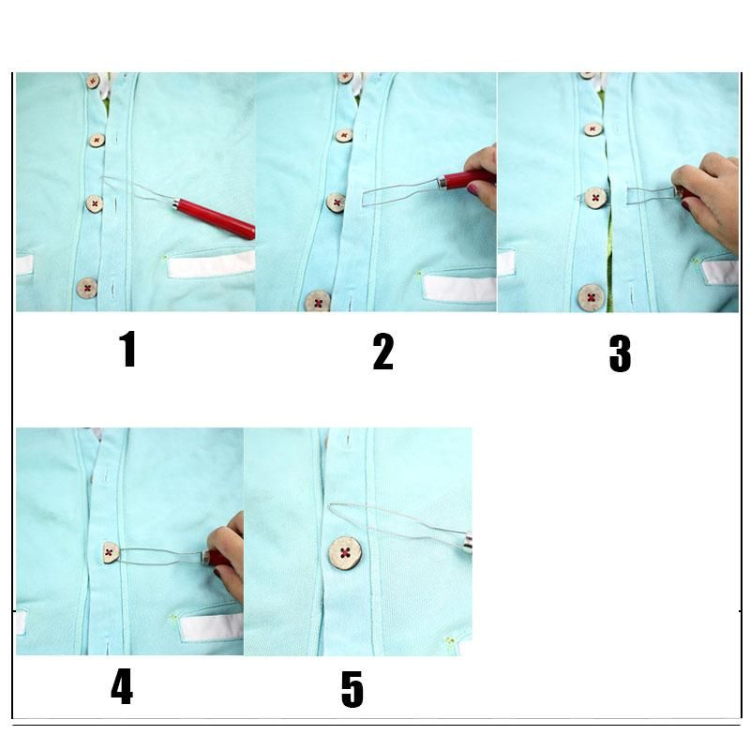

Figure 1. Functionality of button hook.

We will use a 7-DOF kinova 2 arm, which has already been used for dressing applications, with a three digit gripper mounted with Biotac fingers to grip on the buttonhook. The robotic gripper will grip on the buttonhook handle while performing the buttoning task. Once the button hook has been looped around and is in contact with the button, tactile and proprioceptive feedback becomes especially important.

The model detects \textit{slip} and characterizes \textit{shear} force, which are important features for the robotic grasp and manipulation of tools. We expect dynamic contact forces at the button hook tooltip during the complex physical interaction with the shirt and the button. While the binary detection of slip between the fingertip and the tool will be useful for adjusting grip force, we believe that shear force will be especially useful for estimating the manipulation state.

Detecting slip between the tooltip and the environment will be a novel contribution, as they are in relative motion and dynamic contact, with slip being necessary for task completion.

In order to model contacts at both locations of interest (finger-tool and tool-environment), we propose to perceive the of hook as a slender and flexible elastic beam structure, and build simulation model to deconvolve slip and shear force signals, and apportion slip and/or shear force between the two contact locations.

**Project Overview**

In order to correctly synthesize the motion and deformation of the button hook, the rod model will be used. Given the fact that the motion of going through the button slit, and subsequently hooking the button, is three-dimensional, the tension-torsion-bending model for 3-d rods should be used.

In order to maintain its functionality, the hook should actively spring back into its ‘normal’ shape, meaning that, when configuring the equilibrium position for the torsional springs, this should be taken into account.

In terms of possible design and trade studies relative to this project, the following parameters may be of interest to the overall purpose of this project:

* Effects rod deformation on forces felt by the end effector of the manipulator operating the hook
* Effects of different stiffness values (torsional, linear, bending) on motion and functionality of the hook
* Effects of different hook shapes on motion and performance

**Objectives**

The objectives of the project are as follows: accurately depict the current design through simulation of a rod, select material using information gained through simulation, and adjust the geometry to an optimal design. The ultimate objective is to improve the design of the end-effector using simulation as a tool for analysis.

1. Accurately depicting current design – The effects of the forces imposed on the end effector and the physical parameters: such as geometry, stiffness, and material properties will all be used to model the simulation. The simulation will also be fine tuned to match what is observed in the physical system.

2. Selection of material – The simulation will provide the kinematics for the end-effector and since this is a function of material properties, the simulation can be run for different materials and the performance of each material can be compared against one another.

3. Geometry design – Similarly, the kinematics is a function of geometry and therefore different geometries can be simulated and the performance of each can be compared against one another.

**Planned Deliverables**

In order to bring the project to completion, the following tasks will need to be completed:

1. Define button hook as 3-d rod object
2. Test interactions with basic forces
3. Define boundary conditions for various interactions
   1. Go through button hole
   2. Hook Button
   3. Twist motion to align button
   4. Unhook button
4. Simulate interactions
5. Construct motion sequence
6. Compare different geometries and material properties