**Q1. Install MLflow and what’s the version that you have**

**Ans: 3.5.0**



**Q2. Download and preprocess the data**

**How many files were saved to OUTPUT_FOLDER?  
Ans: 4**



**Q3: What is the value of the min_samples_split parameter:**

**Ans: 2**  
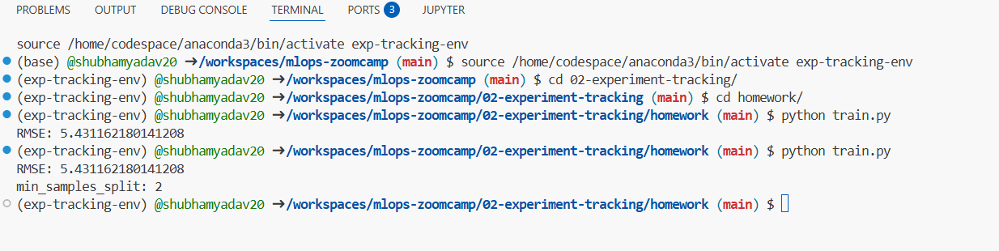

Q4: **Launch the tracking server locally and In addition to backend-store-uri, what else do you need to pass to properly configure the server?  
Ans: default-artifact-root**



**Q5. Tune model hyperparameters and What's the best validation RMSE that you got?**

**Ans: 5.335**

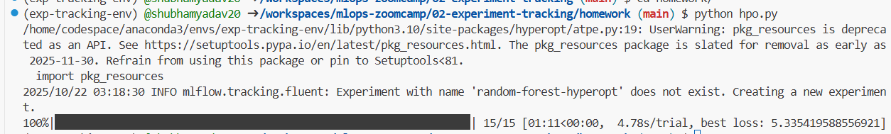

**Q6. Promote the best model to the model registry What is the test RMSE of the best model?**

**Ans: 5.567**

