**Practical-1**

**AIM:-** WAP to print basic information of student.

**INPUT**:-

std_name=str(input("Enter your name: "))

En_no=str(input("Enter your EN. No.:"))

course=str(input("Enter your course:"))

clg_name=str(input("Enter your college name:"))

print("Hello ",std_name)

print("Enrollment Number:",En_no)

print("course:",course)

print("college name:",clg_name)

**OUTPUT:-**

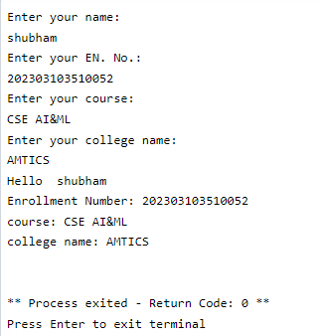

**Practical-2**

**AIM:-** WAP to print basic information of student.

**INPUT**:-

num1 = float(input("Enter first number: "))

num2 = float(input("Enter second number: "))

sum_result = num1 + num2

diff_result = num1 - num2

prod_result = num1 * num2

div_result = num1 / num2

print("Sum is : ", sum_result)

print("Difference is : ", diff_result)

print("Product is : ", prod_result)

print("Division is : ", div_result)

**OUTPUT:-**

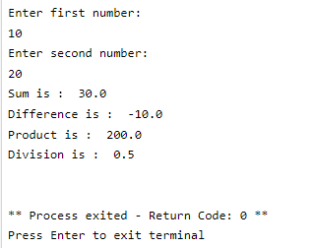

**Practical-3**

**AIM:-** WAP to find whether the number is greater or equal from another number.

**INPUT**:-

num_1=int(input("Enter Your Number:"))

if num_1>0:

print("Your Number Is Positive")

elif num_1<0:

print("Your Number Is Negative")

else :

print("Your Number Is Zero")

**OUTPUT:-**

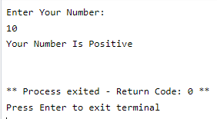

**Practical-4**

**AIM:-** WAP to check whether the number is even,odd or neutral.

**INPUT**:-

num_1=int(input("Enter Your Number:"))

if num_1%2!=0:

print ("The number is even")

elif num_1==0:

print ("The number is neutral")

else :

print ("The number is odd")

**OUTPUT:-**

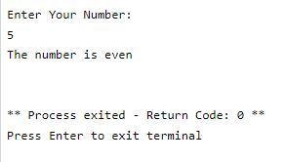

**Practical-5**

**AIM:-** WAP to check the given number is greater than three numbers.

**INPUT**:-

num_1=int(input("Enter Your Number:"))

num_2=int(input("Enter Your Number:"))

num_3=int(input("Enter Your Number:"))

if num_1>num_2:

if num_1>num_3:

print("Greatest number=",num_1)

else :

print("Greatest number=",num_3)

else :

if num_2>num_3:

print("Greatest number=",num_2)

else :

print("Greatest number=",num_3)

**OUTPUT:-**

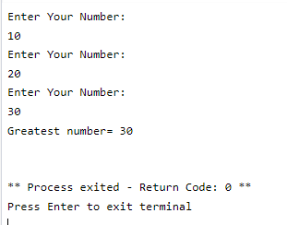

**Practical-6**

**AIM:-** WAP to find an area of a triangle.

**INPUT**:-

import math

s1=int(input("Enter side1 of a triangle:"))

s2=int(input("Enter Side2 of a triangle:"))

s3=int(input("Enter Side3 of a triangle:"))

s=(s1+s2+s3)/2

area=math.sqrt(s*(s-s1)*(s-s2)*(s-s3))

print("area of a triangle is",area)

**OUTPUT:-**

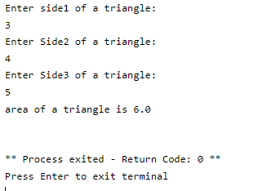

**Practical-7**

**AIM:-** WAP to swap two numbers.

**INPUT**:-

#swaping of number

num1=int(input("enter no1 : "))

num2=int(input("enter no2 : "))

num1=num1+num2

num2=num1-num2

num1=num1-num2

print("after swaping")

print("no 1=",num1)

print("no 2=",num2)

**OUTPUT:-**

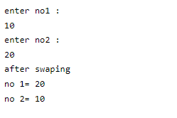

**Practical-8**

**AIM:-** WAP to print fibonaci series.

**INPUT**:-

#FIBBONACIC SERIES

t=10

a=0

b=1

n=0

print("SERIES = ")

print(a)

print(b)

while n<t:

c=a+b

a=b

b=c

print(c)

n=n+1

**OUTPUT:-**

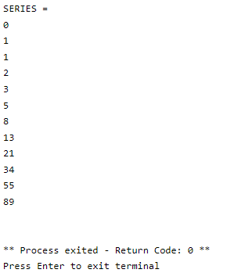

**Practical-9**

**AIM:-** WAP to check whether the number is prime or not.

**INPUT**:-

num = int(input("Enter a number: "))

if num > 1:

is_prime = True

divisor = 2

while divisor < num:

if num % divisor == 0:

is_prime = False

break

divisor += 1

if is_prime:

print(num, "is a prime number")

else:

print(num, "is not a prime number")

else:

print(num, "is not a prime number")

**OUTPUT:-**

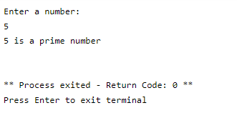

**Practical-10**

**AIM:-** WAP to find whether the number is amstrong number or not.

**INPUT**:-

#armstrong number

no = int(input("Enter a number: "))

temp = no

sum = 0

order = len(str(no))

while temp > 0:

digit = temp % 10

sum += digit ** order

temp //= 10

if no == sum:

print(no, "is an Armstrong number")

else:

print(no, "is not an Armstrong number")

**OUTPUT:-**

