**Practical-8**

**AIM:-** Write a python program to demonstrate the use of

i. if-else:- Python program to check whether the string is Symmetrical or Palindrome

ii. for() :- Program to multiply two matrices using nested loops.

iii. while() :- Program to reverse the number.

**CODE**:-

**1.**

def is_symmetrical(string):

string = string.replace(" ", "").lower()

return string == string[::-1]

def is_palindrome(string):

return string == string[::-1]

input_string = input("Enter a string: ")

if is_symmetrical(input_string):

print("The string is symmetrical.")

else:

print("The string is not symmetrical.")

if is_palindrome(input_string):

print("The string is a palindrome.")

else:

print("The string is not a palindrome.")

**2.**

def matrix_multiplication(matrix1, matrix2):

result = [[0 for _ in range(len(matrix2[0]))] for _ in range(len(matrix1))]

for i in range(len(matrix1)):

for j in range(len(matrix2[0])):

for k in range(len(matrix2)):

result[i][j] += matrix1[i][k] * matrix2[k][j]

return result

matrix1 = [[1, 2, 3],

[4, 5, 6],

[7, 8, 9]]

matrix2 = [[9, 8, 7],

[6, 5, 4],

[3, 2, 1]]

result_matrix = matrix_multiplication(matrix1, matrix2)

print("Result of matrix multiplication:")

for row in result_matrix:

print(row)

**3.**

def reverse_number(num):

reversed_num = 0

while num > 0:

digit = num % 10

reversed_num = reversed_num * 10 + digit

num //= 10

return reversed_num

num = int(input("Enter a number: "))

reversed_num = reverse_number(num)

print("Reversed number:", reversed_num)

**OUTPUT:-**

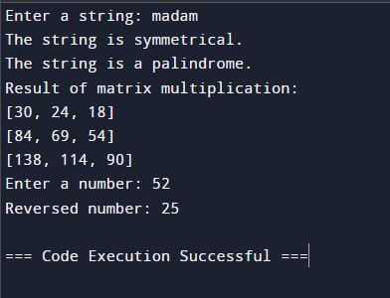

**Practical-9**

**AIM:-** Write a python program to display different patterns.

**CODE**:-

n = 5

for i in range(1, n+1):

for j in range(1, i+1):

print(j, end=" ")

print()

print("-------------------")

n = 5

start = 1

for i in range(1, n+1):

for j in range(start, start+i):

print(j, end=" ")

print()

start += i

print("-------------------")

n = 5

for i in range(1, n + 1):

print(' ' * (n - i) + '*' * (2 * i - 1))

print("-------------------")

n = 5

start_char = ord('A')

for i in range(n):

for j in range(i+1):

print(chr(start_char + i), end=" ")

print()

**OUTPUT:-**

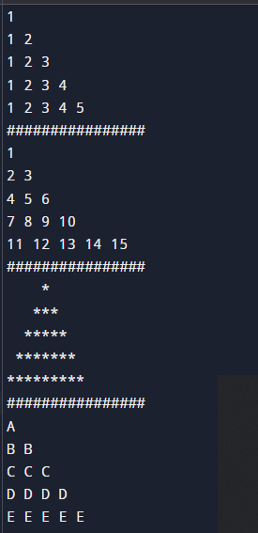

**Practical-10**

**AIM:-** Write a python program to demonstrate the use of user-defined functions with single, multiple and arbitrary arguments. WAP to design simple calculator.

**CODE**:-

def add(x, y):

return x + y

def subtract(x, y):

return x - y

def multiply(x, y):

return x * y

def divide(x, y):

if y == 0:

return "Cannot divide by zero!"

return x / y

print("Select operation:")

print("1. Add")

print("2. Subtract")

print("3. Multiply")

print("4. Divide")

choice = input("Enter choice (1/2/3/4): ")

num1 = float(input("Enter first number: "))

num2 = float(input("Enter second number: "))

if choice == '1':

print("Result:", add(num1, num2))

elif choice == '2':

print("Result:", subtract(num1, num2))

elif choice == '3':

print("Result:", multiply(num1, num2))

elif choice == '4':

print("Result:", divide(num1, num2))

else:

print("Invalid input")

**OUTPUT:-**

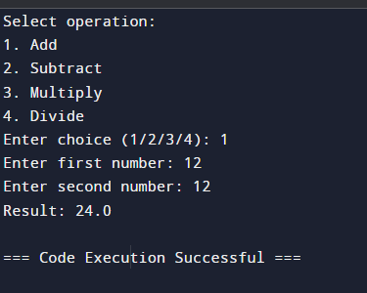

**Practical-11**

**AIM:-** Create a class named employee having attributes - emp_name, emp_age, and emp_city. Create a method named get_data() in employee class that takes user input for these attributes. Derive a class named emp_derived() from the employee class, having an __init__() method that displays the attributes of the employee class upon instantiation.

**CODE**:-

 class Employee:

def __init__(self):

self.emp_name = ""

self.emp_age = 0

self.emp_city = ""

def get_data(self):

self.emp_name = input("Enter employee name: ")

self.emp_age = int(input("Enter employee age: "))

self.emp_city = input("Enter employee city: ")

class EmpDerived(Employee):

def __init__(self):

super().__init__()

def display_info(self):

print("Employee Name:", self.emp_name)

print("Employee Age:", self.emp_age)

print("Employee City:", self.emp_city)

emp = EmpDerived()

emp.get_data()

emp.display_info()

**OUTPUT:-**

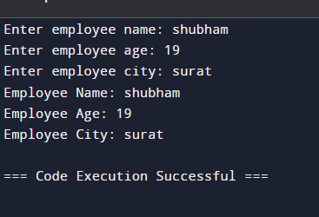

**Practical-12**

**AIM:-** Write a python program to show the need of inheritance and encapsulation. The display() method that prints class attribute values along with attributes of its super class.

**CODE**:-

class Vehicle:

""" Base class for vehicles. """

def __init__(self, make, model):

self.__make = make # Encapsulated attribute

self.model = model # Public attribute

def display(self):

"""Prints the vehicle's make and model."""

print(f"Make: {self.__make}")

print(f"Model: {self.model}")

class Car(Vehicle):

""" Derived class representing cars. """

def __init__(self, make, model, num_doors):

super().__init__(make, model) # Inheriting from Vehicle class

self.num_doors = num_doors

def display(self):

""" Overrides the display() method from the base class.

Prints specific information about the car.

"""

super().display() # Calling the base class display method

print(f"Number of doors: {self.num_doors}")

# Create a Vehicle object (limited functionality due to encapsulation)

vehicle = Vehicle("Generic", "Model X")

# Create a Car object

car = Car("Honda", "Civic", 4)

# Calling display methods

vehicle.display()

car.display()

**OUTPUT:-**

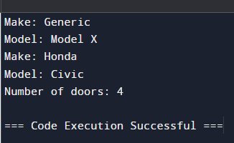

**Practical-13**

**AIM:-** Write a python program to create a class named area. Define a class method find_area() that can find areas of different shapes whose value is given by the user. Invoke the class method by instantiation and prove method overloading.

**CODE**:-

class Area:

@classmethod

def find_area(cls, shape, *args):

if shape.lower() == "square":

if len(args) != 1:

raise ValueError("Square requires one side length")

side = args[0]

return side * side

elif shape.lower() == "circle":

if len(args) != 1:

raise ValueError("Circle requires one radius")

radius = args[0]

return 3.14159 * radius * radius

else:

raise ValueError("Unsupported shape")

shape = input("Enter the shape (square or circle): ")

try:

value = float(input("Enter the value (side for square, radius for circle): "))

except ValueError:

print("Invalid input. Please enter a number.")

exit()

area = Area.find_area(shape, value)

print(f"The area of the {shape} is: {area}")

**OUTPUT:-**

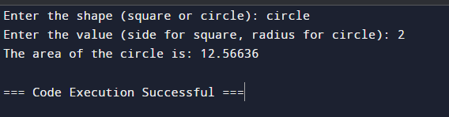

**Practical-14**

**AIM:-** Write a python program to demonstrate the use of method overriding.

**CODE**:-

**class Shape:**

**def calculate_area(self):**

**print("Area calculation not implemented in base class.")**

**class Square(Shape):**

**def __init__(self, side_length):**

**self.side_length = side_length**

**def calculate_area(self):**

**area = self.side_length * self.side_length**

**print(f"Area of square: {area}")**

**class Circle(Shape):**

**def __init__(self, radius):**

**self.radius = radius**

**def calculate_area(self):**

**area = 3.14159 * self.radius * self.radius**

**print(f"Area of circle: {area}")**

**square = Square(5)**

**circle = Circle(3)**

**square.calculate_area()**

**circle.calculate_area()**

**OUTPUT:-**

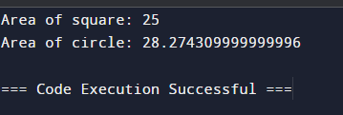

**Practical-15**

**AIM:-** Write a python program to perform basic matrix operations on user entered matrices.

**CODE**:-

def matrix_input(rows, cols):

matrix = []

print("Enter the elements row-wise:")

for i in range(rows):

row = []

for j in range(cols):

element = float(input(f"Enter element [{i+1}][{j+1}]: "))

row.append(element)

matrix.append(row)

return matrix

def matrix_addition(matrix1, matrix2):

if len(matrix1) != len(matrix2) or len(matrix1[0]) != len(matrix2[0]):

print("Matrices should have the same dimensions for addition.")

return None

result = [[matrix1[i][j] + matrix2[i][j] for j in range(len(matrix1[0]))] for i in range(len(matrix1))]

return result

def matrix_subtraction(matrix1, matrix2):

if len(matrix1) != len(matrix2) or len(matrix1[0]) != len(matrix2[0]):

print("Matrices should have the same dimensions for subtraction.")

return None

result = [[matrix1[i][j] - matrix2[i][j] for j in range(len(matrix1[0]))] for i in range(len(matrix1))]

return result

def matrix_multiplication(matrix1, matrix2):

if len(matrix1[0]) != len(matrix2):

print("Number of columns in the first matrix should be equal to the number of rows in the second matrix for multiplication.")

return None

result = [[sum(matrix1[i][k] * matrix2[k][j] for k in range(len(matrix2))) for j in range(len(matrix2[0]))] for i in range(len(matrix1))]

return result

def print_matrix(matrix):

for row in matrix:

print(row)

def main():

print("Matrix Operations Program")

choice = input("Choose operation:\n1. Addition\n2. Subtraction\n3. Multiplication\nEnter choice (1/2/3): ")

rows1 = int(input("Enter number of rows for matrix 1: "))

cols1 = int(input("Enter number of columns for matrix 1: "))

matrix1 = matrix_input(rows1, cols1)

rows2 = int(input("Enter number of rows for matrix 2: "))

cols2 = int(input("Enter number of columns for matrix 2: "))

matrix2 = matrix_input(rows2, cols2)

if choice == '1':

result = matrix_addition(matrix1, matrix2)

elif choice == '2':

result = matrix_subtraction(matrix1, matrix2)

elif choice == '3':

result = matrix_multiplication(matrix1, matrix2)

else:

print("Invalid choice.")

return

if result:

print("Resultant matrix:")

print_matrix(result)

if __name__ == "__main__":

main()

**OUTPUT:-**

