**PRACTICAL:-7**

**AIM:-**Write a HTML Code to Create Form Using Following Tags: <textarea>,

<select>, <option>, <fieldset>, <legend>, <button>.

**CODE:-**

<!DOCTYPE html>

<html lang="en">

<head>

<meta charset="UTF-8">

<meta name="viewport" content="width=device-width, initial-scale=1.0">

<title>p7</title>

</head>

<body>

<h1><center>Registration Page</center> </h1>

<form action="submit.php" method="post">

<fieldset>

<legend> Form</legend>

NAME: <input type="text" name="firstname"><br><br>

Gender :<br>

<input type="radio" name="radio"> Male <br>

<input type="radio" name="radio"> Female <br>

<input type="radio" name="radio"> Other<br><br>

<label for="message">Message:</label><br>

<textarea id="message" name="message" rows="4" cols="50"></textarea><br>

<label for="country">Country:</label>

<select id="country" name="country">

<option value="usa">USA</option>

<option value="canada">Canada</option>

<option value="mexico">Mexico</option>

</select><br><br>

Email:

<input type="email" id="email" name="email"/> <br><br>

Password:

<input type="Password" id="pass" name="pass"> <br><br>

Re-type password:

<input type="Password" id="repass" name="repass"><br><br>

<button type="Reset">Reset</button>

<button type="submit">Submit</button>

</fieldset>

</form>

</body>

</html>

**Information :-**

<textarea> for Entering a Message.

<select> And <option> for Choosing a Reason for Contact.

<fieldset> And <legend> for Grouping Related Form Elements.

<button> for Submitting The Form.

**Output:-**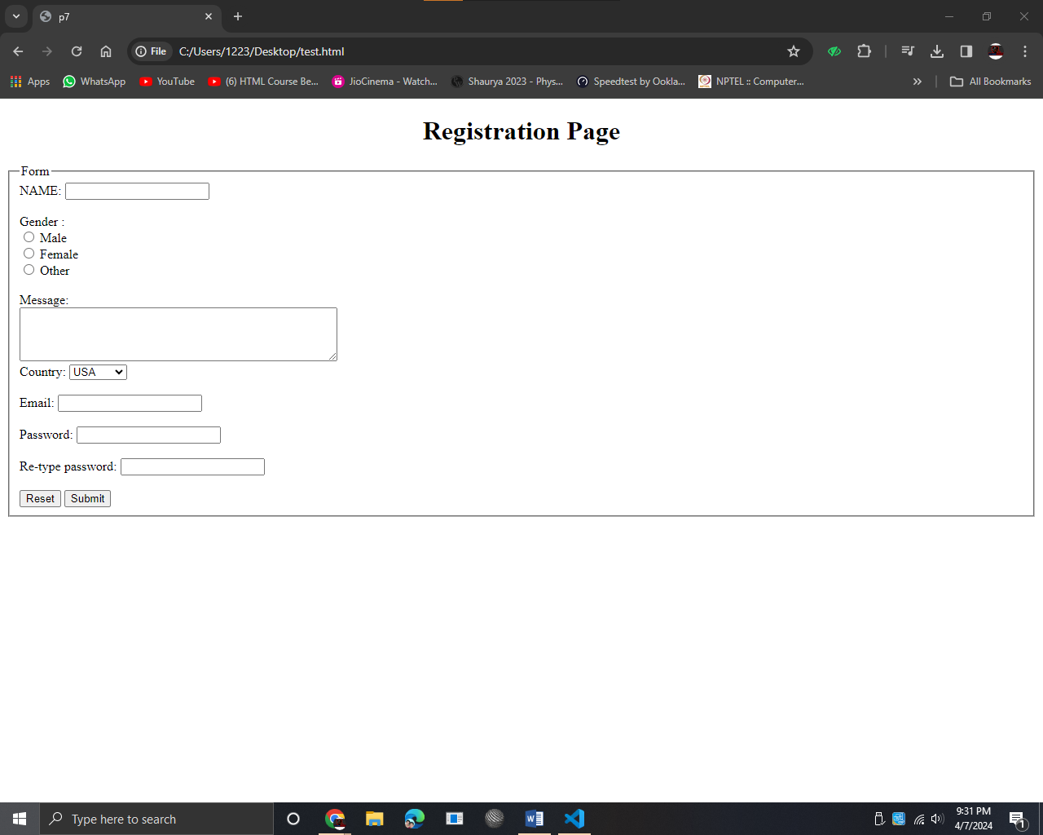

**PRACTICAL:-8**

**AIM:-**Write Internal and Inline CSS Code to Design Your Product Page Using

Following Selector: body, h1, p, hr, img. Apply Following Properties: color, font, text,background, border.

**CODE:-**

<!DOCTYPE html>

<html lang="en">

<head>

<meta charset="UTF-8">

<meta name="viewport" content="width=device-width, initial-scale=1.0">

<title>p8</title>

<style>

body{

background-color:darkgrey;

font-family:Arial, Helvetica, sans-serif;

}

h1{

text-align: center;

color:rgb(0, 0, 0);

color: rgb(240, 233, 233);

}

</style>

</head>

<body>

<h1>Registration Page</h1>

<form action="submit.php" method="post">

<fieldset>

<legend><h2>Form</h2></legend>

<pre>

NAME: <input type="text" name="firstname" placeholder="Enter your name"><br>

MIDDLE NAME:<input type="text" name="middlename" placeholder="Enter your middle name"> <br>

LAST NAME: <input type="text" name="lastname" placeholder="Enter your last name">

</pre>

Gender :<br>

<input type="radio" name="radio" value="Male"> Male <br>

<input type="radio" name="radio" value="Female"> Female <br>

<input type="radio" name="radio" value="Other"> Other<br><br>

Phone :

<input type="text" name="country code" value="+91|"><br><br>

<label for="Address">Address:</label><br>

<textarea id="Address" name="Address" rows="4" cols="50"></textarea><br><br>

Country:

<select id="country" name="country">

<option value="usa">USA</option>

<option value="canada">Canada</option>

<option value="mexico">Mexico</option>

</select><br><br>

Email:

<input type="email" id="email" name="email" placeholder="Enter your Email"> <br><br>

Password:

<input type="Password" id="pass" name="pass"> <br><br>

Re-type password:

<input type="Password" id="repass" name="repass"><br><br>

<button type="Reset">Reset</button>

<button type="submit">Submit</button>

</fieldset>

</body>

</html>

Information :-

<select> And <option> for Choosing a Reason for Contact.

<fieldset> And <legend> for Grouping Related Form Elements.

Radio Button is Used to Choose One Option.

Text Box is Used to Collect Information From The User.

Reset for Reset The Form.

Submit for Submitting The Form.

&nbsp; is Add a Space.

**Output:-**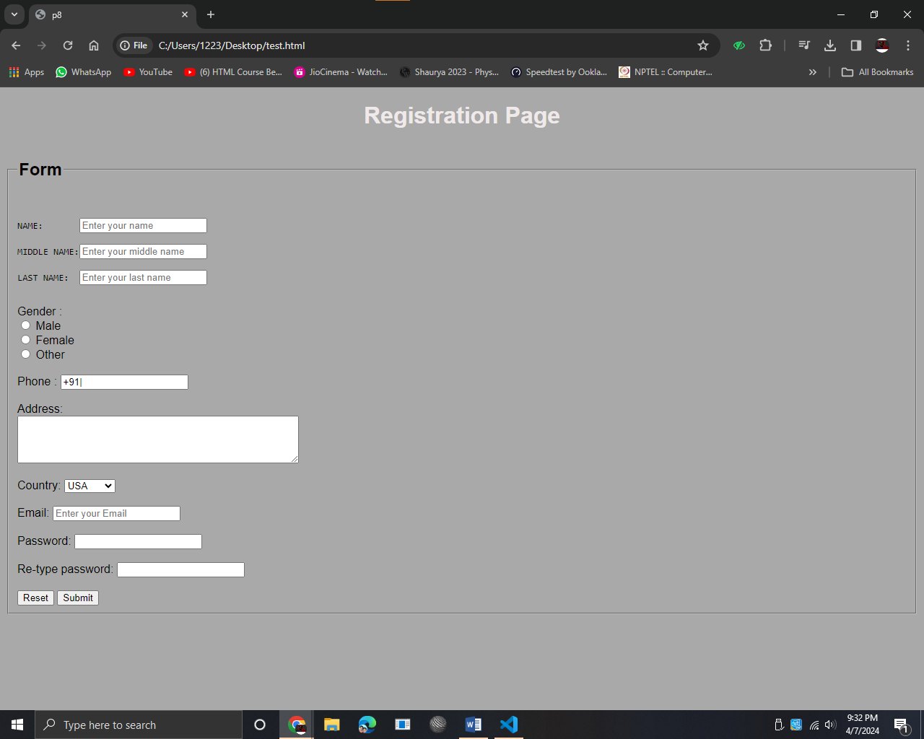

**PRACTICAL:-9**

**AIM:-** Write a CSS Code to Design Your Product Page Using Class, id and Pseudo

Class Selectors. Apply Following Properties: color, font, text, background, border,

margin, padding, list-style and Position Using Concept of class(.) and id(#), Pseudo

Class Selector, Internal and External CSS.

**CODE:-**

<html>

<head>

<title>PRODUCT</title>

<link rel="stylesheet" href="p9.css">

<style>

*{

margin: 0;

padding: 0;

font-family: sans-serif;

}

.body{

background-color: #81bcf3;

}

#navbar{

width: 85%;

margin: auto;

padding: 30px;

display: flex;

align-items: center;

justify-content: space-between;

}

#navbar ul li{

list-style: none;

display: inline-block;

margin: 0 20px;

position: relative;

}

.content{

width: 100%;

position: absolute;

top: 50%;

transform: translateY(-50%);

text-align: center;

color: #0b1d1b;

}

.content h1{

font-size: 70px;

margin-top: 0px;

}

.content p{

margin: 10px;

font-weight: 25px;

line-height: 25px;

}

</style>

</head>

<body class="body">

<div class ="banner">

<div id="navbar">

<ul>

<li>HOME</li>

<li>PRODUCTS</li>

<li>ACCESSORIES</li>

</ul>

</div>

<div class="content">

<h1>Gaming Accessories</h1>

<P>Gaming Accessories store</P>

</div>

</div>

</body>

</html>

**Information :-**

CSS using class, id, and pseudo-class selectors:

- Utilizes class (.class-selector) and id (#id-selector) selectors to target specific elements.

- Pseudo-class selector (p:first-of-type) is used to style the first <p> element within its parent.

- Properties like color, font, text, background, border, margin, padding, list-style, position are employed to design the page.

**Output:-**

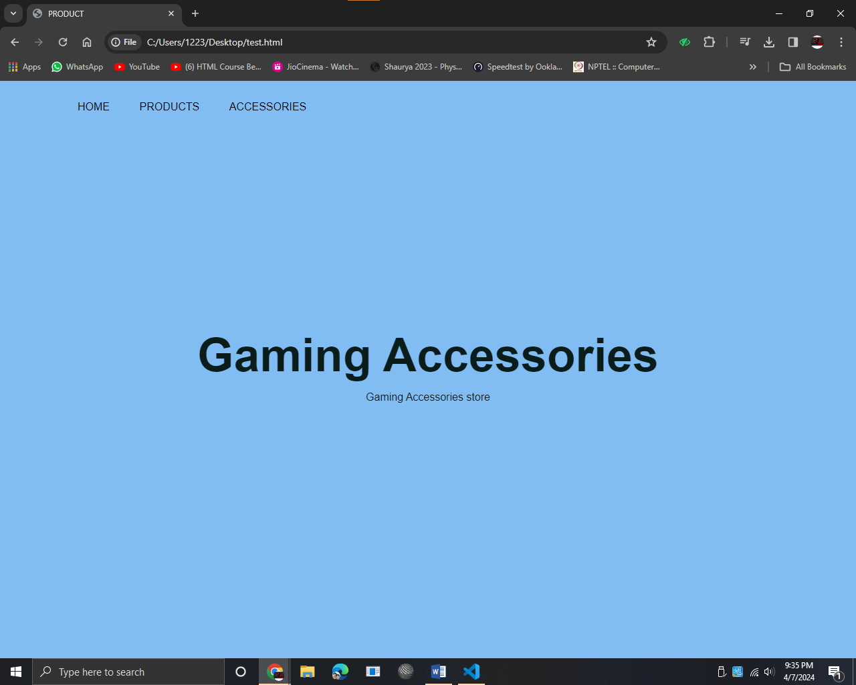

**PRACTICAL:-11**

**AIM:-** Write a CSS Code for Applying Animation, Shadows, Text Effects and

Gradients to Design a Web Page.

**CODE:-**

<html>

<head>

<title>10</title>

<link rel="stylesheet" href="p9.css">

</head>

<body class="gradient">

<div class ="banner">

<div class="navbar">

<ul>

<li><a href="/html/p10.html">HOME</a></li>

<li><a href="/html/p10.1.html">REGISTRATION</a></li>

<li>PRODUCTS</li>

<li>ACCESSORIES</li>

<li>ABOUT US</li>

</ul>

<div class="search-container">

<input type="text" name="search" placeholder="Search..." class="search-input">

<a href="#" class="search-btn">

<i class="fas fa-search">

<img src="search.png" alt="search" height="28px">

</i>

</a>

</div>

</div>

<div class="content">

<h1 class="shadow">Accessories</h1>

<P>Gaming Accessories store</P>

</div>

</div>

</body>

</html>

CSS CODE:-

*{

margin: 0;

padding: 0;

font-family: sans-serif;

}

.body{

background-color: #81bcf3;

}

.shadow{

text-shadow: 1px 1px 1px rgb(255, 255, 255);

}

.gradient{

background-image: linear-gradient(to right, rgba(255, 0, 0, 0.5),rgba(0, 255, 0, 0.5),rgba(0, 0, 255, 0.5));

}

.banner{

width: 100%;

height: 100vh;

background-image: url(bg.jpeg);

background-size: cover;

background-position: center;

}

.navbar{

width: 85%;

margin: auto;

padding: 30px;

display: flex;

align-items: center;

justify-content: space-between;

}

.navbar ul li{

list-style: none;

display: inline-block;

margin: 0 20px;

position: relative;

}

.navbar ul li a{

text-decoration: none;

color: #070101;

text-transform: uppercase;

}

.navbar ul li::after{

content: '';

height: 2px;

width: 0;

background: #ad1717;

position: absolute;

left: 0;

bottom: -5px;

transition: 0.5s;

}

.navbar ul li:hover::after{

width: 100%;

}

.content{

width: 100%;

position: absolute;

top: 50%;

transform: translateY(-50%);

text-align: center;

color: #0b1d1b;

}

.content h1{

font-size: 70px;

margin-top: 0px;

}

.content p{

margin: 10px;

font-weight: 25px;

line-height: 25px;

}

.search-container{

height: 30px;

border-radius: 30px;

padding: 10px 20px;

display: flex;

justify-content: center;

align-items: center;

cursor: pointer;

transition: 0.8s;

box-shadow: 4px 4px 6px 0 rgba(255,255,255,.3),

-4px -4px 6px 0 rgba(116, 125, 136, .2),

inset -4px -4px 6px 0 rgba(255,255,255,.2),

inset 4px 4px 6px 0 rgba(0, 0, 0, .2);

}

.search-container:hover > .search-input{

width: 400px;

}

.search-container .search-input{

background: transparent;

border: none;

outline:none;

width: 0px;

font-weight: 500;

font-size: 16px;

transition: 0.8s;

}

.search-container .search-btn .fas{

color: #5cbdbb;

}

@keyframes hoverShake {

0% {transform: skew(0deg,0deg);}

25% {transform: skew(5deg, 5deg);}

75% {transform: skew(-5deg, -5deg);}

100% {transform: skew(0deg,0deg);}

}

.search-container:hover{

animation: hoverShake 0.15s linear 3;

}

**Information :-**

CSS for web page design with animation, shadows, text effects, and gradients:

- Utilizes CSS to add animation, shadows, text effects, and gradients for visual enhancement.

- Animations (animation property), shadows (box-shadow property), text effects (text-shadow property), and gradients (background property) are applied.

**Output:-**

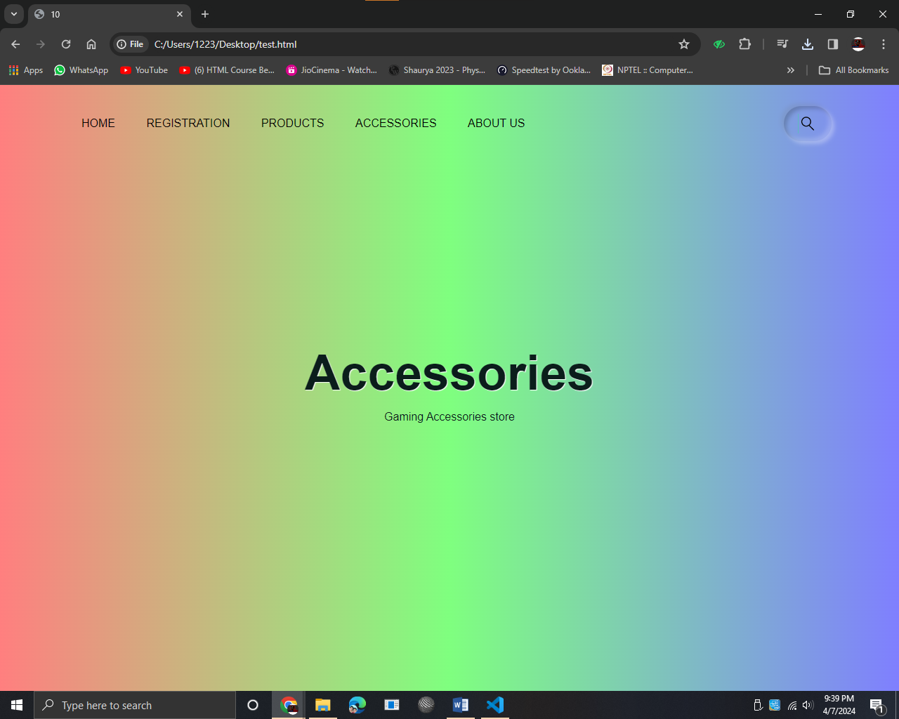

**PRACTICAL:-12**

**AIM:-** Write a JavaScript to Show Alert, Confirm and Prompt Boxes.

**CODE:-**

<!DOCTYPE html>

<html lang="en">

<head>

<meta charset="UTF-8">

<meta name="viewport" content="width=device-width, initial-scale=1.0">

<title>Document</title>

</head>

<body>

<button onclick="myFunction()">alert</button><br><br>

<button onclick="confirmFunction()">confirm</button>

<p id="demo"></p>

<button onclick="promptFunction()">prompt</button>

<p id="text"></p>

<script>

function myFunction(){

window.alert("Alert! You clicked the button.");

}

function confirmFunction() {

var txt;

if (confirm("Press a button!")) {

txt = "You pressed OK!";

} else {

txt = "You pressed Cancel!";

}

document.getElementById("demo").innerHTML = txt;

}

function promptFunction() {

let text;

let person = prompt("Please enter your name:", "Shubham");

if (person == null || person == "") {

text = "User cancelled the prompt.";

} else {

text = "Hello " + person + "! How are you today?";

}

document.getElementById("text").innerHTML = text;

}

</script>

</body>

</html>

**Information :-**

JavaScript for alert, confirm, and prompt boxes:

- Utilizes JavaScript to interact with users through alert, confirm, and prompt boxes.

- Provides user feedback and gathers input through these dialog boxes.

**Output:-**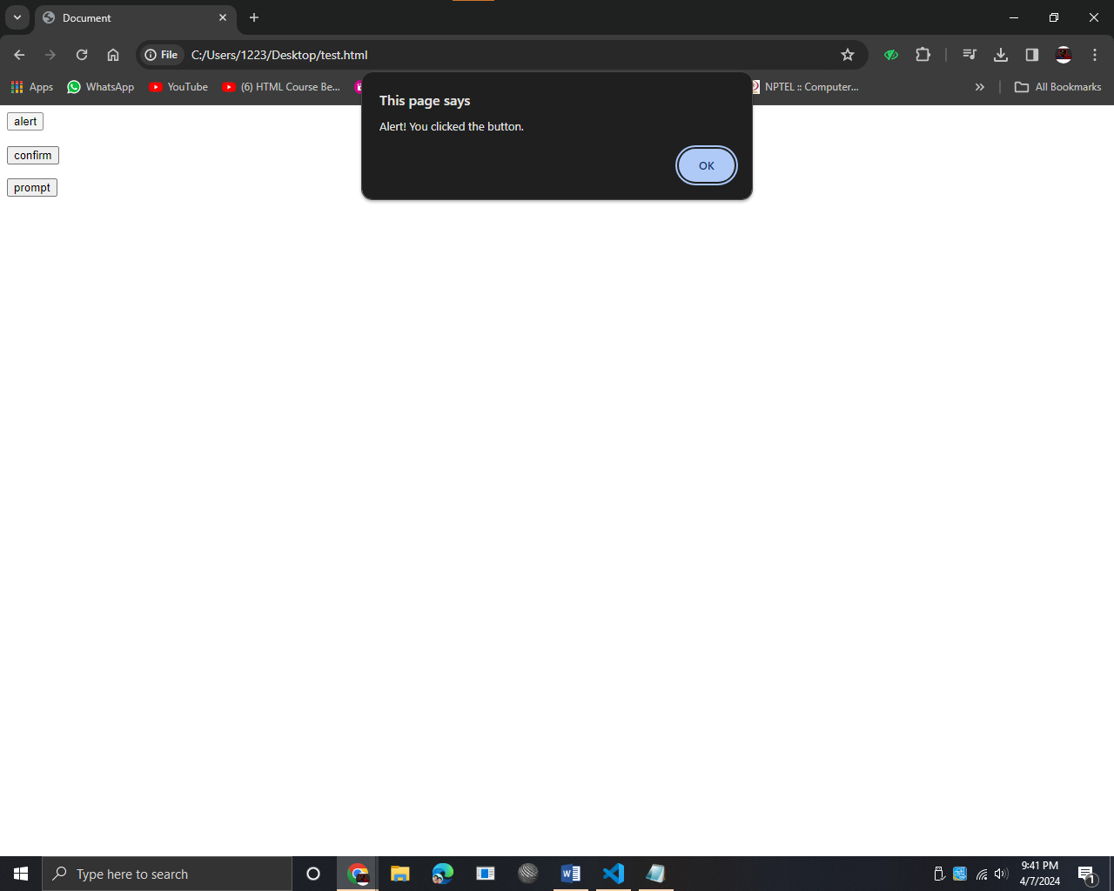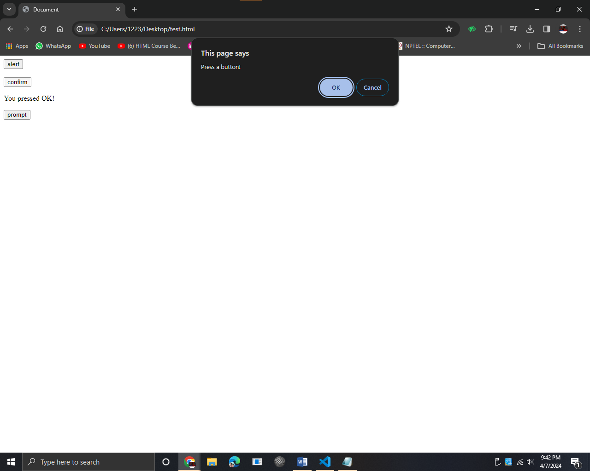

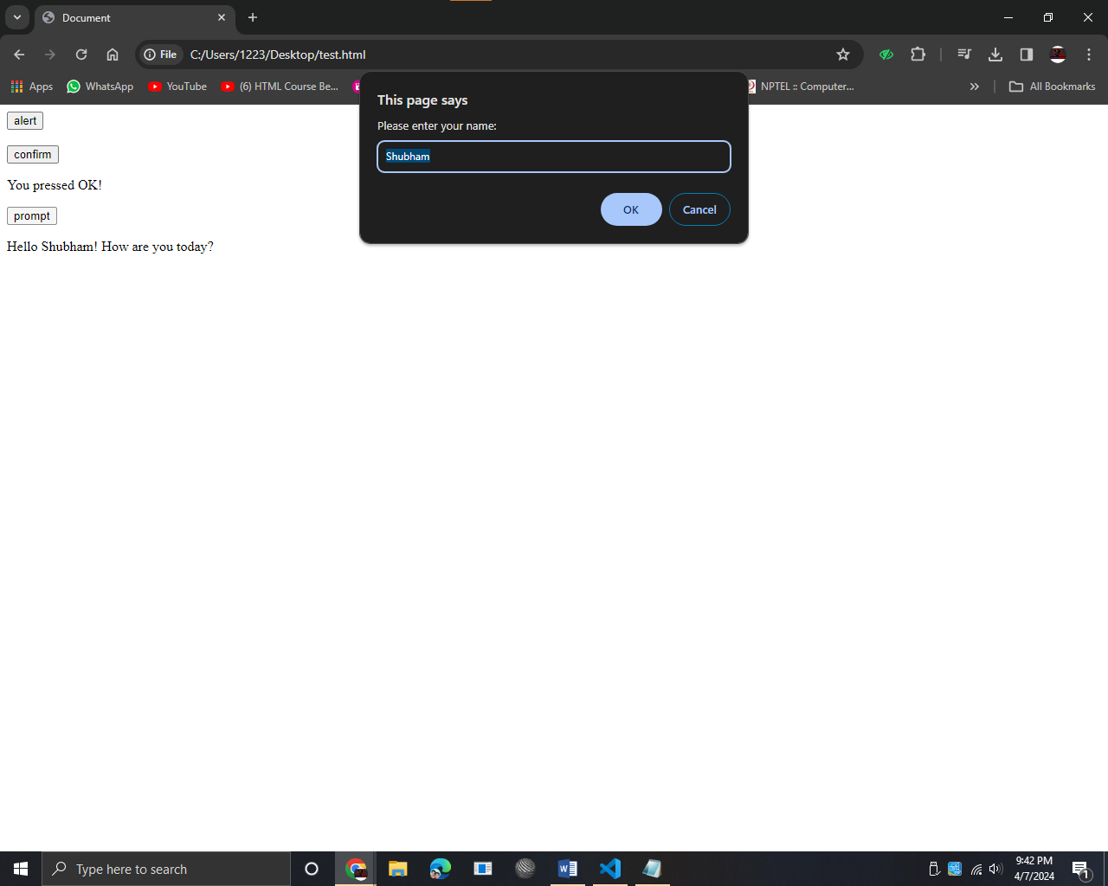

**PRACTICAL:-13**

**AIM:-** Write a JavaScript Function to Find Maximum of Three Numbers Taken From User Using if-else And Print it.

**CODE:-**

<!DOCTYPE html>

<html lang="en">

<head>

<meta charset="UTF-8">

<meta name="viewport" content="width=device-width, initial-scale=1.0">

<title>Which is the Largest Number</title>

</head>

<body>

<h1 >Which is the largest number?</h1>

<input type="" name="num1" id="num1" placeholder="Enter first number"/><br/>

<input type="number" name="num2" id="num2" placeholder="Enter second number"/><br/>

<input type="number" name="num3" id="num3" placeholder="Enter third number"/><br/><br/>

<button onclick="findLargest()">Find The Largest Number</button><br/>

<p id="result"></p>

<script>

function findLargest(){

let num1 = document.getElementById("num1").value;

let num2 = document.getElementById("num2").value;

let num3 = document.getElementById("num3").value;

let largestNum = Math.max(num1, num2, num3);

if (num1 > num2) {

if (num1 > num3) {

largest = num1;

} else {

largest = num3;

}

} else {

if (num2 > num3) {

largest = num2;

} else {

largest = num1;

}

}

document.getElementById("result").innerHTML = "The largest number is: "+largestNum;

}

</script>

</body>

</html>

**Information :-**

JavaScript function to find the maximum of three numbers:

- Implements a JavaScript function using if-else statements to determine the maximum value among three numbers.

- Utilizes conditional logic to compare and identify the maximum value.

**Output:-**

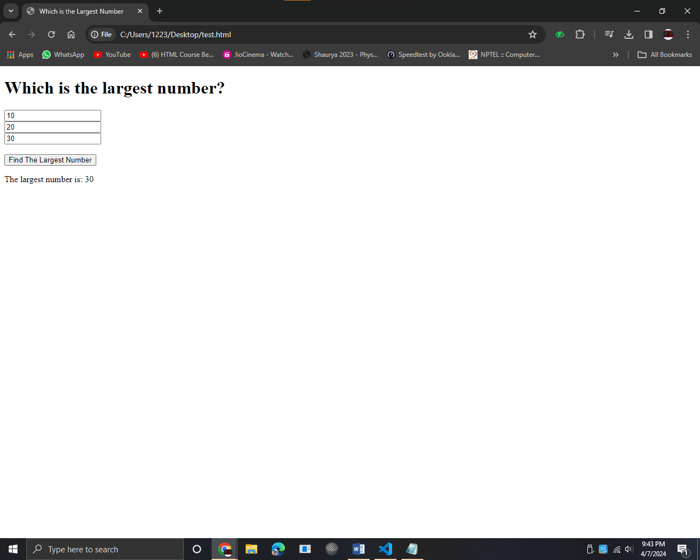

**PRACTICAL:-14**

**AIM:-** Print Date And Time on Click of a Button Using Inner HTML in JavaScript.

**CODE:-**

<!DOCTYPE html>

<html lang="en">

<head>

<meta charset="UTF-8">

<meta name="viewport" content="width=device-width, initial-scale=1.0">

<title>Date and Time</title>

</head>

<body>

<button onclick="datetime()">SHOW DATE AND TIME</button>

<p id="demo"></p>

<script>

function datetime() {

const d = new Date();

document.getElementById("demo").innerHTML = d;

}

</script>

</body>

</html>

**Information :-**

Print date and time on click of a button using inner HTML in JavaScript:

- Utilizes JavaScript to dynamically update the content of an HTML element (such as <p>) upon user interaction (button click).

- Displays date and time using JavaScript's Date object and the innerHTML property to modify the HTML content.

**Output:-**

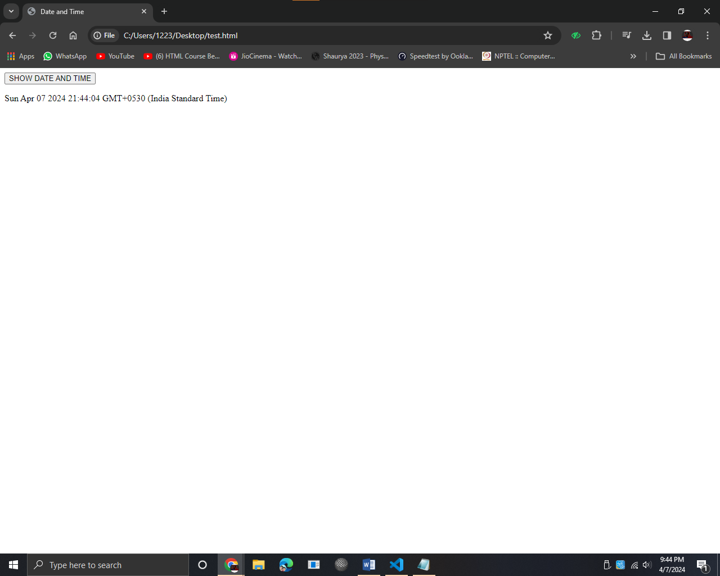

**PRACTICAL:-15**

**AIM:-** Write a HTML/JavaScript code to create a simple calculator.

**CODE:-**

<!DOCTYPE html>

<html lang="en">

<head>

<meta charset="UTF-8">

<meta name="viewport" content="width=device-width, initial-scale=1.0">

<title>Simple Calculator</title>

<style>

body {

font-family: Arial, sans-serif;

background-color: #f0f0f0;

}

.calculator {

width: 300px;

margin: 50px auto;

padding: 20px;

border: 1px solid #ccc;

border-radius: 5px;

background-color: #fff;

box-shadow: 0px 0px 10px rgba(0, 0, 0, 0.1);

}

.calculator input {

width: calc(100% - 20px);

margin-bottom: 10px;

padding: 10px;

font-size: 18px;

border: 1px solid #ccc;

border-radius: 3px;

}

.calculator button {

width: calc(20% - 5px);

margin-right: 5px;

margin-bottom: 5px;

padding: 10px;

font-size: 18px;

border: none;

border-radius: 3px;

background-color: #e0e0e0;

cursor: pointer;

transition: background-color 0.3s ease;

}

.calculator button:last-child {

margin-right: 0;

}

.calculator button:hover {

background-color: #d4d4d4;

}

.calculator button:active {

background-color: #bfbfbf;

}

</style>

</head>

<body>

<table>

<div class="calculator">

<input type="text" id="display" readonly>

<button onclick="clearDisplay()" style="grid-column: span 2;">C</button>

<button onclick="appendToDisplay('/')" style="background-color: #7ac766;">/</button>

<button onclick="appendToDisplay('*')" style="background-color: #5fdd45;">*</button>

<button onclick="appendToDisplay('-')" style="background-color: #fca311;">-</button>

<button onclick="appendToDisplay('7')">7</button>

<button onclick="appendToDisplay('8')">8</button>

<button onclick="appendToDisplay('9')">9</button>

<button onclick="appendToDisplay('+') " style="background-color: #fca311;">+</button>

<button onclick="appendToDisplay('4')">4</button>

<button onclick="appendToDisplay('5')">5</button>

<button onclick="appendToDisplay('6')">6</button>

<button onclick="appendToDisplay('.') "style="background-color: #fca311;">.</button>

<button onclick="appendToDisplay('1')">1</button>

<button onclick="appendToDisplay('2')">2</button>

<button onclick="appendToDisplay('3')">3</button>

<button onclick="calculateResult()" style="background-color: #2ec4b6; grid-column:

span 2;">=</button>

<button onclick="appendToDisplay('0')">0</button>

<button onclick="appendToDisplay('.') "style="background-color: #fca311;">.</button>

</div>

</table>

<script>

function clearDisplay() {

document.getElementById('display').value = '';

}

function appendToDisplay(value) {

document.getElementById('display').value += value;

}

function calculateResult() {

var result = eval(document.getElementById('display').value);

document.getElementById('display').value = result;

}

</script>

</body>

</html>

**Information :-**

HTML/JavaScript code for a simple calculator:

- Combines HTML form elements (input fields and buttons) with JavaScript functions to create a basic calculator.

- Enables users to perform arithmetic calculations directly within the web page.

**Output:-**

