Inventory Management System for B2B SaaS: A Case Study
Candidate: Shubham Zombade
Title: Backend Engineering Intern
Company: Bynry
Technology Stack: Python, Flask, SQLAlchemy, SQLite

Part 1: Code Review & Debugging

Problem Understanding
The given API endpoint created a new product and started the inventory. Although the code has been verified and does not contain compilation errors, there were some failures when faced with typical production environment input deficiencies, repeated data, and partial database failures.

This showed there were problems both in how it was put into practice, a matter of policy, but also in its assumptions

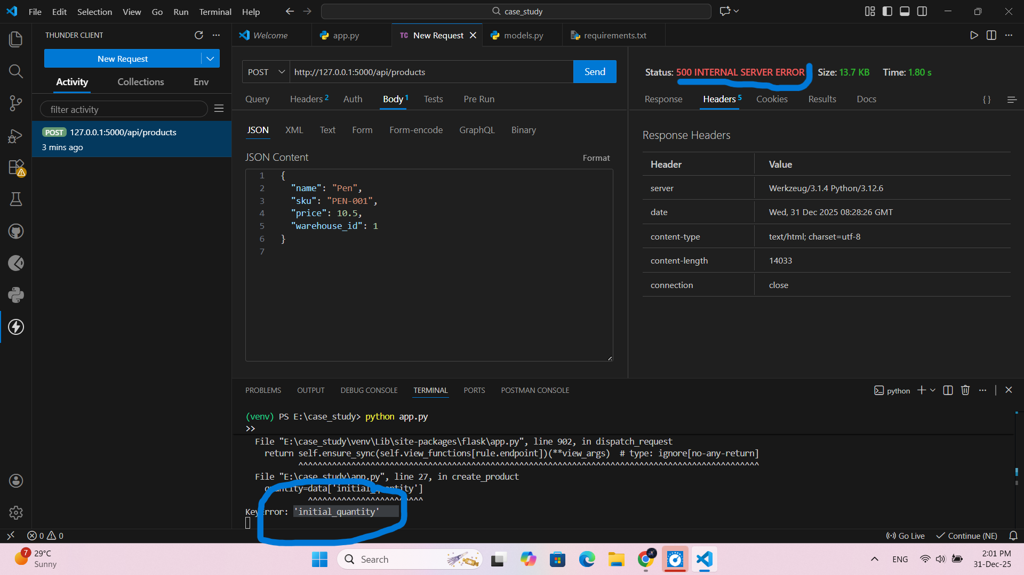

Issues Identified

Category | Issue
Validation | No Input Validation
Data Integrity | SKU uniqueness is not enforced
Design | Product incorrectly tied to a single warehouse
Transactions | Multiple commits without atomicity
Reliability | Optional fields which are treated as
Accuracy | Number represented as a float
User Experience | Success response returned even on partial failure

Production Impact

These can lead to problems such as duplicated products, biased records of inventory, and faulty financial calculations, while API responses mislead. In a B2B system, that translates to less reliable reporting, tougher supplier coordination, and eroded customer trust.
Fix Strategy

- I addressed these issues guided by the following principles:
- Validating inputs before performing database operations
- Avoiding partial writes using atomic database transactions
- Separating Product Definition from Warehouse Inventory
- Working with prices using decimal-safe data types
- Enforcing SKU Uniqueness at the Database Level
- Clear and accurate API responses

The corrected, fully working implementation can be found in the GitHub repository from the link above.

Part 2: Database Design

Design Approach
The database schema was designed to support multiple companies, multiple warehouses per company, and flexible inventory tracking while remaining easy to extend for future requirements like bundles and analytics.
- Core Entities
- Company
- Warehouse
- Product
- Inventory
- Inventory movements
- Supplier
- Bundle Items
Inventory is the junction between products and warehouses, because different warehouses can have the same product and maintain a

Part 3: Low-Stock Alerts API Business Understanding
- The Low Stock Alert feature will automatically notify the user to reorder products before stock-outs can happen, without sending notifications for products that are already inactive.
- Assumptions Made
- Low-stock thresholds are set per product.
- Recent sales are considered on a rolling 30-day period.
- Each product has at least one primary supplier.
- These assumptions are documented due to incomplete requirements.
- API Logic Overview
- It aggregates inventory data across all warehouses belonging to a company, filters products with recent sales activity, compares available stock against defined thresholds, and enriches alerts with supplier details to support quick reordering.
- Edge cases include zero sales rate, missing suppliers, and multiple warehouse records. These are handled gracefully in order to avoid
Api test in thunder client

