Python Project
Chatbots

Introduction to chatbots
what are chatbots?
- Chatbots are simulations which can understand human language, process it and interact back with humans while performing specific tasks.
- The first chatbot was created by joseph wiesenbaum in 1966, named Eliza.

History of chatbots
“Can machines think like humans?” -- Alan Turing

Eliza - 1966
Parry - 1972
A.L.I.C.E - 1995
Smarter Child - 2001
SIRI - 2010
Google Now - 2012
Alexa - 2015

Types of chatbots
Important types- Text-based chatbots and Voice-based chatbots
chatbots are designed using these approaches:
Rule-based chatbots: Bot answers questions based on some rules on which it is trained on. The rules defined can be very simple to very complex.
Self-learning Chatbot: Bot that learns how to communicate using the result of a machine learning model to learn and assess currunt situation.

Top Applications of chatbots
Hundreds of applications today:-
- Helpdesk assistant
- Email Distributor
- Home assistant
- Operations assistant
- Phone assistant
- Entertainment assistant
Architecture of chatbots
a typical chatbot architecture should consist of:

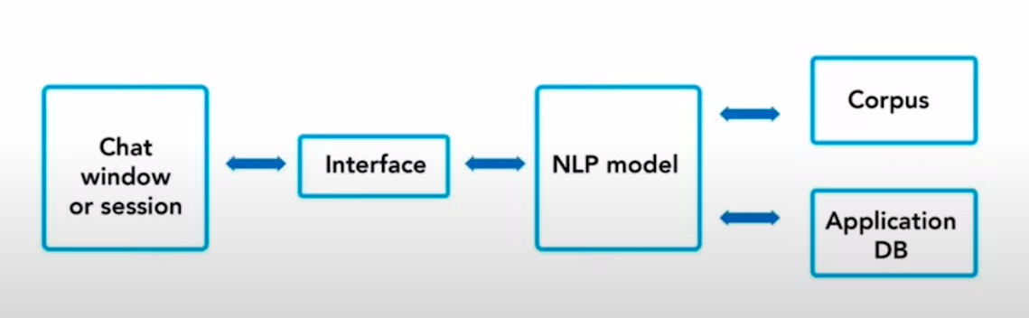
NLP = Natural Language Processing

How does a chatbot work?

1. Import corpus
2. Preprocess the data
3. Text case handling
4, Tokenization
5. Stemming
6. Bag of Words (BOW)
7. One hot encoding

Corpus:
- Corpus is a training data needed for the chatbot to learn
- Without a corpus, it is impossible for a chatbot to learn and reply something useful back to the user.

Data preprocessing – text case handling:
- Convert all the data coming as an input to either upper or lower case.
- This will avoid misrepresentation and misinterpretation of words if spelt under lower or upper cases.

Tokenization
it is the structured process of converting a sentence into individual collection of words.



Stemming:

Original Word | Root Word | Similar Words
Jump | Jump | Words with similar root word i.e., JUMP
Jumped | Jump | Words with similar root word i.e., JUMP
Jumps | Jump | Words with similar root word i.e., JUMP
Jumping | Jump | Words with similar root word i.e., JUMP

Stemming is a process of finding similarities between words with the same root words.

Generating bag of words (BOW):

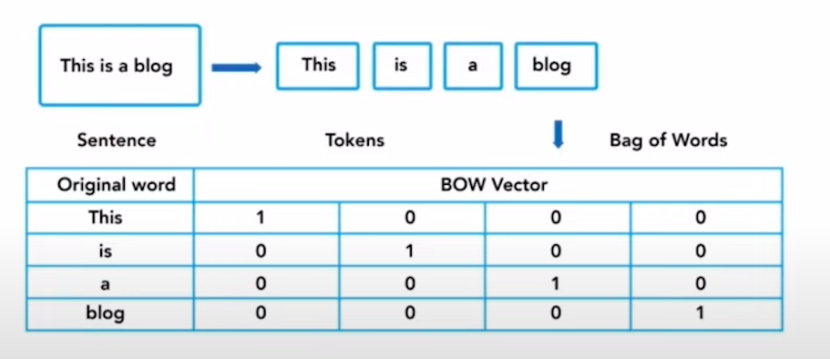
Process of converting words into number by generating vector embeddings from the tokens generated.

One hot encoding:

Tag | One Hot Encoded Vector [11X11]
This | 1 | 0 | 0 | 0 | 0 | 0 | 0 | 0 | 0 | 0 | 0
is | 0 | 1 | 0 | 0 | 0 | 0 | 0 | 0 | 0 | 0 | 0
a | 0 | 0 | 1 | 0 | 0 | 0 | 0 | 0 | 0 | 0 | 0
blog | 0 | 0 | 0 | 1 | 0 | 0 | 0 | 0 | 0 | 0 | 0
name | 0 | 0 | 0 | 1 | 0 | 0 | 0 | 0 | 0 | 0 | 1

One hot encoding is a process by which categorical variables are converted into a form that ML algorithms use.

