1. create all given tables

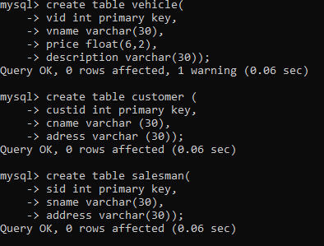

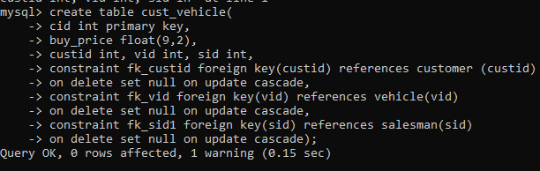

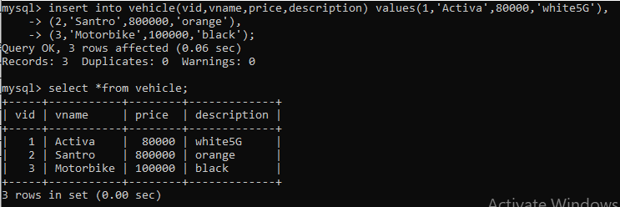

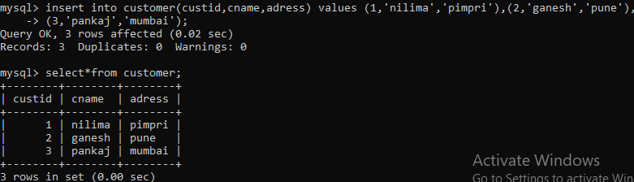

1. create index on vehicle table based on price
2. 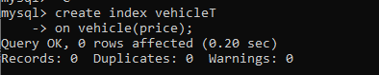

3. find all customer name,vehicle name, salesman name, discount earn by all customer

4. find all customer name,vehicle name,salesman name for all salesman who stays in pune

5. find how many customers bought motor bike

6. create a view find_discount which displays output

-------to create view

create view find_discount

as

select cname,vname,price,buying_price,price-buying_price “discount”

from customer c inner join cust_vehicle cv on c.custid=cv.cid inner join vehicle v on

v.vid=cv.vid

--------to display discount

select * from find_discount;

7. find all customer name, vehicle name, salesman name, discount earn by all customer

8. create view my_hr to display empno,ename,job,comm for all employees who earn

commission

9. create view mgr30 to display all employees from department 30

10. insert 3 employees in view mgr30 check whether insertion is possible

11. insert 3 records in dept and display all records from dept

12. use rollback command check what happens

13. do the following

insert row in emp with empno 100

insert row in emp with empno 101

insert row in emp with empno 102

add savepoint A

insert row in emp with empno 103

insert row in emp with empno 104

insert row in emp with empno 105

add savepoint B

delete emp with empno 100

delete emp with emp no 104

rollback upto svaepoint B

check what all records will appear in employee table

rollback upto A

check what all records will appear in employee table

commit all changes

check what all records will appear in employee table

check whether you can roll back the contents.

14. create a procedure getMin(deptno,minsal) to find minimum salary of given table.