1. To list all records with sal > 2000 and comm>200

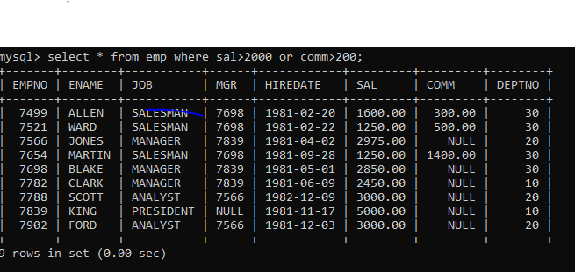

1. To list all record with job=’Clerk’ or sal>2000

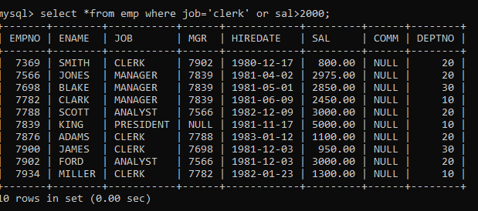

1. To list all the record with sal=1250 or 1100 or 2850

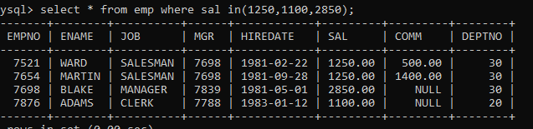

1. To list all employees with sal>1250 and <2850

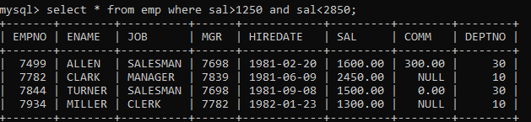

1. To list all employees with name ends with AS



1. To list all employees with job starts with C and ends with K

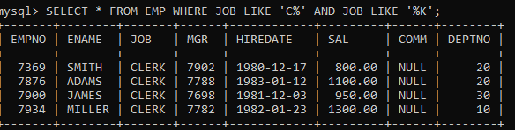

7. To list all employees with job contains L at third position and

M at third last position

1. To list all the record with sal not equal to 1250 or 1100 or 2850

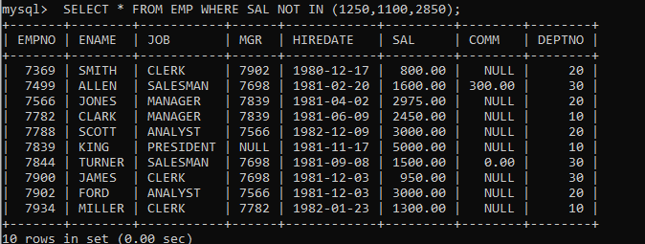

9. To list all employees with salnot >1250 and <2850

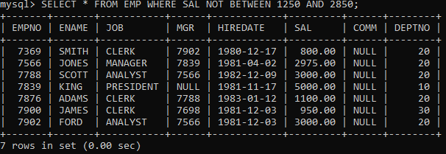

10. To list all employees with job starts with C , E at 3rd position and ends with K

11. To list all rows with comm is null

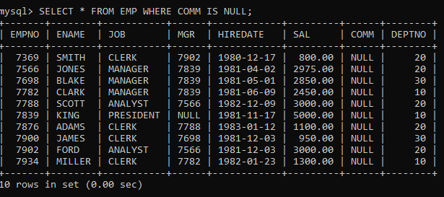

12. To list all employees with sal is null and name starts with ‘S’



13. To list all employees with job contains 5 characters

14. To list all employees with name contain ‘A’ at 1 position and job

Contains 5 characters

Display name concatenated with dept code separated by comma and space. Name

the column as ‘Emp info’.

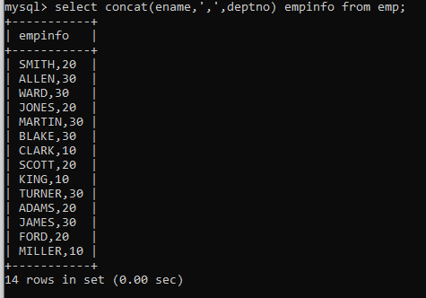

8. Write a query which will display name, department no and date of joining of all

employee who were joined January 1, 1981 and March 31, 1983. Sort it based on date of

joining (ascending).

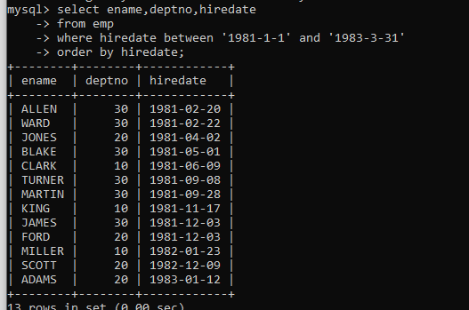

Display the employee details where the job contains word ‘AGE’ anywhere in the Job

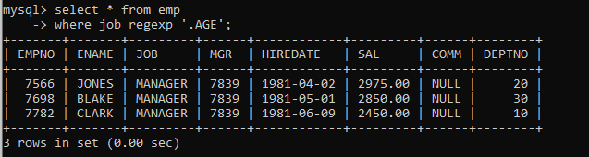

List the details of the employee , whose names start with ‘A’ and end with ‘S’ or

whose names contains N as the second or third character, and ending with either ‘N’ or ‘S’.

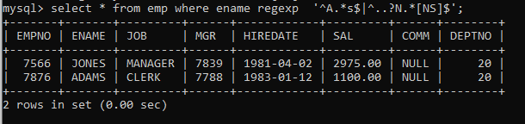

List the names of the emp having ‘_’ character in their name.



.Display the Highest, Lowest, Total & Average salary of all employee. Label the columns

Maximum, Minimum, Total and Average respectively for each Department. Also round the

result to the nearest whole number.

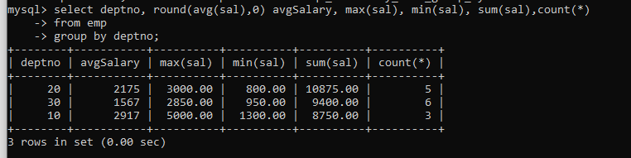

Display Department no and number of managers working in that department. Label the

column as ‘Total Number of Managers’ for each department.

