PREDICTIVE MODELING AND RISK SCORING FOR
BANK CUSTOMER CHURN
A Machine Learning Study of Customer Attrition in European Retail Banking
A Research Paper submitted in partial fulfilment of the requirements of the
Data Science Internship Program
Submitted by
SHUBHANGI PANDEY
Under the mentorship of
Unified Mentor
July 2026

DECLARATION
I hereby declare that this research paper, “Predictive Modeling and Risk Scoring for Bank Customer Churn,” is my own original work, carried out as part of the Data Science Internship Program under the mentorship of Unified Mentor. All data analysis, model development, and interpretation presented herein were performed by me. Wherever the work of other authors has been used, it has been duly acknowledged and cited in accordance with APA (7th edition) referencing conventions. This paper has not been submitted, in whole or in part, for any other degree, diploma, or certification.

Shubhangi Pandey
July 2026

ACKNOWLEDGEMENT
I express my sincere gratitude to Unified Mentor for the structured guidance, the problem framing, and the opportunity to work on an industry-relevant analytics engagement. I am equally thankful to the open-source community behind Python, scikit-learn, XGBoost, SHAP, and Streamlit, whose tools made an end-to-end delivery — from raw data to a deployed decision-support dashboard — achievable within the internship timeline. Finally, I thank my peers and reviewers whose critical feedback materially improved the rigor and clarity of this paper.

EXECUTIVE SUMMARY
Customer churn directly erodes the lifetime value of a retail-banking portfolio: in the 10,000-customer European dataset studied here, 20.37% of customers exited within the observation window. This research builds an end-to-end churn-prediction and risk-scoring system that allows the bank to move from reactive reporting to proactive, targeted retention.
Five classification algorithms — Logistic Regression, Decision Tree, Random Forest, Gradient Boosting, and XGBoost — were benchmarked on a stratified 80/20 train–test split with five-fold cross-validated hyperparameter tuning. The tuned Gradient Boosting classifier was selected as the champion model, achieving a test ROC-AUC of 0.870, PR-AUC of 0.720, precision of 0.794, and F1-score of 0.602. Five engineered behavioral features (including an engagement score and balance-to-salary ratio) strengthened the signal available to all models.
Explainability analysis using gain-based importance, SHAP values, and partial-dependence plots identified four dominant churn drivers: customer age (peaking in the 51–60 band at 56.2% churn), product holdings (customers with three or more products churn at 83–100%, while two-product customers churn at only 7.6%), account engagement (inactive members churn at nearly twice the rate of active members), and German residency (32.4% churn, double that of France or Spain).
The paper closes with six managerial recommendations — including a two-product cross-sell guardrail, an activation campaign for inactive members, and a Germany-specific service diagnostic — and delivers a five-module Streamlit dashboard that operationalizes the model as an interactive risk calculator, portfolio scanner, and what-if simulator for retention teams.

TABLE OF CONTENTS
CHAPTER 1: INTRODUCTION 1
1.1 Background of the Study 1
1.2 Problem Statement 1
1.3 Objectives of the Study 1
1.4 Scope and Significance 2
1.5 Organization of the Report 2
CHAPTER 2: LITERATURE REVIEW 3
2.1 The Economics of Customer Retention 3
2.2 Churn Prediction Methodologies 3
2.3 Explainable Machine Learning in Banking 3
2.4 Research Gap 4
CHAPTER 3: RESEARCH METHODOLOGY 5
3.1 Research Design 5
3.2 Data Description 5
3.3 Feature Engineering 6
3.4 Preprocessing Pipeline 6
3.5 Model Portfolio and Validation Strategy 6
3.6 Evaluation Metrics 7
CHAPTER 4: EXPLORATORY DATA ANALYSIS 8
4.1 Target Distribution and Category-Level Churn 8
4.2 Distributional Differences by Outcome 9
4.3 Correlation Structure and Interaction Effects 10
CHAPTER 5: MODEL DEVELOPMENT AND RESULTS 12
5.1 Benchmark and Tuned Performance 12
5.2 Champion Model Diagnosis 13
CHAPTER 6: MODEL EXPLAINABILITY 14
6.1 Global Feature Importance 14
6.2 SHAP Analysis 15
6.3 Partial Dependence 17
CHAPTER 7: FINDINGS AND RECOMMENDATIONS 18
7.1 Consolidated Findings 18
7.2 Managerial Recommendations 18
CHAPTER 8: LIMITATIONS AND FUTURE SCOPE 20
CHAPTER 9: CONCLUSION 21
REFERENCES 22
APPENDIX A: THE DEPLOYED DASHBOARD 23
APPENDIX B: TECHNOLOGY STACK AND REPRODUCIBILITY 24

LIST OF FIGURES
Figure 1: Target class balance — 2,037 churners (20.4%) among 10,000 customers 8
Figure 2: Churn rate by Geography, Gender, and activity status 8
Figure 3: Feature distributions for retained versus churned customers 9
Figure 4: Correlation matrix across raw and engineered features 10
Figure 5: Churn rate by age band and number of products 10
Figure 6: ROC and precision–recall curves for all candidate models 12
Figure 7: Confusion matrix of the tuned Gradient Boosting model at the 0.5 threshold 13
Figure 8: Gain-based feature importance of the champion model (top 15) 14
Figure 9: SHAP beeswarm summary — direction and magnitude of each feature’s impact 15
Figure 10: Mean absolute SHAP value per feature 16
Figure 11: Partial-dependence profiles for the five dominant drivers 17

LIST OF TABLES
Table 1: Dataset variables and descriptive summary 5
Table 2: Engineered behavioral features 6
Table 3: Candidate model portfolio 6
Table 4: Churn rate by key customer segment 11
Table 5: Comparative model performance on the held-out test set (n = 2,000) 12
Table 6: Top churn drivers by gain importance 14
Table 7: Managerial recommendations mapped to findings 18
Table 8: Technology stack 24

CHAPTER 1: INTRODUCTION

1.1 Background of the Study
Retail banks operate in a mature, commoditized market in which the cost of acquiring a new customer substantially exceeds the cost of retaining an existing one; long-tenured customers additionally hold larger balances, adopt more products, and generate referral value (Reichheld & Sasser, 1990; Gupta, Lehmann, & Stuart, 2004). Customer churn — the voluntary closure or abandonment of a banking relationship — therefore attacks both current revenue and the compounding value of the customer base. The industry consensus that retention improvements of even a few percentage points translate into disproportionate profit gains has made churn management a board-level priority.
Advances in machine learning have shifted churn management from retrospective analysis (“why did customers leave?”) to prospective risk scoring (“which current customers are likely to leave, and why?”). This study applies that prospective lens to a European retail-banking portfolio, combining predictive accuracy with model explainability so that scores can be trusted, audited, and acted upon by business stakeholders.

1.2 Problem Statement
The subject bank loses approximately one customer in five, yet its customer intelligence is descriptive rather than predictive: it cannot identify, ahead of time, which customers are at elevated risk, nor which attributes and behaviors drive that risk. Retention outreach is consequently untargeted, expensive, and late. The problem addressed here is the design, validation, and operationalization of a churn prediction model that produces accurate, calibrated, and explainable customer-level risk scores.

1.3 Objectives of the Study
Primary objectives:
- Predict customer churn with high discrimination (ROC-AUC) on held-out data.
- Produce a churn probability score for every customer to support risk banding.
- Identify and explain the dominant drivers of churn.
Secondary objectives:
- Reduce false-positive retention spend through a precision-oriented decision threshold.
- Make every prediction interpretable for compliance and business stakeholders.
- Enable scenario analysis through an interactive what-if simulation tool.

1.4 Scope and Significance
The study covers a single-snapshot portfolio of 10,000 customers across France, Germany, and Spain, with fourteen raw attributes spanning demographics, account status, and engagement. Its significance is twofold: managerially, it converts raw customer data into a deployed decision-support tool; methodologically, it demonstrates a disciplined benchmark-tune-explain workflow in which model selection is justified by out-of-sample evidence and every headline driver is corroborated by three independent explainability techniques.

1.5 Organization of the Report
Chapter 2 reviews the relevant literature. Chapter 3 details the research methodology. Chapter 4 presents the exploratory data analysis. Chapter 5 reports model development and comparative results. Chapter 6 presents model explainability. Chapter 7 consolidates findings and managerial recommendations. Chapter 8 discusses limitations and future scope, and Chapter 9 concludes.

CHAPTER 2: LITERATURE REVIEW

2.1 The Economics of Customer Retention
Reichheld and Sasser (1990) established the canonical argument that “zero defections” management materially improves profitability, estimating that a five-percentage-point improvement in retention can raise profits by 25–85% in service industries. Gupta, Lehmann, and Stuart (2004) formalized the link between retention and firm value, showing that a one-percent improvement in retention increases customer lifetime value substantially more than an equivalent improvement in acquisition cost or margin. These results motivate the managerial premium on early, accurate churn identification.

2.2 Churn Prediction Methodologies
Early churn models relied on logistic regression for its interpretability and calibrated probabilities. The comparative literature has since demonstrated consistent accuracy advantages for ensemble tree methods: Lemmens and Croux (2006) showed that bagging and boosting classification trees significantly outperform binary logit in churn prediction; Neslin et al. (2006), reporting on a large-scale churn tournament, found that tree-based ensembles dominated the leaderboard and that methodological choices materially affect the economic value of a churn model. Verbeke et al. (2012) extended the evaluation criterion from statistical accuracy to profit-driven measures, arguing that model selection should reflect the asymmetric costs of false positives (wasted retention spend) and false negatives (lost customers) — a consideration reflected in this study’s precision-oriented threshold policy.
Among ensemble methods, Random Forests (Breiman, 2001) reduce variance through bootstrap aggregation of decorrelated trees, while gradient boosting (Friedman, 2001) builds additive stagewise models that typically achieve superior discrimination on structured tabular data. XGBoost (Chen & Guestrin, 2016) is a regularized, computationally efficient implementation of the same principle and a frequent benchmark winner on tabular problems.

2.3 Explainable Machine Learning in Banking
Predictive accuracy alone is insufficient in a regulated industry. SHAP (SHapley Additive exPlanations; Lundberg & Lee, 2017) provides theoretically grounded, locally accurate attributions of each prediction to each feature, enabling model risk management, adverse action reasoning, and stakeholder trust. Partial-dependence analysis complements SHAP by exposing the average shape of each feature–response relationship. This study treats explainability as a first-class deliverable alongside accuracy.

2.4 Research Gap
Much of the academic churn literature stops at comparative model accuracy. Fewer studies carry the model through to a deployed, explainable decision-support artifact with explicit threshold governance for business use. This paper addresses that gap by delivering the full pipeline — data validation, feature engineering, benchmarked and tuned models, three-way explainability, and an interactive dashboard — as a single, reproducible system.

CHAPTER 3: RESEARCH METHODOLOGY

3.1 Research Design
The study follows a quantitative, applied predictive-analytics design structured as: data ingestion and quality validation; exploratory data analysis; feature engineering; model benchmarking; hyperparameter tuning of the leading candidates; final evaluation on a held-out test set; and explainability analysis. All computation was performed in Python using scikit-learn (Pedregosa et al., 2011) and XGBoost, with every preprocessing step embedded in a serialized Pipeline so that training-time transformations are reproduced exactly at inference time.

3.2 Data Description
The dataset comprises 10,000 customer records with fourteen raw attributes from a European retail bank (snapshot year 2025). Data quality validation found zero missing values, zero duplicate records, and consistent binary encodings across all indicator fields.
Table 1: Dataset variables and descriptive summary
Variable | Type | Description
CustomerId, Surname | Identifier | Dropped from modeling; excluded from all outputs
CreditScore | Numeric | Creditworthiness, range 350–850
Geography | Categorical | France (50.1%), Germany (25.1%), Spain (24.8%)
Gender | Categorical | Male (54.6%), Female (45.4%)
Age | Numeric | 18–92 years, median 37
Tenure | Numeric | Years with the bank, 0–10
Balance | Numeric | Account balance; 36.2% of customers at zero
NumOfProducts | Numeric | Products held, 1–4
HasCrCard / IsActiveMember | Binary | Card ownership; activity indicator
EstimatedSalary | Numeric | Annual salary proxy
Exited | Binary (target) | 1 = churned (20.37% prevalence)

3.3 Feature Engineering
Five derived features were constructed to encode behavioral signals not visible in the raw schema:
Table 2: Engineered behavioral features
Feature | Definition | Behavioral hypothesis
BalanceSalaryRatio | Balance / (Salary + 1) | Wealth concentration relative to income
ProductDensity | Products / (Tenure + 1) | Speed of product adoption
EngagementScore | IsActiveMember × Products | Active engagement weighted by breadth
AgeTenureRatio | Age / (Tenure + 1) | Life stage relative to relationship age
ZeroBalance | 1 if Balance = 0 | Flags the dormant-balance segment (36.2%)

3.4 Preprocessing Pipeline
Identifiers and the constant Year column were dropped. Geography and Gender were one-hot encoded; all numeric features were standardized. Both transformations were wrapped with the classifier in a single scikit-learn Pipeline, persisted as one artifact, eliminating training–serving skew.

3.5 Model Portfolio and Validation Strategy
Table 3: Candidate model portfolio
Model | Family | Role in the benchmark
Logistic Regression | Linear | Interpretability baseline (class-weight balanced)
Decision Tree | Tree | Single-tree reference (depth 8, balanced)
Random Forest | Bagged ensemble | Variance reduction (300 trees, balanced)
Gradient Boosting | Boosted ensemble | Sequential additive refinement
XGBoost | Boosted ensemble | Regularized, histogram-based boosting

Data were split 80/20 with stratification on the target, preserving the 20.37% churn prevalence in both partitions (n = 8,000 train; n = 2,000 test). The two leading models by test ROC-AUC were tuned with RandomizedSearchCV (15 candidate configurations each) under five-fold stratified cross-validation on the training partition only; the test set was touched exactly once per final model.

3.6 Evaluation Metrics
Six complementary metrics are reported: Accuracy, Precision, Recall, F1-score, ROC-AUC (threshold-free discrimination), and PR-AUC (average precision, more informative than ROC-AUC under the 20% class imbalance). ROC-AUC on the held-out test set is the selection criterion, with PR-AUC as tie-breaker.

CHAPTER 4: EXPLORATORY DATA ANALYSIS

4.1 Target Distribution and Category-Level Churn
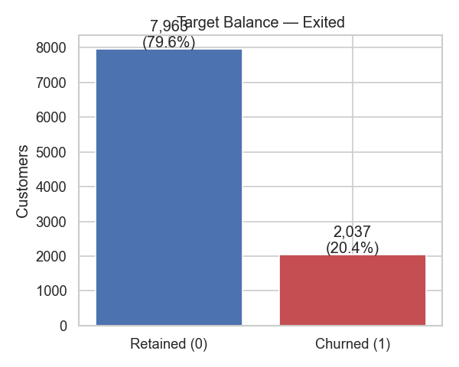
Figure 1: Target class balance — 2,037 churners (20.4%) among 10,000 customers
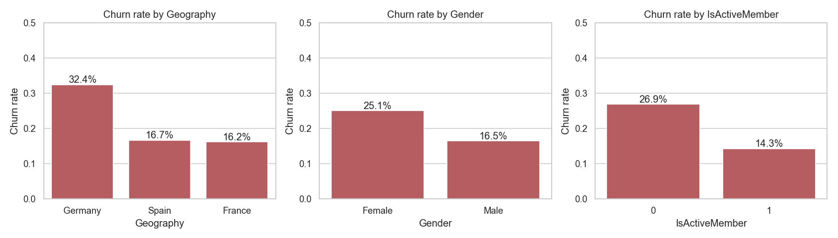
Figure 2: Churn rate by Geography, Gender, and activity status
Three categorical effects stand out. Germany churns at 32.4% — double France (16.1%) and Spain (16.7%) — despite hosting only a quarter of the base. Female customers churn at 25.1% versus 16.5% for male customers. Inactive members churn at 26.9% versus 14.3% for active members — the single most actionable behavioral gap in the portfolio.

4.2 Distributional Differences by Outcome
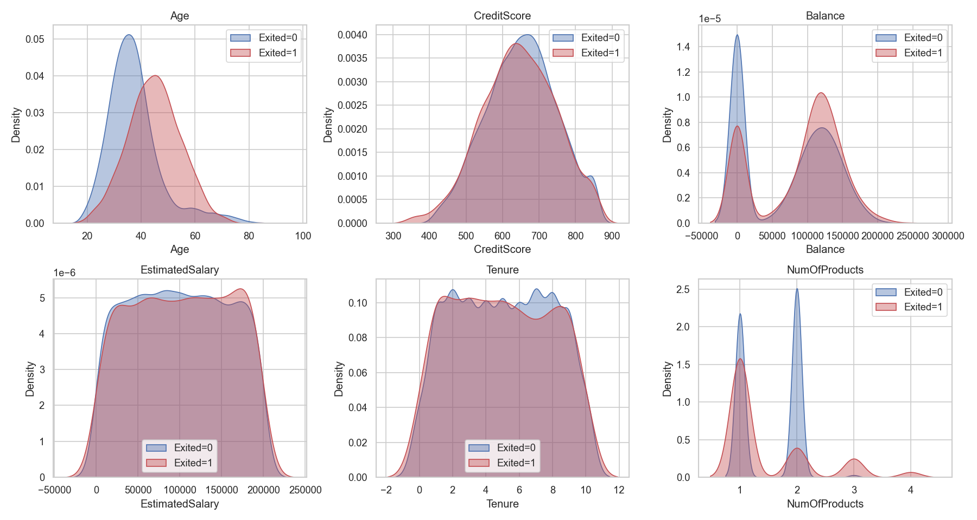
Figure 3: Feature distributions for retained versus churned customers
Age separates the classes most sharply: churn probability climbs from 7.5% among customers aged 18–30 to 56.2% in the 51–60 band. Churned customers also carry systematically higher balances — an early indication that balance is not a loyalty signal in this portfolio.

4.3 Correlation Structure and Interaction Effects
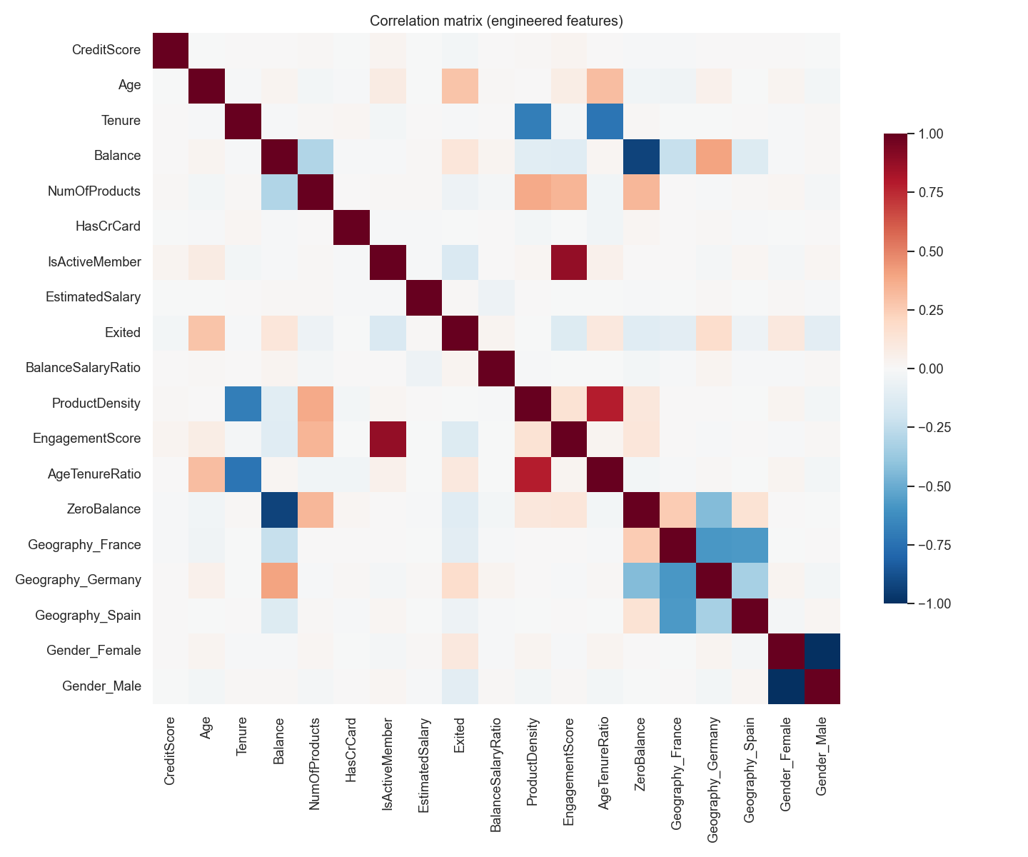
Figure 4: Correlation matrix across raw and engineered features
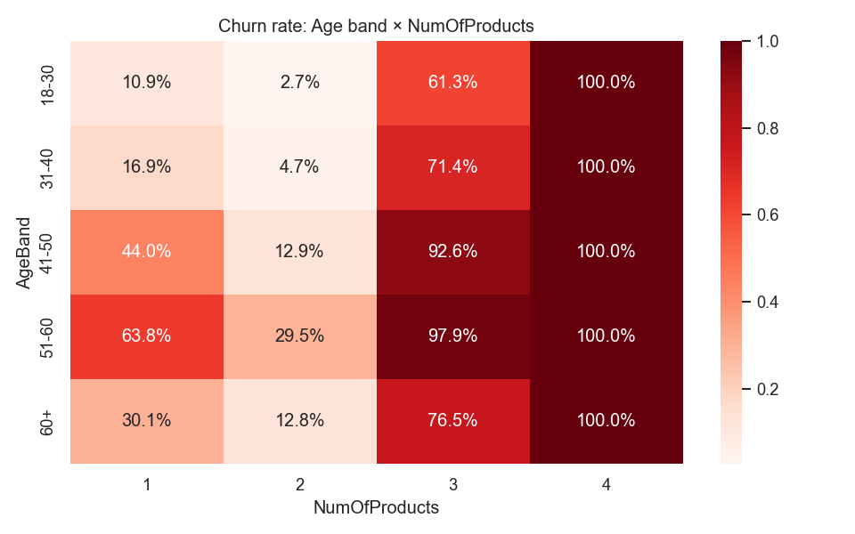
Figure 5: Churn rate by age band and number of products
The age-by-products heatmap exposes the portfolio’s most striking interaction: churn among customers holding three or more products approaches certainty in every age band (82.7% at three products; 100% at four), while two-product customers are the safest segment at 7.6%. The conventional assumption that deeper product relationships imply stickier customers inverts beyond two products — the “three-product trap.”
Table 4: Churn rate by key customer segment
Segment | n | Churn rate
Geography = Germany | 2,509 | 32.4%
Geography = France / Spain | 7,491 | 16.1% / 16.7%
Inactive members | 4,849 | 26.9%
Active members | 5,151 | 14.3%
NumOfProducts = 2 | 4,590 | 7.6%
NumOfProducts ≥ 3 | 326 | 84.5% (combined)
Age 51–60 | 797 | 56.2%
Balance > 0 | 6,383 | 24.1%
Balance = 0 | 3,617 | 13.8%

CHAPTER 5: MODEL DEVELOPMENT AND RESULTS

5.1 Benchmark and Tuned Performance
Table 5: Comparative model performance on the held-out test set (n = 2,000)
Model | Accuracy | Precision | Recall | F1 | ROC-AUC | PR-AUC
Gradient Boosting (tuned) | 0.870 | 0.794 | 0.484 | 0.602 | 0.870 | 0.720
Gradient Boosting | 0.869 | 0.788 | 0.484 | 0.600 | 0.869 | 0.719
XGBoost (tuned) | 0.871 | 0.806 | 0.479 | 0.601 | 0.868 | 0.717
XGBoost | 0.866 | 0.772 | 0.482 | 0.593 | 0.855 | 0.700
Random Forest | 0.862 | 0.769 | 0.457 | 0.573 | 0.853 | 0.682
Decision Tree | 0.760 | 0.446 | 0.742 | 0.557 | 0.804 | 0.624
Logistic Regression | 0.714 | 0.388 | 0.710 | 0.502 | 0.776 | 0.469

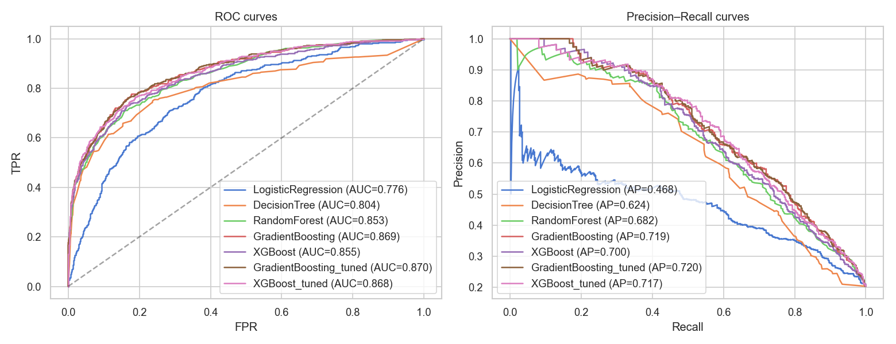
Figure 6: ROC and precision–recall curves for all candidate models
Ensemble boosting dominates: both boosted families exceed 0.85 ROC-AUC, while the interpretable baselines trail by 7–10 points. The tuned Gradient Boosting classifier (learning rate 0.05, 200 estimators, maximum depth 3, subsample 1.0) attains the best test ROC-AUC (0.870) and PR-AUC (0.720). The tuned XGBoost model is statistically indistinguishable; Gradient Boosting was preferred for its smaller dependency footprint in deployment.

5.2 Champion Model Diagnosis
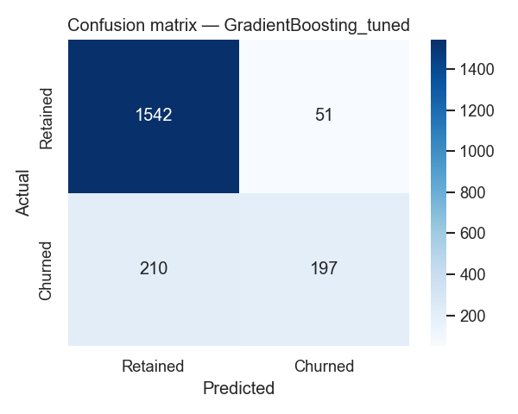
Figure 7: Confusion matrix of the tuned Gradient Boosting model at the 0.5 threshold
At the default 0.5 threshold the champion model favors precision (0.794) over recall (0.484): four of five customers it flags are genuine churn risks, minimizing wasted retention spend, at the cost of catching roughly half of eventual churners. This trade-off is a policy choice, not a model property: lowering the threshold to 0.30 — the dashboard’s medium-risk boundary — captures materially more churners at higher outreach cost. Threshold governance is assigned to the Retention Committee (Recommendation R6).

CHAPTER 6: MODEL EXPLAINABILITY

6.1 Global Feature Importance
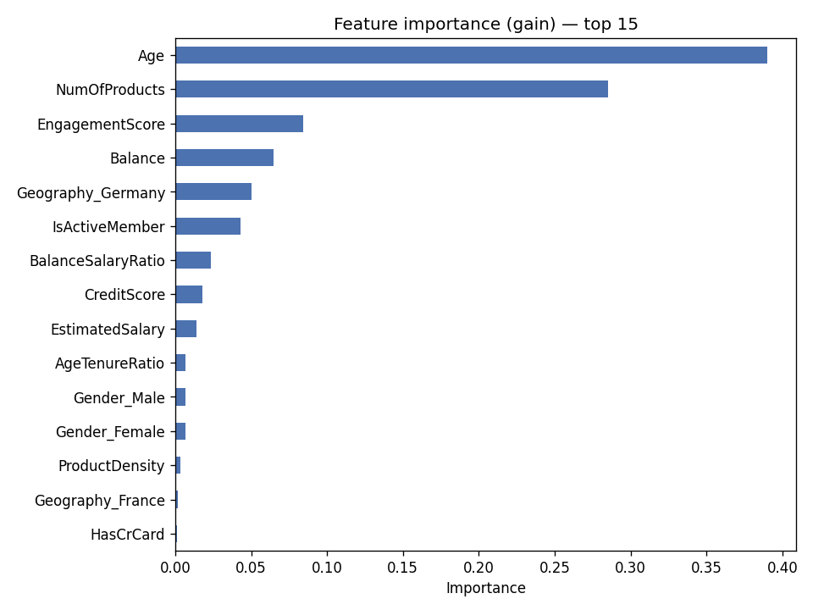
Figure 8: Gain-based feature importance of the champion model (top 15)
Table 6: Top churn drivers by gain importance
Rank | Feature | Importance (gain share)
1 | Age | 0.390
2 | NumOfProducts | 0.285
3 | EngagementScore (engineered) | 0.084
4 | Balance | 0.065
5 | Geography_Germany | 0.050
6 | IsActiveMember | 0.043
7 | BalanceSalaryRatio (engineered) | 0.023
8 | CreditScore | 0.018

6.2 SHAP Analysis
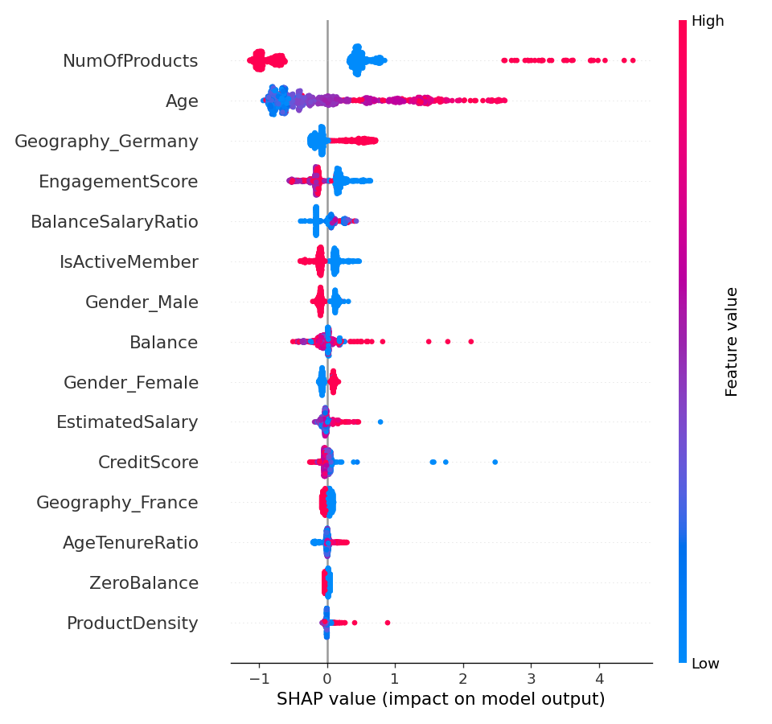
Figure 9: SHAP beeswarm summary — direction and magnitude of each feature’s impact
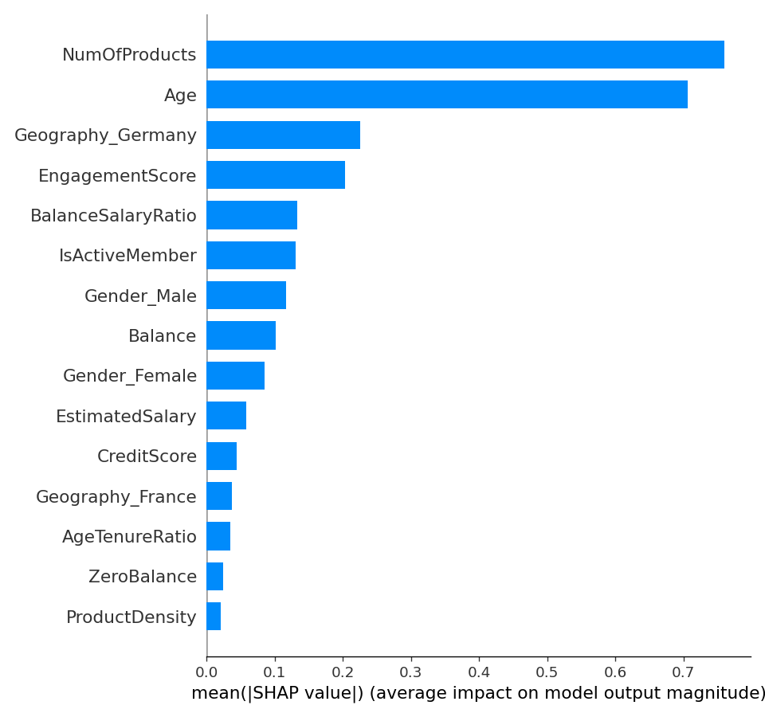
Figure 10: Mean absolute SHAP value per feature
SHAP corroborates the gain ranking and adds direction: high age and three-plus product holdings push predictions toward churn; active membership pulls them away; German residency raises risk while France and Spain are approximately neutral. The engineered EngagementScore ranks third overall, validating the feature-engineering hypothesis that activity interacted with product breadth carries signal beyond either raw variable.

6.3 Partial Dependence
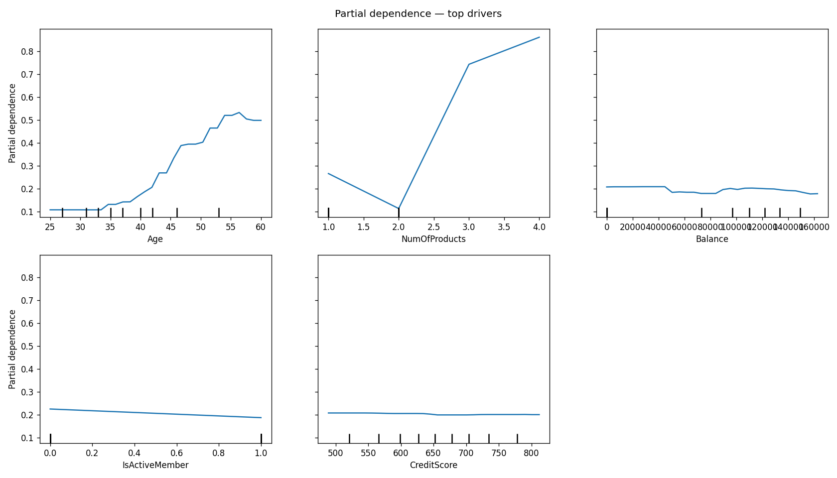
Figure 11: Partial-dependence profiles for the five dominant drivers
Partial dependence confirms the non-linear age curve (risk accelerating between 40 and 60), the two-product safety trough, and the protective effect of activity — consistent across all three explainability lenses.

CHAPTER 7: FINDINGS AND RECOMMENDATIONS

7.1 Consolidated Findings
- F1 — Age is the dominant churn driver; the 51–60 band churns at 56.2%.
- F2 — Product depth is non-monotonic: two products is the retention sweet spot (7.6%); three or more signals near-certain churn (83–100%).
- F3 — Engagement is the cheapest lever: inactive members churn at 26.9% vs 14.3% for active members.
- F4 — Germany churns at double the rate of France and Spain; the effect is not explained by observable demographics or balances.
- F5 — The tuned Gradient Boosting model provides 0.870 ROC-AUC with fully explainable predictions.

7.2 Managerial Recommendations
Table 7: Managerial recommendations mapped to findings
# | Recommendation | Grounding
R1 | Cap automated cross-sell at two products; require a satisfaction check before any third product | F2
R2 | Launch an activation campaign (nudges, relationship-manager outreach) on the inactive cohort — the highest expected ROI lever | F3
R3 | Commission a Germany-specific diagnostic covering pricing, service quality, and product fit | F4
R4 | Design a pre-retirement wealth-transition proposition for customers aged 50–60 | F1
R5 | Operationalize monthly risk scoring; route the top decile to relationship managers; measure uplift with a holdout control group | F5
R6 | Assign decision rights over the alert threshold to the Retention Committee; the 0.30 boundary doubles churner capture at manageable cost | §5.2

CHAPTER 8: LIMITATIONS AND FUTURE SCOPE
- Cross-sectional snapshot: the data cannot support survival analysis (when a customer will churn) or capture time-varying macro effects; a panel extension is the natural next step.
- Recall at the default threshold is 0.484; a cost-sensitive optimization aligned with the bank’s actual retention economics should precede full-scale rollout.
- Fairness has not been audited: Geography (and correlated attributes) is a strong driver, and an adverse-impact assessment on protected characteristics is required before deployment in a supervised jurisdiction.
- Probabilities are uncalibrated; Platt or isotonic calibration is advised where scores feed budget allocation.
- The three-plus-product churn pattern is an association in snapshot data; product-add timestamps are needed to separate distress cross-selling from causal product effects.

CHAPTER 9: CONCLUSION
This research delivers a complete, deployable churn-intelligence system for a European retail bank. A disciplined benchmark of five algorithms, tuned under stratified cross-validation, produced a champion Gradient Boosting model with 0.870 test ROC-AUC whose every prediction is decomposable into feature contributions. The explainability analysis converged on four drivers — age, product depth, engagement, and German residency — and surfaced the portfolio’s most consequential behavioral insight: cross-selling beyond two products is associated with near-certain attrition. Combined with the interactive dashboard and the recommended threshold governance, the system equips the bank to shift retention practice from reactive reporting to targeted, explainable, and measurable intervention.

REFERENCES
Breiman, L. (2001). Random forests. Machine Learning, 45(1), 5–32.
Chen, T., & Guestrin, C. (2016). XGBoost: A scalable tree boosting system. In Proceedings of the 22nd ACM SIGKDD International Conference on Knowledge Discovery and Data Mining (pp. 785–794). ACM.
Friedman, J. H. (2001). Greedy function approximation: A gradient boosting machine. The Annals of Statistics, 29(5), 1189–1232.
Gupta, S., Lehmann, D. R., & Stuart, J. A. (2004). Valuing customers. Journal of Marketing Research, 41(1), 7–18.
Lemmens, A., & Croux, C. (2006). Bagging and boosting classification trees to predict churn. Journal of Marketing Research, 43(2), 276–286.
Lundberg, S. M., & Lee, S.-I. (2017). A unified approach to interpreting model predictions. In Advances in Neural Information Processing Systems 30 (pp. 4765–4774).
Neslin, S. A., Gupta, S., Kamakura, W., Lu, J., & Mason, C. H. (2006). Defection detection: Measuring and understanding the predictive accuracy of customer churn models. Journal of Marketing Research, 43(2), 204–211.
Pedregosa, F., Varoquaux, G., Gramfort, A., Michel, V., Thirion, B., Grisel, O., … Duchesnay, É. (2011). Scikit-learn: Machine learning in Python. Journal of Machine Learning Research, 12, 2825–2830.
Reichheld, F. F., & Sasser, W. E., Jr. (1990). Zero defections: Quality comes to services. Harvard Business Review, 68(5), 105–111.
Verbeke, W., Dejaeger, K., Martens, D., Hur, J., & Baesens, B. (2012). New insights into churn prediction in the telecommunication sector: A profit driven data mining approach. European Journal of Operational Research, 218(1), 211–229.

APPENDIX A: THE DEPLOYED DASHBOARD
The model is operationalized as a five-module Streamlit web application deployed on Streamlit Community Cloud (repository: github.com/shubhangi-ppandey/bank-churn-prediction).
- Risk Calculator — enter a customer profile; receive churn probability, risk band (Low < 30% ≤ Medium < 60% ≤ High), and a recommended action.
- Probability Distribution — scores the full 10,000-customer portfolio; risk-band counts and top-25 high-risk list.
- Feature Importance — interactive gain chart with SHAP and partial-dependence visuals.
- What-If Simulator — perturb a real customer’s engagement, products, or balance and observe the marginal probability change.
- Model Performance — full metrics table, ROC/PR curves, confusion matrix, and EDA gallery.

APPENDIX B: TECHNOLOGY STACK AND REPRODUCIBILITY
Table 8: Technology stack
Layer | Technology
Language / runtime | Python 3.12 (pinned in runtime.txt)
Data handling | pandas, NumPy
Modeling | scikit-learn (Pipeline, GradientBoostingClassifier), XGBoost
Explainability | SHAP (TreeExplainer), sklearn partial dependence
Visualization | Matplotlib, Seaborn, Plotly
Application / deployment | Streamlit; Streamlit Community Cloud; pinned requirements.txt
Version control | Git / GitHub (github.com/shubhangi-ppandey/bank-churn-prediction)

All figures and tables in this paper are regenerated end-to-end by three scripts (src/eda.py, src/train.py, src/explain.py) against the committed dataset, guaranteeing full reproducibility of every reported number.

