"""Q.1) Write a Python program which accepts the user's first and last name and print them in
reverse order with a space between them. """
fname=input("Enter your first name: ")
lname=input("Enter your last name: ")
list1=[fname,lname]
list1.reverse()
print(list1)
print(*list1)

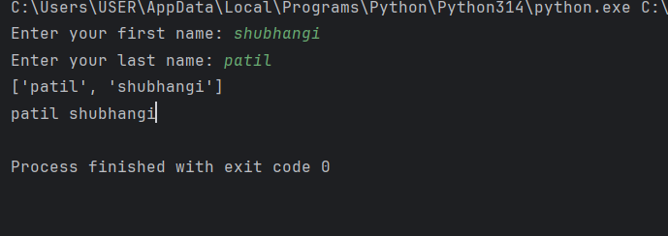

"""Write a Python program to print the calendar of a given month and year.
Note : Use 'calendar' module. """
import calendar
print(calendar.month(2026, 1))

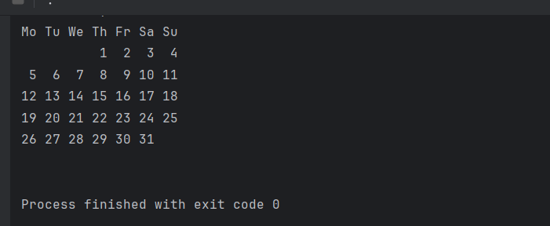

"""Que3:Write a Python program to calculate number of days between two dates.
[ use datetime module ]
Sample dates : (2014, 7, 2), (2014, 7, 11)
Expected output : 9 days"""
from datetime import datetime
d1=input("Enter the 1st date(yyyy/mm/dd):")
d2=input("Enter the 2nd date(yyyy/mm/dd):")
date1=datetime.strptime(d1,"%Y/%m/%d")
date2=datetime.strptime(d2,"%Y/%m/%d")
difference = date2 - date1
print(difference)

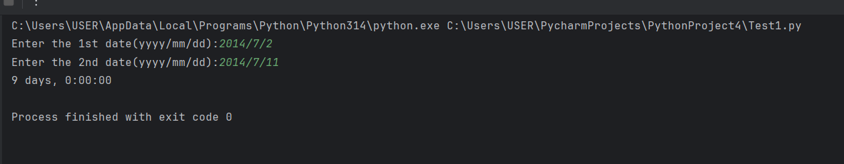

def is_vowel(letter):
letter = letter.lower()
vowels = {'a', 'e', 'i', 'o', 'u'}
return letter in vowels
char1 = 's'
char2 = 'a'
char3 = 'p'
print(is_vowel(char1))
print(is_vowel(char2))
print(is_vowel(char3))

